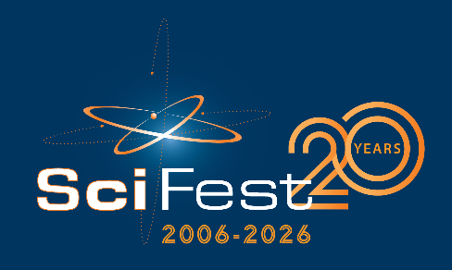

Media Invite
Tomorrow’s innovators showcase their impressive scientific projects at SciFest@School in [Insert name of school]

[insert name of school] students will exhibit [insert number of projects] innovative science projects at SciFest@School [insert year]

Over [number of students] students from [insert year/s] will exhibit [number of projects] projects in [Insert school name]’s SciFest@School science fair.

Projects on display include [insert a line or two about the most unique/interesting/eye catching/fun/ projects].

When: Include day, date and time

Where: Include location,

Contact: Include your contact details – name, email, phone number

ENDS

Notes to editor:
SciFest is a series of one day science fairs, funded primarily by Intel Ireland, Boston Scientific, EirGrid, Keenova and the Department of Education. It is also supported by a number of other companies and organisations.

SciFest@School is where a second-level school hosts their own in-house SciFest science fair. SciFest@School was introduced in 2011 and there has been strong demand from schools to participate. SciFest@School is the first strand of the SciFest programme. Second-level students can also participate in SciFest@College in one of the 16 regional SciFest@College venues, DkIT, TU Dublin (3 venues), MTU (2 venues), TUS (3 venues), ATU (3 venues), SETU (2 venues), DCU or St Mary’s College, Derry. Winners from these fairs go on to compete in a national final each November in Dublin for the chance to represent Ireland at the Regeneron International Science and Engineering Fair (ISEF) in the USA, the Eskom EXPO for Young Scientists and the Long Night of Science in Berlin. In 2025 more than 16,000 second-level students from over 300 schools participated in the SciFest programme.

