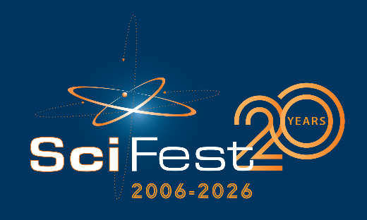

Media Release
Tomorrow’s innovators showcase their impressive scientific projects at SciFest@School in [Insert name of school]

- Students exhibit [insert number of projects] innovative science projects at SciFest@School [insert year] -

<Insert date>: Over [number of students] students from [insert year/s] exhibited [number of projects] projects in SciFest@School in [Insert school name]. This was the school’s [insert number of SciFest@Schools hosted] SciFest@School and it was the biggest one yet!

Students demonstrated their knowledge of science, technology, engineering and maths through their creative and innovative projects. Some of the projects on display included [insert a line or two about some of the more unique projects].

The overall prize went to [insert a line about the winners and their project, i.e. names, year, project title, project synopsis].

Commenting on the success of the science fair, [insert name of principal/Year Head/Teacher] said: “We are thrilled to host SciFest@School at our school, as it provides students with the opportunity to extend their studies in science, technology, engineering, and math beyond the classroom, applying what they've learned to real-world situations. The dedication and hard work that all of our students have put into their projects is commendable, and they should be incredibly proud of their accomplishments. We wish the best of luck to those moving on to the next stage of the SciFest competition, where they will compete in the regional SciFest@College final in [insert name of university].”

Sheila Porter, Founder and CEO of SciFest added: “Since the launch of SciFest@School in 2011, the programme has gone from strength to strength across the country. Each year, I am struck by the energy, curiosity, and commitment shown by students taking part. SciFest@School creates a dynamic space where students can step beyond the classroom, apply their scientific learning in meaningful ways, and explore ideas through creativity and investigation. Their achievements are a real credit not only to the students themselves, but also to the teachers who encourage, support, and inspire them throughout the process.”
Please see www.scifest.ie for further information.
-ends-
For further information, please contact:
INSERT YOUR CONTACT DETAILS HERE.
NAME, SCHOOL, EMAIL, SCHOOL PHONE NUMBER.
Notes to editor:
SciFest is a series of one day science fairs, funded primarily by Intel Ireland, Boston Scientific, EirGrid, Keenova and the Department of Education. It is also supported by a number of other companies and organisations.

SciFest@School is where a second-level school hosts their own in-house SciFest science fair. SciFest@School was introduced in 2011 and there has been strong demand from schools to participate. SciFest@School is the first strand of the SciFest programme. Second-level students can also participate in SciFest@College in one of the 16 regional SciFest@College venues, DkIT, TU Dublin (3 venues), MTU (2 venues), TUS (3 venues), ATU (3 venues), SETU (2 venues), DCU or St Mary’s College, Derry. Winners from these fairs go on to compete in a national final each November in Dublin for the chance to represent Ireland at the Regeneron International Science and Engineering Fair (ISEF) in the USA, the Eskom EXPO for Young Scientists and the Long Night of Science in Berlin. More than 16,000 students from over 300 schools participated in SciFest 2025.

