Critical Incident Management Plan



St. Mary’s Secondary School

Baldoyle

Updated in line with NEPS Critical Incident Guidance and staff meeting slides.
Policy Review and Ratification: 28 May 2026.
Signed:Signed: 
Chairperson of Board of Management Principal/Secretary to the Board of Management
Date: 28/5/ 2026 Date: 28 / 5 / 2026

Contents
- Aim of the Critical Incident Management Plan
- Prevention and Preparation
- Definition of a Critical Incident
- Examples of Critical Incidents
- Critical Incident Management Team
- Procedures on Hearing the News
- Convening the CIMT
- Immediate Plan of Action
- First Day Checklist
- Informing Staff
- Informing Students
- Informing Parents/Guardians
- Critical Incident on a School Trip
- Liaising with the Media
- Staff and Student Support
- Medium-Term Follow-Up
- Designated Rooms
- Evaluation and Review
Appendices 1–9

- Aim of the Critical Incident Management Plan
The aim of the Critical Incident Management Plan is to help school management and staff react quickly and effectively in the event of a critical incident, to maintain a sense of control, and to ensure that appropriate support is offered to students and staff. A good plan should help to limit the effects on the school community and support a return to normality as soon as possible.

2. Prevention and Preparation
Critical incidents are generally unexpected and can be highly distressing. Careful preparation and pre-planning are essential to managing a critical incident in a professional and calm manner. The school will foster a coping, caring and supportive ethos through pastoral care, a code of behaviour, anti-bullying policies and SPHE programmes. The provision of a physically and psychologically safe environment for the whole school community is an absolute priority.
The Critical Incident Management Team will meet regularly to update and review this plan. New and temporary staff will be made aware of the plan, and copies will be available to relevant staff members. The plan will also be reviewed by the Board of Management and shared appropriately with parents where relevant.

3. Definition of a Critical Incident
A critical incident is any incident or sequence of events which overwhelms the normal coping mechanisms of the school and disrupts the running of the school.

4. Examples of Critical Incidents
Critical incidents may include:
- Death of a member of the school community.
- Impending death of a member of the school community.
- Disappearance of a member of the school community.
- Serious accident involving a member of the school community.
- Serious illness involving a member of the school community.
- Serious violence to or threat of serious violence to a member of the school community.
- Serious emergency on the school premises, including bomb scare, chemical spill/explosion, epidemic, intrusion into the school, or pandemic fatalities.
- Serious damage to school buildings through fire, vandalism, flood or other cause.
- An accident or tragedy in the wider community.

5. Critical Incident Management Team
The Principal will establish a Critical Incident Management Team comprising relevant staff members with clearly defined roles. The size and composition of the team may vary depending on the incident and the needs of the school community.
- Principal- Dr. Edel Greene
- Deputy Principal- Mr. Joseph Ryan
- Guidance Counsellor- Ms. Mary Molloy
- Chaplain/Clergy/RE team- Ms Fiona O’Donnell
- Emergency Services Liaison – Mr William Pettitt
- Student/ Parent Community Liaisons- Mr Shane O’Neill/ Mr. Rocco Mulvey
- Appropriate Year Head/Form Teacher
- Admin Team – Una Molloy, Sharon Duffy, Diane Causer
- Other persons relevant to the situation and SNA Teams
Where necessary, back-up personnel will be identified to ensure continuity of response. The success of the team depends on the selection of committed staff who can work calmly and effectively under pressure.

6 . Procedures on Hearing the News
Once a member of staff hears of a critical incident, senior management must be informed immediately. If an emergency is apparent, emergency services must be contacted first. The school will then establish the correct facts before any action is taken.
The school will gather accurate information and check the details carefully, including:
- What happened.
- Where it happened.
- When it happened.
- Who is involved.
- Whether anyone is injured.
- What agencies have already been contacted.
- Whether there is any risk of further injury

7. Convening the CIMT
Once the facts are established, a meeting of available members of the CIMT will be convened as soon as possible. The team will agree a plan of action, assign roles, and determine what communication is needed for staff, students, parents and the media

8. Immediate Plan of Action
The immediate plan of action may include:
- Agreeing a factual, sensitive statement that protects privacy and dispels rumours.
- Assigning duties in line with agreed roles.
- Identifying a designated person for phone enquiries and another for media contact.
- Accommodating families who arrive at school in a designated support room.
- Maintaining the normal school timetable and routine as far as possible.
- Designating rooms for distressed students and those unable to attend class.
- Liaising with relevant support agencies such as NEPS, HSE, DES and other appropriate services.
The school will use NEPS as a resource and will contact it where appropriate. The first day is especially important, and structure, calm communication and clear delegation are essential.

9. First Day Checklist
The following actions should be completed on the first day:
- Gather the facts: who, what, when and where.
- Contact appropriate agencies.
- Convene the Critical Incident Management Team.
- Organise supervision of students.
- Inform staff.
- Agree a statement of facts.
- Identify vulnerable students.
- Allocate responsibility for dealing with phone enquiries.
- Schedule the programme for the day.
- Maintain normal school routine as far as possible.
- Inform parents/guardians.
- Ensure student phones are switched off where appropriate.

10. Informing Staff
All staff, including ancillary staff, should be invited to the meeting. A sensitive account of the facts as known should be shared on a need-to-know basis. A short written memo may be circulated to ensure that everyone receives the same information. Staff should be asked to respect confidentiality and not to comment to the media or outside agencies.
Staff should also be given:
- An opportunity to express their views and feelings.
- Feedback from the CIMT.
- Guidance on how the facts are to be shared with students.
- Information about outside agencies and supports available.
- The identity of vulnerable students who may need to be told individually.
- An avenue for giving feedback during the day.
- Resource handouts as appropriate.
Staff who feel unable to take on a particular task should inform the Deputy Principal so that alternative arrangements can be made.

11. Informing Students
Information should be communicated to students as soon as practicable. A common statement should be agreed before students are informed, and clear, unambiguous facts should be delivered in an appropriate location to reduce rumour.
Staff delegated to inform students should be provided in advance with an agreed script. Students should be informed in a calm, sensitive manner and given time to react and ask questions. They should be kept together where possible so they can grieve in a safe environment, and support staff should circulate and monitor those who may need extra help.
The ideal person to inform a group of students is someone they know and trust. Where SNAs support particular students, they should accompany them if needed. If a member of staff feels uncomfortable informing a group, that should be respected and alternative arrangements made.
The school will identify vulnerable students, including close friends, relatives, recently bereaved students, and those with additional learning needs. Cultural sensitivity and awareness should always be observed.

12. Informing Parents/Guardians
Parents/guardians of students directly involved should be informed as soon as practicable, initially by text where appropriate and then in writing. Parents/guardians who are directly affected should not receive a group text before personal contact has been made.
Communication with parents/guardians should include how the school proposes to respond in the short, medium and long term, and how parents/guardians can support their daughter and others affected. The school will maintain an updated list of mobile numbers and will contact families individually where no mobile number is available.

13. Critical Incident on a School Trip
Where a critical incident occurs on a school trip, teachers should have emergency contact numbers with them and should notify school management immediately. Accurate factual information should be gathered and shared, and a clear statement should be prepared by the CIMT.
A group of staff should assist with contacting parents/guardians. Those most affected should be spoken to face to face where possible. Families or carers should be offered practical support and contact information. If someone is alone and not accessible, local Gardaí, clergy, social services or emergency contacts should be informed as appropriate.

14. Liaising with the Media
Only nominated persons will speak to the media. All other staff should respond to media queries with “no comment”. The privacy and wellbeing of those affected are the priority.
Media statements should be brief, factual, sensitive, limited to what is known, and free from speculation. Where possible, media briefings should be held outside the school premises. The school office should control access, and the back gate should be closed or access limited as appropriate.

15. Staff and Student Support
The school will provide support for staff and students in the immediate and longer term. Staff wellbeing is important, and access to support services should be made available.
Useful support contacts include:
- Employee Assistance Programme for teachers and SNAs: 1800 411 057.
- Irish Hospice Foundation Bereavement Support Line: 1800 80 70 77, Monday to Friday, 10 am to 1 pm.
The school will also ensure that identified vulnerable students are monitored, that students can access counselling or external support where needed, that staff are kept informed of support arrangements, and that quiet or designated rooms are available

16. Medium-Term Follow-Up
In the days and weeks following the incident, the school will review affected students, follow up on referral procedures, support the return of any bereaved pupil, return personal belongings sensitively, consider memorials carefully, mark significant dates sensitively, and review and, if necessary, update the Critical Incident Plan.
The school will also monitor the wellbeing of staff and students over time, especially where there are known vulnerabilities.

17. Designated Rooms
The school will identify designated rooms in advance for use during a critical incident:
- A room for distressed or vulnerable students.
- A room for families arriving at the school.
- A media briefing room outside the school premises where possible.
- Rooms for counselling and individual support.
These rooms should be close to toilets, staff support areas and facilities for tea and coffee where appropriate. Access to student support rooms should be restricted to affected pupils and relevant staff.

18. Evaluation and Review
The Critical Incident Management Team will undertake an evaluation and review of the policy and response following any incident, and also as part of its regular meetings during the year. The plan will be reviewed annually and updated as required.

Appendices

Appendix 1: Critical Incident Management Team
Critical Incident Management Team updated 26-27
Principal/ Dr Edel Greene
Media Liaison
Deputy Principal/ Mr Joseph Ryan
Community Liaison

Staff Liaison Mr Geoff Woods

Guidance Counsellor Ms. Mary Molloy

Chaplain/Clergy/RE team Ms F. O’Donnell
Fr Peter O’Connor

Emergency Services Liaison Mr William Pettitt

Student Liaison Mr Shane O’Neill
Mr Rocco Mulvey

School Secretary/Administrator Ms. Una Molloy
Ms Sharon Duffy
Ms Diane Causer

Appropriate Year Head/Form Teacher Year Head/Form Teacher
Other Persons relevant to the situation and SNA Team

Appendix 2: Emergency Contact List

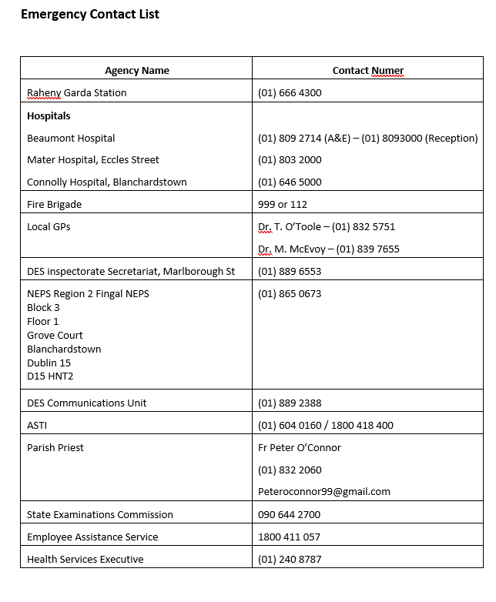

Appendix 3: Establishing the Facts
Use the following checklist:
- Name of person contacting the school.
- Who is present to support them.
- Nature and location of the incident.
- What happened.
- Who is involved.
- Number of casualties.
- Who is injured.
- Extent of injuries.
- Location of injured and uninjured persons.
- Risk of further injury.
- Who has already been contacted.
- Which agencies have been contacted.

Appendix 4: Sample Statement for Staff
We have assembled here to impart some very sad news.
A member of our school community has died/been injured/been killed.
The basic facts we know are these.
We need to inform the students and we will do so by the agreed procedures.
If anyone does not feel up to meeting students, please let a member of the Critical Incident Management Team know.
We would ask you to refrain from commenting to outside groups, agencies or media sources.

Appendix 5: Sample Letter to Parents
St. Mary’s has experienced the sudden death/accidental injury of one of our students/staff members. We are deeply saddened by this event.
We have a Pastoral Care Team in place to help your daughter cope with this tragedy.
You can help by taking time to listen and encouraging your daughter to express her feelings.
Please give truthful information that is appropriate to her age.
If you would like advice or assistance, you may contact the Principal, Deputy Principal, Guidance Counsellor, Form Teacher or Year Head.

Appendix 6: Consent Letter for Outside Support
Following the recent tragedy/death, we have arranged professional support for students who need particular help.
This support may consist of talking to children individually or in small groups and offering reassurance and advice.
If you would like your child to receive this support, please sign and return the consent form by the date requested.

Appendix 7: Sample Media Statements
At present, information is just beginning to filter into the school. We are therefore unable to comment any further at this point.
Further statements should only confirm facts, outline the school response, and protect privacy. No speculation should be included.

Appendix 8: Principal’s Checklist
The Principal’s checklist should include:
- Call a meeting of the CIMT.
- Assign tasks to team members.
- Identify rooms for students, parents and media.
- Contact relevant Year Heads and class tutors.
- Gather factual information.
- Contact affected families and agencies.
- Inform staff.
- Identify vulnerable students.
- Arrange support and supervision.
- Review the day at the end of the first day.

Appendix 9: Designated Rooms
- Canteen: for designated student groups or those unable to attend class.
- Chapel/Pastoral Care Room: for families arriving at the school.
- Media briefing room: outside the school premises where possible.
- Counselling rooms: for special cases or high-risk individuals.

