Grennan College

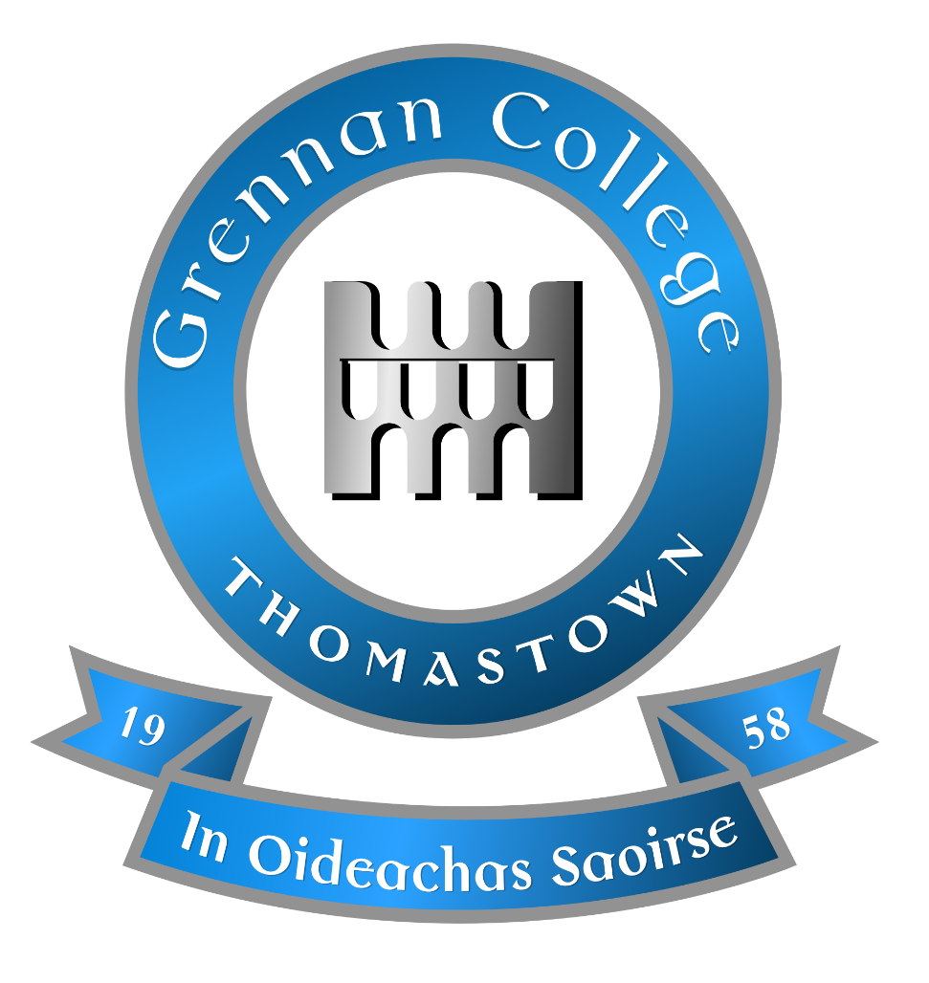

Droichead policy
Policy revised April 2026

- Rationale:
In line with the Teaching Council’s policy on Droichead: (The Integrated Professional Induction Framework, September 2026), Grennan College is a school offering Droichead as a route of induction for newly qualified teachers (NQTs).

- Purpose:
The purpose of this policy is:
➢ to guide the whole school implementation of Droichead to support the induction of NQTs
➢ to identify the roles and clarify the responsibilities across the school community support of Droichead
➢ to identify the protocols underpinning the Droichead process in the school
➢ to identify the documents in support of the process

The main objective of the Droichead process is to support the professional learning of NQTs during the induction phase, thus laying the foundations for subsequent professional growth and learning for the next phase of their career.

- Legal Framework
This Induction Policy has been informed by the following:
- The Education Act (1998)
- The Education (Welfare) Act 200
- The Code of Professional Conduct for Teachers (2nd Edition) 2012
- Droichead: The Integrated Professional Induction Framework 2026
- Post-qualification Professional Practice Procedures and Criteria 2018.19
- Children First Act 2015 and DES Child Protection Procedures for Primary and Post-Primary Schools 2017
- Safety, Health and Welfare at Work Act 2005
- Looking at our School 2022
- General Data Protection Regulation (GDPR) 2018

- Settings in which the Droichead process can take place:
A post-primary teacher may complete Droichead in a recognised post-primary school where:
- post-primary curricular subject(s) is taught and is eligible to submit students for state examinations etc., Junior Cycle or Leaving Certificate examinations.
– The NQT is teaching a post-primary curricular subject i.e., Junior Cycle or Leaving Certificate subjects (including LCA and LCVP) and has full responsibility for state examination preparations.
- The principal coordinator is a registered post-primary teacher.
- The PST is comprised of registered post-primary teachers.

- Duration of professional practice required:
A post-primary teacher must complete a minimum of 200 hours’ teaching employment in an eligible setting to include the teaching of a post-primary curricular subject(s) to a designated class on the school’s timetable, or employment in a learning support, special needs or language support position.
Where a NQT has additional time in their school over and above the minimum requirements set out above, that extra time be used to support the Droichead process.

- Roles and Responsibilities of the PST
The PST is a team of fully registered teachers from the school who work collaboratively to support and mentor the NQT(s) during school-based induction, in the first stages of their professional journey.
All PST members have completed a programme of professional learning with NIPT, including mentor skill development.
The members of the school Professional Support Team (PST) are Maura Cottrell & Denis Doyle
The dual role of the PST is to:
➢ guide and advise the NQT throughout school-based induction, in the first stages of their professional journey
➢ form a joint declaration with the NQT that they have participated in a quality teaching and learning process

The Responsibilities of the PST are:
- To co-ordinate the overall Droichead process in collaboration with the NQT including communicating meeting schedules & agendas
- To enable the NQT to be proactive when identifying emerging professional needs and supports required
- Organise Droichead Release Time for induction activities (observations and feedback)
- To clarify school policies and procedures for the NQT.
- To attend Droichead professional development.
- To be Professional and provide pedagogical support for the NQT
- To enable and empower the NQT to seek/source answers to questions
- To work in partnership with the NQT in the classroom e.g. observation and discussion
- Brief school staff on the nature and purpose for the school’s involvement in Droichead
- Liaise with other staff members in relation to opportunities for the NQT to visit/observe in classrooms and work alongside them
- To accept and give feedback in a constructive, open and professional manner
- To keep relevant records
- To co-ordinate the conclusion of the Droichead process with the NQT and other PST members and sign Form D
- To review the process when it is concluded with the NQT
Our PST’s responsibilities are not intended to be exhaustive or prescriptive and will be reviewed considering our experience as a Droichead school.
In support of an NQT’s Droichead process, the PST will invite the wider school staff to provide opportunities for the following activities:
➢ Co-planning and Co-teaching
➢ Sharing of resources
➢ Engaging in professional conversations
➢ Facilitating class observation

- The role of the NQT at a school level.
Through their engagement in the Droichead process, the NQT will:
1. have engaged professionally with school-based induction and additional professional learning activities
2. have shown their professional commitment to quality teaching and learning for their students
3. have engaged in reflective practice that supports their professional learning and practice, both individually and collaboratively.
Based on the above, the NQT will sign a joint declaration with the PST, that they have participated in a quality teaching and learning process.

NQT Responsibilities
- Apply to commence the Droichead process via the My Registration Portal of the Teaching Council website www.teachingcouncil.ie
- Retain a copy of the confirmation email and give a copy of same to the PST
- Be aware of relevant school policies and procedures
- Be familiar with relevant Droichead documentation including the Droichead Policy, Droichead Outline Plan, the Droichead Standards, etc.
- Engage professionally with school-based induction activities, including, but not limited to, observations.
- Engage professionally with additional professional learning activities
- Prior to engaging with the Cluster Meetings, NQTs must complete an online webinar provided by Oide, outlining the steps in the Droichead process.
- All NQTs must attend at least one cluster meeting through an education support centre. The additional cluster meeting may be provided online.
- NQTs must attend one general and one focused cluster meeting as part of their Droichead process.
- NQTs must also engage in one other professional learning activity, identified by themselves in accordance with their professional learning needs.
- The NQT must share one element of their Taisce with their PST that specifically concerns a professional learning need that they want to address.
- The NQT should also find a piece of existing research, such as a published journal article, relevant to the identified need to support the professional conversation. This professional conversation should be used by the NQT to identify a Strand B Professional Learning Activity in consultation with the PST.
- Complete at least two observations of experienced teachers. The NQT will also be observed, on at least two occasions, by members of the PST.
- Engage in reflective practice that supports professional learning and practice, both individually and collaboratively. “As a self-directed learner, and to support reflective practice, NQTs will maintain a Taisce, (arising from the Gaeilge translation treasure trove)”.
- Reflect on professional learning and identify an area(s) of interest for future professional learning which is to be included on Form D.
- At the end of the Droichead process, complete Form D with the PST. It is the responsibility of the NQT to submit the completed Form D to the Teaching Council via their My Registration account.

- Data Protection
All data relating to this Policy and the Droichead process will be kept in accordance with the General Data Protection Regulation Act 2018.

- Professional Support Team (PST) at Grennan College:

Trained Supporting Teachers Maura Cottrell
Denis Doyle

Principal: Sharon Coffey
Deputy Principal: Marie Maher
Guidance Counsellor. Derek Dooley

Department Teacher Co-operating Subject Teachers.

