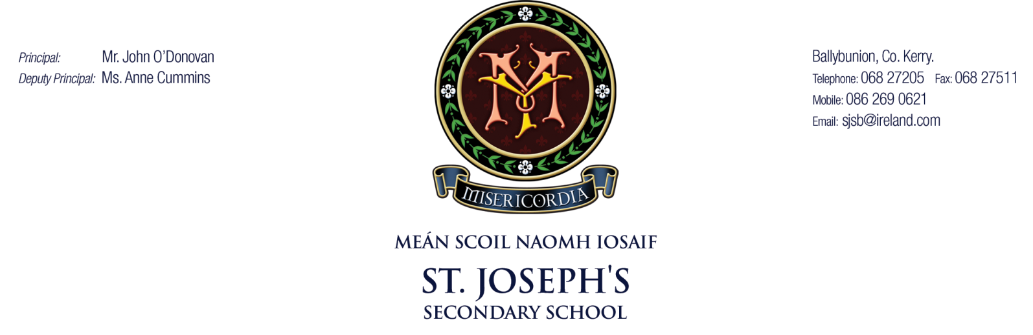

Subject Choice Policy

Date staff consulted: | 7/5/2025

Date parents consulted:

Date students consulted:

Date ratified at B.O.M. meeting:

Date for Review:

Signed _____________________________________ Date ________________
Chairperson, Board of Management

Signed _____________________________________ Date ________________
Principal/Secretary to the Board of Management

Policy on Subject Choice
The aim of this policy is to meet the educational needs of each individual student, and to assist them in reaching their full potential. This policy will also offer students and parents all relevant information regarding subject choice in the Junior and Senior Cycles.
Junior Cycle
At Junior Cycle, students study a core curriculum and, in addition, study a number of optional subjects. Students will study all the available subjects between beginning of year and October mid-term break, and then they will make their subject choices within these options.
Core Subjects | Optional Subjects
English  Mathematics  Irish  History  Geography  Science  Religious Education  Wellbeing (C.S.P.E., S.P.H.E., P.E.) | Business, Graphics  Art, German  Home Economics, Wood Technology  Music, French
Every effort is made to help the students to make an informed choice as it can impact on how successful the student will be in terms of satisfaction, motivation and educational benefit. Information is imparted in the following ways
- The parents of prospective students are given a school prospectus which outlines the school curriculum.
- A presentation is given to parents and students at the Open Night which outlines the school curriculum.
- Parents are invited to a meeting at which subject choice is discussed in detail before October mid-term to outline the process involved and relevant deadlines for picking subjects.
Senior Cycle
Guidance in relation to Leaving Certificate Programmes and Subject Choice is offered to third and transition year students. The school offers the following programmes at senior cycle:
- The Leaving Certificate Programme
- The Leaving Certificate Vocational Programme
- The Leaving Certificate Applied Programme
- Transition Year Programme
Students will decide in March of 3rd year if they will pursue fifth year or transition year or LCA 1. This will then determine their subject choices for Senior Cycle. During transition year, students will sample all optional Leaving Certificate subjects. The guidance programme in transition year facilitates students to make informed choices through work experience and career research. Students are also encouraged to talk to teachers of optional subjects and ask questions. Students are also welcome to consult with the guidance counsellor regarding their choices.

At senior cycle (LCP and LCVP) students must study a core curriculum, and choose from the following optional subjects:
Core Subjects | Optional Subjects
English  Mathematics  Irish  Religious Education  P.E. | Art  History  Geography  Biology  Chemistry  Physics  Agricultural Science  Business  German  Design & Communication Graphics  Construction Technology  Home Economics  French  Music

Third year and transition year students receive ongoing guidance in helping them choose the optional subjects. The following procedures are followed:
- The guidance counsellor gives information to each class group on subject choices, with particular reference to third level requirements and career choices.
- A preliminary survey of subject interest will be carried out and from this a grouping of subjects will be complied.
- Parents are invited to an information evening to discuss senior cycle options and subject choices.
- Presentations will be given by teachers of optional subjects to third year and transition year students and students are encouraged to talk to the teachers of optional subjects regarding their choices.
- When all the relevant information has been given to students, they are then presented with the combination of subjects on offer and are asked to make a choice of four subjects. This is carried out on our school platform Tyro.
- Before a final choice is made, there is ongoing consultation with students to ensure that each one has made a choice with is compatible with his/her individual aptitude, interest and future career and third level need.
LCA
All students of Leaving Certificate Applied must take the following subjects (courses); Vocational Preparation and Guidance, English and Communications, Information and Communication Technology, Arts Education (Visual Art), Social Education, Gaeilge Chumarsáideach, Modern Language and Leisure and Recreation.

Leaving Certificate Applied students have the option to access Leaving Certificate Established Maths instead of LCA Mathematical Applications. Where they are not required to study both they can do so if they wish.

Furthermore, a student may choose to study a Leaving Cert Established Modern Foreign Language but this will be in addition to the Modern European Language as part of their LCA programme.

If a student has an exemption from Irish at Junior Cycle it carries over to the LCA programme. A modern European Language exemption however would have to be a separate application.

In addition to the above students must also complete two specialist vocational subjects. These Vocational Specialisms develop specific skills and knowledge relevant to a range of careers. Schools choose two Vocational Specialism options relevant to the school's available resources.

Students also engage with Elective modules over the course of the two years. Elective modules are chosen at a school level relevant to the school's available resources.

LCVP
All students are required to take part in the LCVP in fifth year.

Deadlines
Students are given specific deadlines before which they choose subject options and subject levels.
First Years
The deadline will be in the October mid-term.
Third Year students - The deadline is the Easter break of their final year.
Transition Year students - The deadline is the Easter break.
General recommendations:
- Requests for subject options changes after the above deadlines may be considered only in exceptional cases pending advice and recommendation of teacher and in consultation with parents.
- In some circumstance a subject may be taken up at Leaving Certificate where there has been no prior instruction at Junior Certificate, conditional on advice and recommendation of teacher.
- Subject levels taken at Leaving Certificate will generally correspond to the level taken at Junior Certificate. It is only in exceptional cases that a student would take higher level, having taken a lower level at Junior Cert. Where students achieve a grade less than 40% (grades E, F or NG) in a higher paper in Junior Cert, it is recommended that they take Ordinary level in the Leaving Certificate.

Changing Subjects
The procedure with regard to seeking to change subject is as follows:
First Years
- Student discusses the change with their parents
- Student discusses the change with their current subject teacher
- Student discusses the change with the guidance counsellor
- The guidance counsellor will discuss the change with the current and prospective subject teacher
- If necessary, the parent of the student will be contacted
- The guidance counsellor will meet with the student and discuss the outcome
- Changing of subject is dependent on class size, timetable restrictions, amount of course covered and parental consent
- Students can within reason, change a subject within two weeks of making their subject choice.
Fifth Years
- Student discusses the change with their parents
- Student discusses the change with their current subject teacher
- Student discusses the feasibility and possible repercussions of the change with the guidance counsellor.
- The guidance counsellor will discuss the change with the current and prospective subject teacher
- If necessary, the parent of the student will be contacted
- The guidance counsellor will meet with the student and discuss the outcome
- Changing of subject is dependent on class size, timetable restrictions, amount of course covered and parental consent
*Form (appendix 1) must be signed fully, in the sequence outlined, before any change of subject mat take place.
It is not permitted for students in any other year to change subjects.
It is not advisable for student to withdraw from any optional subject or core subject at Junior or Leaving Certificate Level. If a student is considering withdrawing from a subject at that stage it is essential that they discuss the situation with the career guidance counsellor. In such a case the merits of the situation will be discussed between the principal, guidance counsellor and class teacher before a decision is given to the student.
In the event that the student is permitted to withdraw from a particular subject, the student will remain in the subject class at the particular time the subject is timetabled.
Subject Levels
Students will be divided into higher and ordinary level classes for core subjects in second year and also in fifth year. The appointment of a student to a subject level will be in consultation with the student, the teacher and the parent.
When deciding on a suitable level for the student to take, it is imperative that students and parents take the professional opinion and experience of the subject teacher into account. This expert opinion must be valued and considered. In order to pursue Higher level in a subject, the student should average a grade (Minimum 55%) in their test results.
Students who are not performing or working to standard at Higher level will be asked to move to Ordinary or Foundation level, as the case may be, by the teacher. Each individual subject Department will have their own criteria for the level a student will work at. These criteria will be available in each subject department plan. A written record has to be sent to the Parents re recommending a level for each student.

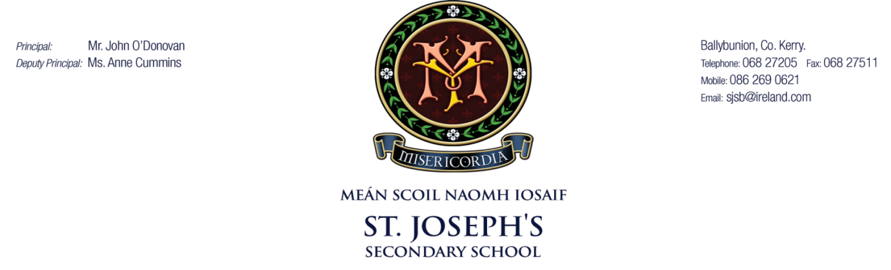
Change of Optional subject Form
Appendix 1

Student name: …………………………………………………………………………………………………………….

Guidance Counsellor………………………………………………………………………………………………………….

Signature of present teacher: ……………………………………………………………………………………………

Signature of new teacher: ……………………………………………………………………………………….

Signature of parent: ……………………………………………………………………………………………………….

Reason for changing subjects after the deadline………………………………………………………………

………………………………………………………………………………………………………………………………………….

Signature of Principal…………………………………………………………………………………………………………
Please return this form fully signed to the Principal/ Deputy Principal.
Do not move classes without this form fully signed and returned. Changing subjects after the deadline cannot always be accommodated, please see our subject choice policy.

