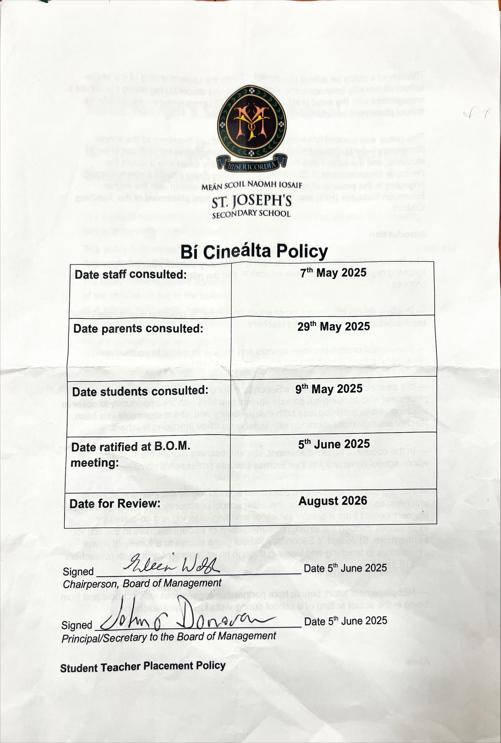

Saint Joseph’s Secondary School

Bí Cineálta Policy to Prevent and Address Bullying Behaviour

The Board of Management of Saint Joseph’s Ballybunion has adopted the following policy to prevent and address bullying behaviour.
This policy fully complies with the requirements of Bí Cineálta: Procedures to Prevent and Address Bullying Behaviour for Primary and Post-Primary Schools 2024.
The board of management acknowledges that bullying behaviour interferes with the rights of the child as set out in the United Nations Convention on the Rights of the Child. We all, as a school community, have a responsibility to work together to prevent and address bullying behaviour and to deal with the negative impact of bullying behaviour.
We are committed to ensuring that all students who attend our school are kept safe from harm and that the wellbeing of our students is at the forefront of everything we do. We recognise the negative impact that bullying behaviour can have on the lives of our students and we are fully committed to preventing and addressing bullying behaviour.
We confirm that we will, in accordance with our obligations under equality legislation, take all such steps that are reasonably practicable to prevent the harassment of students or staﬀ on any of the nine grounds specified: gender, civil status, family status, sexual orientation, religion, age, disability, race and membership of the Traveller community.
We confirm that we will take all such steps that are reasonably practicable to prevent the bullying or harassment of our students in whatever form and however motivated.
Catholic schools have a distinctive understanding of the human person, recognizing that every person is created in God’s image and likeness and has inherent dignity as a child of God. This is the basis for ensuring that each person in our school is treated with respect and care, in accordance with the Catholic Schedule.
As a Catholic school, we are committed to respecting the dignity of every individual. No human person is to be devalued, and all have an indispensable part to play in the school community, regardless of difference.

Definition of bullying
Bullying is defined in Cineáltas: Action Plan on Bullying and Bí Cineálta: Procedures to Prevent and Address Bullying Behaviour for Primary and Post-Primary Schools as targeted behaviour, online or oﬄine that causes harm. The harm caused can be physical, social and/or emotional in nature. Bullying behaviour is repeated over time and involves an imbalance of power in relationships between two people or groups of people in society. The detailed definition is provided in Chapter 2 of the Bí Cineálta procedures.
Each school is required to develop and implement a Bí Cineálta policy that sets out how the school community prevents and addresses bullying behaviour. Strategies to deal with inappropriate behaviour that is not bullying behaviour are provided for within the school’s Code of Conduct.

Section A: Development/review of our Bí Cineálta policy to prevent and address bullying behaviour
All members of our school community were provided with the opportunity to input into the development/review of this policy.

 | Date consulted | Method of consultation
School Staﬀ
Students
Parents
Board of Management
Wider school community as appropriate, for example, bus drivers
Date policy was approved:
Date policy was last reviewed:

Section B: Preventing Bullying Behaviour

This section sets out the prevention strategies that will be used by this school to address all forms of bullying behaviour, in whatever form and however motivated, including online bullying behaviour, homophobic and transphobic bullying behaviour, racist bullying behaviour, sexist bullying behaviour and sexual harassment.
In developing preventative strategies which this school will use to prevent all forms of bullying behaviour, we come from the context of our Catholic ethos where inclusivity permeates the school in a real way.
This school takes positive steps to ensure that the culture of the school is one which welcomes a respectful dialogue and encounter with diversity and difference, by ensuring that prevention and inclusivity strategies are given priority and discussed regularly at board of management and staff meetings.
The dignity and the wellbeing of the individual person is of paramount concern in our Christian response. This school will listen closely to and dialogue with parents, thereby building a relationship of mutual understanding, respect, trust and confidence.

The school environment should be an inclusive space where both students and staff experience a sense of belonging and feel safe and supported. Relationships between all members of the school community should be underpinned by our core CEIST values of dignity, inclusion, compassion, community and excellence in education.

The school community has a responsibility to prevent and address bullying behaviour. Schools should work in partnership with their board of management, staff, students and their parents to implement their Bí Cineálta policy. Boards of management must have oversight of the development of their school’s Bí Cineálta policy and ensure that the appropriate preventative strategies in place are effective. School staff can prevent and address bullying behaviour by promoting empathy, intervening promptly and implementing policies that create a positive and inclusive environment that fosters kindness among students Each member of school staff has a responsibility to take a consistent approach to addressing bullying behaviour.

Students have an important role to play by supporting their peers and reporting incidents of bullying behaviour. Collaboration between parents and school staff is essential to effectively prevent and address bullying behaviour. Schools should promote active partnership with parents which can help reinforce values that discourage bullying behaviour.

Appropriate supervision procedures are in place. Supervision is provided before school, after school and at morning and lunch breaks. Staff supervision is timetabled for designated areas both within and around the school grounds including timetabled supervision of our Astro turf facility at break and lunch. Students have designated areas where they can socialise and eat. We offer a variety of supervised lunchtime clubs as well as a quiet space for our students in our Hub. Every student belongs to a class group, with a class teacher who conducts regular check-ins with their groups by means of a drop box system that is conducted through the RE Department. This system helps to highlight any pastoral care or discipline issues that may arise, incidents of which will be referred forward to the groups relevant Year Head where necessary. There is a School Support Team in place also.
In continuing to develop prevention strategies, this school will listen to young people and parents, to help establish their particular context and needs. Frequent periods of reflection and engagement by the school, young people and parents, will be used to discern appropriate supports for young people in this school and to help inform future prevention strategies.
This following section of our policy sets out the prevention strategies that will be used by the school. The Wellbeing Policy Statement and Framework for Practice document provides four key areas that have been taken into consideration when developing measures to prevent bullying behaviour. These are: Culture and Environment, Curriculum, Policy and Planning, and Relationships and Partnerships.

Culture and Environment:

- Promoting a positive and inclusive school culture in Saint Joseph’s Secondary School Ballybunion.
- Effective leadership that supports an inclusive school culture.
- Mission Statement – Inclusive of all students in a nurturing environment.
- Ceist Core Values and Ethos communicated and supported by the whole school community.
- Fostering respectful relationships and open communication between the BOM, school staff, students and parents.
- Cultivating an environment where students feel they can talk to a trusted adult.
- Mobile phones are not permitted unless under the supervision of teacher to aid Teaching and Learning.
- Safe physical spaces for our students.
- Appropriate supervision of our students within the school building and outside areas with morning, break, lunch and after school supervision.
- School’s Support Team.
- Guidance Counsellor Support.
- Breakfast club and various lunch clubs (chess club, games club, quiz club, choir etc)
- Extra-curricular opportunities for students, sporting and non-sporting.
- Posters promoting positivity and inclusivity visible throughout the school corridors and within classrooms.
- Awareness weeks and days e.g. World Autism Awareness Day
- Various school programmes available – TY, LCA, LCVP, L2LP.
- Support for our AEN and EAL students.
- Student Voice – Student Council.

Curriculum (Teaching and Learning):

- Opportunities for students to work in pairs and groups and to engage with their peers.
- Access to SPHE and RSE classes.
- Digital Literacy and Awareness, for example, Internet Safety.
- Anti-Bullying Week.
- Wellbeing Week.
- Seachtain na Gaeilge.
- Participation in the school’s RE, CSPE, PE and Guidance subjects.
- Varied teaching methodologies and use of ICT where necessary to aid learning.
- Mentoring Programme to aid with the transition from primary school to post primary.
- Exchange Trips to further aid the learning of a language.

Policy and Planning:

- On-going evaluation on the effectiveness of our Bí Cinealta Policy and procedures – a focus group established.
- All of the following policies support the Bi Cinealta procedures and can work to prevent and address bullying behaviour: Code of Conduct, Child Safeguarding Policy, Admissions Policy, Whole School Guidance, ICT Policy, Mobile Phone Policy, Trips Policy.
- Engagement in teacher professional learning courses (CPD).
- Sharing experiences of best practice to inform our Bi Cinealta Policy and procedures.
- Ethos Promotion and Mission Statement.
- Student Voice Input through Dropbox system and Student Council Meetings.
- Parents Association.

Relationships and Partnerships:

- Communication with Year Head.
- Communication with Class Teachers.
- Student Support Team.
- Bí Cinealta Focus Group.
- Dropbox system in place.
- Parent Teacher meetings for each year group.
- Opportunities to speak with parents through information evenings/ coffee mornings etc.
- Mentoring of Students – Links with KDYS
- Transition Year Programmes such as Future Leaders.
- Establishing positive relationships with feeder Primary Schools.
- Bullying awareness initiatives – guest speakers/workshops where applicable.
- Encouraging peer support, for example the Mentoring Programme.
- Supporting the active participation of our parents in school life, Parent’s Association
- Participation in the school’s student council.

Section C: Addressing Bullying Behaviour
The teacher(s) with responsibility for addressing bullying behaviour is (are) as follows:
All staff have a responsibility to report suspected incidences of bullying. These should be brought to the attention of the student’s year head, who should then refer it to the Deputy Principal or Principal if necessary and appropriate. A bullying Incident Report should be completed by the member of staff reporting the bullying behaviour.

When bullying behaviour occurs, the school will:
- Ensure that the student experiencing bullying behaviour is heard and reassured.
- Seek to ensure the privacy of those involved.
- Conduct all conversations with sensitivity.
- Consider the age and ability of those involved.
- Listen to the views of the student who is experiencing the bullying behaviour as to how best to address the situation.
- Take action in a timely manner.
- Inform parents of those involved.

Identifying if Bullying Behaviour has Occurred

Bullying is defined in ‘Cineáltas: Action Plan on Bullying and Bí Cineálta: Procedures to Prevent and Address Bullying Behaviour for Primary and Post-Primary Schools’ as targeted behaviour, online or offline that causes harm. The harm caused can be physical, social and/or emotional in nature. Bullying behaviour is repeated over time and involves an imbalance of power in relationships between two people or groups of people in society. To determine whether the behaviour reported is bullying behaviour the following questions will be considered:

1. Is the behaviour targeted at a specific student or group of students?
2. Is the behaviour intended to cause physical, social or emotional harm?
3. Is the behaviour repeated?

If the answer to each of the questions above is Yes, then the behaviour is bullying behaviour and the behaviour should be addressed using the Bí Cineálta Procedures.

If the answer to any of these questions is No, then the behaviour is not bullying behaviour and the Code of Conduct will be addressed.

One-off incidents may be considered bullying in certain circumstances. A single hurtful message posted on social media can be considered bullying behaviour as it has a high likelihood of being shared multiple times and thus becomes a repeated behavior.

Strategies to deal with inappropriate behaviour are provided for within our school’s Code of Conduct. When identifying if bullying behaviour has occurred, staff members should consider the what, where, when and why?

- If a group of students is involved, each student should be engaged with individually at first. Thereafter all students involved should be met as a group.
- At the group meeting, each student should be asked for their account of what happened to ensure that everyone in the group is clear about each other’s views. Each student should be supported, as appropriate, following the group meeting. It may also be helpful to ask the students involved to write down their account of the incident.
- The definition of bullying provided in Chapter 2 sets out clear criteria to help schools to identify bullying behaviour.
- Incidents can occur where behaviour is unacceptable and hurtful but the behaviour is not bullying behaviour. Strategies that deal with inappropriate behaviour are provided for within the school’s Code of Conduct.

Where Bullying Behaviour Has Occurred
.
- School staff should know what to do when bullying behaviour is reported to them or when they witness bullying behaviour.
- Parents are an integral part of the school community and play an important role in addressing bullying behaviour. Where bullying behaviour has occurred, the parents of the students involved must be contacted at an early stage to inform them of the matter and to consult with them on the actions to be taken to address the behaviour.
- The school is obliged to investigate any alleged incidents of bullying which are reported by parents.
- Where the student displaying the bullying behaviour is not a student in the school, but the student who is experiencing the bullying behaviour is a student in the school, the school should support the student who is experiencing the bullying behaviour as appropriate and engage with them and their parents to determine what steps can be taken.
- A school is not expected to deal with bullying behaviour that occurs when students are not under the care or responsibility of the school. However, where this bullying behaviour has an impact in school, schools are required to support the students involved. Where the bullying behaviour continues in school, schools should deal with it in accordance with their Bí Cineálta policy.

- It is important for school staff to be fair and consistent in their approach to address bullying behaviour. Both the student who is experiencing bullying behaviour and the student who is displaying bullying behaviour need support. It is important that the student who is experiencing bullying behaviour is engaged with without delay so that they feel listened to, supported and reassured. School staff should identify the supports needed for the student who is displaying bullying behaviour to better manage relational difficulties and ensure that their needs are met.
- The actions and supports agreed to address the bullying behaviour will be documented. All bullying behaviour will be recorded. This will include the type of behaviour, where and when it took place and the date of engagement with students and parents. It is important to listen to the views of the student who is experiencing the bullying behaviour as to how best to address the situation.

- A record should be kept of the engagement with all involved. This record should document the form and type of bullying behaviour, if known. The record should include the views of the students and their parents regarding the actions to be taken to address the bullying behaviour.

- If the bullying behaviour is a Child protection Concern the matter will be addressed without delay in accordance with Child Protection Procedures for Primary and Post Primary Schools.

Follow Up Where Bullying Behaviour Has Occurred

- The teacher/year head/deputy/principal must engage with the students involved and their parents again - no more than 20 school days after the initial engagement.
- Important factors to consider as part of this engagement are the nature of the bullying behaviour, the effectiveness of the strategies used to address the bullying behaviour and the relationship between the students involved.
- The staff member responsible for dealing with the bullying incident should document the review with students and their parents to determine if the bullying behaviour has ceased and listen to the views of students and their parents in relation to this.
- The date that the bullying behaviour has ceased should also be recorded.
- Any engagement with external services/supports should be noted.
- These records should be retained in accordance with the school’s record-keeping policy and in line with data protection regulations.
- Where a Student Support File exists for a student, schools are encouraged to place a copy of the record on the student’s support file.
- Even though the bullying behaviour may have ceased, ongoing supervision and support may be required for both the student who has experienced the bullying behaviour as well as the student who has displayed the behaviour.
- If the bullying behaviour has not ceased, the staff member responsible should review the strategies used in consultation with the students involved and their parents. A timeframe should be agreed for further engagement until the bullying behaviour has ceased.
- If it becomes clear that the student who is displaying the bullying behaviour is continuing to display the behaviour, then consideration should be given to using the strategies to deal with inappropriate behaviour as provided for within the school’s Code of Conduct. If disciplinary sanctions are considered, this is a matter between the relevant student, their parents and the school.

- If a parent(s) is not satisfied with how the bullying behaviour has been addressed by the school, in accordance with the Bí Cineálta Procedures to Prevent and Address Bullying Behaviour for Primary and Post-Primary Schools, they should be referred to the school’s complaints procedures.

- If a parent is dissatisfied with how a complaint has been handled, they may make a complaint to the Ombudsman for Children if they believe that the school’s actions have had a negative effect on the student.

Supports

The school may seek the support of any of the following when working with students affected by bullying: Supports are available to help prevent and address bullying behaviour.

- Year Head
- Class Teacher
- School Guidance Counsellor
- Student Support Team
- RE Department
- SPHE Department
- National Educational Psychological Service (NEPS)
- Oide
- Webwise
- National Parents Council
- Use of restorative practices to re-build and maintain relationships
- Co-operation and open communication with parents
- Referral to outside agencies (if necessary) in co-operation with parents
- Building self-esteem and developing social skills
- Dublin City University (DCU) Anti-Bullying Centre
- Tusla

All bullying behaviour will be recorded on the ‘Bullying Incident Report Form’. This will include the type of behaviour, where and when it took place, and the date of the engagement with students and parents. The actions and support agreed to address bullying behaviour will be documented. If bullying behaviour is a child protection concern, the matter will be addressed without delay in accordance with Child Protection Procedures for Primary and Post-Primary Schools.

Section D: Oversight
The principal will present an update on bullying behaviour at each board of management meeting. This update will include the number of incidents of bullying behaviour that have been reported since the last meeting, the number of ongoing incidents and the total number of incidents since the beginning of the school year. Where incidents of bullying behaviour have occurred, the principal will also provide a verbal update which will include where relevant, information relating to trends and patterns identified, strategies used to address the bullying behaviour and any wider strategies to prevent and address bullying behaviour where relevant. This update does not contain personal or identifying information. (See Chapter 7 of the Bí Cineálta procedures).
This policy is available to our school community on the school’s website and in hard copy on request. A student friendly version of this policy is displayed in the school and is also available on our website and in hard copy on request.
This policy and its implementation will be reviewed, following input from our school community, each calendar year or as soon as practicable after there has been a material change in any matter to which this policy refers.

Signed: Date: (Chairperson of board of management)
_______________________________________
Signed: Date: (Principal)
________________________________________

Appendix 1: Bullying Incident Report Form

