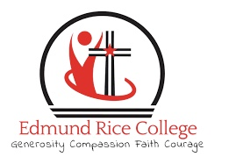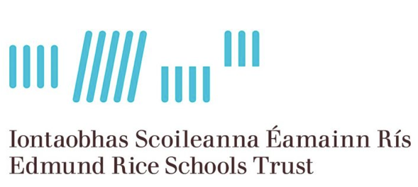

Board of Management of
Edmund Rice College Phoenix Park,
Dublin 15
Invites applications for the post of

Deputy Principal

To take effect from 1st September 2026

Edmund Rice College Phoenix Park is a co-educational Catholic Secondary School (Enrolment 913) under the
trusteeship of ERST and is conducted in accordance with the ERST Charter Values.

The application and further documentation can be obtained by emailing:

dpapplication@ercdublin.ie

Completed typed application forms as a PDF attachment should be returned as an email to dpapplication@ercdublin.ie

Emails with completed application form will be accepted up to Friday 8th May at 4pm

Short-listing may apply.

The Board of Management is an equal opportunity employer.

Provisional Date for interviews: Week beginning 1st June 2026

This appointment is subject to sanction by the Department of Education

