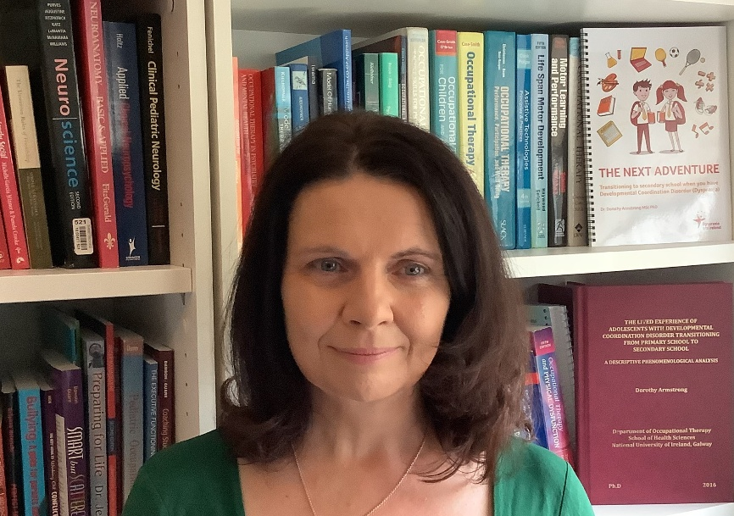 |  |  | EMOTIONAL REGULATION - HELPING NEURODIVERGENT CHILDREN AND TEENS WHEN THEY FEEL OVERWHELMED, STRESSED OUT OR ANGRY
Webinar of 1.5 hours duration.
Thursday, February 5th – 10 AM to 11:30 AM
Dr Dorothy Armstrong  Profile |  |  | Overview
Dr Dorothy Armstrong  Profile |  |  | Emotional regulation is about learning how to calm yourself down when upset; deal with the difficulties (small and large) that can be part of life; and match emotion to the size of an issue. This can be challenging for anyone but is especially difficult for neurodivergent children and teenagers.  This Webinar will:  - Explain what emotional regulation is;  - Explain why emotional regulation can be so difficult for neurodivergent children and teenagers;  - Give strategies to help a child with emotional regulation;  - There will also be an opportunity to ask your own questions.  How to book:  https://www.eventbrite.ie/e/emotional-regulation-for-neurodivergent-children-dr-dorothy-armstrong-tickets-1977301831004?aff=oddtdtcreator
Dr Dorothy Armstrong (MSc PhD) is an expert Occupational Therapist who specialises in neurodivergence. She works on projects to promote inclusion and delivers training, education and advice to organisations. She has made television and radio appearances and is the author of the book 'The Next Adventure: Transitioning to Secondary School when you have Developmental Coordination Disorder'. She also offers clinical supervision to Occupational Therapists.

Website
More information about Dorothy can be found on her website: www.dorothyarmstrongconsultantot.com

