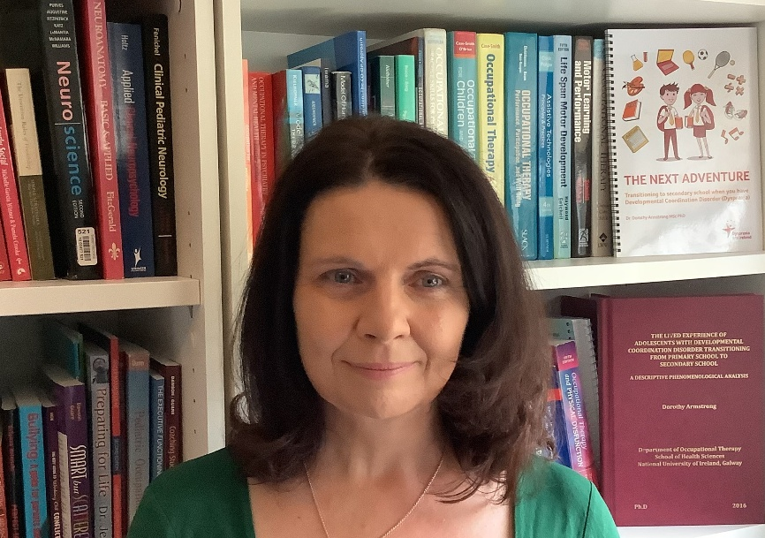 |  |  | SENSORY PROCESSING DISORDER – OVERLOADED, OVERWHELMED AND MISUNDERSTOOD!

Webinar of 1.5 hours duration.
Thursday, February 12th – 7 PM to 8:30 PM

Dr Dorothy Armstrong  Profile |  |  | Overview
Dr Dorothy Armstrong  Profile |  |  | Many neurodivergent people have ‘supersonic’ senses. Noises seem louder than they do to others; clothes that other people have no problem wearing feel scratchy or sore; smells that others don’t even notice make them sick or uncomfortable? Many neurodiverse people experience sensory overload, it’s an invisible phenomenon that others can find difficult to understand but it’s very real! Environments have become increasingly loud and busy which can result in even more heightened anxiety, feelings of exhaustion and overload for Neurodiverse people. In this webinar you will learn:  - What is sensory processing?  - Understanding a child’s sensory profile.  - Tools for protecting sensory sensitivities.  - Sensory tools for calming.  - Sensory tools for concentrating and learning.  How to Book:  https://www.eventbrite.ie/e/copy-of-sensory-processing-disorder-dr-dorothy-armstrong-tickets-1977314510930?aff=oddtdtcreator
Dr Dorothy Armstrong (MSc PhD) is an expert Occupational Therapist who specialises in neurodivergence. She works on projects to promote inclusion and delivers training, education and advice to organisations. She has made television and radio appearances and is the author of the book 'The Next Adventure: Transitioning to Secondary School when you have Developmental Coordination Disorder'. She also offers clinical supervision to Occupational Therapists.

Website
More information about Dorothy can be found on her website: www.dorothyarmstrongconsultantot.com

