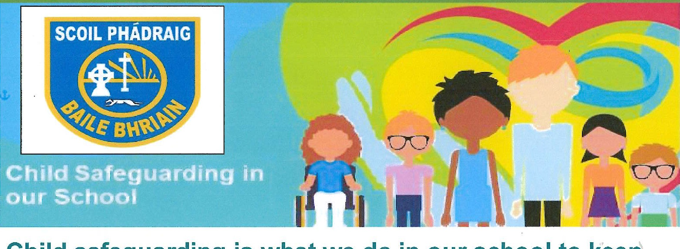
Child safeguarding is what we do in our school to keep children and young people safe from harm.
We teach the Stay Safe Programme to help you feel safe at school and in your life outside of school too.
We also think about other ways to keep everyone safe and we write these down. This is called our Child Safeguarding Statement
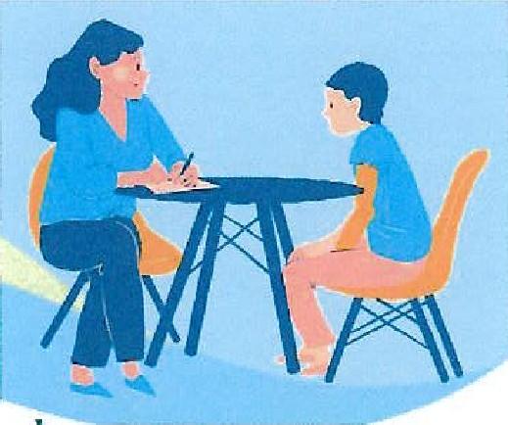
We check this every year. When we do this we will ask you what you think about safeguarding in our school.
If someone says or does something to hurt you or makes you feel uncomfortable, you can tell an adult that you trust.
  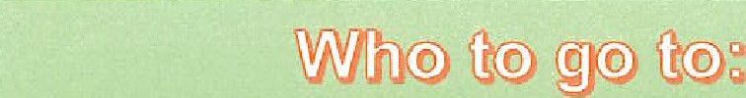
  Any trusted adult For example, a teacher, SNA secretary/caretaker or the principal
  What we do:
  Listen and understand
  Guide or look for help
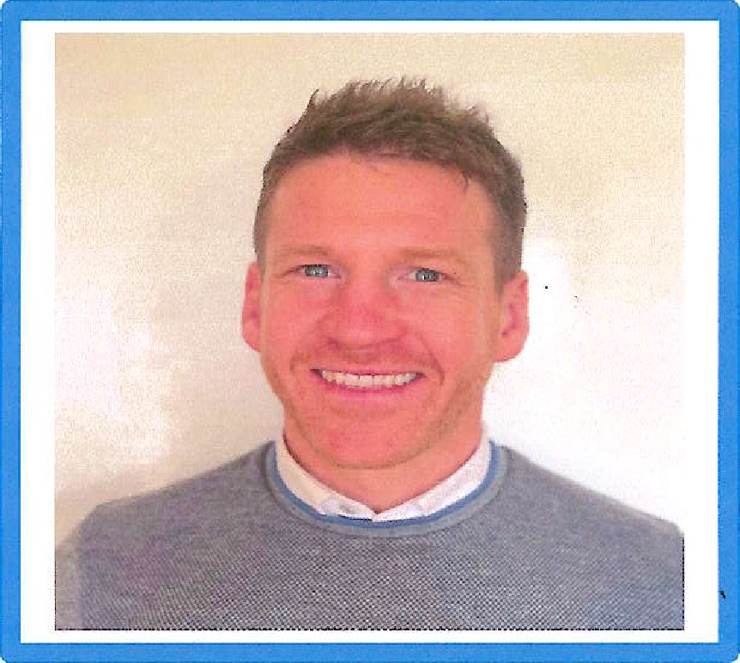

Every school has a person in charge of child safeguarding. This person is called the Designated Liaison Person or DLP. The DLP for cur school is Mr. Darby

