Scoil Naomh Phédraig, Ballybrvan Code of behaviour — School Rules
1. Children are expected to tell the truth at all times, to be honest with everybody, not to cheat or copy from others, never to steal, to be always just and fair, thoughtful and polite and be respectful to teachers, visitors and to each other,
2. Bullying, fighting, calling names or threatening other children is forbidden.Use of bad language is unacceptable.
- Disruptive behaviour in the class will not be allowed. Upsetting the class and teacher by being defiant, cheeky, displaying bad manners, continually talking and coming late into class, will be regarded as breaches of discipline.
- Pupils are expected to do their work, in school and at home, to the best of their ability.
- In the playground, pupils must behave properly. Children are expected to play in their designated areas. An inclusive environment is promoted in the school yard, Climbing walls, swinging off goalposts/basketball uprights/hand rails/potes/ fence etc. is dangerous and is therefore forbidden. Safe practices among staff members are adopted to minimise the possibility of harm or accidents happening to children. Teachers and SNAs may only use reasonable interventions to restrain a child from endangering him/herself or others, as a last resort in a crisis situation.

- All children are expected to wear their full school uniform except on PE days/school tour days etc. Notes are to be provided to the class teacher if uniform is only partially/not worn to school.
7. The wearing of jewellery, except watches and stud earrings, is forbidden in the interest of safety, especially in the playground and during P.E.
8. During school hours, children are not allowed to leave the school without the permission of the principal. Parents/Guardians known to children must sign the "Sign out Book" at the classroom before pupils are removed.
9, If absent from school, a note of explanation/phone call or Aladdin message from parent/guardian must be received.
10. Respect for the school, and other student property is to be practised at all times.
- School commences at 9.20 am and closes at 3.00 prm School staff are not responsible for children before supervision begins at 9:10am and after 3pm.
- A nutritional lunch is promoted and recommended.
- Homework must be signed by at least 1 parent or guardian each night.
- The use of mobile phones by pupils is strictly prohibited in school. Pupils found to be in possession of phones will have phones confiscated, being returned by the Principal to parents only.

To be reviewed: December 2026
2 |  | 010
 |  | 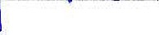
Principal: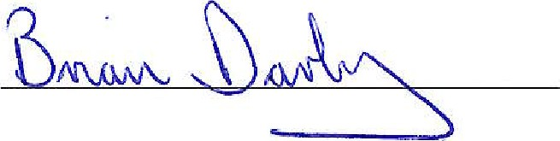 Date:

