
Scoil Phådraig Ballybryan
Child Protection Policy
Reviewed December 2025
The Board of Management recognises that child protection and welfare considerations permeate all aspects of school life and must be reflected in all of the school's policies, practices and activities. Accordingly, in accordance with the requirements of the Department of Education and Skills' Child Protection Procedures for Primary and Post Primary Schools, the Board of Management of Scoil Phådraig, Ballybryan has agreed the following updates to the child protection policy:
I. The Board of Management has adopted and will implement fully and without modification the Department's Child Protection Procedures for Primary and Post
Primary Schools as part of this overall child protection policy.
2. The Designated Liaison Person (DLP) is Mr. Brian Darby
3. The Deputy Designated Liaison Person (Deputy DLP) is Mr. David Brady
4. In its policies, practices and activities, Scoil Phådraig, Ballybryan will adhere to the following principles of best practice in child protection and welfare:
The school will
- Recognise that the protection and welfare of children is of paramount importance, regardless of all other considerations.
- Fully co-operate with the relevant statutory authorities in relation to child protection and welfare matters
- Adopt safe practices to minimise the possibility of harm or accidents happening to children and protect workers from the necessity to take unnecessary risks that may leave themselves open to accusations of abuse or neglect; Teachers and SNA's may use reasonable interventions to restrain a child from endangering him/herself or others, in the moment.
e Develop a practice of openness with parents and encourage parental involvement in the education of their children; and
• Fully respect confidentiality requirements in dealing with child protection matters.
All new staff will be informed of their obligations, with regard to Child Protection, participate in TUSLA online training and be given a copy of the School's Risk Assessment and Safeguarding Statement.
- Practices and activities that are particularly relevant to child protection include The
Code of Behaviour/Anti-bullying Policy, Pupil Attendance Strategy etc.)
The Board has ensured that the necessary policies, protocols or practices as appropriate are in place in respect of each of the above listed items.
- This policy has been made available to school personnel, The Board of Management and is readily accessible to parents on request. A copy of this policy will be made available to the Department and the patron if requested.
- This policy will be reviewed by the Board of Management once in every school year.
Introductory Statement
The staff, parents and Board of Management of Scoil Phådraig, Ballybryan have developed and agreed this policy in line with the current recommendations and guidelines relating to child abuse prevention and child protection guidelines.
This policy addresses the responsibilities of the school in the following areas:
Prevention - Sign out book in case of pupil withdrawal and Curriculum Provision
  - Procedures - procedures for dealing with concerns / disclosures
  - Practice - best practice in child protection.
An individual copy of this policy document will be made available to all staff to familiarise themselves with both it and the Children First Act 2015, "Children First" National Guidance for the Protection and Welfare of Children 2017 and the Child
Protection Procedures for Primary and Post-Primary Schools. Revised 2023
Aims
This policy aims to
Create a safe, trusting, responsive and caring environment.
  - Provide a personal safety skills education which specifically addresses abuse prevention for all the children in the school.
Develop awareness and responsibility in the area of child protection amongst the whole school community
  - Put in place procedures for good practice to protect all children and staff,
Ensure that all staff members are aware of and familiar with the "Children First" and the DES guidelines and procedures in relation to reporting concerns and / or disclosures of child abuse.
  - The Board of Management will co-operate with the DES and the Diocese in ensuring that any training provided by either body will be attended by members of the teaching staff or Board of Management.
Prevention

These measures should be proportionate to the level of risk and should not unreasonably penalise the employee in any way unless to protect the child,
If the nature of the allegations warrant immediate action in the Chairperson's opinion, the Board of Management should be convened to consider the matter. The Board will consider feedback if any has been received from the Health Board, Gardai or relevant source. This may result in the Board of Management directing that the employee absent him/herself from the school forthwith while the matter is being investigated (Administrative Leave). When the Board of Management is unsure as to whether this should occur, advice should be sought from the Gardaf and/or the Child Care Manager of the Health Board and the legal advisers to the Board of Management.

Administrative Leave
Should the Board of Management direct that the employee absent him/herself as above, such absence of the employee would be regarded as administrative leave of absence with pay and not suspension and would not imply any degree of guilt. The DES should be immediately informed.
Board of Management
The Chairperson should inform the Board of Management of all the details and remind the members of their serious responsibility to maintain strict confidentiality on all matters relating to the issue and the principles of due process and natural justice.
Links to other policy / planning areas:
SPHE curriculum — strand unit "Safety and Protection"
The Code of Discipline
Anti-Bullying Policy
Health and Safety Statement
TUSLA Strategy for Pupil Attendance
8
Review and Monitoring:
This policy will be monitored and reviewed by the BOM on an annual basis or when the need arises. The Board of Management will ensure that adequate training and support is provided for all staff.
Reviewed and ratified by Board of Management, 26th November 2025
Signed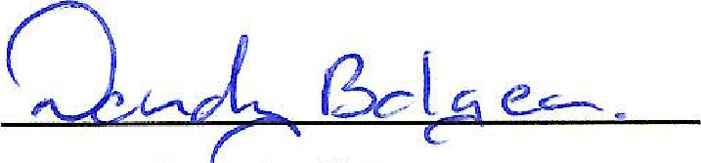
Chairperson, Board of Management
Signed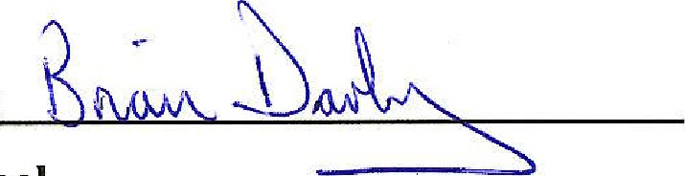
Principal
9



