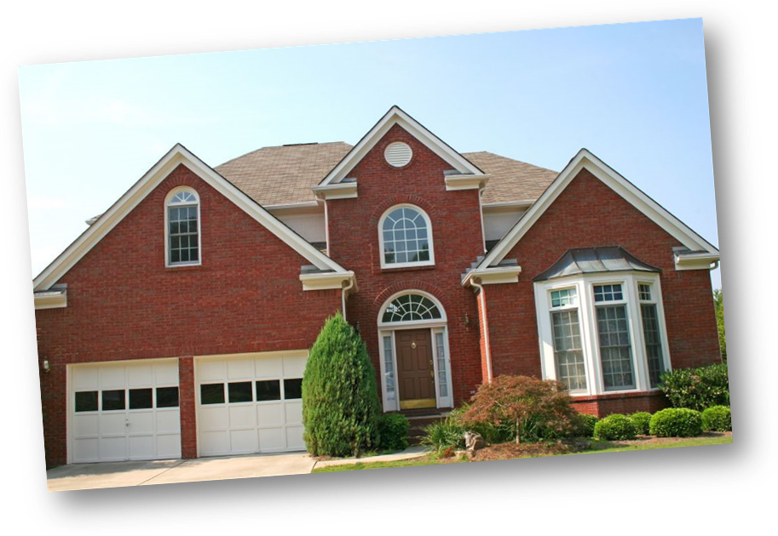
Find Out What Your
Home Is Worth For Free!
If you’ve ever wondered about what your North Florida home could be worth, here’s a really simple way to find out what your home (and one’s like yours) are selling for in today’s market.

Plus you’ll get a free report with stats based on all the homes for sale and also one’s that have sold in your area over the last few months.

To get your Free 2013 report on your home, just call or text XXX-XXX-XXXX X XXXX for an automatic message or go to www.YourDomain.com

