Asking prices up in 86 of 100 largest markets

Trulia: In some rebounding markets, dramatic price gains mask red flags
By Inman News, Tuesday, February 5, 2013.
Inman News®
Trend image via Shutterstock.
Asking prices of homes listed for sale on real estate portal Trulia.com in January were up from a year ago in 86 of the 100 largest U.S. metros, according to a monthly report released today.
The report, which covers roughly 4.5 million for-sale and for-rent properties listed on Trulia through Jan. 31, showed asking prices up 5.9 percent from a year ago, and growing by a seasonally adjusted 0.9 percent from December to January -- the biggest month-over-month gain since March 2012.
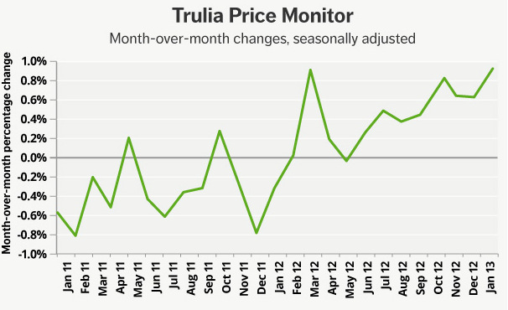
In some markets, the strong growth in asking prices doesn't necessarily indicate that worries are over, said Jed Kolko, Trulia's chief economist.
"In many local markets today, dramatic price gains can mask serious red flags," Kolko said in a blog post. "Strong job growth, low vacancy rate, and low foreclosure inventory -- not huge price gains -- are signs of a healthy housing market."
Trulia identified San Francisco, San Jose, Seattle, Denver and Salt Lake city as "booming" markets with strong fundamentals.
Article continues below

Advertise with Inman
"Rebounding" markets like Phoenix (where asking prices were up 24.8 percent from a year ago), Las Vegas (up 16.8 percent), Riverside-San Bernardino (up 14 percent) and Detroit (up 14.2 percent) remain vulnerable to factors like slow job growth, high vacancies, or future foreclosures, the report said.
January 2013 Trulia asking price summary
Time period | Change in asking prices | Change in asking prices, excluding foreclosures | No. of 100 largest metros with list-price increases
Month-over-month | 0.9% | 1.2% | (N/A)
Quarter-over-quarter | 2.2% | 2.9% | 79
Year-over-year | 5.9% | 6.5% | 86
Source: Trulia. Monthly and quarterly increases are seasonally adjusted.
January marked the first time since last spring that asking rents posted a smaller year-over-year increase (4.1 percent) than asking price. The report noted that construction of new multi-unit rental properties has helped grow rental inventories in some markets.

Jed Kolko
"Rent gains are slowing down because of more supply, not less demand," Kolko said.
Metros* where rent gains slowed the most in the last six months
Rank | Metro | Change in asking rents from a year ago | Change in asking rents from a year ago, July 2012 | Difference between Jan. 2013 and July 2012
1 | San Francisco | 2.4% | 11.5% | -9.1%
2 | Portland, Ore.-Wash. | 4.7% | 9.2% | -4.4%
3 | Seattle | 6.4% | 10.8% | -4.4%
4 | Denver | 7.4% | 10.3% | -2.9%
5 | San Diego | 2.0% | 4.4% | -2.4%
Source: Trulia. *Among the 25 largest rental markets
Contact Inman News:

