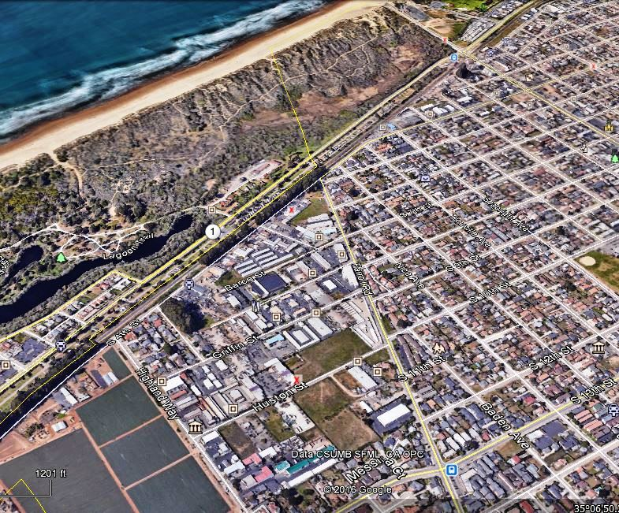

THE ECONOMIC IMPACTS OF INTRODUCING CANNABIS
BUSINESSES TO AN INDUSTRIAL OVERLAY IN GROVER BEACH

A study quantifying the impacts and proposing solutions for businesses affected by the introduction of cannabis businesses into the industrial area of Grover Beach.

Debbie Peterson, Broker

R E A L T Y
160 S. 3rd. Street
Grover Beach, CA 93433
Table of Contents

INTRODUCTION 3
STAKEHOLDERS INTERVIEWED 4
PURPOSE OF REPORT…………………………………………………………………………………………………………………….….….5
FINDINGS 5
BUSINESSES IN THE INDUSTRIAL ZONE 5
List (Provided on request)
DISPLACED BUSINESSES……….……......………………………………………..………………………………………………………...6
List (Provided on request)
LESSONS FROM COLORADO………………………………………………………………………………………………………………7
MARIJUANA BOOM SQUEEZES DENVER INDUSTRIAL SPACE………………………………………………………………7
COMMERCIAL PROPERTY FOR SALE……………………………………………………………………………………………….......9
Comparative Market Analysis Summary of Comparable Listings
Comparative Market Analysis Map Layout
Comparative Market Analysis Days on Market
Comparative Market Analysis Price Graph
Comparative Market Analysis Listing Details
Statistics by Status and Type
COMMERCIAL PROPERTY FOR LEASE - SQUARE FEET & PRICE …………………………………………………………11
Table
Businesses That Could Move To Other Grover Zones (Provided on Request)
RECOMMENDATIONS …………………………………………………………………………………………………………………….…….12
RECOMMENDATIONS FROM INDUSTRIAL BUSINESSES …………………………………………………………………….12
List of requirements prior to opening a cannabis business
ZONING IN GROVER BEACH………………………………………………………….…………………………..…….……….……13
Commercial Zones Allowable Land Uses and Permit Requirements
Zoning Map
Commercial Zones Development Standards
Legal Issues, Licensing article, ‘The Marijuana Industry is not at War with the Poor’…………..…………15
STREETS and PARKING……………………………………………………………………………………………………………………….17
OTHER SUGGESTIONS…………………………………………………………………………………..……………………………………18
APPENDICES
TRIBUNE ARTICLE, NEW TIMES ARTICLE
ABOUT THE AUTHOR
Resume

The information contained in this report is deemed sufficient for the purposes of analysis and accurate at the date of the report but is subject to change and therefore not guaranteed.
INTRODUCTION
In 2016 the Grover Beach City Council asked voters if they wished to legalize, tax and regulate cannabis sales in their city. (Measure L-16). They proposed doing so in an industrial area described as an Overlay Zone. Cannabis businesses from all over the United States took notice and when the measure passed by 72%, prices in the Overlay Zone soared. By February 2017, even before ordinances regulating land use and operation were approved, 36 of 204 small businesses in the Overlay Zone found rents doubling and tripling, or received notice to vacate in 120 days or less. This report quantifies those impacts and suggests actions that businesses and the city can take to preserve its small business economic base while bringing in an exciting new industry.

The existing small businesses most impacted are those that lease premises; 60% of the businesses in the overlay. These businesses support head of household jobs and serve customers in the Five Cities area of San Luis Obispo County. They range from one-man car repair services sourcing up to $30,000 in parts from Grover Beach auto retailers, to contractors with 100 employees. Although most supply the local market, some have developed national and international markets such as the Penny Man, who manufactures machines that crush and imprint pennies, and Hotlix, the confectionary company famous worldwide for tequila worm suckers and edible snack crickets. Annual sales of these businesses range from $46,000 to $65M a year, with businesses established from as long ago as 1963 to as recently as 2013.

The information contained in this report is derived from interviews, meetings and email exchanges with nearly 100 business owners and interested parties, public comment from business representatives at city meetings, online resources including the CA Secretary of State, and online business data sources such as Manta.com, Wikibusiness, usa-co.com, orgwest.com, creditability.com, and 4 tours of the industrial area. Real estate statistics were compiled from the Central Coast Regional Multiple Listing Service, First American Title online San Luis Obispo County title records, Craigslist, conversations with local real estate brokers, and online property listings. Where possible information has been cross-verified between sources. Where data sheets show no entries this is because we have been unable to verify or obtain information. Annual sales turnover and employment data may be a few years out of date and will be updated as new information becomes available. Real estate statistics and information on displaced businesses is current within days of this report. A list of individuals contributing or interviewed follows, but does not include all who have attended and contributed at public meetings. This report is an iterative process and while deemed reliable for the purposes of analysis, corrections and additions are welcome. Recommendations are highlighted in blue for easy reference.

STAKEHOLDER INTERVIEWS & PARTICIPANTS & SPEAKERS DURING PUBLIC COMMENT

Tim Gayda, Broker, Cornerstone Realty
Hank Neizen, Broker, & Patrick Wilkinson, Central Commercial Group
Sheila Hardy, Broker, C21 Hometown Realty VG
Laurie Pemberton, Dennis Allen, Broker, Allen Real Estate Investments
Lynette Navarro, Custom Canvas
Sharon Brown, former planning commissioner Fort Collins, CO.
California West, Property Managers
Nick Barnick, Barnick Wood Designs & Custom Cabinetry
Whitney Barnick, Attorney
Ginger Schenck, C&S Industrial Coatings
Dan Arndt, Toyworx
Larry Robinson, Central Coast Diesel
Korban Ensign, Adapt Autoworks
Mike Shannon, Alec
Andrew & Lauri Brown, Troxel’s
Justin Watson
Kathy Schultz, Coastal Dance & Music Academy
Leland Simpson, Delterra Manufacturing Center
TJ Cape, Brian Touhy & Wendy Cronin, 805 Beach Breaks
Todd Mitchell, Medicinal Greens
Edward & Laurie Pipan, Supreme Auto, Property & Business Owners
Karen Deering, ModelHom
Sunni Mullinax, President, Monarch Group Partners
Cynthia Gonzales & Tammy Pelusa, Elite Care SF
Dennis O’Neill
Christine Cooper
Zachary Victor, Operational Experts, LLC
Sheldon Moseley
Mike Frederick, Property Owner & Landlord
David & Susan Cleek, DMC Company & Landlord
Paula & Tom Richardson, Central Coast Refreshments
Anthony Salas, Epic Entertainment
Peter Keith, Century Investments
Rick Freeman, Channel Island Arts
Steve & Karla Cool
Marie Roth, SLOCCBA
John & Melanie Hodges

PURPOSE OF REPORT - This report is provided as a public service by Peterson Team Realty to aid and encourage Grover Beach officials, businesses, and stakeholders in collaborating to ensure the economic vitality of both existing and new businesses.

FINDINGS
BUSINESSES IN THE INDUSTRIAL ZONE
The business statistics considered here are only those for businesses in the industrial area originally identified by the city council for cannabis businesses which was described as an overlay zone. In response to unintended consequences, the Council has added the additional industrial area in the city, but it is a small area and has been insufficient to address the crisis.

There are 204 businesses in 128 buildings on approximately 123 lots in the main industrial area bordered by 13th Street, Highland Way, South 4th Street and Farroll Road. The First American Title Company parcel map shows 31 vacant lots, although many of them are used for storage. Of those 204 businesses we were able to obtain sales figures for 101 and employees for 126. Totals assume the remainder mirror those for whom statistics were obtained.

DISPLACED BUSINESSES
Of the 204 businesses in the industrial area 36 have already moved, will be moving in the next 30 days, or are at risk of being eviction. Scaled up to include the businesses for which figures were unavailable, together they represent a potential loss of 129 jobs and over $8,300,000 in sales to Grover Beach. The exodus is due to near zero-vacancy in the industrial area and limited industrial premises elsewhere in the city or the immediate area. These figures do not include two companies that have had to bear the cost of an unplanned move, but managed to find premises in Grover Beach. As will be shown in the following paragraphs, without immediate mitigation, displaced businesses will find it increasingly difficult to relocate in Grover Beach. Many of the industrial businesses operate extremely large industrial machinery that is expensive to move, and requires specialized permitting, premises and zoning. It can take up to a year for many of these companies to successfully organize a move. Twenty out of the 36 identified are gone or going within the next month and represent 65 jobs. Sixteen are at risk, representing another 39 jobs for a total of 104 jobs at risk of going altogether or moving out of town. As micro businesses averaging three employees many of these are head of household jobs.
The majority of the businesses are being displaced due to quick sales of premises to cannabis businesses. In many cases buildings house multiple businesses, ranging from two to 10 units. Thirteen businesses lease premises that are being sold. In four cases owners are taking the opportunity to close their doors and retire to out of town locations. In one case an owner moved out of the country. Eleven businesses are finding their businesses cannot absorb rents that are increasing up to 300%.

.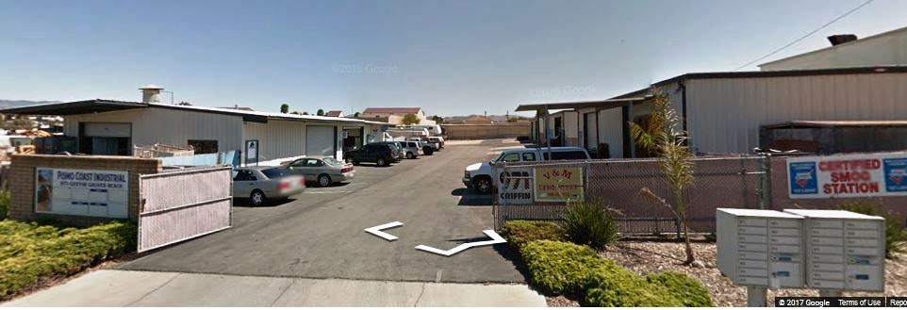 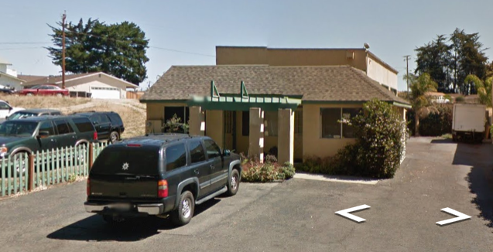
This owner retired years ago, renting his building to a
food distributer who was able to relocate in Grover
Beach when the building sold for $925,000 in 30 days.
This landlord told tenants he may sell many of his properties in the overlay. He has given notice to tenants in the first two units on the right in favor of a dispensary.

LESSONS FROM COLORADO
The positive economic impacts of a new tax base and appreciating real estate are a powerful force for good for Grover Beach and are embraced by the business and industrial community and documented far and wide. Many recognize that it will not be the sale of just marijuana that will generate economic benefits, but even larger benefit will be the sales of equipment and agricultural suppliers to the cannabis industry. A lesser documented benefit is the boom that will occur for the local trades. As cannabis businesses gear up for production there will be a huge demand for electricians, plumbers, contractors and building supplies.
The recent Grover Beach experience of businesses being dislocated is almost undocumented, and even less so are mitigations. We are in new territory as we work together as an industrial community to find solutions, but an article in the Denver publication Confluence, offers insight into what to plan for. http://www.confluence-denver.com/features/marijuana Guidance Grover Beach can benefit from is highlighted in red type. One stark difference is that the Denver industrial area had a vacancy rate of 33% when the cannabis business began. Grover Beach has a near-zero vacancy rate, a challenge of even greater magnitude.

MARIJUANA BOOM SQUEEZES DENVER INDUSTRIAL SPACE
Margaret Jackson January 7, 2015
There's a very tight market for industrial real estate space in Denver, thanks to the city's marijuana boom. As makers and manufacturers compete with grow operations, is the situation stifling entrepreneurial activity in the city?

Since voters approved a ballot initiative to legalize marijuana for recreational use in 2012, growers have absorbed more than 1 million square feet of primarily low-quality space throughout 2013, according to the Market Trends report by Newmark Grubb Knight Frank. The total space occupied by the industry is more than 4 million square feet, and the report indicates expansion would continue during the second half of this year.

The limited supply and high demand for space also is pushing lease rates up in Denver, which is more grower-friendly than many other municipalities. People in the real estate industry estimate that lease rates in the city have increased from about $4 a square foot to as high as $18 a square foot. Metro Denver Market Snapshot by Cassidy Turley attributes the rising rates to economic growth causing existing companies to expand, as well as "marijuana uses willing to pay well above market rates in order to secure space."

Businesses leaving

Gloria Staebler, owner of natural history publishing company Lithographie, is being forced out of her 3,600-square-foot warehouse. In July, the building's new owner offered Staebler a three-year lease for $18 a square foot, a significant increase from the $8 a square foot she had been paying. "He said we had to sign it within 30 days or get out, so we started looking right away," Staebler said. She's still looking. "There are a ton of people who have left Denver and headed west because the marijuana industry has made it impossible to find space," Marcum said.
Staebler's broker, Scott Marcum of Marcum Commercial Advisors, said the area had a 33 percent industrial vacancy in 2012. That dropped to 6 percent at the beginning of this year and currently stands at just over 3 percent.

Steve Art, director of economic development in Wheat Ridge, said Denver's loss of expanding businesses is a gain for his city. Other communities benefiting from small manufacturers being pushed out of Denver include Arvada, Aurora and Adams and Jefferson counties. "The majority of industrial space in Aurora is in one of three main business parks, which don't allow marijuana," said Jason Thomas of Avalon Realty Advisors, an agency that helps marijuana growers find warehouse space.

With the state allowing new players to enter the grow industry in October, warehouse space is likely to become even more scarce.

“As moratoriums on recreational marijuana in other Colorado municipalities are lifted and more states legalize weed, lease rates are sure to drop and growers will search for better real estate deals. That could leave Denver with vacant warehouses and a manufacturing base that is not very diverse”, Staebler said. "Once we're established somewhere else, are we going to go back?" Staebler asked. "Who's going to do that? How will the city ever lure us back?"

COMMERCIAL PROPERTY FOR SALE
The four commercial properties on the market outside the industrial area with a total list value of $5.4M, include one sold, one pending and two active units over the past five months. This is on the high side of normal activity for Grover Beach where the industrial and commercial market tends to be slow-moving and limited in scope. That has changed fivefold in 2017. Properties on the market include vacant land ranging from 1/3 to over 7 acres and buildings ranging from 1,400 – 7,000 square feet, at prices from $442,000 to $3M. The Central Coast Regional Multiple Listing Service (MLS) shows the following sales activity in 2017: 15 properties currently for sale, an additional three in escrow, and three sold, with a total listed value of $21,842,746. There are an additional two properties known to be in escrow outside of the MLS with a list value over $4,000,000. It is also understood that two of the expired properties are still available for purchase, representing an additional $2,000,000, for a total listed market value conservatively estimated at $28M. In a normal market this ratio of active to sold commercial properties would represent 12 to 36 months of inventory. Given the response of the market to date to actions of the city council, it is likely that these 15 properties will sell by the end of 2017. The property list shows that properties on the market prior to the cannabis boom were on the market for multiple years at a list price averaging around $200 per square foot. Since the passage of Measure L-16, properties in the industrial area are selling in a matter of weeks at nearer $500 a square foot. There are only two industrially zoned properties for sale in the additional industrial zoned area of the city. There are also two lots and two buildings for sale outside the industrial areas.
The perception has been that the industrial area is underutilized because there are several undeveloped vacant lots. This misperception is the root of the current problem. The cannabis incomers, in the rush to obtain premises do not have sufficient time to develop vacant lots prior to the deadline to apply for cannabis licenses that require premises as a condition of approval. Displaced businesses do not have time to develop property due to the urgent need of the new owners or landlords to acquire premises. As these businesses expand over time these vacant lots will be developed. For now, the lots remain unsold and new businesses flush with cash swamp the no-vacancy market displacing local businesses.

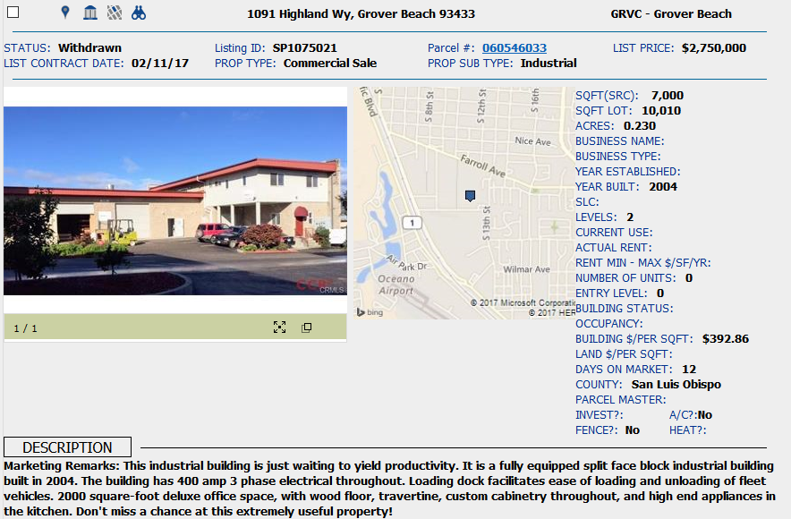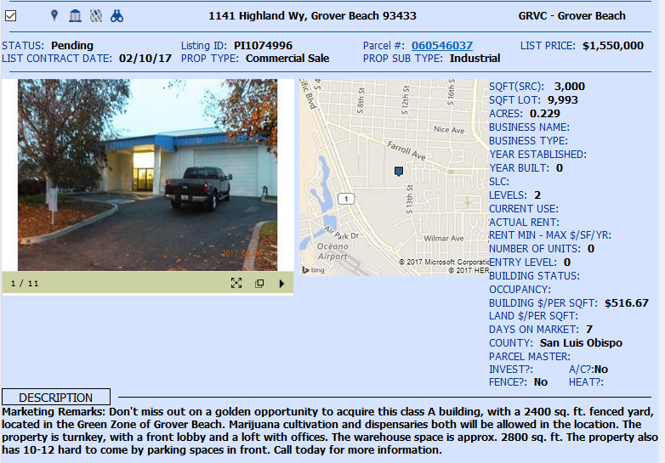
This 3,000 sf building listed for $1.55M was on the market for just 7 days before going into escrow. The sale reportedly fell through a few weeks later when the buyers discovered the CC&Rs do not allow illegal businesses and neighboring businesses were unwilling to amend the CC&Rs.
.
This 7,000 sf building sold for $2M on 3/15/17. The two tenants, an artisan manufacturing company with 5 employees and a turnover of $350,000 a year moved to San Luis Obispo. The other, a 2-person professional firm, moved to Arroyo Grande.

COMMERCIAL PROPERTY FOR LEASE
Although many cannabis businesses are purchasing premises, the very few units for lease in the industrial area have also been snapped up by the cannabis industry and by displaced businesses. However, the zero-vacancy rate in the industrial area does not follow through to other areas of the city. There are numerous rental premises available throughout the city. The chart ‘Commercial Property Available’ details the properties available for rent throughout the city. As of March 2017 a total of 26,064 commercial square feet outside the industrial area was available for lease in over 23 units averaging $1.24 per square foot. One 3,750 sf building was for sale for $609,500, ($162.53 per square foot). Two lots were for sale, one at 15,000 sf and the other at 7 acres.
This compares with only two warehouse spaces advertised privately in the industrial area at 1,500 sf for $2,250 each. A total of 14 buildings were for sale in cannabis zoning averaging $462.28/sf. Seven lots were for sale, a total of just under 7 acres. An additional two properties were known to be in escrow outside the multiple listing service, adding 13,100 sf. Craigslist also featured an ad from an active commercial broker claiming seven off-market opportunities to purchase properties from 1,400 – 7,000 sf ranging from $700,000-$3M, demonstrating that the need documented in the multiple listing service is conservative compared to the demand. Buying and selling frenzies have occurred in fits and starts around the timing of city council ordinance changes or approvals. It is currently in a more settled phase and expected to ramp up again around the May 1, 2017 first reading and May 15, 2017 first and final readings of the ordinances and then again near the June 14th date on which applications will begin to be reviewed for cannabis permits and then in the 30 to 90 day period following after which permits are granted. This activity is par for the course when cannabis is introduced to a new area with multiple offers, speculation and prospecting in the rush to obtain a foothold in the market. Generally two out of five of the listings and offers can be expected to result in closed sales, but even so, at this pace there are a great number of sales generated and an immediate demand for industrial space that far outweighs the supply.

RECOMMENDATIONS
Recommendations are listed by level of importance according to the judgment of the author based on feedback from the business community and observations arising out of compilation of this research. Several of the findings grew out of meetings with the affected businesses in which they suggested ways that the City could partner with them to enable them to continue to remain in Grover Beach. This list follows and was presented by the business owners to the City of Grover Beach in a February 2017 council meeting.
RECOMMENDATIONS FROM INDUSTRIAL BUSINESSES
- CONDUCT AN ECONOMIC IMPACT STUDY
- Remove the overlay and immediately allow cannabis businesses in all appropriately zoned areas in the city
- Apply the zoning code so that only parcels meeting code can be developed - no variances. That will leave room for existing businesses to continue and will moderate prices
- Provide incentives to develop vacant lots, thus reducing the evictions of existing businesses
- Remember, we still need our mechanics, our car repair shops, our cabinet makers, our jobs for our Grover Beach working class, our tow truck businesses, our contractors, our small businesses, our head of household jobs. We mustn't drive out our own people. Remember the dot.com boom and bust. Let's not do that in Grover Beach. Moderation, please
- Give preference to local cannabis businesses.
- Streamline the planning process so local owners who sell can redevelop in the industrial area quickly to relocate their tenants when they sell. Otherwise, local tenants will lose their businesses if they have to close between moves, or they will have to move out of town.
- Facilitate the development of an industrial business park that has business condos for sale or lease so local lessees could buy or lease
- Develop a charitable organization that will fund relocation of local businesses that local owners and cannabis businesses can donate to rather than paying out big amounts of taxes.
- Require landlords or new tenants to cover relocation costs of businesses they displace.
- Create a 1-page bullet point list of cannabis business requirements for REALTORS

ZONING IN GROVER BEACH
In response to feedback from existing businesses, new cannabis businesses and the community, in March 2017 the city council extended the area in which cannabis businesses could operate from one overlaid industrial area to all industrial areas of the city. This was in response to marijuana dispensary owners who were particularly concerned about disabled patients having to negotiate a less hospitable industrial area to access medical assistance, feeling that their services would be better located in a more appropriately zoned area. Although the council eased the pressure somewhat on the industrial area originally designated, it was not sufficient to retain several businesses that have already had to move to accommodate new cannabis businesses. There is considerable benefit to the entire community by opening up other areas to cannabis businesses where the business use is appropriate to the zoning. Nearly as often as we hear “fix the streets” in Grover Beach, we hear “fill the vacant buildings”. The city has also been advised that it is not possible to generate a level of business to fill the vacant lots and buildings on Grand Avenue. Given the business interest generated by the cannabis industry, the beach front hotel and conference center and fiber optic availability, this may be a one time opportunity for the city to prove that wrong – provided the city can generate a win-win outcome that retains the existing business base while ushering in new industry. As has been shown, there is almost a zero vacancy rate in the industrial areas, and these units have skyrocketed in price in a manner that cannot be absorbed by the existing business base, of which over 17% has been driven out. An examination of the Grover Beach zoning code shows the following opportunities to address both issues:
While industrial zoning allows nearly all uses, many cannabis business uses could be appropriately located per City zoning in other parts of the city. The greatest fear voiced by residents is that of the “stoners” loitering in their vicinity, and associated crime. However, there are currently over 16 cannabis businesses operating in the city without any of the worrisome stereotypes associated with marijuana. Properly regulated and taxed, additional businesses will be nearly as invisible except for the added revenues and infrastructure improvements they fund. There is also a misperception that businesses will be “on Grand Avenue”. Most premises vacancies, with the exception of under-utilized lots, are not on Grand Avenue, but on surrounding streets or in multi-unit buildings. It is not just cannabis business uses that need accommodation, but also displaced businesses from the industrial area.
The uses that might pass zoning approval in other parts of town are both cannabis and non-cannabis businesses including laboratories, medical dispensaries, recreational dispensaries, nurseries, craft metal and wood workers, auto shops, and business services, representing 23 of the 36 displaced businesses, although arguably the zoning code in reference to nurseries is more likely referencing retail operations, rather than growing operations. The 23 displaced businesses were analyzed as to use, space requirement, and potential zoning and matched to available spaces citywide within that zoning. These businesses need a total of 42,623 sf to operate. Available space for rent citywide is 26,064 sf. Only 7 of the 23 displaced businesses could be matched to right-sized space in appropriate zoning, leaving an unmet need of 36,900 sf for 16 businesses that could otherwise be re-housed elsewhere in the city.
The greatest need is for light industrial units of 3,000-7,500 sf and smaller units of 300-500 sf, or some form of flexi-unit space that could be partitioned to meet individual tenant requirements.
Twelve displaced businesses have industrial uses that could not locate out of the industrial zone and with one exception require 1,000 – 4,000 square feet of operating space. This adds up to an immediate need for 13,700 square feet. The displaced businesses in total have an immediate unmet need for 50,600 square feet.
The properties available for rent were also analyzed for suitability for cannabis businesses with uses that could be accommodated in other zonings, such as laboratories, medical marijuana clinics and dispensaries, and recreational dispensaries, and perhaps nurseries. Six of the available properties for lease were unsuitable due to location within 600’ of Grover Beach Elementary School, residential zoning, or landlords known not to rent for cannabis uses. However, opening up the remaining other available rentals would create a further 15 new units and 13,745 sf for cannabis businesses. The advantage is that all landlords and property owners benefit from the income and customer traffic generated by the new industry, and the existing business base is less negatively impacted, thus protecting head of household jobs, sales tax, and the stable local economic business base.
These numbers assume the city will allow cannabis businesses in other zoning as a matter of urgency, and takes into account only the demand as at March 2017. It does not allow for six cannabis businesses documented by this research still known to be seeking property in the industrial areas, nor does it allow for additional ancillary business demand created by the ground breaking of the hotel and conference center this summer and opening in 2019.
There remains a huge gap in supply of 1,000 – 7,000 sf units. Brad Forde has three buildings already designed and approved to create about 36,000 sf of industrial space in the CI and CC zoned areas north of Grand Avenue. There will never be higher demand for those units than there is today. The city should do everything in its power to enable an immediate build of those units so that they can be ready in the next few months to accommodate the need of cannabis businesses to apply for licenses before 2018.
There is sufficient demand to support at least one more, and probably two business parks on vacant land in the southern industrial area. The city should work with developers to fast-track the building of business parks, giving consideration to industrial condos to enable business owners to own their units. A third industrial park could be built for smaller hot-house start up type business activities, a use long-envisioned by many in the community.
Owners of vacant buildings and under-utilized land city-wide should be encouraged to market their property for lease or sale.
It is critical that the city not repeat the mistake of failing to analyze and plan for demand created by its economic development activity. If the city wishes to salvage its existing business base as it moves into the future, it must immediately engage competent experts to analyze and plan for future demand for space so as to optimize taxable income opportunities for the city and jobs for its residents.
The city must immediately reach out to developers to encourage development of business parks in the industrial area.
An article in Colorado, Legal Issues, Licensing says it best.
The Marijuana Industry is not at War with the Poor
By Robert McVay on May 27, 2016
Jon Murray, a reporter for the Denver Post, had an article in Politico magazine salaciously titled The Marijuana Industry’s War on the Poor. Despite the title, the article contained relatively straight-forward reporting on the impacts marijuana businesses can have on certain communities. This density of demand and its location in only certain areas of the city has major community impact: higher rents.

Cannabis entrepreneurs are simply looking for affordable space where owners and employees can get to work easily and make cost-effective deliveries to retail shops. In general, the location of new marijuana businesses is influenced by a few key factors. First, there are state law limitations, which range from limiting proximity to schools to prohibitions on entire sectors of the industry. Next there are local law limitations and bans. Zoning ordinances may push marijuana businesses out of all commercially zoned sections of town and into areas zoned only for heavy industry. Local bans can have wide-ranging impacts. This also partially explains the rent hikes cannabis businesses seem to cause in certain neighborhoods. If there’s only one part of town in which you can legally locate, you are going to bid up the price of available real estate. This can be detrimental to existing businesses whose margins relied on lower rents.
For Colorado, and Denver specifically, many of these issues will take a long time to fix. It wouldn’t be fair to cannabis businesses to change the rules only after they have made huge investments in the community, but the mayor and city council don’t want to ignore the legitimate complaints of working class community members that live and work in areas affected by cannabis businesses.

But for cities and states that are still developing their cannabis laws, Washington, Oregon, and Colorado do provide some key lessons. No matter what state and local leaders do, there will likely be some oversubscription to the industry when legalization hits. The market is just too exciting to too many entrepreneurs who want to benefit from first-mover advantage locally. There will likely be a big boom of cannabis activity early after legalization, but the rate of growth in the market will relax over time. It also helps to disallow local cannabis bans. This will do wonders for decreasing the concentration of cannabis producer/processors, spreading out the impact.

So no, the marijuana industry is not at war with the poor. But the industry should not pretend that it doesn’t impact communities because it does. It is up to states and communities to engage in smart urban planning that works to improve communities in the long term. At the same time, they should encourage and incentivize marijuana businesses to be good neighbors. Only through cooperation, will cannabis businesses and communities be able to coexist with minimal negative impacts.

STREETS and PARKING
The “Fix the Streets” cry from the community at large applies also to the industrial zone, in the areas shown in the two maps below. It is important to prioritize repair of industrial area streets, especially as they become more likely to deteriorate due to higher use. Most accesses to the industrial area have significant damage, impacting not only access, but also public perception of the area. Three areas are reduced to single lane traffic, and huge potholes including Huber Street and Griffin Street where they intersect Highland Way, and South 4th St. south of Highland Way.
Also of local concern is parking. The existing industrial area south of Farroll is highly impacted. Parking rules are not enforced and while new standards are now in place, most businesses operate under historic approvals. The recent dedication of Huber to the city is a good first step, but the city will need the help of its planning commission to come up with solutions that allow safe and efficient travel through the industrial streets, especially if it intends to keep less compatible industrial uses adjacent to one another, such as medical marijuana retail dispensaries and clinics for elderly and ill or disabled patients alongside highly trafficked industrial uses.
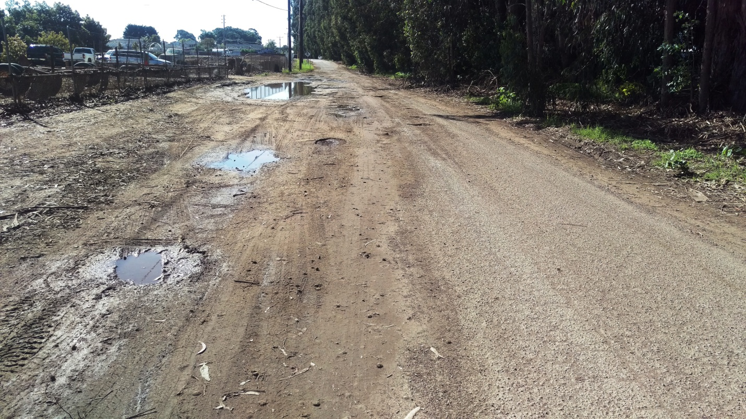 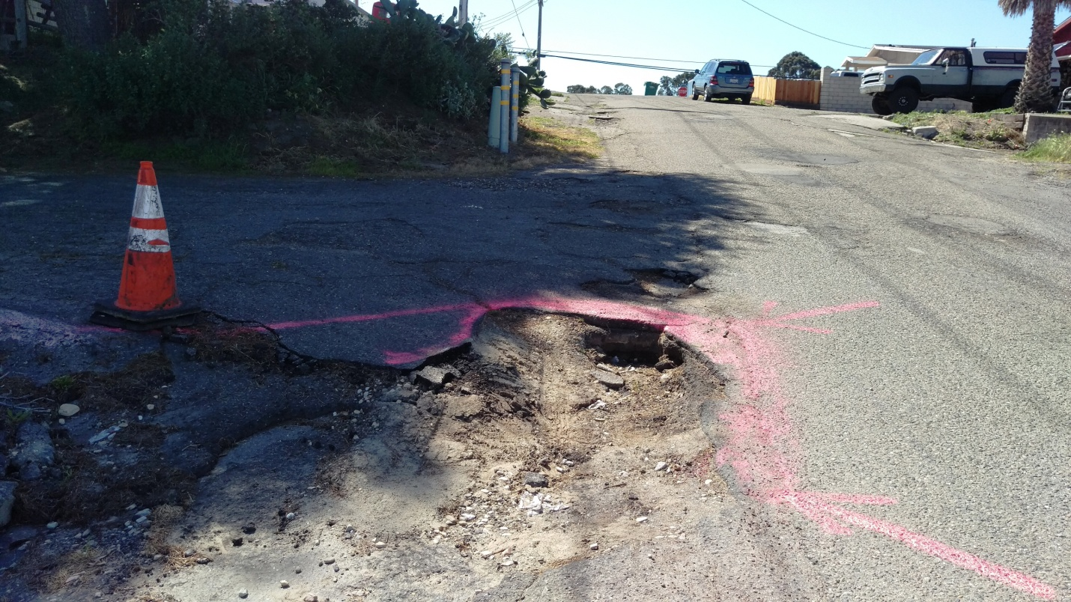 Single Lane S. 4th St. Griffin St. at Calvin Ct.

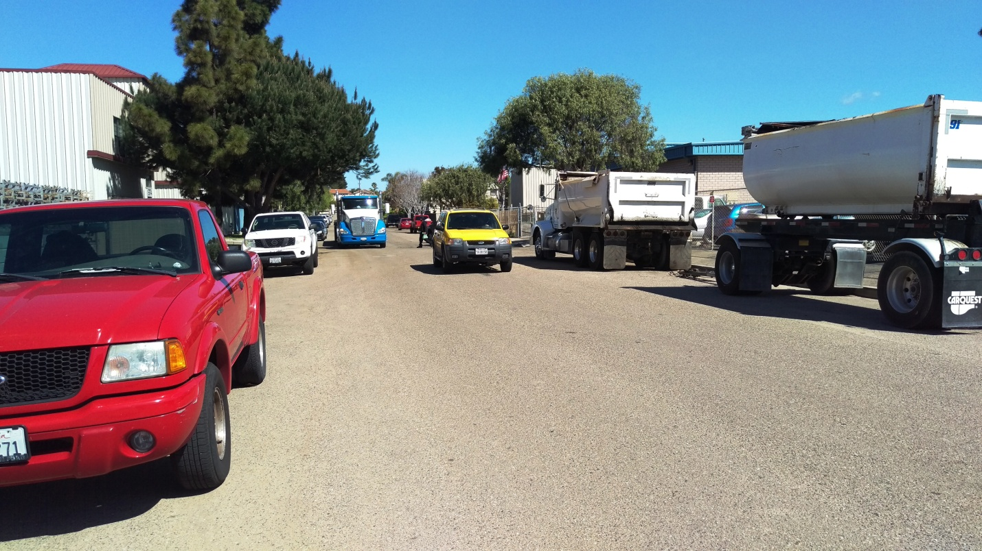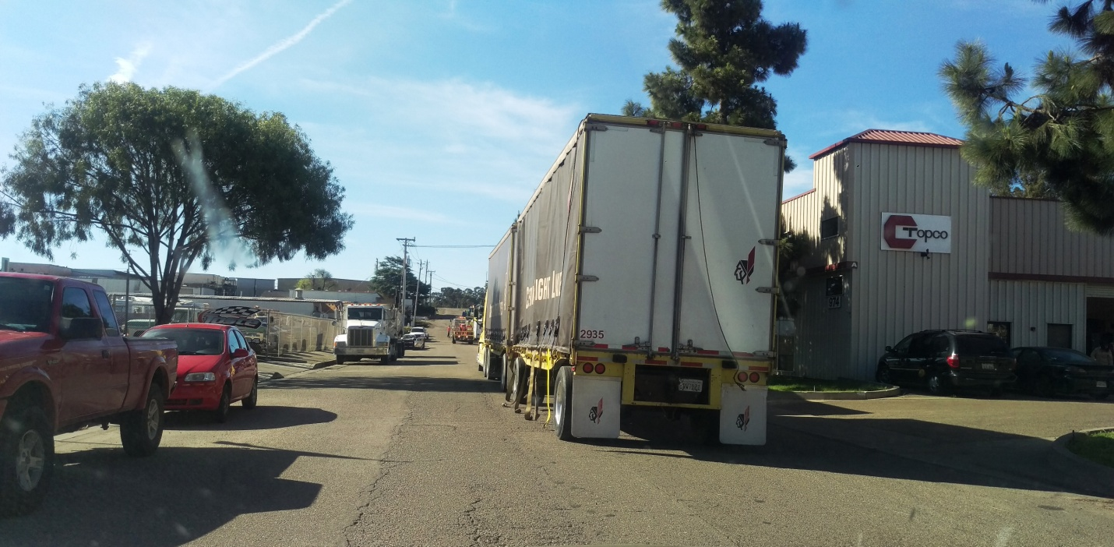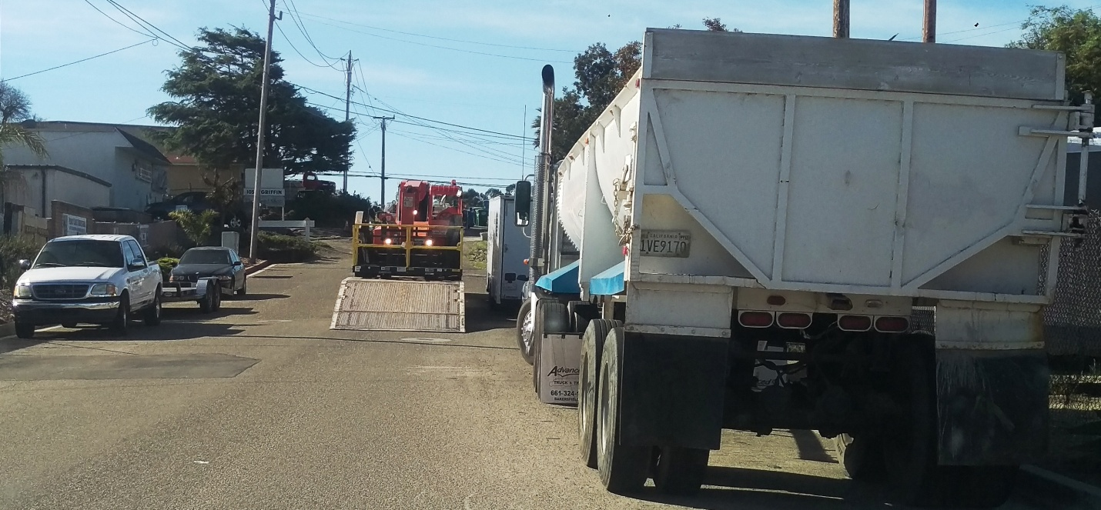
Where streets are in reasonable repair they are blocked by parked cars and large vehicles attempting to make deliveries.

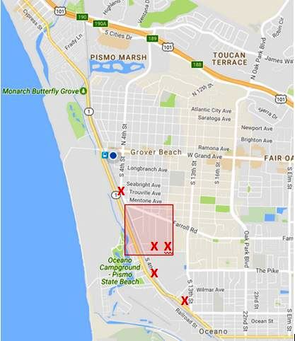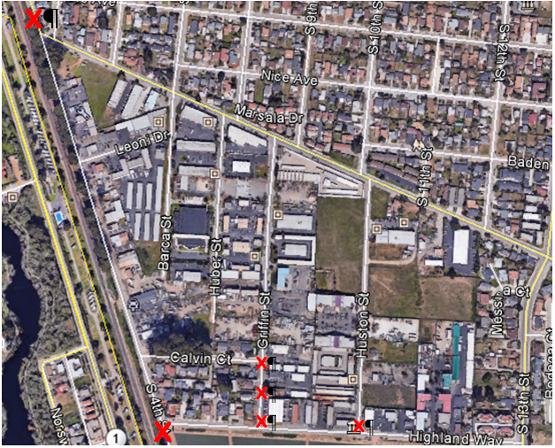
This overview and close up of the industrial area shows most industrial area accesses are impacted by street damage.

OTHER SUGGESTIONS

Some contributors have suggested allowing medical only marijuana providers an unlimited number of permits, with the 4 permit limit applied only to recreational use or multi-use dispensaries.

Much of the industrial area is still on septic tanks because the Grover Beach sewer system does not extend to parts of Farroll Road, Highland Way and several of the streets in the industrial area. Use CDBG or impact fees to hook up the industrial properties that remain on septic to the sewer system.

A Maxlite webinar for horticultural grow lights reports at www.Maxlite.com that Legal marijuana
indoor grow facilities accounted for 1 percent of national electricity use at a cost of $6 billion per
year. The same site quotes Bloomberg noting that in 2015 Denver reported 1,200 licensed grow
facilities which contributed to half the state’s new power demands (equivalent to 35,000 households).
PG&E government representatives have expressed concern as to the viability of providing the
amount of electricity that may be needed for growers.

Several growers have warned the City Council that the water use estimates they have produced could
be gravely underestimating the water that will be required for many of the grow processes that may
be used. The City must check and double check that there are adequate electricity and water resources
for the anticipated industrial use.

