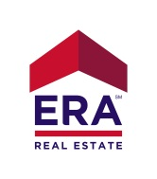 **THANKS FOR VISITING!**

As you’re probably aware, this is a private property.

The current owner kindly requests that guests check-in upon arrival

because this helps keep the property safe and secure for all visitors.

Please check-in below

**OPEN HOUSE CHECK-IN *Property:_________________________ Date:__________________***

***Name Email Phone#***

|  |  |  |
| --- | --- | --- |
|  |  |  |
|  |  |  |
|  |  |  |
|  |  |  |
|  |  |  |
|  |  |  |
|  |  |  |
|  |  |  |
|  |  |  |
|  |  |  |

*We will only contact you with information & inquiries relevant to your real estate needs ERA ADVANTAGE REALTY 941-255-5300

www.eraportcharlotte.com