Charter Communications (CHTR) — Q2 2026 Earnings Preview
Ticker: CHTR Earnings Date: Late July 2026 Prepared: July 23, 2026

1. Earnings Preview
Key Takeaway: The setup is mixed-to-cautious — the bar is low on broadband subs (consensus at ~-141K internet net adds) but ARPU remains the critical swing factor; any signal that the cost pass-through planned for late summer is landing, or that converged ARPU is stabilizing, could be the positive catalyst the stock needs after a historic -47% drawdown from pre-Q1 levels.
CHTR heads into Q2 2026 with the stock trading near multi-year lows (~$128, down ~47% from pre-Q1 levels), having suffered its worst single-day decline in company history (-25%) on April 24 after ARPU commentary spooked investors. The bar is low — consensus expects internet net losses of ~141K (worse than Q1's -120K) and EBITDA of ~$5.57B, with broadband ARPU expected to remain roughly flat YoY at ~$70.97. Management has deliberately deferred a cost pass-through from Q1 to "later in the summer," paired with value enhancements, which could provide a modest ARPU tailwind in Q2 or Q3. The Cox acquisition remains the key catalyst overhang — California CPUC approval was requested by August 13, and a close would unlock $800M+ in run-rate OpEx synergies and a massive mobile greenfield opportunity. The wildcard is whether CMCSA's Q2 print today (broadband losses of -167K, ARPU -3.8% YoY) reads as a negative read-through for the cable sector broadly, or whether Charter's different pricing strategy (no free line dilution, cost pass-through pending) differentiates the setup.

2. KPIs & Consensus Expectations
Key Takeaway: Consensus sets a low bar on broadband subs but ARPU is the real swing factor — any improvement vs. the “close either way to flat” Q1 commentary could re-rate the stock. Mobile net adds (~383K consensus) are a secondary positive catalyst.

Table 1 — Current Quarter Snapshot (Q2 2026)
KPI | Q1 2026 Actual | Q2 2025 Actual | Q2 2026 Consensus | YoY Change | Guidance | Consensus vs. Guidance
Total Revenue | $13.597B | $13.766B | $13.506B | -1.9% | Slight EBITDA growth FY2026 (ex-Cox transition costs) | N/A
EBITDA (Operating) | $5.637B | $5.693B | $5.575B | -2.1% | Slight growth FY2026 | ~In-line
EPS (Diluted) | $9.17 | $9.18 | $10.00 | +8.9% | N/A | N/A
Internet Net Adds | -120K | -116K | -141K | Worse YoY | N/A | N/A
Mobile Line Net Adds | +368K | +491K | +383K | -22% YoY | N/A | N/A
Residential Internet ARPU | $70.72 | $71.25 | $70.97 | -0.4% YoY | "Close either way to flat" FY2026 | ~In-line
Total Mobile Lines (EOP) | 12.134M | 10.856M | 12.517M | +15.3% YoY | N/A | N/A
Video Net Adds | -60K | -80K | -63K | Better YoY | N/A | N/A
Free Cash Flow | $1.372B | $1.046B | $1.072B | +2.5% YoY | FCF inflection from CapEx decline | ~In-line
CapEx (ex-line ext.) | $2.043B | $1.846B | $1.954B | +5.8% YoY | Declining toward <$8B by 2028 | N/A
Source: Visible Alpha Consensus and Actuals Data.

Table 2 — Beat/Miss History (Last 8 Quarters)

Internet Net Adds
Quarter | Reported | Consensus | Surprise | Result
Q2 2024 | -149K | -73K | -103% | Miss
Q3 2024 | -110K | -83K | -33% | Miss
Q4 2024 | -177K | -130K | -36% | Miss
Q1 2025 | -181K | -100K | -81% | Miss
Q2 2025 | -116K | -73K | -59% | Miss
Q3 2025 | -109K | -83K | -31% | Miss
Q4 2025 | -119K | -130K | +9% | Beat
Q1 2026 | -120K | -100K | -20% | Miss

EBITDA (Operating)
Quarter | Reported | Consensus | Surprise | Result
Q2 2024 | $5.51B | $5.52B | -0.2% | Miss
Q3 2024 | $5.47B | $5.50B | -0.5% | Miss
Q4 2024 | $5.60B | $5.57B | +0.5% | Beat
Q1 2025 | $5.64B | $5.64B | 0.0% | In-line
Q2 2025 | $5.69B | $5.77B | -1.3% | Miss
Q3 2025 | $5.56B | $5.60B | -0.7% | Miss
Q4 2025 | $5.69B | $5.60B | +1.6% | Beat
Q1 2026 | $5.64B | $5.63B | +0.1% | In-line
Pattern: CHTR has consistently missed on internet net adds (7 of last 8 quarters), though the magnitude of misses has narrowed. EBITDA has been more balanced, with 3 beats, 4 misses, and 1 in-line over the same period. Source: Visible Alpha Consensus and Actuals Data.

3. Guidance & Commentary Evolution
Key Takeaway: Full-year EBITDA guidance (slight growth ex-Cox transition costs) has been maintained at both post-Q1 conferences, but the ARPU trajectory remains the key uncertainty — management has pivoted to “converged ARPU” as the preferred metric while deferring the cost pass-through to later in the summer.
Metric | Initial Guidance (Q1 2026 Earnings, Apr 24) | Revised Guidance | Current Consensus | Note
FY2026 EBITDA | Slight growth YoY (ex-Cox transition costs) | No change | $22.51B | Reiterated at MoffettNathanson (May 14) and JPM (May 20) conferences
Residential Broadband ARPU | "Close either way to flat" for FY2026 | No change | $71.12 | CFO at JPM: 2-yr price locks (2-product bundles) begin sunsetting Q4 2026; cost pass-through deferred to late summer with value enhancements
Internet Net Adds | No explicit guidance | No change | -503K FY2026 | Management framing as "top of funnel" challenge; competitive environment unchanged per May conferences
Mobile Line Net Adds | No explicit guidance | No change | 1.528M FY2026 | 12M+ lines crossed; penetration of internet base just over 20%
CapEx | Declining trajectory; rural build completing 2026; network evolution ~50% complete by year-end | No change | $8.18B FY2026 | Rural initiative ending is key FCF inflection driver
Cox Acquisition | California CPUC decision requested by Aug 13; $800M+ run-rate OpEx synergies | No change | N/A | Settlements reached with Cal Advocates and CETF; all other approvals complete

4. Guidance vs. Estimate Revision Tracker
Key Takeaway: Estimates have drifted modestly lower since Q1 earnings for both Q2 and FY2026, reflecting the ARPU uncertainty — but the magnitude of revision is small, suggesting the street is largely holding its numbers pending the Q2 print and Cox close.
KPI | Period | Estimate (Apr 29, 2026 — 5 days post Q1) | Current Consensus | Estimate Δ | Initial Guidance | Current Guidance | Guidance Δ | Consensus vs. Guidance
Total Revenue | Q2 2026 | $13.530B | $13.506B | -0.2% | N/A | N/A | N/A | N/A
Total Revenue | FY2026 | $54.324B | $54.293B | -0.1% | N/A | N/A | N/A | N/A
EBITDA | Q2 2026 | $5.609B | $5.575B | -0.6% | Slight growth | Slight growth | Unchanged | ~In-line
EBITDA | FY2026 | $22.571B | $22.513B | -0.3% | Slight growth | Slight growth | Unchanged | ~In-line
EPS (Diluted) | Q2 2026 | $10.25 | $10.00 | -2.4% | N/A | N/A | N/A | N/A
EPS (Diluted) | FY2026 | $41.91 | $41.41 | -1.2% | N/A | N/A | N/A | N/A
Internet Net Adds | Q2 2026 | -140.7K | -140.7K | ~0% | N/A | N/A | N/A | N/A
Mobile Net Adds | Q2 2026 | +382.9K | +382.7K | ~0% | N/A | N/A | N/A | N/A
Residential Internet ARPU | Q2 2026 | $71.11 | $70.97 | -0.2% | "Close either way to flat" | Unchanged | Unchanged | ~In-line
Source: Visible Alpha Consensus and Actuals Data. Estimate revisions have been minimal since Q1 earnings — the street is essentially holding its numbers, with EBITDA revised down only ~$34M for Q2 and ~$58M for FY2026. The lack of meaningful downward revision despite the stock’s -47% drawdown suggests the market is pricing in structural risk beyond what consensus captures, or is waiting for Cox close clarity before resetting numbers.

5. Stock Performance
Key Takeaway: CHTR has declined ~47% from pre-Q1 levels (from $241.78 on Apr 23 to ~$128 today), dramatically underperforming CMCSA (-20.5%) and TMUS (-10.2%) since the Q1 print — the selloff is almost entirely sentiment/multiple-driven, not estimate-driven, as EBITDA revisions have been minimal.
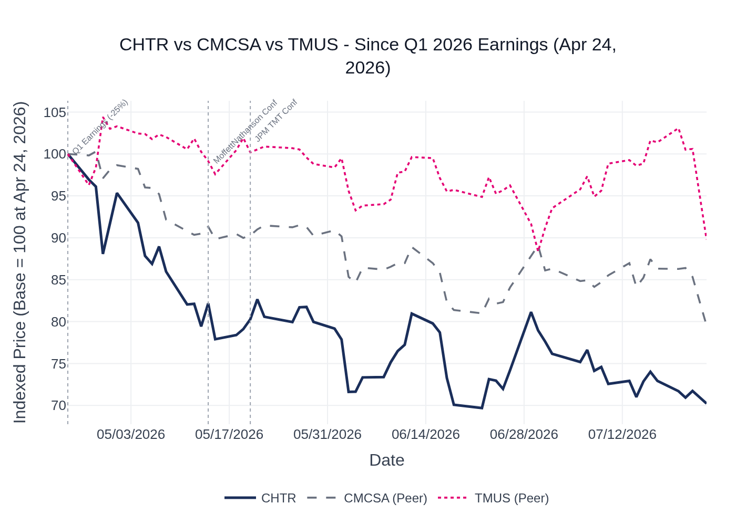
CHTR vs. CMCSA vs. TMUS — Indexed Price Performance Since Q1 2026 Earnings (Apr 24, 2026). Base = 100. Source: Stock Price Data.
CHTR closed at $129.22 on July 22, 2026 (post-market ~$128.00), down approximately 46.5% from its pre-Q1 close of $241.78 on April 23. The stock fell 25.2% on Q1 earnings day alone (April 24: $241.78 → $180.13), then continued to drift lower through May and June, hitting a trough near $125 in late June. CMCSA fell 20.5% over the same period (also reporting Q2 today), while TMUS declined 10.2%. The divergence between CHTR’s stock performance and its relatively stable EBITDA estimates (-0.3% revision for FY2026) confirms this is a multiple compression story driven by ARPU uncertainty and Cox integration risk, not a fundamental earnings deterioration. At current levels, the stock is trading at implied negative perpetuity growth per management’s own characterization.

6. Material News & Developments
Key Takeaway: The Cox acquisition California approval (August 13 deadline) is the single most important near-term catalyst — a close unlocks $800M+ in synergies and a massive mobile greenfield, while a delay would extend the uncertainty overhang.
- July 23, 2026 — CMCSA Q2 2026 Earnings (today): Comcast reported broadband losses of -167K (improved 34K YoY), ARPU -3.8% YoY, and record mobile net adds of 448K (10.2M total lines). Implication: ARPU pressure is a sector-wide phenomenon, not Charter-specific, but CMCSA’s free wireless line strategy is a key driver of ARPU dilution that Charter does not replicate at the same scale.
- July 22, 2026 — AT&T Q2 2026 Earnings: AT&T reported its best-ever Q2 for fiber net adds, 432K postpaid phone net adds, and wireless service revenue +3.3% YoY. Fiber ARPU -1.3% YoY (Lumen acquisition impact). Implication: Fiber overbuild continues to accelerate into Charter’s footprint; AT&T’s convergence strategy is gaining traction.
- July 23, 2026 — T-Mobile Q2 2026 Earnings (today): TMUS reported FWA net adds in the “upper 400K range,” postpaid service revenue +13%, and raised FCF guidance by $200M. Majority of FWA share gains still coming from cable. Implication: FWA competitive pressure on Charter’s broadband base is not abating.
- June 29, 2026 — Charter Q2 2026 Earnings Webcast Announced: Charter announced the Q2 2026 earnings webcast date for late July 2026.
- May 20, 2026 — JPM TMT Conference (CFO Jessica Fischer): Reiterated no change to FY2026 EBITDA guidance; confirmed 2-yr price lock sunset begins Q4 2026 and 3-yr price lock sunset begins Q4 2027; confirmed cost pass-through deferred to late summer with value enhancements; Cox trending toward summer close.
- May 14, 2026 — MoffettNathanson Conference (CEO Chris Winfrey): Confirmed market reaction to Q1 was “centered very much around broadband ARPU”; reiterated converged ARPU is growing; Cox synergies raised to $800M from $500M; Nick Jeffery joining as COO September 1 with focus on go-to-market and NPS improvement.
- September 1, 2026 (upcoming) — Nick Jeffery Joins as COO: Covering marketing, sales, field operations, and customer operations. Implication: New operational leadership could accelerate NPS improvement and go-to-market execution, but impact will take time to materialize.
- Cox Acquisition — California CPUC: Settlements reached with Cal Advocates and CETF; August 13 decision deadline requested; all other state and federal approvals complete as of March 2026. Implication: This is the single most important near-term binary catalyst.

7. Peer Commentaries — Read-Throughs for Q2 2026
Key Takeaway: Today’s Q2 prints from CMCSA and TMUS, plus AT&T’s Q2 yesterday, provide the most current read-through for Charter’s Q2 setup — the sector-wide ARPU pressure from CMCSA is a mixed signal (validates Charter’s challenge but also shows it’s not Charter-specific), while TMUS’s continued FWA share gains from cable confirm the competitive headwind is structural.
This section covers peer commentary from the last 60 days relevant to Charter’s Q2 2026 reporting period. Only commentary about Q2 2026 dynamics or forward-looking statements made after Q1 2026 earnings is included.

A. CMCSA Q2 2026 Earnings (July 23, 2026) — Most Direct Read-Through
- Broadband ARPU -3.8% YoY in Q2: Comcast explicitly did not take a broadband rate increase and migrated customers to simplified pricing with lower everyday price points. Free wireless line accounting is dilutive to broadband ARPU. Management expects “modest improvement” in ARPU starting Q3 as they anniversary the go-to-market strategy launch and free lines convert to paid. Read-through for CHTR: ARPU pressure is a sector-wide phenomenon. Charter’s deferred cost pass-through (planned for late summer) could provide a relative ARPU tailwind vs. CMCSA in Q2/Q3.
- Broadband losses -167K in Q2 (improved 34K YoY): Comcast cited “irrational” promotional behavior from some competitors and continued fiber/FWA/satellite competition. ~45% of base now on gig-plus tiers. Read-through for CHTR: Sector broadband losses remain elevated; Charter’s consensus of -141K is slightly better than CMCSA’s actual, which could be a mild positive signal if Charter’s different pricing approach (no free line dilution) is working.
- Mobile record — 448K net adds, 10.2M total lines, converged ARPU of $85: Comcast described converged ARPU as “significantly below the competition,” indicating a long runway for growth. Read-through for CHTR: Cable mobile is working broadly; Charter’s 12M+ lines and comparable converged ARPU validate the convergence thesis.
- Competition: “Fixed wireless remains aggressive. Fiber continues to expand. Satellite is emerging.” Promotional intensity increased in some markets with “irrational” behavior. Read-through for CHTR: Competitive environment for Q2 is consistent with what Charter described at May conferences — no improvement.

B. AT&T Q2 2026 Earnings (July 22, 2026)
- Best-ever Q2 for AT&T fiber net adds; added over 1M fiber locations in Q2: Accelerating pace toward 8M new locations in 2026, including 4M+ from Lumen. AT&T CEO stated “where we have fiber, we win with fiber and wireless.” Read-through for CHTR: AT&T’s fiber build is accelerating into Charter’s footprint — a direct competitive threat to Charter’s broadband base.
- Fiber ARPU -1.3% YoY (Lumen acquisition impact; ex-Lumen, flat YoY): AT&T explicitly targeting value segment and underpenetrated markets. Read-through for CHTR: AT&T is competing aggressively on price in fiber markets, which could pressure Charter’s ability to take price in overlapping geographies.
- AT&T CEO noted “Comcast run plays to work on retaining the base”: Also noted cable’s “wireless base is maybe going to require a little bit more maintenance at this juncture.” Read-through for CHTR: AT&T sees cable wireless as a potential vulnerability — worth monitoring whether Charter’s mobile churn trends are stable in Q2.
- 432K postpaid phone net adds; wireless service revenue +3.3% YoY; pricing actions took effect in Q2: Read-through for CHTR: Wireless pricing environment is rational; AT&T’s pricing actions did not appear to disrupt the market.

C. T-Mobile Q2 2026 Earnings (July 23, 2026)
- FWA net adds “upper 400K range” again in Q2; majority of FWA share gains still coming from cable: T-Mobile’s FWA speeds 50% faster than next fixed wireless competitor; NPS higher than all broadband categories including fiber. Read-through for CHTR: FWA competitive pressure on Charter’s broadband base is structural and not abating. T-Mobile is taking share primarily from cable, not from other FWA providers.
- T-Mobile raised FWA subscriber target to 15M by 2030; two-thirds of FWA customers in top 100 markets: Read-through for CHTR: The competitive threat is concentrated in Charter’s densest, most valuable markets.
- Postpaid service revenue +13%, core adjusted EBITDA +12%, FCF margin 25%: Read-through for CHTR: T-Mobile’s financial strength enables continued aggressive investment in network and FWA, sustaining competitive pressure.
- ~70% of T-Mobile’s broadband customers also have mobile (vs. Charter’s ~20% mobile penetration of internet base): Read-through for CHTR: Charter’s mobile attach rate has significant runway but also highlights the convergence gap vs. T-Mobile.

D. Conference Commentary (May 2026) — Forward-Looking Signals for Q2
- CMCSA at MoffettNathanson (May 14): Comcast guided to “some incremental pressure in the second quarter” on ARPU, with “relief as we come out of the year.” Confirmed fixed wireless “will continue to be aggressive.” DOCSIS 4.0 deployments “starting to accelerate.” Read-through for CHTR: CMCSA’s own Q2 ARPU guidance (incremental pressure) was confirmed by today’s -3.8% print — validates that Q2 is a trough quarter for cable ARPU broadly.
- T-Mobile at MoffettNathanson (May 13): Majority of FWA share gains from cable; T-Mobile’s 5G broadband speeds 50% faster than next FWA competitor; increased FWA subscriber target to 15M. Read-through for CHTR: Consistent with Q2 earnings — FWA pressure is structural.
- AT&T at JPM (May 19): AT&T confirmed accelerating fiber build; noted Comcast “run plays to work on retaining the base.” Reaffirmed EBITDA growth acceleration and cash flow improvement for Q2. Read-through for CHTR: AT&T’s fiber acceleration is a confirmed headwind for Charter’s Q2 and beyond.
- Verizon at JPM (May 18): Verizon decided “not going to take up pricing again” — lapping by Q3, becoming a tailwind. Promo amortization headwind of ~190bps expected to “begin to turn” possibly as soon as Q3. Read-through for CHTR: Verizon’s pricing restraint reduces one source of competitive pressure in wireless, but Verizon’s FWA deceleration (10+ straight quarters of decelerating growth per TMUS) means it is less of a broadband threat to Charter than TMUS.

8. Insider Transaction Activity
Key Takeaway: The most notable signal is clustered open-market buying by the CEO and two independent directors immediately after the Q1 earnings selloff (April 28) — a strong conviction signal at the lows. Liberty Broadband’s dispositions are structural (related to the Cox merger mechanics) and should not be read as bearish.
Name | Title | Transaction Type | Value (Est.) | Shares | Date (Effective) | Note
Christopher L. Winfrey | President & CEO | Open Market Buy | ~$500K | 3,468 shares (+ 3,468 via spouse) | April 28, 2026 | Discretionary buy day after Q1 earnings selloff; also bought via spouse account
Wade Davis | Director | Open Market Buy | ~$750K | 5,728 shares | April 28, 2026 | Discretionary buy day after Q1 earnings selloff
Balan Nair | Director | Open Market Buy | ~$130K | 1,000 shares | April 28, 2026 | Discretionary buy day after Q1 earnings selloff
Mauricio Ramos | Director | Open Market Buy | ~$1.3M | 9,929 shares | May 15, 2026 | Discretionary buy ~3 weeks post-earnings
Thomas Rutledge | Director Emeritus | Open Market Sale | ~$9.2M | 69,633 shares | May 26, 2026 | Discretionary sale; Rutledge is Director Emeritus (retired CEO), not active management
Liberty Broadband Corp | 10% Owner / Director | Structural Disposition | Various | 1,262,078 / 31,315 / 129,907 shares | May 12, Jun 11, Jul 14, 2026 | Structural dispositions related to Cox merger mechanics; not a discretionary bearish signal
The cluster of open-market buys by CEO Winfrey (personally and via spouse), Director Davis, Director Nair, and Director Ramos in the days immediately following the Q1 selloff is a meaningful bullish signal — insiders bought at prices ranging from ~$130–$175, well below current levels. Rutledge’s sale is from a retired executive and carries less informational weight. Liberty Broadband’s dispositions are structural and merger-related. Source: SEC Form 4 filings.

