EQT Corporation (NYSE: EQT) — Q2 2026 Earnings Preview
Company | EQT Corporation (NYSE: EQT)
Upcoming Earnings | July 21, 2026 (after market close) | Conference Call: July 22, 2026, 10:00 a.m. ET
Prepared | July 20, 2026
Sector | Natural Gas E&P — Appalachian Basin

1. Earnings Preview
Key Takeaway: EQT heads into Q2 with a low bar set by weaker Henry Hub pricing (~$2.77–$3.14/MMBtu vs. $3.02–$3.42 in Q2 2025), but production is expected to come in toward the high end of guidance (~606 Bcfe per UBS), and the real story is whether management upgrades the power/data center demand narrative and signals H2 FCF acceleration.
EQT enters Q2 2026 with consensus EPS of $0.43 and EBITDA of $1.12B — a structurally low bar reflecting the shoulder-season curtailment strategy (10–15 Bcf embedded in guidance) and peak CapEx timing that management explicitly flagged on the Q1 call. Management declared the EQT transformation "complete" on the Q1 call, entering Q2 largely unhedged on the upside but with an in-the-money hedge book providing downside protection — a confident posture that has not shifted since April. Estimates have been revised down sharply since Q1 earnings: Q2 EPS is down 23% (from $0.56 to $0.43), Q2 FCF is down 26% (from $376M to $279M), and FY2026 EPS is down 9% (from $4.80 to $4.36) — all driven by lower Henry Hub, not operational deterioration, as production estimates have actually been nudged slightly higher. The stock has significantly underperformed the E&P sector since Q1 earnings, declining ~13.9% vs. XOP +3.1% (a ~17 percentage point gap), trading near 52-week lows around $49 against a consensus price target of $68 (~39% implied upside) — suggesting the market is pricing in a prolonged low-gas-price environment rather than the structural demand inflection EQT's management is describing. The key wildcard is any update on contracted power/data center supply agreements (management cited "multiple Bcf/day" of active negotiations) or MVP Boost progress, either of which could re-rate the stock; conversely, further Henry Hub weakness or wider basis differentials remain the primary downside risk.

2. KPIs & Consensus Expectations
Key Takeaway: Consensus sets a low bar on earnings and FCF given the shoulder-season curtailment strategy and peak CapEx quarter; production volume is the key swing factor, with UBS expecting ~606 Bcfe toward the high end of guidance — consistent with EQT’s 8-quarter streak of production beats.

Table 1 — Q2 2026 Current Quarter Snapshot (All Key KPIs)
KPI | Q1 2026 Actual | Q2 2025 Actual (Prior Year) | Q2 2026 Consensus | YoY Change | Guidance | Cons vs. Guidance
Total Revenue | $3,379M | $2,558M | $1,792M | -30.0% | N/A | N/A
Adj. EPS (Diluted) | $2.33 | $0.45 | $0.43 | -4.4% | N/A | N/A
EBITDA (Operating) | $2,679M | $1,158M | $1,122M | -3.1% | N/A | N/A
Free Cash Flow | $1,945M | $340M | $279M | -18.0% | N/A | N/A
Gas Equiv. Production (Bcfe) | 617.7 | 568.2 | 606.6 | +6.8% | ~590–620 Bcfe (10–15 Bcf curtailments embedded) | ~Midpoint
Capital Expenditures | $598.5M | $549.6M | $764.0M | +39.0% | Peak CapEx quarter per mgmt | N/A
Net Debt | $5,666M | $7,760M | $5,735M | -26.1% | ~$5B target by year-end | On Track
Note: Revenue and FCF are structurally lower in Q2 vs. Q1 due to shoulder-season pricing and curtailments. CapEx is peak for the year due to growth investment timing. All consensus figures sourced from Visible Alpha.

Table 2 — Beat/Miss History (Last 8 Quarters, Top 2 KPIs: Adj. EPS & Gas Production)
Quarter | EPS Reported | EPS Consensus | EPS Surprise | Production Reported (Bcfe) | Production Consensus (Bcfe) | Production Surprise | Result
Q2 2024 | -$0.08 | -$0.18 | +$0.10 | 507.5 | 483.0 | +5.1% | Beat
Q3 2024 | $0.16 | $0.06 | +$0.10 | 581.4 | 540.3 | +7.6% | Beat
Q4 2024 | $0.69 | $0.50 | +$0.19 | 605.2 | 583.8 | +3.7% | Beat
Q1 2025 | $1.18 | $1.06 | +$0.12 | 570.8 | 562.3 | +1.5% | Beat
Q2 2025 | $0.45 | $0.44 | +$0.01 | 568.2 | 559.5 | +1.6% | Beat
Q3 2025 | $0.52 | $0.40 | +$0.12 | 634.4 | 621.4 | +2.1% | Beat
Q4 2025 | $0.90 | $0.77 | +$0.13 | 609.0 | 598.5 | +1.8% | Beat
Q1 2026 | $2.33 | $2.05 | +$0.28 | 617.7 | 596.5 | +3.6% | Beat
Pattern: EQT has beaten on both EPS and production in each of the last 8 consecutive quarters, with an average EPS beat of ~$0.13 and production consistently 2–8% above consensus. A production beat is likely again in Q2, but the magnitude of the EPS beat will be constrained by lower Henry Hub pricing (~$2.77–$3.14/MMBtu vs. $3.02–$3.42 in Q2 2025).

3. Guidance & Commentary Evolution
Key Takeaway: No formal guidance revision since Q1 earnings; management signaled they are “at least at midpoint of guide” through Q1 and will consider a full-year update at midyear. Q2 is the peak CapEx quarter with FCF expected to accelerate sharply in H2 as capital spending declines meaningfully into Q3 and Q4.
Metric | Initial Guidance (Q1 2026 Earnings Call, Apr 21) | Revised Guidance | Current Consensus | Note
FY2026 Production | ~2.4 Bcfe/day (implied from quarterly guidance) | — No change | 2,399 Bcfe (FY) | 10–15 Bcf Q2 curtailments embedded; optimization strategy
FY2026 CapEx | ~$2.7B (implied) | — No change | $2,705M | Q2 is peak; meaningful declines in H2 expected
FY2026 FCF | ~$3.5–$4.0B (implied) | — No change | $3,621M | “At least at midpoint of guide” per mgmt; H2 FCF acceleration expected
Q2 2026 Production | ~590–620 Bcfe (implied, with curtailments) | — No change | 606.6 Bcfe | 10–15 Bcf curtailments embedded; curtailments act as “synthetic storage”
Net Debt Target | $5B by year-end 2026 | — No change | $5,735M (Q2E) | Fitch upgraded to BBB; leverage below 1x net debt/EBITDA
LNG Portfolio FCF | $500M/yr uplift at strip when online 2030 | — No change | N/A | Could reach $2.5B in high-volatility environment; formal offtake agreements expected 2028–2029

4. Guidance vs. Estimate Revision Tracker
Key Takeaway: Estimates have been revised down materially since Q1 earnings, driven entirely by lower Henry Hub pricing — Q2 EPS is down 23% and FY2026 EPS is down 9% from the post-Q1 baseline. Production estimates have actually been nudged slightly higher, confirming the downward pressure is price-driven, not operational, and the bar is now lower than management’s own expectations.
KPI | Period | Estimate (Apr 28, 2026 — Post-Q1 Baseline) | Current Estimate (Jul 18, 2026) | Estimate Delta (%) | Initial Guidance (Q1 Call) | Cons vs. Guidance
Adj. EPS | Q2 2026 | $0.56 | $0.43 | -22.9% | N/A | —
Adj. EPS | FY2026 | $4.80 | $4.36 | -9.2% | N/A | —
EBITDA (Operating) | Q2 2026 | $1,270M | $1,122M | -11.6% | N/A | —
EBITDA (Operating) | FY2026 | $6,999M | $6,633M | -5.2% | N/A | —
Free Cash Flow | Q2 2026 | $376M | $279M | -25.8% | N/A | —
Free Cash Flow | FY2026 | $3,931M | $3,621M | -7.9% | N/A | —
Gas Production | Q2 2026 | 600.8 Bcfe | 606.4 Bcfe | +0.9% | ~590–620 Bcfe | ~Midpoint
Total Revenue | Q2 2026 | $1,850M | $1,789M | -3.3% | N/A | —
Total Revenue | FY2026 | $9,542M | $9,193M | -3.7% | N/A | —
Commentary: The divergence between earnings/FCF revisions (-23% to -26% for Q2) and production revisions (+0.9% for Q2) confirms that the downward pressure is entirely price-driven (lower Henry Hub), not operational. Production estimates have actually been nudged slightly higher, consistent with UBS’s expectation that EQT will come in toward the high end of guidance. This creates a setup where a production beat is likely but may not be enough to offset the earnings miss vs. the post-Q1 baseline. The key question for the call is whether management updates full-year guidance at midyear and how they frame the H2 FCF acceleration story.

5. Stock Performance
Key Takeaway: EQT has significantly underperformed the E&P sector since Q1 earnings, declining ~13.9% vs. XOP +3.1% — a ~17 percentage point gap driven entirely by multiple compression on lower Henry Hub, not operational deterioration. The stock is near 52-week lows despite record Q1 FCF, suggesting the market is pricing in a prolonged low-gas-price environment.
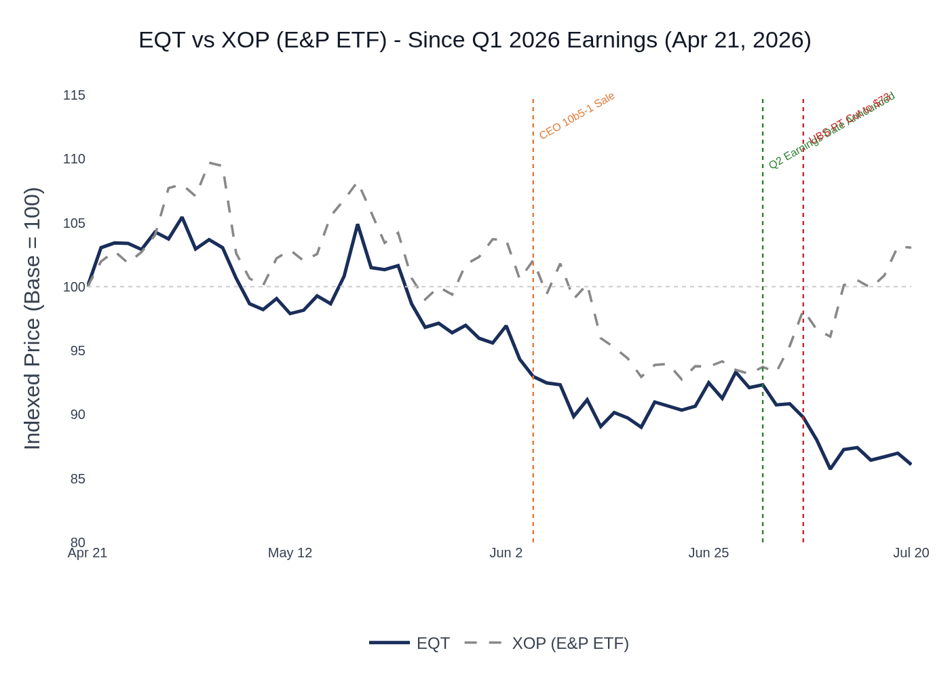
EQT vs. XOP (SPDR S&P Oil & Gas E&P ETF) — Indexed Performance Since Q1 2026 Earnings (Apr 21, 2026). EQT: -13.9% | XOP: +3.1%
EQT’s underperformance vs. XOP is notable given the company’s record Q1 FCF and balance sheet improvement. The divergence reflects the market’s sensitivity to Henry Hub pricing — EQT’s unhedged posture, which was a massive tailwind in Q1, has become a headwind as prices moderated into the shoulder season. The stock’s failure to recover despite the XOP sector rally in late June/early July suggests company-specific concerns around the gas price outlook rather than sector-wide sentiment. With consensus price target of $68 implying ~39% upside from current levels (~$49), the setup is asymmetric to the upside if gas prices recover or if management delivers a strong demand narrative on the Q2 call. Henry Hub spot prices for Q2 2026 averaged $2.77/MMBtu (April), $2.94/MMBtu (May), and $3.14/MMBtu (June) — all below the Q2 2025 comparable period ($3.42, $3.12, $3.02 respectively), which is the primary driver of the YoY earnings decline.

6. Material News & Developments
Key Takeaway: The most important development since Q1 earnings is the continued deterioration in Henry Hub pricing into the shoulder season, which has driven ~23% downward EPS revisions; however, the structural demand narrative (data centers, LNG, power) continues to strengthen and could be the catalyst for re-rating on the Q2 call.
- July 8, 2026 — UBS lowers PT to $73 (from $74), maintains Buy: Expects Q2 production toward high end of guidance (~606 Bcfe); strong operations to offset weaker Henry Hub and slightly wider differentials. Lowered 2026 Henry Hub outlook is the driver of the PT cut. Street broadly constructive but trimming numbers on gas price.
- July 2, 2026 — Jefferies lowers PT to $75 (from $77), maintains Buy: Expects Q2 EBITDA of $1.13B, slightly below consensus of $1.19B. Sell-side broadly aligned on a modest miss vs. prior consensus but still bullish on the long-term thesis.
- June 30, 2026 — Freedom Broker initiates with Buy, $79 PT: Highlights EQT’s position as largest U.S. natural gas producer and improving market fundamentals. New coverage adds to the bullish camp.
- June 23, 2026 — DVN at JP Morgan Natural Resources Conference: Devon discussed power demand bull case and Permian gas dynamics. Sector-wide confirmation of accelerating power demand narrative.
- June 8, 2026 — CEO Toby Rice sells 1,731 shares under 10b5-1 plan: Pre-planned sale; disclosed via Form 4 filed June 9, 2026. Routine 10b5-1 plan execution; not a discretionary signal. CEO retains 2,333,193 shares.
- April 29, 2026 — Director Vicky Bailey sells 4,116 shares (full exit): Disclosed via Form 4 filed April 29, 2026. Volume_owned_eod = 0, representing a complete exit of position. Likely personal financial planning rather than a fundamental signal.
- Moody’s upgrades EQT outlook to Positive: Citing ~$8B debt reduction post-Equitrans acquisition. Credit trajectory continues to improve; supports the path to investment-grade across all agencies.
- Ongoing — Data center/power demand pipeline: Management cited “multiple Bcf/day” of supply negotiations with power generators and data center developers in Appalachia. NextEra announced 10 GW in Pennsylvania; 9+ GW facility announced in Ohio (Portsmouth). West Virginia’s 50x50 plan (15 GW to 50 GW by 2050). Any signed supply agreement would be a significant positive catalyst.
- Ongoing — Permitting reform: Management flagged urgency for permitting reform “in the next few months” to enable infrastructure buildout. Regulatory risk to the demand growth thesis; failure to pass reform could delay contracted projects.

7. Peer Commentaries — Q2 2026 Read-Throughs
Key Takeaway: Appalachian peers (AR, RRC, CHK/Expand Energy) all reported Q1 2026 earnings after EQT and provided Q2 2026 forward commentary — the consistent themes are: (1) Q2 is peak CapEx for all Appalachian producers, (2) structural demand from LNG, data centers, and power is accelerating beyond prior expectations, and (3) basis differentials are expected to improve as in-basin demand grows. These are broadly positive read-throughs for EQT’s Q2 narrative and long-term thesis.
Note: All peer commentary below is sourced from Q1 2026 earnings calls (reported after EQT’s Q1 2026 call on April 21, 2026) and the DVN JP Morgan Natural Resources Conference (June 23, 2026). Commentary is forward-looking, pertaining to Q2 2026 and beyond.

Antero Resources (AR) — Q1 2026 Earnings Call (April 30, 2026)
Focus: Q2 2026 forward commentary and Appalachian demand outlook
Theme | AR Commentary | EQT Read-Through
LNG Demand Surge | LNG export demand rising 7 Bcf/day by end of 2027; Golden Pass shipped first cargo and ramping to 1.6 Bcf capacity in 2026, ultimately 2.4 Bcf/day in 2027. EU exited winter at second-lowest storage on record (below 30%), with Middle East imports down 91% in March/April. | Positive — Direct positive for EQT’s LNG thesis and basis differential outlook. Accelerating LNG pull tightens Appalachian supply/demand balance.
Appalachian Data Center Demand | Publicly announced power projects in AR’s region totaling over 8 Bcf/day of demand; including non-disclosed projects, estimates exceed 10 Bcf/day. WV’s 50x50 plan (15 GW to 50 GW by 2050). Microsoft/NVIDIA and Google projects announced in WV. AR participated in RFPs for gas supply totaling over 5 Bcf/day. | Positive — Directly corroborates EQT’s “multiple Bcf/day” pipeline commentary. Demand pipeline is real and accelerating.
Basis Differential Improvement | Expects tightness from LNG and regional power to improve local market pricing in two ways: more attractive pricing on long-term supply deals, and improved overall local market pricing. AR’s integrated upstream/midstream position cited as competitive advantage for winning supply contracts. | Positive — Positive read-through for EQT’s corporate differential. EQT’s vertical integration is an even stronger competitive advantage.
Q2 CapEx Profile | AR guided Q2 CapEx in the $300M range (full HG acquisition contribution); consistent with the sector-wide pattern of Q2 being peak CapEx. | Neutral — Consistent with EQT’s Q2 peak CapEx commentary. Sector-wide pattern validates EQT’s H2 FCF acceleration thesis.
Cost Reduction | Reduced 2026 cash cost guidance by $0.10/Mcfe at midpoint; Q2–Q4 cash production expenses down $0.26/Mcfe (>10% below 2025 average). | Positive — Positive read-through for EQT’s cost structure. Sector-wide cost deflation supports EQT’s low-cost positioning.

Devon Energy (DVN) — Q1 2026 Earnings Call (May 6, 2026) & JP Morgan Conference (June 23, 2026)
Focus: Broader E&P sector read-through (Devon is primarily oil-focused but has Appalachian gas exposure and provides sector-wide demand commentary)
Theme | DVN Commentary | EQT Read-Through
Commodity Backdrop Stronger Than Expected | “The commodity backdrop is meaningfully stronger than what anyone underwrote coming into this year.” Production expected to step up in Q2. Cost structure “well controlled.” | Positive — Broadly positive sector sentiment. Supports EQT’s operational confidence heading into Q2.
Power Demand Bull Case | DVN’s CTO highlighted “firm always-on, 365-day power demand” across the U.S. as an unexpected positive; “continue to be pretty bullish on that power demand story.” | Positive — Corroborates EQT’s power demand upgrade from bull case to base case. Cross-sector validation of the demand thesis.
Curtailment Strategy | DVN manages high-GOR wells by pulling back production during periods of negative Waha prices — consistent with EQT’s curtailment-as-storage philosophy. “You saw a little bit of that in the first quarter.” | Neutral — Sector-wide validation of the curtailment optimization approach. Confirms EQT’s strategy is industry best practice.

Peer Read-Through Summary
Theme | AR | RRC | Expand Energy | DVN | EQT Read-Through
Q2 = Peak CapEx | ✓ | ✓ | ✓ | — | Positive
LNG Demand Acceleration | ✓ | ✓ | ✓ | — | Positive
Data Center / Power Demand | ✓ | ✓ | ✓ | ✓ | Positive
Basis Differential Improvement | ✓ | ✓ | — | — | Positive
Curtailment as Optimization | — | — | ✓ | ✓ | Neutral
Cost Deflation | ✓ | — | — | ✓ | Positive

8. Insider Transaction Activity
Key Takeaway: Only two insider transactions since Q1 earnings — CEO Toby Rice’s pre-planned 10b5-1 sale and Director Vicky Bailey’s full exit of her position. Neither signals fundamental concern; the CEO sale is routine and the director exit is likely personal financial planning. The absence of open-market purchases at current ~$49 levels (near 52-week lows) is worth noting.
Name | Title | Transaction Type | Shares | Est. Value | Effective Date | Disclosed Date | Note
Toby Z. Rice | President & CEO, Director | 10b5-1 Planned Sale | 1,731 | ~$91K (at ~$52.98) | June 8, 2026 | June 9, 2026 | Pre-planned 10b5-1 plan; routine execution; retains 2,333,193 shares
Vicky A. Bailey | Director | Open Market Sale | 4,116 | ~$243K (at ~$59.11) | April 27, 2026 | April 29, 2026 | Full exit of position (0 shares remaining); likely personal financial planning
No open-market purchases by insiders since Q1 earnings. The absence of insider buying at current levels (~$49, near 52-week lows) is worth noting — management has not yet stepped in to signal conviction at these prices, though the CEO’s large retained position (2.33M shares, valued at ~$114M at current prices) remains a meaningful alignment signal.
Sources: Visible Alpha Consensus and Actuals Data; SEC Form 4 Filings (Insider Transaction Data); EQT Q1 2026 Earnings Call Transcript (April 21, 2026); AR Q1 2026 Earnings Call Transcript (April 30, 2026); RRC Q1 2026 Earnings Call Transcript (April 22, 2026); CHK/Expand Energy Q1 2026 Earnings Call Transcript (April 29, 2026); DVN Q1 2026 Earnings Call Transcript (May 6, 2026); DVN JP Morgan Natural Resources Conference Transcript (June 23, 2026); UBS Research (July 8, 2026); Jefferies Research (July 2, 2026); EIA Henry Hub Natural Gas Spot Price Data.

