Las Vegas Sands Corp (LVS) — Q2 2026 Earnings Preview
Ticker: LVS Upcoming Earnings Date: July 22, 2026 (After Market Close) Prepared: July 21, 2026

Earnings Preview
Key Takeaway: The Q2 2026 setup is mixed — Singapore remains a structural earnings engine but Macao faces a meaningful headwind from the FIFA World Cup-driven June GGR collapse (-12.1% YoY), making this a quarter where the bar is lower than Q1 but the narrative around Macao recovery trajectory will dominate the call.
Heading into Q2 2026, LVS faces a bifurcated setup: Marina Bay Sands (MBS) is expected to deliver another strong quarter anchored by mass gaming and slots, while Macao EBITDA consensus has been revised down materially post-Q1 earnings, reflecting the well-documented June GGR weakness driven by the expanded 48-team FIFA World Cup diverting Chinese consumer spending away from casino floors. Q2 Macao industry GGR came in essentially flat YoY (down ~0.1%), with April +5.5% and May +6.7% offset by a sharp June decline of -12.1% — the weakest month of 2026. Consensus for Q2 2026 Operating EBITDA sits at ~$1.21B, down from the $1.26B baseline right after Q1 earnings, suggesting the Street has already de-risked the Macao print. The stock has underperformed significantly since Q1 earnings — down ~20% vs. SPY +5.2% — meaning the bar is low and the setup is more about what management says about Q3 and the Macao recovery trajectory post-World Cup than the Q2 number itself. The wildcard is Singapore rolling chip volume: Q1's $18B was described as "extraordinary" and management cautioned on quarter-to-quarter volatility, so any normalization in MBS VIP could be the incremental negative surprise.

KPIs & Consensus Expectations
Key Takeaway: Consensus is a low bar for Macao EBITDA given the FIFA World Cup headwind in June, but Singapore EBITDA expectations (~$728M) remain elevated relative to history — any MBS VIP normalization is the bigger swing factor.
Table 1 — Current Quarter Snapshot (Q2 2026)
KPI | Q1 2026 Actual | Q2 2025 Actual (Prior Year) | Q2 2026 Consensus | YoY Change | Guidance | Consensus vs. Guidance
Total Revenue | $3,585M | $3,175M | $3,331M | +4.9% | No explicit guidance | N/A
Macao Operations EBITDA | $633M | $566M | $559M | -1.2% | $700M+ quarterly (long-term target) | -20.1% vs. LT target
Marina Bay Sands EBITDA | $788M | $768M | $728M | -5.2% | No explicit quarterly guidance | N/A
Operating EBITDA | $1,338M | $1,265M | $1,209M | -4.4% | No explicit guidance | N/A
Adj. EPS (Diluted Operating) | $0.91 | $0.79 | $0.75 | -5.1% | No explicit guidance | N/A
Source: Visible Alpha consensus as of July 21, 2026. Q2 2026 Macao EBITDA consensus of $559M is below Q2 2025 actual of $566M, reflecting the FIFA World Cup June GGR headwind. MBS EBITDA consensus of $728M remains well above the prior year but below Q1 2026’s record $788M, consistent with management’s own caution that Q2 is “typically our softest” quarter and that Q1 benefited from extraordinary rolling chip volume.
Table 2 — Beat/Miss History (Last 8 Quarters)
Macao Operations EBITDA
Quarter | Reported | Consensus | Surprise % | Result
Q2 2024 | $561M | $609M | -7.9% | Miss
Q3 2024 | $585M | $565M | +3.5% | Beat
Q4 2024 | $571M | $598M | -4.5% | Miss
Q1 2025 | $535M | $586M | -8.7% | Miss
Q2 2025 | $566M | $561M | +0.9% | Beat
Q3 2025 | $601M | $597M | +0.7% | Beat
Q4 2025 | $608M | $628M | -3.2% | Miss
Q1 2026 | $633M | $601M | +5.3% | Beat
Marina Bay Sands EBITDA
Quarter | Reported | Consensus | Surprise % | Result
Q2 2024 | $512M | $491M | +4.3% | Beat
Q3 2024 | $406M | $496M | -18.1% | Miss
Q4 2024 | $537M | $499M | +7.6% | Beat
Q1 2025 | $605M | $527M | +14.8% | Beat
Q2 2025 | $768M | $533M | +44.1% | Beat
Q3 2025 | $743M | $607M | +22.4% | Beat
Q4 2025 | $806M | $692M | +16.5% | Beat
Q1 2026 | $788M | $715M | +10.2% | Beat
Pattern: MBS has beaten consensus in 7 of the last 8 quarters by an average of ~12%, reflecting the Street’s persistent underestimation of Singapore’s earnings power. Macao has been more volatile — 4 beats and 4 misses — with misses concentrated in periods of competitive reinvestment pressure.

Guidance & Commentary Evolution
Key Takeaway: No formal numerical guidance was revised post-Q1 earnings; the key evolution is management’s explicit acknowledgment that Q2 is seasonally soft and that Macao margins will continue to face near-term pressure from service investment spending.
Metric | Initial Guidance (Q1 2026 Earnings Call, Apr 22) | Revised Guidance | Current Consensus | Note
Macao Quarterly EBITDA Target | $700M+ (long-term goal) | Unchanged | $559M (Q2 2026E) | Long-term target; not a near-term quarterly guide. Management noted Q2 is “typically our softest” quarter
Macao EBITDA Margin | ~29.6% hold-adjusted in Q1; near-term pressure expected | Unchanged | ~28–29% implied | Investments in service/training will “continue to negatively impact margins” near-term; improvement expected over time
MBS EBITDA | No explicit quarterly guidance; internal forecast raised to potentially $2.9B+ annually | Unchanged | $728M (Q2 2026E) | Bernstein Conference (May 27): no measurable impact from jet fuel shortages on Singapore demand
Maintenance CapEx | ~$500M annually (raised on Q1 call); viewed as non-discretionary | Unchanged | N/A | Increase reflects commitment to maintaining asset quality; SCL-level CapEx also moved up
Share Repurchases | Continued buybacks; $740M repurchased in Q1 2026 | Unchanged | N/A | 14.3% of shares repurchased over last 10 quarters; company views additional repurchases as meaningfully accretive
Venetian Renovation | Room refresh begins Q3 2026; full completion by end of 2027/early 2028 | Unchanged | N/A | No meaningful disruption expected; demand to be redistributed across portfolio

Guidance vs. Estimate Revision Tracker
Key Takeaway: Estimates for Q2 2026 have been revised DOWN ~4–7% since the Q1 earnings baseline, driven by the FIFA World Cup June GGR collapse in Macao; FY 2026 estimates are also modestly lower, suggesting the Street has partially de-risked the year but not fully.
KPI / Period | Estimate (Apr 28, 2026 — 5 Days Post Q1 Earnings) | Current Consensus (Jul 21, 2026) | Estimate Δ (%) | Initial Guidance (Q1 Call) | Current Guidance | Guidance Δ | Consensus vs. Guidance
Total Revenue — Q2 2026 | $3,406M | $3,331M | -2.2% | No explicit guide | No change | N/A | N/A
Total Revenue — FY 2026 | $14,195M | $14,066M | -0.9% | No explicit guide | No change | N/A | N/A
Macao EBITDA — Q2 2026 | $599M | $559M | -6.7% | No explicit guide | No change | N/A | -20.1% vs. $700M LT target
Macao EBITDA — FY 2026 | $2,516M | $2,457M | -2.3% | No explicit guide | No change | N/A | N/A
MBS EBITDA — Q2 2026 | $732M | $728M | -0.5% | No explicit guide | No change | N/A | N/A
MBS EBITDA — FY 2026 | $3,006M | $3,004M | -0.1% | No explicit guide | No change | N/A | N/A
Operating EBITDA — Q2 2026 | $1,260M | $1,209M | -4.0% | No explicit guide | No change | N/A | N/A
Adj. EPS — Q2 2026 | $0.796 | $0.751 | -5.7% | No explicit guide | No change | N/A | N/A
The revision pattern is clear — Macao EBITDA estimates for Q2 have been cut the most (-6.7%), consistent with the June GGR data showing a -12.1% YoY decline driven by the FIFA World Cup. MBS estimates have been remarkably stable (-0.5%), reflecting confidence in Singapore’s structural earnings power. FY 2026 estimates are down modestly (-0.9% revenue, -2.3% Macao EBITDA), suggesting the Street views the World Cup impact as a one-quarter phenomenon rather than a structural deterioration.

Stock Performance
Key Takeaway: LVS has underperformed sharply since Q1 earnings — down ~20% vs. SPY +5.2% — driven by multiple compression on Macao GGR concerns (FIFA World Cup) and sector-wide de-rating, not earnings revisions; the stock now trades at a significant discount to consensus price targets (~$65–67), implying ~43–47% upside.
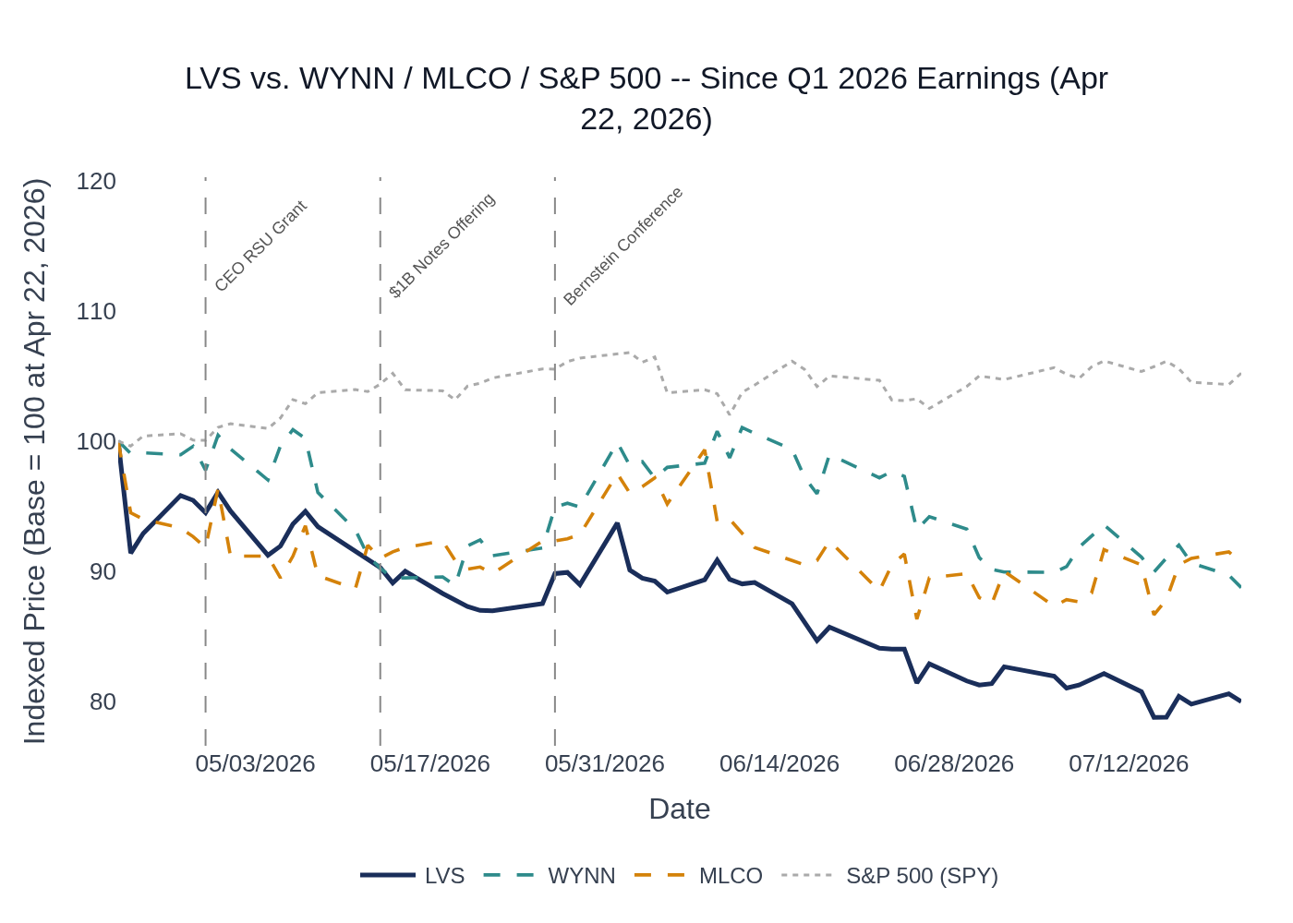
LVS vs. WYNN, MLCO & S&P 500 (SPY) — Indexed to 100 at April 22, 2026 (Q1 2026 Earnings Date). Source: Stock Price Data.
Name | Apr 22, 2026 Close | Jul 21, 2026 Close | Return Since Q1 Earnings
LVS | $56.85 | $45.47 | -20.0%
WYNN | $106.64 | $94.63 | -11.3%
MLCO | $5.99 | $5.43 | -9.3%
S&P 500 (SPY) | $711.21 | $748.28 | +5.2%
Analyst Sentiment: 18 analysts cover LVS — 11 Buy/Strong Buy, 7 Hold, 0 Sell. Average price target ~$65–67, implying ~43–47% upside from current levels (~$45.47). Recent PT changes: Barclays cut PT $65→$63 (Jul 9, maintained Overweight); JPMorgan cut PT $71→$68 (Apr 23, maintained Overweight); Mizuho raised PT $65→$67 (Apr 23, Outperform); Jefferies raised PT $61→$63 (Apr 23, Hold); Seaport cut PT $72→$69 (Apr 21, Buy). LVS’s underperformance relative to peers (WYNN -11.3%, MLCO -9.3%) suggests company-specific concerns around Macao competitive positioning and the magnitude of the World Cup impact, rather than pure sector headwinds.

Peer Commentaries — Q2 2026 Read-Throughs (Last 60 Days)
Key Takeaway: Peer Q1 2026 earnings calls (reported April 29 – May 7) provide forward-looking commentary directly relevant to LVS’s Q2 2026 setup — the key read-throughs are: (1) Macao mass market momentum carried into Q2 per WYNN, (2) the FIFA World Cup June headwind was broadly anticipated, (3) premium/VIP demand remains healthy, and (4) all operators are investing in product upgrades to compete for the premium segment.

WYNN Resorts — Q1 2026 Earnings (May 7, 2026)
Relevance to LVS Q2 2026: HIGH — Direct Macao/premium mass competitor
- Mass momentum into Q2 (Direct positive read-through): WYNN explicitly stated “mass drop was extremely strong, up 19% year-on-year” in Q1, and that “momentum persisted into the second quarter with mass drop running ahead of last year.” This is a direct positive signal for LVS’s Macao mass segment in Q2.
- VIP April softness (Mild negative read-through): WYNN noted April was not the strongest month for VIP. Consistent with MLCO’s commentary. Mild negative for LVS’s Singapore rolling chip volume normalization.
- Premium demand structural (Positive): “Premium demand continues to drive the Macau market” — WYNN opened its expanded Chairman’s Club to “strong customer reception,” reinforcing the premium-led recovery thesis that underpins LVS’s Macao strategy.
- Promotional discipline (Positive): WYNN stated they “stay really disciplined” on reinvestment and have not seen the promotional environment “change substantively” — a positive read-through suggesting competitive reinvestment pressure may be stabilizing.
- New investment — The Enclave at Wynn Palace (Longer-term competitive watch): WYNN announced a $900M–$950M all-suite hotel addition (432 suites, +25% room count, +50% suite count) at Wynn Palace, targeting $400M incremental GGR and $150–175M EBITDA. Signals conviction in Macao’s long-term demand but increases future competitive intensity for LVS’s premium suite product.

Melco Resorts (MLCO) — Q1 2026 Earnings (April 30, 2026)
Relevance to LVS Q2 2026: HIGH — Direct Macao competitor; provides Singapore-adjacent demand color
- May Golden Week positive (Direct positive read-through): MLCO noted that geopolitical tensions (~10% flight cancellations from China to international markets) have benefited short-haul Asian destinations: “for May Golden Week, we’re seeing both occupancy and player quality improve on a year-on-year basis.” Direct positive read-through for LVS’s Macao and Singapore properties.
- VIP April soft (Mild negative): MLCO stated April “was probably not the strongest month” for VIP and that it “did not set the world on fire for VIP.” Consistent with WYNN’s commentary. Mild negative for LVS Singapore rolling chip normalization.
- Competitive reinvestment stable (Neutral/Positive): MLCO noted “player reinvestment levels tick up” but believes “they’re stable for now” and does not foresee them increasing or decreasing in the near term — consistent with LVS’s own commentary about optimizing promotional programs.
- REM luxury hotel opening Q3 2026 (Competitive watch): MLCO’s new 149-key luxury hotel at City of Dreams opens in Q3 2026, adding competitive pressure in the premium suite segment that LVS is also targeting with its Venetian renovation. MLCO expects “a pretty big revenue uplift as that ramps.”
- Macao government diversification fund (Watch item): Macau government announced a MOP 20B economic diversification fund targeting up to MOP 9B from private parties. MLCO noted its commitment “will not increase” — worth monitoring for LVS’s potential obligations.

MGM Resorts (MGM China) — Q1 2026 Earnings (April 29, 2026)
Relevance to LVS Q2 2026: MODERATE — MGM China is a Macao competitor; US operations not relevant to LVS
- Market confidence (Positive read-through): MGM CEO Bill Hornbuckle stated “I think we feel really good about the balance of the year” on Macao. Constructive read-through for the Macao demand environment heading into Q2 and H2 2026.
- Side bets driving hold (Structural positive): MGM noted “increasing adoption of some side bets on gaming floors” which “carry a house advantage higher than traditional games,” contributing to better-than-historical mass hold. Consistent with LVS’s own commentary about side wager adoption increasing in both Macao and Singapore — a structural positive for hold rates across the industry.
- Premium product investment (Competitive context): MGM completed suite conversions and renovated premium gaming areas at MGM Cotai “ahead of the upcoming Golden Week holiday” and is designing ~100 additional suites at MGM Macau. Confirms the industry-wide premium product arms race that LVS is participating in with its Venetian renovation.
- Margins sustainable (Positive): MGM CFO guided property-level margins (before brand fee) to continue “in the mid- to even high 20s” — consistent with LVS’s own Macao margin trajectory in the high-20s to low-30s range.
- Market share stable (Neutral): MGM China’s Q1 market share was 15.4%, with March at 17.3% “which has held steady into April” — suggesting competitive dynamics were relatively stable entering Q2.

Material News & Developments
Key Takeaway: The most material post-Q1 development is the FIFA World Cup-driven June GGR collapse in Macao (-12.1% YoY), which has already been partially priced in via estimate cuts; the $1B senior notes refinancing is balance-sheet-neutral and the Bernstein Conference confirmed no demand disruption in Singapore.
- June 2026 Macao GGR -12.1% YoY (Jul 3, 2026): Industry GGR fell to MOP18.52B ($2.29B) in June, the weakest month of 2026 and the first YoY decline, driven by the expanded 48-team FIFA World Cup diverting Chinese consumer spending toward sports wagering. Q2 2026 total GGR was ~MOP61B, essentially flat (-0.1%) YoY. Implication: Macao EBITDA will be the weak spot in Q2; the question is whether LVS’s premium mix and Singapore strength can offset.
- May 2026 Macao GGR +6.7% YoY (Jun 2, 2026): May GGR reached MOP22.6B ($2.80B), the strongest May since 2019, beating analyst forecasts. April was +5.5% YoY. Implication: The quarter started well before the World Cup disruption — LVS’s April/May performance likely tracked the market.
- LVS completes $1B Senior Notes Offering for refinancing (May 13, 2026): LVS completed a $1B senior notes offering, using proceeds to refinance existing debt. Disclosed via 8-K filed May 13, 2026. Implication: Balance sheet management action; extends maturity runway. Neutral to slightly positive.
- Bernstein Strategic Decisions Conference (May 27, 2026): CEO Patrick Dumont participated. Management confirmed no measurable impact from jet fuel shortages or flight disruptions on Singapore demand as of late May 2026. Implication: Singapore demand remained robust through at least late May.
- Barclays cuts LVS price target $65→$63 (Jul 9, 2026): Maintained Overweight rating. Implication: Reflects World Cup GGR headwind but analyst remains constructive on the stock.
- Post-Q1 analyst PT revisions (Apr 23, 2026): JPMorgan cut PT $71→$68 (Overweight); Mizuho raised PT $65→$67 (Outperform); Jefferies raised PT $61→$63 (Hold); Seaport cut PT $72→$69 (Buy). Implication: Mixed PT moves post-Q1 beat, with most analysts remaining constructive but acknowledging Macao uncertainty.
- Annual Meeting — Shareholders approve directors, auditor, executive compensation (May 18, 2026): Routine governance action. No material implications.

Insider Transaction Activity
Key Takeaway: No open-market buys or discretionary sells of significance since Q1 earnings; all transactions are either RSU grants (compensation-related) or estate/trust restructuring by the Adelson family — no meaningful signal for the upcoming print.
Name | Title | Transaction Type | Value / Size | Transaction Date | Filing Date | Note
Patrick Dumont | Chairman & CEO | RSU Grant (Compensation) | 167,081 units | Apr 27, 2026 | Apr 29, 2026 | Annual equity compensation grant; not a market signal
D. Zachary Hudson | EVP & General Counsel | RSU Grant (Compensation) | 62,684 units | Apr 27, 2026 | Apr 29, 2026 | Annual equity compensation grant
Randy Hyzak | EVP & CFO | RSU Grant (Compensation) | 31,111 units | Apr 27, 2026 | Apr 29, 2026 | Annual equity compensation grant
Charles D. Forman | Director | Open Market Sale | 11,400 shares (~$600K) | Apr 27, 2026 | Apr 29, 2026 | Discretionary sale; relatively small size; no 10b5-1 plan noted
Multiple Directors (6) | Directors | RSU Grant (Compensation) | 3,948 units each | May 14, 2026 | May 18, 2026 | Annual director equity compensation grants
Miriam Adelson | 10% Owner | Estate/Trust Restructuring (Gift) | ~175.4M shares (transfers) | Jun 16, 2026 | Jun 18, 2026 | Internal trust restructuring between Adelson family trusts; no economic change in beneficial ownership; not a market signal
The only open-market sale was Director Charles Forman’s 11,400-share sale on April 27, 2026 — a relatively small, discretionary transaction with no 10b5-1 plan noted. The Adelson family trust restructuring (June 16) involved large share counts but represents internal estate planning with no change in economic exposure. No insider buying has occurred since Q1 earnings, which is notable given the ~20% stock decline — the absence of buying is not alarming given the Adelson family’s dominant ownership structure, but it is worth monitoring.

