Northern Trust Corporation (NTRS) — Q2 2026 Earnings Preview
Company | Northern Trust Corporation
Ticker | NTRS
Upcoming Earnings Date | July 22, 2026
Reporting Period | Q2 2026 (quarter ended June 30, 2026)
Last Earnings Date | April 21, 2026 (Q1 2026)
Preparation Date | July 21, 2026

1. Earnings Preview
Key Takeaway: Setup leans toward a beat — the bar is manageable, peers BK and STT both reported record revenues and raised NII guidance for 2026, and NTRS management characterized Q2 conditions as "Goldilocks" at the June Morgan Stanley conference; the biggest swing factor is whether the elevated institutional deposit levels from Q1 were sustained into Q2.
Heading into Q2 2026 earnings, the setup for NTRS is constructive. Consensus expects operating EPS of $2.70 and NII of ~$653M, both representing meaningful year-over-year growth, yet the bar appears achievable given the favorable macro backdrop that persisted through the quarter — stable rates, elevated market volatility, and strong client activity. Management's tone at the June 9 Morgan Stanley conference was unambiguously positive: CFO David Fox described conditions as a "Goldilocks-type situation" and reaffirmed full conviction in all guidance issued at Q1 earnings, including the upgraded NII outlook of mid-to-high single-digit growth for the full year. Estimate revisions have drifted modestly higher since the Q1 print, with Q2 EPS consensus up ~2% and NII consensus up ~0.4% from the post-Q1 baseline, suggesting the Street has incrementally raised the bar but not aggressively so. The stock has rallied ~7.8% since last earnings (vs. ~13.8% for STT and ~13.8% for BK), implying NTRS has underperformed custody bank peers despite its strong Q1 beat, which could mean either relative catch-up potential or that the market is already pricing in some mean-reversion from Q1's unusually elevated institutional deposits. The key wildcard is deposit sustainability: management guided to retaining only $4–5B of the ~$9B Q1 deposit surge into Q2 averages, and whether NII can still grow sequentially on a smaller balance sheet will be the single most watched data point on the call.

2. KPIs & Consensus Expectations
Key Takeaway: Consensus sets a manageable bar — NII is the bigger swing factor given the deposit normalization guided at Q1, while trust fees are expected to benefit from constructive equity markets and strong client activity seen at peers.

Table 1 — Q2 2026 Current Quarter Snapshot
KPI | Q1 2026 Actual (Last Quarter) | Q2 2025 Actual (Prior Year) | Q2 2026 Consensus Estimate | YoY Change | Guidance | Consensus vs. Guidance
Operating EPS ($) | $2.71 | $2.13 | $2.70 | +26.8% | No specific Q2 guidance provided | N/A
Net Interest Income ($M) | $654M | $611M | $653M | +6.9% | FY2026: mid-to-high single-digit growth YoY | Tracking within guidance range
Trust, Investment & Other Servicing Fees ($M) | $1,341M | $1,231M | $1,351M | +9.8% | Organic growth target >3% for all segments | Above organic target
Operating Revenue (FTE) ($M) | $2,213M | $2,003M | $2,198M | +9.7% | Positive operating leverage >100bps FY2026 | Tracking to guidance
Operating Expenses ($M) | $1,508M | $1,417M | $1,495M | +5.5% | Direction of travel: down for remainder of 2026 | Expenses declining QoQ as guided
Operating Efficiency Ratio (%) | 68.1% | 70.7% | 68.1% | -260bps YoY | Positive operating leverage >100bps FY2026 | Consistent with guidance
Net Interest Margin FTE (%) | 1.75% | 1.69% | 1.76% | +7bps YoY | Stable balance sheet positioning | Tracking guidance
AUC/A ($T) | $35.8T | $31.4T | $35.9T | +14.3% | No specific guidance | N/A
Source: Visible Alpha consensus and actuals data. All consensus figures as of July 21, 2026.

Table 2 — Beat/Miss History (Last 8 Quarters)

Operating EPS ($)
Quarter | Reported | Consensus | Surprise % | Result
Q1 2026 | $2.71 | $2.33 | +16.3% | BEAT
Q4 2025 | $2.69 | $2.38 | +13.0% | BEAT
Q3 2025 | $2.29 | $2.24 | +2.2% | BEAT
Q2 2025 | $2.13 | $2.09 | +1.9% | BEAT
Q1 2025 | $1.90 | $1.86 | +2.2% | BEAT
Q4 2024 | $2.26 | $2.04 | +10.8% | BEAT
Q3 2024 | $2.01 | $1.76 | +14.2% | BEAT
Q2 2024 | $1.78 | $1.77 | +0.7% | BEAT
Pattern: NTRS has beaten operating EPS consensus in each of the last 8 consecutive quarters, with an average surprise of +7.7%; the magnitude of beats has been accelerating, with the last two quarters delivering double-digit surprises driven by NII upside and operating leverage.

Net Interest Income ($M)
Quarter | Reported ($M) | Consensus ($M) | Surprise % | Result
Q1 2026 | $654M | $622M | +5.1% | BEAT
Q4 2025 | $642M | $595M | +7.9% | BEAT
Q3 2025 | $591M | $586M | +0.9% | BEAT
Q2 2025 | $611M | $578M | +5.7% | BEAT
Q1 2025 | $568M | $552M | +2.9% | BEAT
Q4 2024 | $564M | $552M | +2.2% | BEAT
Q3 2024 | $562M | $525M | +7.0% | BEAT
Q2 2024 | $523M | $509M | +2.7% | BEAT
Pattern: NTRS has beaten NII consensus in each of the last 8 quarters, with an average surprise of +4.3%; NII beats have been the primary driver of EPS upside, and the trend of positive surprises has been consistent even as the Street has progressively raised its estimates.
Source: Visible Alpha consensus and actuals data.

3. Guidance & Commentary Evolution
Key Takeaway: NII guidance was upgraded at Q1 earnings and has not been revised since — CFO Fox reaffirmed full conviction at the June Morgan Stanley conference; the tone is constructive with no changes to capital plans or operating leverage targets.
Metric | Initial Guidance (Q1 2026 Earnings Call, Apr 21) | Revised Guidance | Current Consensus | Note
FY2026 NII Growth (YoY) | Mid-to-high single digits (upgraded from low-to-mid single digits at Q4 2025 earnings) | — | ~$2.64B FY2026 (implying ~+7% YoY) | Reaffirmed at Morgan Stanley Conference Jun 9, 2026; CFO stated "NII strategy is still there" and "conviction is still there"
FY2026 Operating Leverage | >100bps positive operating leverage for full year | — | Consensus efficiency ratio ~67.7% FY2026 vs. ~68.1% FY2025 (implies ~40bps improvement) | Reaffirmed Jun 9; CFO: "sticking to our guns"; direction of travel on expenses is down for remainder of 2026
FY2026 Expense Trajectory | Direction of travel on expenses is down for remainder of 2026; productivity funds investment | — | Q2 consensus opex $1,495M vs. Q1 actual $1,508M (down ~$13M QoQ) | Consistent with guidance; no post-earnings revision
FY2026 Effective Tax Rate | ~26% to 26.5% | — | N/A — not tracked in VA consensus | Unchanged; no post-earnings update
FY2026 Capital Return | At least 100% of earnings returned to shareholders (excludes Visa gain) | — | N/A | CFO confirmed at Jun 9 conference that 100% payout target excludes Visa gain; Visa proceeds (~$470M pretax) being evaluated separately
Organic Growth Target | >3% for all three segments (Wealth Mgmt, Asset Servicing, Asset Mgmt) | — | N/A | Unchanged; Wealth Management hiring (high single-digit % increase in revenue-generating roles by year-end) on track
Technology Spend Growth | Single-digit growth in 2026 (down from 8–13% range over last 5 years) | — | N/A | CIO confirmed at Jun 9 conference; AI budget tripled in 2026, expected to double or triple again in 2027

4. Guidance vs. Estimate Revision Tracker
Key Takeaway: Estimates have drifted modestly higher since the Q1 print — Q2 EPS consensus is up ~2.1% and NII is up ~0.4% from the post-earnings baseline — suggesting the Street has incrementally raised the bar but not aggressively; the gap between consensus and guidance remains a cushion rather than a risk.
KPI (Period) | Estimate ~Apr 28, 2026 (Post-Q1 Baseline) | Current Consensus (Jul 21, 2026) | Estimate Δ (%) | Initial Guidance (Q1 Earnings Call) | Current Guidance | Guidance Δ | Consensus vs. Guidance (%)
Operating EPS — Q2 2026 | $2.64 | $2.70 | +2.1% | No specific Q2 guidance | No specific Q2 guidance | N/A | N/A
Operating EPS — FY2026 | $10.86 | $11.11 | +2.3% | No specific FY EPS guidance | No specific FY EPS guidance | N/A | N/A
Net Interest Income — Q2 2026 | $650M | $653M | +0.4% | FY2026: mid-to-high single-digit growth YoY | Unchanged (reaffirmed Jun 9) | No change | Tracking within guidance range
Net Interest Income — FY2026 | $2,626M | $2,642M | +0.6% | Mid-to-high single-digit growth YoY (~$2.5B–$2.65B implied) | Unchanged (reaffirmed Jun 9) | No change | At upper end of guidance range
Trust & Servicing Fees — Q2 2026 | $1,332M | $1,351M | +1.4% | Organic growth >3% for all segments | Unchanged | No change | Above organic target
Operating Revenue (FTE) — Q2 2026 | $2,172M | $2,198M | +1.2% | Positive operating leverage >100bps FY2026 | Unchanged (reaffirmed Jun 9) | No change | Tracking to guidance
Estimates have moved consistently higher across all key KPIs since the Q1 print, with EPS revisions (+2.1–2.3%) outpacing NII revisions (+0.4–0.6%), suggesting the Street is also modeling some operating leverage improvement beyond NII. The absence of any downward revisions and management’s reaffirmation of all guidance at the June conference indicate the gap between consensus and guidance represents a cushion rather than a risk heading into the print.
Source: Visible Alpha consensus and actuals data. Post-Q1 baseline uses consensus as of April 28, 2026 (approximately 5 trading days after the April 21, 2026 earnings release).

5. Stock Performance
Key Takeaway: NTRS has rallied +7.8% since Q1 earnings but has meaningfully underperformed custody bank peers BK (+13.8%) and STT (+19.4%), suggesting the market has not fully credited NTRS for its Q1 beat or the improved NII trajectory — creating potential catch-up optionality if Q2 delivers another strong print.
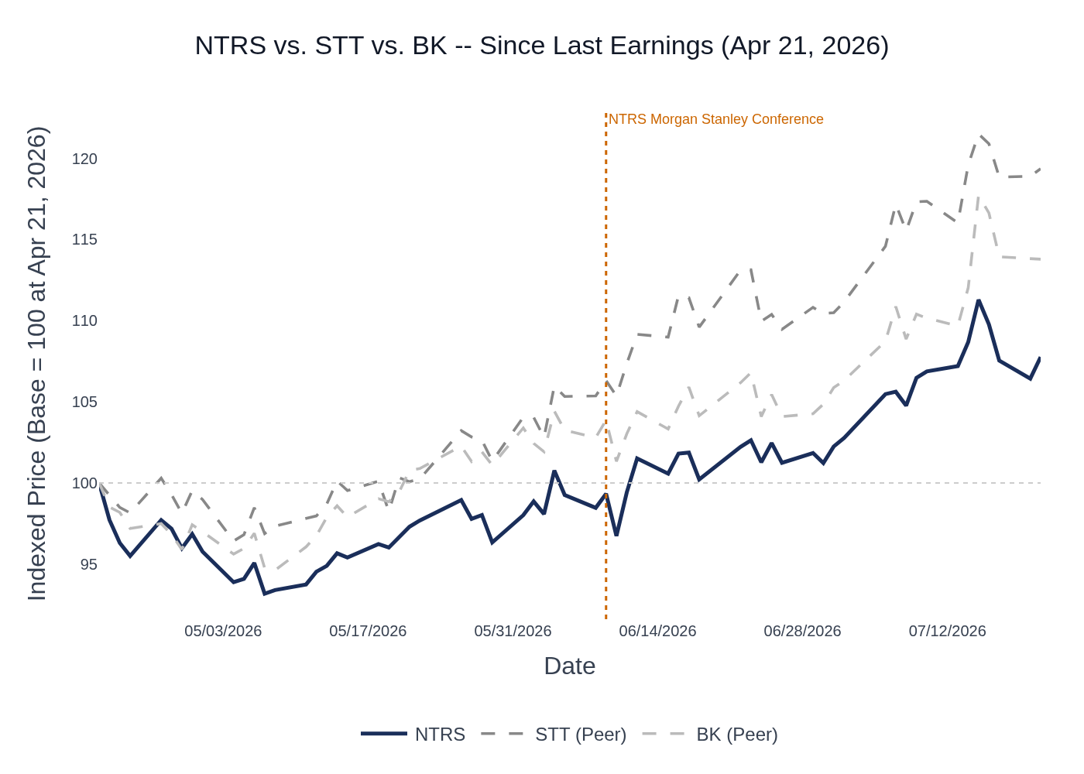
NTRS vs. STT vs. BK — Indexed Price Performance Since Q1 2026 Earnings (April 21, 2026 = 100). Source: Stock Price Data.
NTRS opened the post-earnings period with a strong +8.0% gap-up on April 21 following the Q1 beat, but the stock subsequently gave back a portion of those gains and has traded in a relatively tight range of $160–$177 through late May. The stock began a more sustained re-rating in mid-June, reaching $191 on July 15 before pulling back modestly to $185 as of July 21. The underperformance vs. peers is notable: STT rallied sharply on its own Q2 earnings beat (July 16) and BK surged on its Q2 results (July 15), both reporting record revenues and raising full-year NII guidance — developments that are directly read-through positive for NTRS. The sector ETF (KRE) and broader market tailwinds have also supported the group. NTRS’s relative lag likely reflects the market’s uncertainty around deposit normalization from Q1’s unusually elevated institutional balances, which management guided would partially reverse in Q2. A strong Q2 print that demonstrates NII resilience despite lower average deposits could be the catalyst to close the performance gap with peers.

6. Peer Commentaries — Q2 2026 Read-Throughs
Key Takeaway: Both BK (reported July 15) and STT (reported July 16) delivered record revenues, raised full-year NII guidance, and reported strong operating leverage in Q2 2026 — all directly read-through positive for NTRS heading into its July 22 print; the common themes of elevated deposits, constructive markets, and strong client activity are highly relevant to NTRS’s model.
Note: Only commentary about Q2 2026 (the current reporting quarter) is included below. Q1 2026 earnings call commentary from peers about their own Q1 results is excluded. Pre-earnings conference commentary (BK Morgan Stanley Jun 10, STT Bernstein May 27, STT Morgan Stanley Jun 10) is included where it speaks to Q2 2026 trends or the forward outlook.

BNY Mellon (BK) — Q2 2026 Earnings (Reported July 15, 2026)
Relevance to NTRS: BK is the most direct custody bank peer. Its Q2 results and commentary on NII, deposits, fee revenue, and operating leverage are the highest-quality read-through for NTRS.
- Record revenues & strong operating leverage: BK reported record Q2 revenue of $5.7B (+13% YoY) and ~600bps of positive operating leverage, expanding pre-tax margin to 40% and ROTCE to 31%. This is a strong read-through for NTRS’s own operating leverage trajectory, which consensus expects at ~68% efficiency ratio (vs. 70.7% in Q2 2025).
- NII raised to +12–13% YoY for FY2026: BK raised its full-year NII guidance to +12–13% YoY (from prior guidance), driven by stronger-than-expected deposit balances. Average deposits moderated only 1% sequentially in Q2, far less than feared. This is directly positive for NTRS, which guided to retaining $4–5B of Q1’s $9B deposit surge — if BK’s deposits held better than expected, NTRS’s may have as well.
- Deposit resilience: BK CFO noted that noninterest-bearing deposits held flat sequentially and that deposits "come as a result of client activity" — a structural argument that NTRS management has also made. BK’s 2/3 operational deposit base mirrors NTRS’s institutional deposit mix, suggesting similar resilience.
- Fee revenue momentum: Investment services fees in Asset Servicing were up 12% YoY, driven by higher client activity and market values. ETF AUC reached $4.4T (+35% YoY) and alternatives AUC grew 17% YoY. Strong fee momentum at BK is a positive read-through for NTRS’s trust and servicing fees, where consensus expects +9.8% YoY growth.
- 14th consecutive quarter of YoY sales growth: BK reported two consecutive record sales quarters, with average deal size up >20% YoY. This client activity backdrop is supportive of NTRS’s own organic growth targets (>3% across all segments).
- Q3 seasonality caution: BK flagged that Q3 is "seasonally the slowest quarter" and will be a tough YoY comp for NII and deposits given an unusually strong Q3 2025. This is relevant context for how NTRS may frame its Q3 outlook on the call.
- Pre-earnings (Morgan Stanley Conference, Jun 10): BK CFO McDonogh described Q2 conditions as "dynamic" but "constructive," reaffirmed the 10% YoY NII guide, and noted deposits "moderated slightly into Q2 as expected." He characterized himself as a "risk-adjusted optimist" and highlighted 64% growth in clients buying from 3+ lines of business — a cross-sell metric NTRS also tracks.

State Street (STT) — Q2 2026 Earnings (Reported July 16, 2026)
Relevance to NTRS: STT is a direct custody bank peer with similar institutional client base, AUC/AUM dynamics, and NII sensitivity. Its Q2 results are a strong read-through for NTRS’s fee revenue, NII, and operating leverage.
- Record NII of $860M (+18% YoY): STT reported record NII driven by 17bps NIM expansion to 113bps, with average deposits coming in at ~$270B vs. prior guidance of $250–260B. STT raised its FY2026 NII guidance to +14–15% YoY (from +8–10%). This is a strong positive read-through for NTRS’s NII, where the key question is whether deposits held better than the $4–5B retention guided at Q1.
- Record fee revenue of $3.2B (+16% YoY): STT raised its FY2026 fee revenue growth outlook to +12–13% (from +7–9%), driven by organic growth in servicing and management fees plus healthy client activity in markets. Servicing fees were up 13% YoY with ~7% organic growth. This is directly positive for NTRS’s trust and servicing fee outlook.
- 10th consecutive quarter of positive operating leverage: STT delivered 645bps of positive operating leverage in Q2 and raised its FY2026 operating leverage target to ~500bps (implying ~32% pre-tax margin). This is a strong read-through for NTRS’s own operating leverage trajectory, where consensus expects continued improvement from Q1’s 700bps+ print.
- AUC reached record $57.9T (+18% YoY): Higher period-end market levels, client flows, and net new business drove AUC to a record. AUM also hit a record $6.3T (+23% YoY) with $114B of net inflows. This is positive for NTRS’s AUC/A consensus estimate of ~$35.9T.
- Expenses up 10% YoY but operating leverage still strong: STT’s expense growth of 10% was primarily revenue-related (6ppts) plus strategic investment (2.5ppts). Headcount was down ~3% YoY. This mirrors NTRS’s own expense philosophy where productivity funds investment, and suggests NTRS’s guided expense decline for the remainder of 2026 is achievable.
- Pre-earnings (Morgan Stanley Conference, Jun 10): STT CFO provided explicit Q2 color: revenues tracking "low teens % YoY" (better than expected), NII "a little better than expected," deposits "a little bit north" of the $250–260B range, and operating leverage "400bps or more for the quarter." All of these are positive read-throughs for NTRS.
- Pre-earnings (Bernstein Conference, May 27): STT CEO O’Hanley described the operating environment as "constructive" with "still very strong economic activity" and noted the AI secular boom driving "really strong investment activity across the board." He highlighted 9 consecutive quarters of positive operating leverage and $2B in cumulative productivity savings over 5 years — a comparable transformation story to NTRS’s own productivity-first model.

8. Insider Transaction Activity
Key Takeaway: All open-market sales since Q1 earnings were executed under pre-established 10b5-1 plans — no discretionary selling — and the one open-market purchase (Director Moritz, May 1) is a modestly positive signal; overall insider activity is routine and does not raise any flags.
Name | Title | Transaction Type | Shares | Approx. Value | Date | Note
Moritz, Robert Edward Jr. | Director | Open Market Buy | 225 | ~$36,000 | May 1, 2026 | Discretionary purchase; modestly positive signal from independent director
Bellows, Clive | Co-President, Asset Servicing | Open Market Sale (10b5-1) | 2,800 | ~$459,000 | Apr 24, 2026 | Pre-planned 10b5-1 sale; routine; not discretionary
Fox, David W Jr. | EVP & CFO | Open Market Sale (10b5-1) | 19,987 | ~$3.3M | Apr 28, 2026 | Pre-planned 10b5-1 sale via trust; routine; not discretionary
Fox, David W Jr. | EVP & CFO | Open Market Sale (10b5-1) | 13 | ~$2,100 | Apr 29, 2026 | Pre-planned 10b5-1 sale via trust; small residual tranche; routine
South, Thomas A. | EVP & CIO | Open Market Sale (10b5-1) | N/A (Form 144 — intended sale) | N/A | May 4 & May 22, 2026 | Form 144 notices of intended sale; pre-planned; routine
Hallinan, Aengus | EVP | Open Market Sale (10b5-1) | 3,668 | ~$617,000 | Jun 3, 2026 | Pre-planned 10b5-1 sale; routine; not discretionary
All executive sales since Q1 earnings were executed under pre-established 10b5-1 trading plans, indicating they were scheduled in advance and carry no informational signal about management’s near-term outlook. The one notable open-market purchase was by Director Robert Moritz (225 shares, ~$36K on May 1), which is a modestly positive signal but too small to be directionally meaningful. The absence of any large discretionary sales by senior management — including CEO, President, or other C-suite — is consistent with management’s constructive tone heading into Q2 earnings.
Source: SEC Form 4 filings. Approximate values calculated using stock price on or near transaction date. Director stock awards (transaction code A) excluded as they are compensation grants, not open-market transactions.

