PulteGroup, Inc. (PHM) — Q2 2026 Earnings Preview
Company: PulteGroup, Inc. (PHM) Earnings Date: July 22, 2026 Prepared: July 21, 2026 Reporting Period: Q2 2026 (quarter ended June 30, 2026)

1. Earnings Preview
Key Takeaway: Setup is mixed — consensus is a manageable bar on revenue but the gross margin line is the real swing factor, and DHI's report today (July 21) flagging softer demand and a 20% cancellation rate is the most important pre-print data point for PHM's Q2 orders.
Heading into PHM's Q2 2026 print, the bar looks achievable on revenue (~$3.94B consensus, within the implied guidance range) but the Street is already pricing in some gross margin downside, with consensus at ~23.8% sitting slightly below the guided trough range of 24.1–24.4% — meaning any margin upside surprise would be the most powerful catalyst. Management's tone on the April 23 call was cautiously optimistic: Q2 was explicitly flagged as the gross margin trough for the year, with back-half recovery expected as build-to-order and active adult closings ramp, and full-year guidance was fully reaffirmed across closings (28,500–29,000), ASP ($550–560K), and gross margin (24.5–25.0%, likely lower end). Estimate revisions since the Q1 print have been modest and slightly negative — revenue and EPS both trimmed ~0.3–1.0% from the post-earnings baseline — suggesting the Street has largely digested the incentive headwind without a dramatic reset. The stock has underperformed since Q1 earnings, down ~4.9% vs. the S&P 500 up ~5.6%, trading at roughly 12x NTM EPS — a discount to historical averages — which means the multiple itself is not a headwind and any positive surprise could drive meaningful re-rating. The key wildcard is D.R. Horton's report today: DHI flagged demand softened 'a little softer post our call in April,' cancellation rates rose to 20%, and annual delivery guidance was cut — a cautionary signal for PHM's Q2 net new orders, though PHM's 60% move-up/active adult buyer mix and Florida strength should provide meaningful insulation relative to DHI's more entry-level-heavy book.

2. KPIs & Consensus Expectations
Key Takeaway: Consensus is a manageable bar on revenue and closings, but gross margin is the bigger swing factor — the Street is already pricing in a slight miss vs. guidance, so any upside on the margin line would be the most powerful catalyst. Net new orders (a leading indicator) will be closely watched given DHI's softer demand commentary today.

Table 1 — Q2 2026 Current Quarter Snapshot
KPI | Q1 2026 Actual | Q2 2025 Actual (Prior Year) | Q2 2026 Consensus Est. | YoY Change | Guidance (Q1 Call) | Cons. vs. Guide
Revenue ($B) | $3.41B | $4.40B | $3.94B | -10.5% | $3.62–$3.91B (implied) | +3.5% above midpoint
EPS — Diluted Operating ($) | $1.79 | $3.03 | $2.36 | -22.1% | N/A (explicit) | N/A
Home Sale Gross Margin (%) | 24.4% | ~26.4% | ~23.8% | ~-260 bps | 24.1%–24.4% | -30 bps below midpoint
Closings (units) | 6,102 | 7,639 | 6,994 | -8.4% | 6,700–7,100 | At midpoint
Net New Orders (units) | 8,034 | 7,083 | 7,494 | +5.8% | N/A | N/A
Average Selling Price ($K) | $542K | $559K | $547K | -2.1% | $540–$550K | At midpoint
Avg. Community Count (#) | 1,043 | 994 | 1,039 | +4.5% | 3–5% YoY growth | In range
Order Cancellation Rate (%) | 12.0% | 15.0% | 15.7% | +70 bps | N/A | N/A
Source: Visible Alpha consensus and actuals data; PHM Q1 2026 earnings call (April 23, 2026) for guidance figures.

Table 2 — Beat/Miss History (Last 8 Quarters)

Revenue
Quarter | Reported ($B) | Consensus ($B) | Surprise % | Result
Q2 2024 | $4.60B | $4.50B | +2.2% | Beat
Q3 2024 | $4.48B | $4.30B | +4.2% | Beat
Q4 2024 | $4.92B | $4.66B | +5.6% | Beat
Q1 2025 | $3.89B | $3.84B | +1.3% | Beat
Q2 2025 | $4.40B | $4.39B | +0.3% | Beat
Q3 2025 | $4.40B | $4.31B | +2.1% | Beat
Q4 2025 | $4.61B | $4.37B | +5.5% | Beat
Q1 2026 | $3.41B | $3.39B | +0.5% | Beat

EPS — Diluted Operating
Quarter | Reported ($) | Consensus ($) | Surprise % | Result
Q2 2024 | $3.83 | $3.36 | +14.0% | Beat
Q3 2024 | $3.35 | $3.14 | +6.7% | Beat
Q4 2024 | $3.50 | $3.28 | +6.7% | Beat
Q1 2025 | $2.57 | $2.42 | +6.2% | Beat
Q2 2025 | $3.03 | $2.92 | +3.8% | Beat
Q3 2025 | $2.96 | $2.87 | +3.1% | Beat
Q4 2025 | $2.56 | $2.82 | -9.2% | Miss
Q1 2026 | $1.79 | $1.81 | -1.1% | Miss
Pattern: PHM has beaten revenue consensus for 8 consecutive quarters. EPS beat 6 of 8 but has missed the last 2 as incentive pressure intensified — the bar on EPS is now lower and more realistic heading into Q2 2026. Source: Visible Alpha consensus and actuals data.

3. Guidance & Commentary Evolution
Key Takeaway: No guidance revisions since the April 23 Q1 2026 earnings call — all metrics remain at initial levels. The most notable signal is that full-year gross margin guidance (24.5–25.0%) sits above current consensus (~23.9%), suggesting the Street is skeptical of the back-half BTO-driven recovery. Management tone was cautiously optimistic, with Q2 explicitly flagged as the trough.
Metric | Initial Guidance (Q1 2026 Earnings, Apr 23) | Revised Guidance | Current Consensus | Note
Q2 2026 Closings | 6,700–7,100 homes | — | 6,994 units | Consensus at midpoint of range; no revision
Q2 2026 ASP | $540,000–$550,000 | — | $547K | Consensus at midpoint; incentives expected to remain elevated
Q2 2026 Gross Margin | 24.1%–24.4% (guided as 2026 trough) | — | ~23.8% | Consensus ~30 bps below midpoint; Street pricing in downside risk
FY 2026 Closings | 28,500–29,000 homes | — | 28,737 units | Consensus at low end of range
FY 2026 ASP | $550,000–$560,000 | — | $554K | Consensus below midpoint; incentive pressure persists
FY 2026 Gross Margin | 24.5%–25.0% (likely lower end) | — | ~23.9% | Consensus below guidance range; back-half recovery dependent on BTO mix shift
FY 2026 SG&A (% of revenues) | 9.5%–9.7% | — | ~9.4% | Consensus slightly below guidance; operating leverage expected as revenues recover
FY 2026 Land Spend | $5.4B | — | N/A | No revision since Q1 earnings; supports community count growth of 3–5%
Note: No post-earnings guidance revisions or 8-K updates since the April 23, 2026 earnings call. All guidance figures sourced from PHM Q1 2026 earnings call transcript.

4. Guidance vs. Estimate Revision Tracker
Key Takeaway: Estimates have been modestly trimmed since the Q1 print — revenue and EPS both down ~0.3–1.0% from the post-earnings baseline — a contained revision cycle. The more important gap is FY 2026 gross margin consensus (~23.9%) sitting below the guided range (24.5–25.0%), which means the Street is not giving management credit for the back-half BTO recovery. If Q2 margin comes in at or above the guided trough, that gap could close and drive upward revisions.
KPI / Period | Estimate (Apr 28, 2026) | Current Consensus | Estimate Δ (%) | Initial Guidance (Apr 23) | Current Guidance | Guidance Δ | Cons. vs. Guide (%)
Revenue — Q2 2026 | $3.954B | $3.941B | -0.3% | $3.62–$3.91B (implied) | Unchanged | — | +1.6% above midpoint
Revenue — FY 2026 | $16.466B | $16.435B | -0.2% | N/A (explicit) | N/A | — | N/A
EPS Diluted Operating — Q2 2026 | $2.387 | $2.363 | -1.0% | N/A (explicit) | N/A | — | N/A
EPS Diluted Operating — FY 2026 | $10.099 | $10.034 | -0.6% | N/A (explicit) | N/A | — | N/A
Home Sale Gross Margin — Q2 2026 | N/A | ~23.8% | N/A | 24.1%–24.4% | Unchanged | — | ~-40 bps below midpoint
Source: Visible Alpha consensus and actuals data. Apr 28, 2026 = 5 trading days post Q1 2026 earnings (Apr 23, 2026), representing the clean post-print baseline before revisions.

5. Stock Performance
Key Takeaway: PHM has underperformed both the homebuilder ETF (XHB) and the S&P 500 since Q1 earnings, driven by multiple compression on incentive/margin concerns rather than estimate revisions. The late-June recovery (+14% from trough to peak) was peer-driven — LEN and KBH earnings provided positive read-throughs — but the stock has since given back some of those gains ahead of the Q2 print.
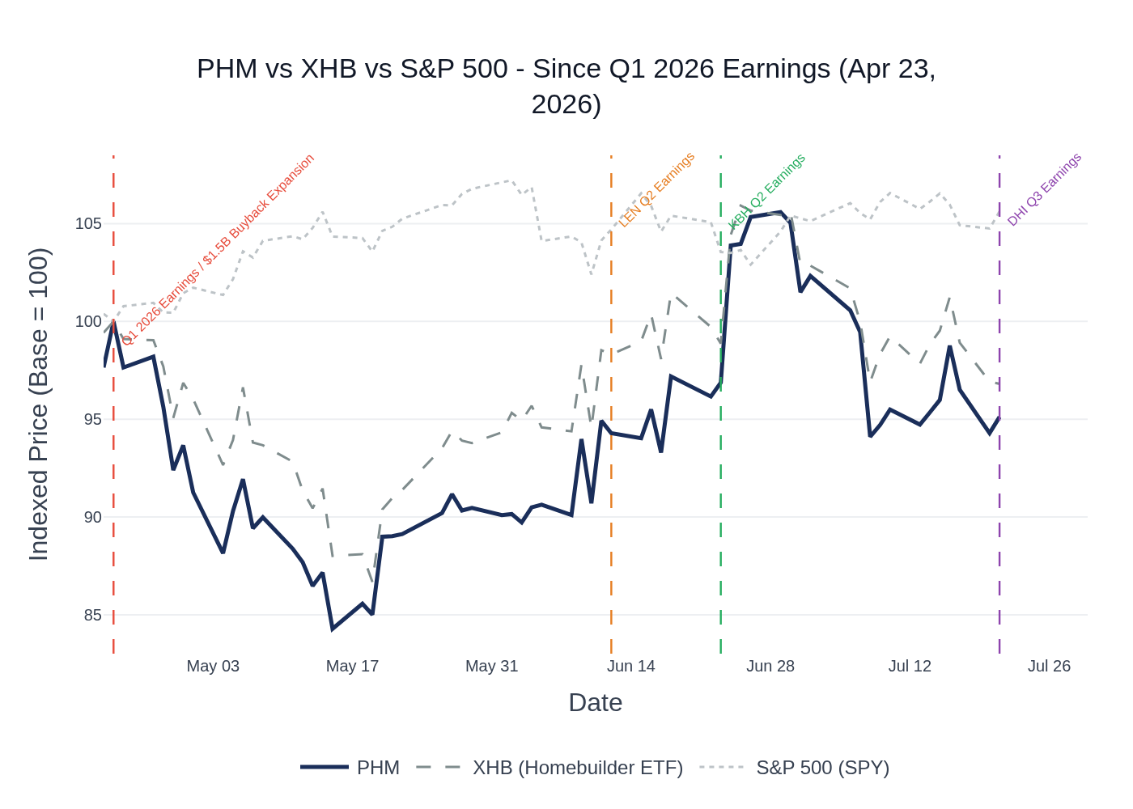
PHM vs. XHB (Homebuilder ETF) vs. S&P 500 (SPY) — Indexed to 100 at Q1 2026 Earnings (Apr 23, 2026). Source: Yahoo Finance / Stock Price Data.
PHM sold off sharply post-Q1 earnings through mid-May, bottoming around $110 (indexed ~84) on May 15 as macro concerns, elevated incentive commentary, and the EPS miss weighed on the sector — underperforming XHB by roughly 5 points during this leg. The stock recovered meaningfully in late June following positive read-throughs from Lennar (June 12) and KB Home (June 23) earnings, briefly touching ~$137 before pulling back. PHM currently trades at ~$124, roughly flat to its post-earnings close of $130.64, and has underperformed the S&P 500 by approximately 10 percentage points since Q1 earnings. The stock trades at approximately 12x NTM EPS, a discount to its 3-year average and well below the broader market, suggesting the multiple itself is not a headwind and any positive surprise could drive meaningful re-rating. Analyst sentiment remains constructive: Barclays boosted its target to $123 (Equal Weight, July 14); Wells Fargo boosted to $150 (Overweight, July 6); UBS at $162 (Buy); consensus average target ~$142, implying ~15% upside from current levels. Sector ETF used: XHB (SPDR S&P Homebuilders ETF), which tracks the S&P Homebuilders Select Industry Index and is the most widely used benchmark for the residential construction sub-sector.

6. Peer Commentaries Read-Through (Last 60 Days — Q2 2026 Relevant)
Key Takeaway: Three major peers reported in the last 60 days with mixed-to-cautious signals for PHM's Q2. LEN and KBH showed improving incentive trends and stable demand, while DHI (reported today, July 21) flagged softer demand post-April and a 20% cancellation rate — the most direct and timely read-through for PHM's Q2 net new orders. PHM's higher-end buyer mix provides partial insulation, but the macro backdrop is clearly more challenging than the Q1 call implied.

D.R. Horton (DHI) — Q3 FY2026 Earnings (Reported July 21, 2026 — TODAY)
Relevance: Most direct and timely read-through. DHI is the largest U.S. homebuilder by volume with significant overlap in geographies (Florida, Southeast, Texas, Midwest). Reported this morning, July 21, 2026.
- Demand softened post-April: Sales were 'a little softer post our call in April,' below internal expectations, driving a reduction in annual delivery guidance. Management noted buyers need to 'be a little more confident in the overall economy.'
- Cancellation rate rose to 20%: Up from 17% YoY and 16% sequentially, driven by market softening mid-quarter and in the later part of the quarter. Primary reason remains 'largely qualification' and 'lack of confidence' among buyers. Exit rate still 'within normal historical range.'
- Incentives remain elevated: Average buy-down decreased slightly to 1.6% from 1.7% in Q2; mortgage rate for backlog buyers at 4.9% vs. market rate of ~6.5%. DHI expects 'incentives to remain elevated relative to historical levels.'
- Gross margin beat: Q3 home sales gross margin of 20.7% beat the high end of guidance, driven by lower stick-and-brick costs and slightly lower incentives. Q4 guided at 20.5–21%, 'relatively flat' sequentially. Margin beat driven by cost reduction efforts, not pricing power.
- Regional color: North (Mid-Atlantic, Ohio Valley, Midwest) showing relative strength; Northwest (especially Seattle) weaker due to software job shifts and layoffs; Florida and Southeast 'performing pretty consistently.'
- PHM Read-Through: Softer demand and higher cancellation rates at DHI are a cautionary signal for PHM's Q2 net new orders. However, PHM's 60% move-up/active adult buyer mix (vs. DHI's more entry-level focus) should provide meaningful insulation. PHM's Florida strength (orders up 18% in Q1) aligns with DHI's Florida commentary. Cost reduction driving margin beats is a positive read-through for PHM's own cost savings narrative.

Lennar (LEN) — Q2 FY2026 Earnings (Reported June 12, 2026)
Relevance: Second-largest U.S. homebuilder; broad geographic overlap. Reported June 12, covering the April–May 2026 period — directly overlapping with PHM's Q2 2026.
- Incentives declining for the first time in three years: Incentive rate on deliveries fell to 12.9% in Q2, down from 14.1% in Q1 and 14.5% in Q4 2025. CEO Stuart Miller called this 'starting to look like a trend' and 'our own incentives are slowly declining for the first time in three years.' LEN did not guide to further Q3 incentive declines, noting they've 'taken some pressure off of pushing into the market.'
- Demand remains 'choppy': Traffic is 'inconsistent, intent is high, but urgency to close is still measured and deliberate rather than confident and energized.' Mortgage rates 'remained stubbornly elevated in the mid to upper 6% range'; 30-year fixed at 6.4–6.5%; Fed 'off the table as a near-term source of relief.'
- Inflation picture more complicated: May CPI at 4.2% YoY (highest since early 2023), driven by energy (gasoline +40% YoY due to Iran conflict). Higher energy prices 'tend to depress consumer confidence.'
- Annual delivery guidance cut: Adjusted to 82,000–83,000 homes 'given current pressures on interest rates and continued macro uncertainty.' Completed unsold homes reduced from 3 per community to 2.1 per community ('kind of our comfort zone').
- PHM Read-Through: LEN's declining incentive trend is a positive read-through for PHM's gross margin trajectory and supports management's thesis that incentives can come down via mix shift. However, LEN's guidance cut and 'choppy' demand characterization suggest the macro backdrop for PHM's Q2 orders may be softer than the Q1 2026 earnings call implied. PHM's higher ASP and BTO mix shift should provide margin support LEN doesn't have at its price point.

KB Home (KBH) — Q2 FY2026 Earnings (Reported June 23, 2026)
Relevance: Mid-size builder with strong BTO model focus; geographic overlap in California, Texas, Southeast. Reported June 23, covering the March–May 2026 period.
- Steady order pace through June: Absorption rate of 4 net orders per month. Management noted 'in June, we are not seeing any surprising changes from how things trended in the second quarter' — order pace 'steady and tracking in line with expectations.' BTO mix continues to build as a percentage of orders.
- Stable cancellation rate: Attributed to 'high-quality, committed buyers who are able to close on their homes' — a contrast to DHI's rising cancellation rate and a positive signal for builders with higher-end buyer profiles like PHM.
- BTO margin premium confirmed: BTO homes carry ~400 bps gross margin premium over spec homes, consistent for 'the better part of two years.' Q3 housing gross margin guided at 16.0–16.6%; full year 16.1–16.5%; sequential improvement expected driven by BTO mix shift and West Coast mix.
- Land market easing: Sellers 'starting to come to terms with the reality of the current market' — better terms, some price reductions, less competition. Consistent with PHM's Q1 observations on land price stabilization.
- PHM Read-Through: KBH's stable cancellation rate and steady order pace through June are modestly positive for PHM. The BTO margin premium thesis aligns directly with PHM's own BTO shift strategy (targeting 60% BTO by Q1 2027). Land price easing commentary supports the medium-term margin recovery thesis, though the P&L benefit won't materialize until 2027–2028 given the 18–24 month lag.

7. Material News & Developments
Key Takeaway: The most important development since Q1 earnings is DHI's report today (July 21) flagging softer demand and higher cancellations — a direct read-through for PHM's Q2 orders. The $1.5B buyback expansion announced alongside Q1 earnings signals management confidence in the balance sheet and provides a floor for the stock.
- July 21, 2026 — DHI Q3 FY2026 Earnings (TODAY): D.R. Horton reported demand softened 'a little softer post our call in April,' cancellation rate rose to 20%, and annual delivery guidance was cut. Most direct peer read-through for PHM's Q2 2026 results. Implication: Cautionary signal for PHM's Q2 net new orders; PHM's higher-end buyer mix provides partial insulation.
- June 23, 2026 — KBH Q2 FY2026 Earnings: KB Home reported stable cancellation rates, steady order pace through June, and sequential gross margin improvement guided. Implication: Modestly positive read-through for PHM's demand environment and BTO margin thesis.
- June 12, 2026 — LEN Q2 FY2026 Earnings: Lennar reported incentive rates declining for the first time in three years (12.9% vs. 14.1% in Q1). Annual delivery guidance cut to 82–83K homes. Implication: Declining incentive trend is positive for PHM's gross margin trajectory; guidance cut reflects ongoing macro headwinds.
- July 14, 2026 — Analyst Target Changes: Barclays boosted PHM price target to $123 (from $112), maintaining Equal Weight. July 6: Wells Fargo boosted to $150 (from $140), maintaining Overweight. April 24: UBS boosted to $162 (from $159, Buy); Evercore boosted to $151 (from $146, Outperform); Goldman Sachs boosted to $142 (from $133, Neutral). Implication: Post-Q1 earnings, most analysts raised targets despite the EPS miss, reflecting confidence in full-year guidance reaffirmation; consensus average target ~$142 implies ~15% upside.
- April 23, 2026 — $1.5B Share Repurchase Authorization Expansion: PulteGroup expanded its share repurchase authorization by $1.5 billion, announced alongside Q1 2026 earnings. Implication: Strong balance sheet signal; management confidence in ~$1B FY2026 cash generation; provides a floor for the stock at depressed levels.
- May 1, 2026 — Annual Meeting: Shareholders approved all board nominees, auditors, and executive pay. Routine governance event; no material implication.
- May 21, 2026 — Q2 2026 Earnings Date Announcement: PHM confirmed Q2 2026 earnings release and webcast scheduled for July 22, 2026. Confirms reporting date.
- Macro — Mortgage Rates & Inflation: 30-year mortgage rates remain in the 6.4–6.5% range (per LEN June 12 commentary); May CPI at 4.2% YoY (highest since early 2023) driven by energy (gasoline +40% YoY due to Iran conflict); Fed funds rate at 3.5–3.75% with little probability of near-term cut. Implication: Affordability headwinds persist; PHM's rate buy-down programs remain critical to demand; no near-term macro tailwind expected.

8. Insider Transaction Activity
Key Takeaway: No open-market buys since Q1 earnings. The only discretionary open-market sale was by COO Matthew Koart (7,457 shares on May 27) — a modest discretionary sale with no 10b5-1 plan indicated. Director Lila Snyder also sold 3,339 shares on May 8. The absence of insider buying at depressed prices (stock hit ~$110 in mid-May) is worth noting, though the overall activity level is low and not alarming.
Name | Title | Transaction Type | Shares | Date | Note
Kevin A. Henry | EVP & Chief People Officer | Tax Withholding (F) | 2,093 | Jun 22, 2026 | Routine tax withholding on vesting; not discretionary
Matthew William Koart | EVP & COO | Open Market Sale | 7,457 | May 27, 2026 | Discretionary open-market sale; no 10b5-1 plan indicated
Matthew William Koart | EVP & COO | Tax Withholding (F) | 6,861 | May 18, 2026 | Routine tax withholding on vesting; not discretionary
Lila Snyder | Director | Open Market Sale | 3,339 | May 8, 2026 | Discretionary open-market sale; no 10b5-1 plan indicated
Multiple Directors (8) | Board of Directors | Annual Equity Grant (A) | 1,507 each | Apr 29, 2026 | Routine annual director compensation grants; not discretionary
Source: SEC Form 4 filings. Open-market buys (code P) and sells (code S) only, plus tax withholding (code F) and equity grants (code A) for context. No 10b5-1 plan initiations disclosed in the period.

