Rollins, Inc. (ROL) — Q2 2026 Earnings Preview
Company | Rollins, Inc.
Ticker | ROL (NYSE)
Reporting Period | Q2 2026 (quarter ending June 30, 2026)
Earnings Date | July 23, 2026 — 8:30 AM ET
Prepared | July 21, 2026
Sector / Industry | Consumer Staples / Pest Control & Facility Services

1. Earnings Preview
Key Takeaway: The setup into Q2 is a moderate beat on revenue with organic growth likely landing at or above the 7% threshold, but the bar on margins and EPS is tighter given elevated insurance/claims costs and CFO transition uncertainty; the single biggest swing factor is whether peak-season volume acceleration in June is enough to offset the April–May choppiness management flagged at the June conferences.
Heading into the Q2 2026 print, the bar for Rollins is achievable but not easy. Consensus sits at roughly $1.09B in revenue (approximately +9% total, ~7% organic) and $0.34 adjusted EPS — both broadly consistent with management’s full-year 7–8% organic growth and 25–30% incremental margin guidance. The tone from management has been cautiously constructive: at the June 4 Baird conference and June 3 William Blair conference, the new CFO Will Harkins explicitly reaffirmed all financial targets and characterized the CFO transition as seamless, but also acknowledged continued choppiness in April and into May, with peak summer months cited as the key recovery catalyst. Estimate revisions have been modestly negative since the Q1 print — the Q2 adjusted EPS consensus has drifted from ~$0.34 to ~$0.34 (essentially flat), while the stock has fallen roughly 21% since last earnings, almost entirely driven by multiple compression (NTM EV/EBITDA from ~27.7x to ~22.2x) rather than estimate cuts, suggesting the market is discounting execution risk on the margin story rather than pricing in a fundamental demand deterioration. The stock is now trading near 52-week lows at ~$44, offering a more attractive entry if management can demonstrate that June’s peak-season acceleration is real and that insurance/claims costs are moderating. The wildcard is the insurance and claims line: at 3.7% of sales in Q1 vs. a 2.9% full-year 2025 rate, any further elevation would pressure gross margins and incremental margins below the 25–30% target, while a normalization toward 3.0–3.2% would be a meaningful positive surprise.

2. KPIs & Consensus Expectations
Key Takeaway: Consensus is a moderate bar — 7% organic growth is achievable given the strong March exit rate, but the bigger swing factor is gross margin and incremental margin, where insurance/claims costs and fleet gains remain volatile headwinds. Revenue is the more predictable beat candidate; EPS is the higher-risk line.

Table 1 — Q2 2026 Current Quarter Snapshot (All Key KPIs)
KPI | Q1 2026 Actual | Q2 2025 Actual (Prior Year) | Q2 2026 Consensus Estimate | YoY Change | Guidance | Consensus vs. Guidance
Revenue ($M) | $906.4M | $999.5M | $1,092.7M | +9.3% | 7–8% organic + 2–3% M&A | ~In line with midpoint
Organic Revenue Growth (%) | 6.6% | 7.3% | 7.0% | -30 bps YoY | 7–8% full year | At low end of range
Adjusted Operating Income ($M) | $152.8M | $205.9M | $227.0M | +10.2% | 25–30% incrementals | ~In line
Adjusted EPS (Diluted) | $0.24 | $0.30 | $0.34 | +13.3% | No specific Q2 guide | N/A
Free Cash Flow ($M) | $111.2M | $168.0M | $224.6M | +33.7% | >100% FCF conversion | Above guidance threshold
Source: Visible Alpha Consensus and Actuals Data. All consensus figures as of July 21, 2026.

Table 2 — Beat/Miss History (Last 8 Quarters)

Top KPI #1: Revenue
Quarter | Reported ($M) | Consensus ($M) | Surprise % | Result
Q2 2024 | $919.2M | $897.4M | +2.4% | Beat
Q3 2024 | $916.3M | $912.0M | +0.5% | Beat
Q4 2024 | $832.2M | $819.3M | +1.6% | Beat
Q1 2025 | $822.5M | $820.0M | +0.3% | Beat
Q2 2025 | $999.5M | $989.0M | +1.1% | Beat
Q3 2025 | $1,026.1M | $1,022.1M | +0.4% | Beat
Q4 2025 | $912.9M | $927.7M | -1.6% | Miss
Q1 2026 | $906.4M | $896.1M | +1.1% | Beat

Top KPI #2: Adjusted EPS (Diluted)
Quarter | Reported ($) | Consensus ($) | Surprise % | Result
Q2 2024 | $0.27 | $0.27 | +1.4% | Beat
Q3 2024 | $0.29 | $0.30 | -3.5% | Miss
Q4 2024 | $0.23 | $0.23 | -0.2% | In Line
Q1 2025 | $0.22 | $0.22 | +0.2% | In Line
Q2 2025 | $0.30 | $0.30 | -0.3% | In Line
Q3 2025 | $0.35 | $0.33 | +6.2% | Beat
Q4 2025 | $0.25 | $0.27 | -7.4% | Miss
Q1 2026 | $0.24 | $0.24 | +1.1% | In Line
Source: Visible Alpha Consensus and Actuals Data.
Pattern: Revenue has beaten consensus in 7 of the last 8 quarters, with the sole miss in Q4 2025 driven by weather-related disruption to one-time services. Adjusted EPS has been more volatile — two misses in the last four quarters (Q3 2024 and Q4 2025) — reflecting the sensitivity of the margin line to insurance/claims costs and fleet gains. The Q2 setup favors a revenue beat; EPS is the tighter call.

3. Guidance & Commentary Evolution
Key Takeaway: Management has held all financial targets unchanged since the Q1 2026 earnings call, but the tone has shifted modestly more cautious on near-term organic growth (acknowledging April–May choppiness) while remaining confident in the full-year 7–8% target on the basis that peak summer months are ahead. The CFO transition is the most significant post-earnings development and has been explicitly framed as non-disruptive to strategy or targets.
Metric | Initial Guidance (Q1 2026 Earnings Call, Apr 23) | Revised Guidance | Current Consensus | Note
Organic Revenue Growth (FY2026) | 7–8% | — | ~7.2% | Reaffirmed at Baird (Jun 4) and William Blair (Jun 3) conferences; management noted April–May choppiness but cited peak summer months as recovery catalyst
M&A Revenue Contribution (FY2026) | 2–3% | — | ~2.5% | Reaffirmed; Romex acquisition (Apr 2026) supports the range
Incremental Margins — Near Term (FY2026) | 25–30% | — | ~25–28% implied | Reaffirmed; insurance/claims headwind acknowledged as persistent near-term pressure; improvement expected in H2 2026
Incremental Margins — Medium Term | 30–35% | — | N/A (multi-year target) | Reaffirmed at Investor Day (May 14) and June conferences; commercial productivity ramp in 2027 cited as key driver
Free Cash Flow Conversion (FY2026) | >100% | — | ~100%+ | Reaffirmed; no change
Effective Tax Rate (FY2026) | <25% (~100 bps improvement YoY) | — | ~24–25% | Reaffirmed; tax optimization cited as a tangible, durable lever
Pricing Contribution (FY2026) | 3–4% (CPI-plus) | — | ~3–4% | Reaffirmed; CPI in 2–3% range; management expects to be positive on price/cost for the year

4. Guidance vs. Estimate Revision Tracker
Key Takeaway: Estimates for Q2 2026 and FY2026 have been essentially flat since the Q1 print — a slight negative drift of ~0.5–1% on EPS — suggesting the street has absorbed the CFO transition and April–May choppiness without materially cutting numbers. The gap between consensus and guidance is narrow, leaving little cushion if peak-season volume disappoints.
KPI (Period) | Estimate ~5 Days Post Q1 Earnings (Apr 29, 2026) | Current Consensus (Jul 21, 2026) | Estimate Δ (%) | Initial Guidance (Q1 Call) | Current Guidance | Guidance Δ | Consensus vs. Guidance (%)
Revenue — Q2 2026 | $1,093.7M | $1,092.7M | -0.1% | 7–8% organic + 2–3% M&A | Unchanged | — | ~At midpoint
Revenue — FY2026 | $4,124.5M | $4,123.3M | -0.0% | 7–8% organic + 2–3% M&A | Unchanged | — | ~At midpoint
Organic Growth % — Q2 2026 | 7.1% | 7.0% | -10 bps | 7–8% full year | Unchanged | — | At low end
Adj. EPS — Q2 2026 | $0.340 | $0.335 | -1.5% | No specific Q2 guide | N/A | — | N/A
Adj. EPS — FY2026 | $1.243 | $1.243 | 0.0% | No specific FY EPS guide | N/A | — | N/A
Adj. Operating Income — Q2 2026 | $226.5M | $227.0M | +0.2% | 25–30% incrementals | Unchanged | — | ~In line
FCF — FY2026 | $719.0M | $715.8M | -0.4% | >100% conversion | Unchanged | — | Above threshold
Source: Visible Alpha Consensus and Actuals Data. Post-earnings baseline as of April 29, 2026 (5 trading days after Q1 2026 earnings release on April 22, 2026).
The near-zero revision in revenue and FY EPS estimates since the Q1 print is notable: despite the CFO departure announcement (May 26), the Bernstein downgrade, and management’s explicit acknowledgment of April–May choppiness, the street has not cut numbers. This suggests analysts are giving management the benefit of the doubt on the peak-season recovery thesis — but it also means there is limited cushion if Q2 organic growth comes in below 7%.

5. Stock Performance
Key Takeaway: ROL has fallen ~21% since Q1 earnings (April 22, 2026), dramatically underperforming both XLP (-2%) and the S&P 500 (+5%). The decline is almost entirely multiple compression — NTM EV/EBITDA has contracted from ~27.7x to ~22.2x — driven by the CFO departure announcement and market skepticism about the margin improvement thesis under new leadership, not by estimate cuts.
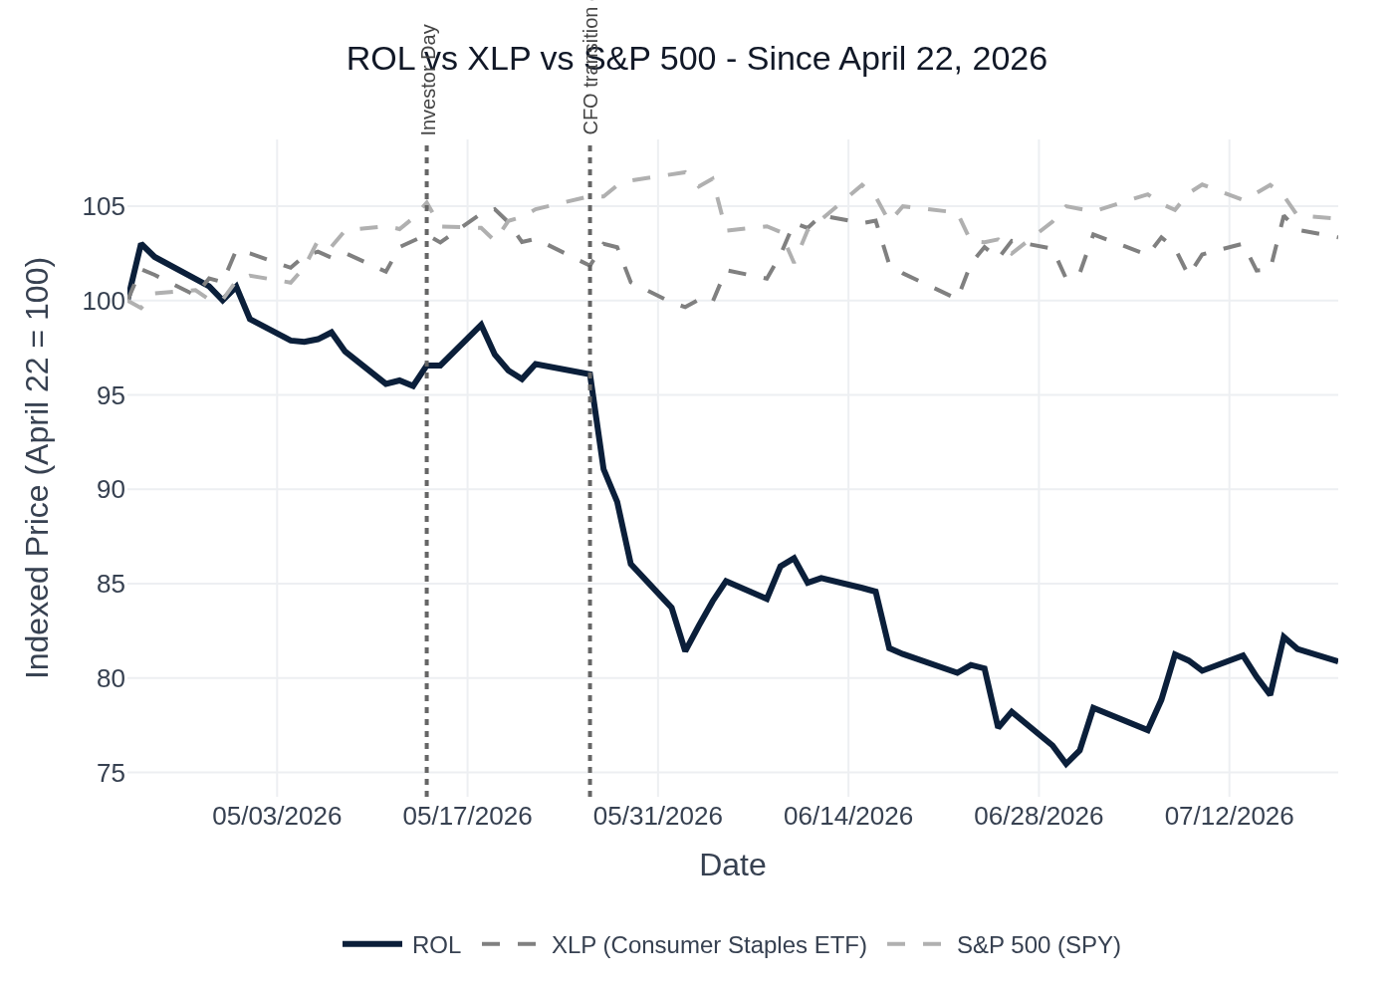
ROL vs. XLP (Consumer Staples ETF) vs. S&P 500 — Indexed to 100 at Q1 2026 Earnings (April 22, 2026). Source: Yahoo Finance / Stock Price Data.
The chart above illustrates the sharp divergence between ROL and both benchmarks. Three distinct phases are visible: (1) a brief post-Q1 relief rally through early May as the strong March exit rate was digested positively; (2) a sharp ~15–20% selloff in late May following the CFO resignation announcement on May 26, which triggered a Bernstein downgrade and drove the stock to new 52-week lows; and (3) a partial stabilization in June–July as management reiterated targets at the Baird and William Blair conferences, though the stock has not recovered meaningfully. XLP was essentially flat over the period, and the S&P 500 gained approximately 5%, making ROL’s underperformance almost entirely idiosyncratic. The NTM P/E has compressed from ~42.7x to ~33.8x over the same period, and NTM EV/EBITDA from ~27.7x to ~22.2x — both now below the 3-year average, suggesting the market is pricing in execution risk rather than a fundamental demand deterioration.

6. Material News & Developments
Key Takeaway: The CFO departure (May 26) is the most consequential post-Q1 development and the primary driver of the stock’s underperformance; management’s explicit reaffirmation of all targets at June conferences is the key counterpoint, and the Q2 print will be the first real test of continuity under new CFO Will Harkins.
- May 26, 2026 — CFO Ken Krause Resignation (8-K): Rollins filed an 8-K disclosing Krause’s resignation effective June 15, 2026, to join a pre-IPO AI data center company. Chief Accounting Officer Will Harkins (joined March 2025, background at Mohawk Industries and Coca-Cola) was named successor CFO. Krause will provide advisory services through September 30, 2026. Implication: Triggered a Bernstein downgrade (Outperform → Market Perform) on concerns that Krause was the architect of the margin transformation story. Stock fell ~15–20% in the week following the announcement, reaching new 52-week lows.
- April 2026 — Romex Pest Control Acquisition: Rollins completed the acquisition of Romex Pest Control, a top-40 pest management company per PCT rankings, providing entry into new markets. Implication: Supports the 2–3% M&A revenue contribution guidance for FY2026; consistent with the company’s disciplined tuck-in M&A strategy.
- May 14, 2026 — Investor and Analyst Day (NYSE): Management formally presented the “Rollins Way” modernization program, quantifying gross margin upside from technician turnover improvement ($15–20M annually / 30–40 bps), procurement centralization ($10M / 15–25 bps), and fleet optimization. SG&A opportunity from systems modernization characterized as “several hundred basis points over time.” Organic growth through first four months of 2026 disclosed at ~6.5–7%. Implication: Provided the most detailed sizing of the margin improvement thesis to date; broadly positive but did not change near-term estimates.
- June 3–4, 2026 — William Blair and Baird Conferences: New CFO Will Harkins presented alongside CEO Jerry Gahlhoff. Key messages: (1) no change to strategy or financial targets; (2) April–May organic growth choppiness acknowledged; (3) peak summer months cited as recovery catalyst; (4) one-time ancillary services (exclusion, insulation) showing consumer-driven softness; (5) RAC financing being expanded across brands to support high-ticket purchases. Implication: Partially reassured the market on CFO transition continuity, but the explicit acknowledgment of April–May weakness kept the stock under pressure.
- July 8, 2026 — Q2 2026 Earnings Date Announcement: Rollins confirmed Q2 2026 results will be released July 23, 2026, with an 8:30 AM ET earnings call. No pre-announcement or guidance update was included. Implication: Absence of a pre-announcement is modestly positive — no negative surprise was flagged ahead of the print.
- Ongoing — Insurance & Claims Cost Elevation: Insurance and claims ran at 3.7% of sales in Q1 2026 vs. 2.9% in full-year 2025 and 3.2% in 2024. Management attributed the elevation to post-COVID vintage claims still maturing and elevated insurance market costs. Lead indicators (accident/injury frequency rates) are improving but the full benefit will take several years. Implication: Key margin wildcard for Q2; any moderation toward 3.0–3.2% would be a meaningful positive; further elevation would pressure incremental margins below the 25–30% target.
- Ongoing — Digital Channel / AI Impact on Lead Generation: Management acknowledged for the first time that AI-driven search changes have impacted lead volumes, while framing the net effect as not entirely negative (higher lead quality, better close rates). Rollins’ multi-channel customer acquisition (door-to-door, real estate inspections, homebuilder channel) cited as a structural differentiator. Implication: Modest headwind to one-time residential services; recurring base largely unaffected.

7. Peer Commentary & Current-Quarter Read-Throughs
Key Takeaway: The only qualified peer read-through from the last 60 days with direct relevance to Rollins’ Q2 2026 reporting period is Ecolab’s June 2, 2026 William Blair conference commentary, which discussed Ecolab’s then-current Q2 2026 quarter. Ecolab’s pest segment is performing within long-term targets, and the company’s broader commentary on pricing power, margin recovery, and resilient commercial demand in essential services is directionally positive for Rollins. Rollins’ own June 3–4 conference commentary (Baird and William Blair) is the most direct source of current-quarter color and is covered in Section 6.
Methodology Note: Per the user’s instruction, this section includes ONLY peer commentary made in the last 60 days (since approximately May 21, 2026) that discusses the peer’s then-current reporting quarter (Q2 2026) or forward outlook. Commentary from prior earnings calls about prior reported quarters is excluded. Rollins’ own management commentary at the June 3–4 conferences is treated as primary source material (covered in Sections 3 and 6) rather than a “peer” read-through.

Ecolab (ECL) — William Blair Growth Stock Conference, June 2, 2026
Relevance: Ecolab operates a dedicated Pest Elimination segment that competes directly with Rollins in commercial pest control. Ecolab’s June 2 commentary was made mid-Q2 2026 (Ecolab’s Q2 ends June 30, same as Rollins), making it a genuine current-quarter read-through. Ecolab is a larger, more diversified company (institutional cleaning, water treatment, food safety), so the read-through is partial — most relevant for commercial pest demand, pricing dynamics, and margin trajectory in essential commercial services.

Key Quotes & Read-Through Analysis
Theme | Ecolab Commentary (Jun 2, 2026) | Read-Through for ROL | Signal
Pest Segment Demand | “In Pest, we’re performing within our long-term sales target and have a long runway as we scale our Pest intelligence platform.” Pest is one of Ecolab’s “growth engines” representing ~1/4 of the company and “growing faster than the enterprise with margins accretive to Ecolab.” | Positive: Ecolab’s commercial pest segment is on-track mid-Q2, consistent with Rollins’ own characterization of commercial as resilient and growing. Supports the view that commercial pest demand is not deteriorating. | Positive
Pricing Power in Essential Services | “In the second half of this year, we expect organic sales growth to accelerate to 6% to 7%, with pricing roughly 2x the inflationary headwinds, helping to quickly stabilize gross margins.” Ecolab launched an energy surcharge in April 2026 and raised Q2 EPS guidance from 7–12% to 9–12% growth. | Positive: Demonstrates that essential commercial service providers retain pricing power even in a choppy macro environment. Rollins’ CPI-plus pricing model (3–4% contribution) appears similarly durable. Ecolab’s raised Q2 guidance is a positive read-through for commercial services broadly. | Positive
Gross Margin Trajectory | “We expect gross margins to stabilize as we exit Q2” and “organic gross margin expands 75 basis points” in H2 2026. Ecolab expects to be “fully offsetting the impact of commodity costs and earnings and margins in just a few quarters.” | Modestly Positive: Ecolab’s margin stabilization narrative in Q2 is consistent with Rollins’ expectation of improving margins through peak season. However, Rollins’ margin headwinds (insurance/claims, fleet gains) are company-specific and not directly read-through from Ecolab’s commodity/energy cost dynamics. | Modestly Positive
Resilient Business Model / Recurring Revenue | “More than 90% of our revenue comes from consumable products that are mission-critical to our customers” — creating a “very resilient model.” | Positive: Validates the recurring, essential-service model that Rollins also operates (~75% recurring revenue). Supports the thesis that the recurring base is insulated from consumer softness even as one-time services face pressure. | Positive
Technology / IoT in Pest Control | Ecolab’s “Pest Intelligence” platform shifts from “95% of time checking empty traps” to “95% of time solving customer problems,” delivering “nearly 90% Pest-free locations vs. industry average in the low 90s.” | Neutral / Watch: Ecolab’s technology-driven differentiation in commercial pest is a competitive dynamic to monitor. Rollins is deploying IoT/remote monitoring in commercial accounts (particularly data centers) but has been a later adopter. Near-term, this is not a material headwind to Rollins’ Q2 results. | Neutral
Overall Read-Through Assessment: Ecolab’s June 2 commentary is the most directly relevant qualified peer read-through available for Rollins’ Q2 2026 print. The signal is net positive: commercial pest demand is on-track, pricing power in essential services is intact, and the recurring-revenue model is proving resilient. The primary limitation is that Ecolab’s pest business is predominantly commercial and technology-forward, while Rollins’ Q2 swing factors (insurance/claims costs, one-time residential ancillary softness, CFO transition) are largely company-specific and not read-through from Ecolab.
Peers Not Qualifying: No other pest control or home services peers (ServiceMaster, Rentokil, Anticimex) reported or presented at conferences in the last 60 days with commentary specifically about their Q2 2026 current-quarter performance. Rollins’ own management commentary at the June 3–4 Baird and William Blair conferences is the most direct source of current-quarter color and is covered in Sections 3 and 6 above.

8. Insider Transaction Activity
Key Takeaway: No open-market insider purchases or discretionary sales were identified in the SEC Form 4 database for ROL in the period since the Q1 2026 earnings release (April 22, 2026 through July 21, 2026). The absence of insider buying following a ~21% stock decline is notable but not alarming given the CFO transition period and typical blackout windows ahead of earnings.
Name | Title | Transaction Type | Value | Date | Note
No qualifying transactions identified | — | — | — | — | No open-market buys or discretionary sales filed via Form 4 in the post-Q1 window (Apr 22 – Jul 21, 2026)
Source: SEC Form 4 filings database. Search window: April 22, 2026 – July 21, 2026. Open-market transaction codes P (purchase) and S (sale) only.
Context: The lack of insider buying following a ~21% stock decline is worth noting but should be interpreted carefully. The company is in a pre-earnings blackout window (typically 30 days before the earnings date), which would restrict open-market purchases by executives. Additionally, the CFO transition (Ken Krause departing June 15, Will Harkins effective June 15) may have created additional compliance constraints. The outgoing CFO’s separation agreement includes 8,000 shares of restricted stock vesting around February 2027 contingent on advisory services through September 30, 2026 — this is a non-cash, non-open-market arrangement and does not constitute a Form 4 open-market transaction. No insider buying signal is present to confirm management conviction at current levels.

