T-Mobile US (TMUS) — Q2 2026 Earnings Preview
Earnings Date: July 23, 2026 (Before Market Open) Prepared: July 22, 2026

1. Earnings Preview
Key Takeaway: The setup into Q2 is constructive — consensus is a manageable bar, management pre-signaled ARPA moderation (guided ~2% YoY vs. ~4% in Q1), and the wildcard is whether postpaid account net adds can again beat a consensus that has historically underestimated TMUS.
TMUS heads into Q2 2026 earnings with a well-telegraphed setup: management explicitly guided for ~$19B service revenue (+9% YoY) and ~$9.4B Core Adjusted EBITDA (+10% YoY) on the Q1 call, leaving consensus closely anchored to those figures. The ARPA growth deceleration to ~2% YoY in Q2 (from 3.9% in Q1) is fully expected and mechanically driven by lapping Q2 2025 rate plan optimizations and the dilutive ARPA impact of UScellular, Metronet, and Lumos customer additions — management guided for re-acceleration in H2. Postpaid account net adds are the key swing factor: consensus sits at ~259K vs. a company that has beaten this metric in 6 of the last 8 quarters, often by wide margins (Q2 2024: 301K vs. 199K consensus; Q3 2025: 396K vs. 334K). The stock has underperformed the S&P 500 since Q1 earnings (+2.3% vs. +5.0% for SPY), weighed down by a sharp mid-June selloff (stock hit ~$168 on June 30) before recovering — the stock is not pricing in a beat. The wildcard is AT&T's Q2 2026 print (reported today, July 22): AT&T posted its best consumer postpaid wireless account additions in over three years (147K), which could signal a more competitive environment for TMUS, though AT&T's churn improvement was partly attributed to lower device upgrade activity rather than convergence-driven stickiness.

2. KPIs & Consensus Expectations
Key Takeaway: Consensus is a manageable bar anchored to management’s own Q2 guidance. Postpaid account net adds (~259K consensus) is the biggest swing factor — TMUS has beaten this metric consistently and by wide margins.

Table 1 — Current Quarter Snapshot (Q2 2026)
KPI | Q1 2026 Actual | Q2 2025 Actual | Q2 2026 Consensus | YoY Change | Q2 Guidance | Cons. vs. Guidance
Total Service Revenue | $18.83B | $17.44B | $19.02B | +9.1% | ~$19.0B | +0.1%
Core Adjusted EBITDA | $9.24B | $8.54B | $9.40B | +10.1% | ~$9.4B | 0.0%
Postpaid Account Net Adds | 217K | 318K | 259K | -18.6% | 950K–1,050K FY | N/A
Postpaid ARPA | $151.93 | $149.87 | $153.01 | +2.1% | 2.5%–3.0% FY growth | N/A
Postpaid Churn | 1.058% | 1.028% | 1.038% | +1.0 bps | N/A | N/A
FWA Net Adds | 442K | 454K | 419K | -7.7% | N/A | N/A
Total Broadband Customers | 9.93M | 7.43M | 10.43M | +40.4% | N/A | N/A
Diluted EPS | $2.27 | $2.84 | $2.58 | -9.2% | N/A | N/A
Adjusted Free Cash Flow | $4.60B | $4.60B | $4.53B | -1.5% | $18.1B–$18.7B FY | N/A
Note: EPS YoY decline reflects elevated D&A from UScellular integration and higher interest expense — not an operational deterioration. Core EBITDA growth of ~10% YoY is the more relevant profitability metric. All consensus figures sourced from Visible Alpha.

Table 2 — Beat/Miss History (Last 8 Quarters)

Postpaid Account Net Adds
Quarter | Reported | Consensus | Surprise % | Result
Q1 2026 | 217K | 193K | +12.4% | Beat
Q4 2025 | 261K | 367K | -28.9% | Miss
Q3 2025 | 396K | 334K | +18.6% | Beat
Q2 2025 | 318K | 256K | +24.2% | Beat
Q1 2025 | 205K | 199K | +3.0% | Beat
Q4 2024 | 263K | 351K | -25.1% | Miss
Q3 2024 | 315K | 274K | +14.6% | Beat
Q2 2024 | 301K | 199K | +51.3% | Beat

Core Adjusted EBITDA
Quarter | Reported | Consensus | Surprise % | Result
Q1 2026 | $9.24B | $9.09B | +1.7% | Beat
Q4 2025 | $8.45B | $8.40B | +0.5% | Beat
Q3 2025 | $8.68B | $8.65B | +0.3% | Beat
Q2 2025 | $8.54B | $8.40B | +1.7% | Beat
Q1 2025 | $8.26B | $8.09B | +2.1% | Beat
Q4 2024 | $7.91B | $7.83B | +0.9% | Beat
Q3 2024 | $8.22B | $8.12B | +1.2% | Beat
Q2 2024 | $8.03B | $7.98B | +0.7% | Beat
Pattern: TMUS has beaten Core EBITDA in all 8 of the last 8 quarters. Postpaid account net adds are more volatile — TMUS missed in Q4 2024 and Q4 2025 (seasonally weaker quarters), but has beaten in 6 of 8 quarters overall, often by double-digit percentages. Q2 is historically a stronger seasonal quarter for net adds.

3. Guidance & Commentary Evolution
Key Takeaway: Guidance has been raised since last earnings on accounts and EBITDA; no post-earnings revisions to service revenue or CapEx. Management tone is confident and consistent — no signs of caution heading into Q2.
Metric | Initial Guidance (Q1 2026 Earnings, Apr 28) | Revised Guidance | Current Consensus | Note
FY Service Revenue | ~$77B (+8% YoY) | — | $76.8B | Consensus slightly below midpoint
FY Core Adj. EBITDA | $37.1B–$37.5B | — | $37.3B | Raised $100M at low end on Q1 call
FY Postpaid Acct Net Adds | 950K–1,050K | — | 1,045K | Raised from prior 900K–1,000K range on Q1 call
FY Postpaid ARPA Growth | 2.5%–3.0% | — | N/A | Includes dilutive M&A impact; organic growth higher
FY Adjusted FCF | $18.1B–$18.7B | — | $18.6B | Raised $100M at low end on Q1 call
FY Cash CapEx | ~$10B | — | N/A | Unchanged
Q2 Service Revenue | ~$19B (+9% YoY) | — | $19.02B | Consensus in line with guidance
Q2 Core Adj. EBITDA | ~$9.4B (+10% YoY) | — | $9.40B | Consensus in line with guidance
Management’s tone at three post-earnings conferences (MoffettNathanson May 13, JPM May 18, Evercore June 2) was consistently bullish. CEO Gopalan stated “quarter 2 is going really well” at the JPM conference. CFO Osvaldik confirmed CLVs were “up double digits year-over-year in Q1 and that trend has continued into Q2.” Device subsidies were “trimmed and optimized already in Q2” — a deliberate margin-protective move. The only notable post-earnings development was the July 7 leadership change: Michael Katz (Chief Business & Product Officer, 20+ year TMUS veteran) stepped down effective July 8, with Chris Sambar appointed as new Chief Enterprise Officer (effective by Oct 14). Management framed this as a planned evolution, not a disruption.

4. Guidance vs. Estimate Revision Tracker
Key Takeaway: Estimates have been largely stable since Q1 earnings, tracking closely to management’s own guidance. The slight downward drift in Q2 service revenue consensus (from $19.08B to $19.02B) is immaterial. No meaningful divergence between guidance and estimates — an unusually clean revision picture.
KPI | Period | Estimate (May 5, 2026) | Current Consensus | Estimate Δ | Initial Guidance (Q1 Call) | Current Guidance | Guidance Δ | Cons. vs. Guidance
Service Revenue | Q2 2026 | $19.08B | $19.02B | -0.3% | ~$19.0B | ~$19.0B | — | +0.1%
Service Revenue | FY 2026 | $76.97B | $76.83B | -0.2% | ~$77.0B | ~$77.0B | — | -0.2%
Core Adj. EBITDA | Q2 2026 | $9.45B | $9.40B | -0.5% | ~$9.4B | ~$9.4B | — | 0.0%
Core Adj. EBITDA | FY 2026 | $37.42B | $37.34B | -0.2% | $37.1B–$37.5B | $37.1B–$37.5B | — | -0.4% vs. mid
Postpaid Acct Net Adds | Q2 2026 | 250K | 259K | +3.6% | N/A | N/A | — | N/A
Postpaid Acct Net Adds | FY 2026 | 1,041K | 1,045K | +0.4% | 950K–1,050K | 950K–1,050K | — | Within range
Diluted EPS | Q2 2026 | $2.58 | $2.58 | 0.0% | N/A | N/A | — | N/A
Diluted EPS | FY 2026 | $10.33 | $10.37 | +0.4% | N/A | N/A | — | N/A
The estimate revision picture is unusually clean — consensus has barely moved since Q1 earnings, reflecting management’s precise guidance and the market’s high confidence in TMUS’s execution. The slight EBITDA drift lower (-0.5% for Q2) is within normal noise. The upward revision to postpaid account net adds (+3.6% for Q2) reflects growing confidence in subscriber momentum. All consensus figures sourced from Visible Alpha.

5. Stock Performance
Key Takeaway: TMUS has underperformed the S&P 500 (+2.3% vs. +5.0%) since Q1 earnings, with the underperformance concentrated in a sharp mid-June selloff (stock fell to ~$168 on June 30 — a ~10% drawdown from post-earnings highs). The stock has since recovered to ~$191, suggesting the selloff was sentiment/macro-driven rather than fundamental. TMUS has also underperformed the telecom sector ETF (IYZ: -0.1%).
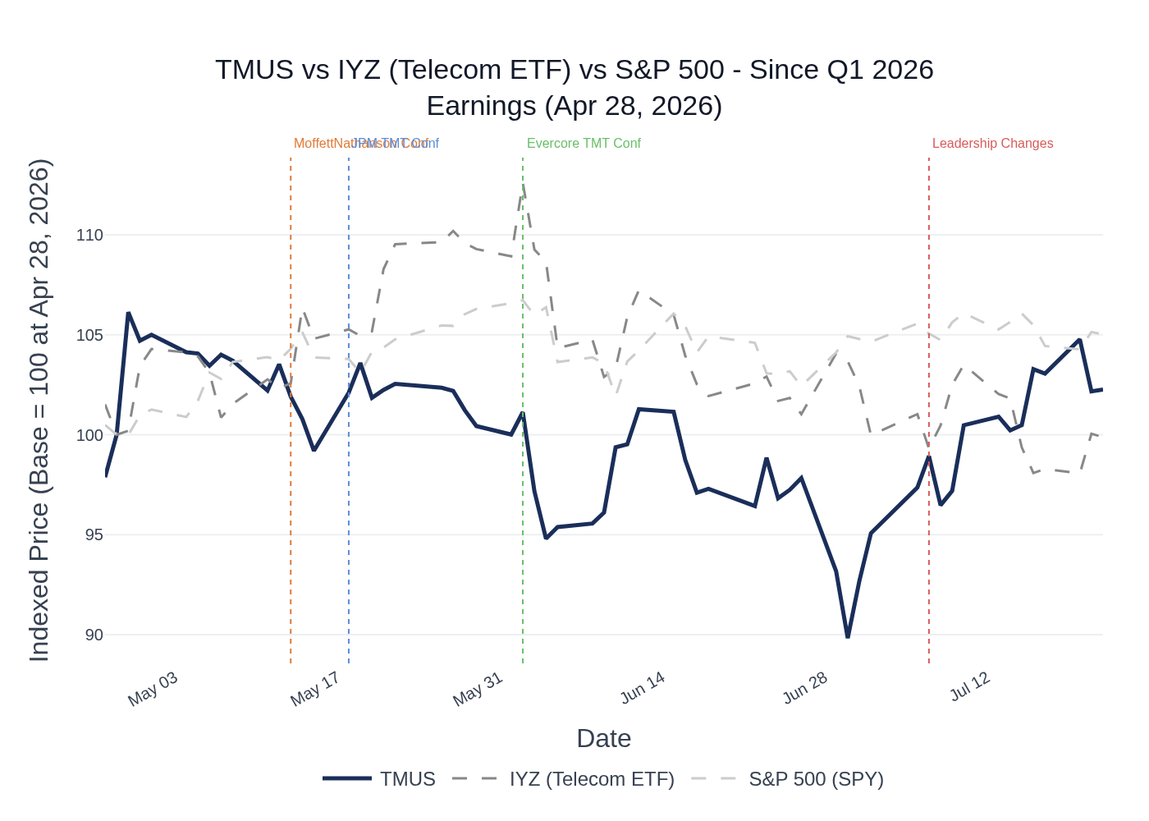
TMUS vs. IYZ (Telecom ETF) vs. S&P 500 — Indexed to 100 at Q1 2026 Earnings Date (Apr 28, 2026). Source: Stock Price Data.
TMUS opened at $186.72 on April 28 (Q1 earnings day) and surged to $198.17 the following day (+6.1%), reflecting a strong initial reaction to the beat-and-raise. The stock then drifted lower through May–June, hitting a trough of $167.73 on June 30 — a -15.2% drawdown from the post-earnings high. The selloff coincided with broader telecom sector weakness and appears macro/sentiment-driven rather than company-specific. The stock has since recovered to ~$191, essentially flat since earnings (+2.3%). The IYZ telecom ETF is also flat (-0.1%), while the S&P 500 has gained +5.0% over the same period — TMUS has been a relative underperformer vs. the market but in line with the sector. The stock is not pricing in a beat, which is constructive for the setup.

6. Peer Commentaries — Q2 2026 Read-Throughs
Key Takeaway: AT&T’s Q2 2026 print (reported today, July 22) is the most relevant read-through — AT&T posted its best consumer postpaid wireless account additions in 3+ years, signaling healthy industry demand, but also highlighted improving churn partly driven by lower device upgrade activity, which could be a mild headwind to TMUS gross adds. Competitive intensity is moderating, which is a net positive for TMUS’s Q2 economics.

AT&T (T) — Q2 2026 Earnings (Reported July 22, 2026)
AT&T reported Q2 2026 results today, providing the most timely read-through for TMUS’s Q2 print tomorrow. Key takeaways relevant to TMUS:
- Postpaid wireless demand healthy: AT&T added 432K postpaid phone net adds and 147K consumer postpaid wireless accounts in Q2 — its best account result in 3+ years. This signals healthy industry-level demand, a positive read-through for TMUS.
- Churn improving industry-wide: AT&T grew postpaid phone ARPU YoY while simultaneously reducing postpaid phone churn. AT&T attributed churn improvement partly to “a little bit of suppression right now in device switching” — lower upgrade activity helps churn across the industry, which should benefit TMUS as well.
- Competitive intensity moderating: AT&T’s CEO noted that promotional intensity has “settled down” after accelerating in 2025, consistent with TMUS management’s Q1 commentary that “Feb and March and going into April, we’ve seen some cooling down of that environment.” This is a positive read-through for TMUS’s Q2 churn and gross add economics.
- Convergence vs. FWA debate: AT&T’s fiber strategy is accelerating (best-ever Q2 fiber net adds, 8M new locations planned for 2026), but AT&T’s CEO explicitly stated FWA is “not the optimal technology to serve fixed traffic over the long haul.” This is consistent with TMUS’s view that FWA and fiber serve different segments, and does not suggest AT&T is meaningfully competing with TMUS’s FWA product.
- Device cost inflation ahead: AT&T’s CEO flagged that device costs are expected to increase (Apple signaling higher prices, memory costs rising), which “when prices go up, demand goes down.” This could modestly suppress gross add volumes industry-wide in H2 2026 — a watch item for TMUS’s Q3/Q4 guidance.
- Wireless service revenue growth: AT&T grew wireless service revenue 3.3% YoY — well below TMUS’s guided ~9% YoY for Q2, reinforcing TMUS’s structural share gain story.

TMUS Management Conference Commentary (May–June 2026)
Management provided several forward-looking comments at conferences that are directly relevant to Q2 performance:
- “Quarter 2 is going really well” — CEO Gopalan at JPM TMT Conference (May 18, 2026). Direct confirmation of in-quarter momentum.
- CLV trends continuing into Q2: CFO Osvaldik at Evercore TMT Conference (June 2, 2026) confirmed “CLVs in Q1 were up double digits year-over-year and that has continued into Q2” — a strong signal of customer quality and pricing power.
- Device subsidy optimization ongoing: CFO confirmed “we’ve trimmed and optimized already in Q2 on device offers” — deliberate margin protection, consistent with EBITDA guidance.
- ARPA moderation well-understood: CFO reiterated the ~2% Q2 ARPA growth is purely mechanical (lapping Q2 2025 rate plan optimizations + M&A dilution from UScellular, Metronet, Lumos), with re-acceleration expected in H2. No new information vs. Q1 call.
- Competitive environment cooling: CEO noted December–January was “more intense” but conditions have cooled — consistent with AT&T’s Q2 commentary on moderating promotional intensity.
- FWA competitive backdrop favorable: CEO noted “Verizon appears to be deemphasizing FWA a bit and AT&T kind of scaling their efforts” — a favorable competitive dynamic for TMUS’s FWA market share.

Cable Sector Context (Charter/Comcast — Not Yet Reported)
Charter (CHTR) and Comcast (CMCSA) report Q2 2026 on July 24. Pre-earnings expectations are for continued broadband subscriber losses at both companies, driven by fiber overbuild and FWA substitution. Charter is expected to have lost broadband customers again in Q2 (consensus: ~100K–150K net losses), and Comcast similarly. This structural cable weakness is a direct tailwind for TMUS’s FWA net adds — the majority of TMUS’s FWA share gains come from cable, as CFO Osvaldik confirmed “the majority is still cable” when discussing FWA share source. If cable losses are worse than expected, it would be incrementally positive for TMUS’s FWA trajectory. Charter’s Q2 result will be judged on broadband losses, underlying pricing, mobile economics, and free cash flow — any deterioration in cable broadband metrics would reinforce the FWA substitution thesis.

7. Material News & Developments
Key Takeaway: The most material post-earnings development is the July 7 leadership change (Michael Katz departure), which introduces modest uncertainty around enterprise strategy execution. The S&P credit upgrade to BBB+ in May is a positive structural development.
- July 7, 2026 — Leadership Changes (8-K): Michael Katz (Chief Business & Product Officer, 20+ year TMUS veteran) stepped down effective July 8. Chris Sambar appointed as new Chief Enterprise Officer (effective by Oct 14). Andre Almeida transitions to Chief Marketing, Brand & Broadband Officer. Dr. John Saw’s responsibilities expanded to include product engineering and cybersecurity. Katz remains as strategic advisor through December 2026. Implication: Modest uncertainty around enterprise go-to-market continuity; Katz was a key architect of the T-Mobile for Business strategy. Watch for management commentary on enterprise pipeline on the Q2 call.
- July 22, 2026 — AT&T Q2 2026 Results: AT&T reported today — best consumer postpaid account additions in 3+ years, improving churn, moderating competitive intensity. Net positive read-through for TMUS’s Q2 setup.
- June 18, 2026 — Annual Shareholder Meeting: Shareholders approved board, auditors, and executive pay without controversy. No material governance concerns.
- May 2026 — S&P Credit Upgrade to BBB+: S&P upgraded TMUS’s credit rating to BBB+, reflecting continued market share gains and improving credit metrics. Positive for cost of debt and financial flexibility.
- May 14, 2026 — Industry Satellite JV (T-Mobile, AT&T, Verizon): T-Mobile joined AT&T and Verizon in an agreement in principle to form a JV aimed at eliminating wireless dead zones via satellite. Management framed this as satellite becoming a standard feature of premium wireless rather than a differentiator — neutral to slightly positive for TMUS’s competitive positioning.
- April 28, 2026 — Two New Fiber JVs Announced (GoNetSpeed/Greenlight Networks & i3 Broadband): Totaling ~$2.7B of investment and ~1.8M new fiber passings. Tracking well with 20% first-year penetration in greenfield markets. Positive for long-term broadband TAM expansion.

8. Insider Transaction Activity
Key Takeaway: The only open-market buy since Q1 earnings was a modest purchase by Chief Broadband Officer Andre Almeida (~$1M, May 1). The COO Jon Freier sold ~$1M under a 10b5-1 plan. No clustered insider buying or unusual selling — activity is routine.
Name | Title | Transaction Type | Value (approx.) | Transaction Date | Note
Andre Almeida | Chief Broadband, Enterprise & Emerging Business Officer | Open Market Buy | ~$1.0M (5,097 shares) | May 1, 2026 | Discretionary buy; only open-market purchase post-earnings
Michael J. Katz | Chief Business & Product Officer | Open Market Sale | ~$1.0M (5,000 shares) | May 1, 2026 | 10b5-1 planned sale; pre-scheduled, not discretionary
Jon Freier | Chief Operating Officer | Open Market Sale | ~$0.9M (4,799 shares) | May 21, 2026 | 10b5-1 planned sale; pre-scheduled, not discretionary
Multiple Directors (6) | Board of Directors | Equity Award (A) | N/A | June 16, 2026 | Routine annual equity compensation grants; not open-market transactions
Mark Wolfe Nelson | Chief Legal Officer & GC | Equity Award (A) | N/A | June 11, 2026 | Routine equity award; not open-market transaction
Thomas Dannenfeldt | Director | Tax Withholding Sale | ~$0.06M (311 shares) | June 6, 2026 | Tax withholding on equity award; not discretionary
The one notable signal is Almeida’s open-market buy of ~5,097 shares (~$1M) on May 1 — a discretionary purchase by the executive overseeing TMUS’s broadband business, suggesting confidence in the FWA/fiber growth trajectory. All sales are 10b5-1 pre-scheduled or tax-withholding related, carrying no negative signal. The absence of clustered insider buying from senior leadership (CEO, CFO) is neutral — not a concern given the stock’s modest post-earnings performance. Source: SEC Form 4 filings.

