The Cigna Group (CI) — Q2 2026 Earnings Preview
Ticker | CI
Earnings Date | July 30, 2026 (pre-market, 6:30am ET; call at 8:30am ET)
Reporting Period | Q2 2026 (quarter ended June 30, 2026)
Prepared | July 29, 2026
Sector ETF Benchmark | XLV (Health Care Select Sector SPDR)

1. Earnings Preview
Key Takeaway: The setup into Q2 2026 is modestly constructive — consensus EPS of ~$7.60 implies roughly 25% of the full-year $30.35+ guide, exactly in line with management's own cadence commentary, making the bar achievable but not easy; the single biggest swing factor is the Q2 MCR, which management guided to be "slightly above the high end" of the 83.7%–84.7% full-year range, and any outperformance there would be the clearest catalyst for a positive reaction.
Heading into Q2 2026, Cigna's setup is one of managed expectations rather than a high bar: management explicitly guided Q2 adjusted EPS to approximately 25% of the full-year outlook (implying ~$7.59 at the $30.35 floor), and consensus at $7.60 sits almost exactly on that target, leaving little room for a large beat but also limiting downside if execution is clean. The most watched metric will be the Medical Care Ratio — management pre-signaled a sequential step-up from Q1's favorable 79.8% to "slightly above" the 84.7% high end of full-year guidance, driven by normal seasonality, the absence of the Medicare business (which had flatter MCR seasonality), and a higher proportion of Bronze ACA members; any print at or below ~85% would likely be viewed as in-line to favorable. Evernorth's Specialty & Care Services segment remains the growth engine — it delivered 20% adjusted earnings growth in Q1 and consensus expects continued momentum — while Pharmacy Benefit Services (PBS) is expected to remain a headwind as large client renewal economics and Signature model investment costs weigh on year-over-year comparisons, fully in line with prior guidance. The stock has been essentially flat since Q1 earnings (+2.0% vs. XLV +13.9%), reflecting ongoing investor skepticism about the multi-year PBS transformation and the absence of a re-rating catalyst ahead of the September 2026 Investor Day. The key wildcard is whether peer read-throughs from UNH and ELV — both of which reported Q2 beats driven by favorable MCR and raised full-year guidance — have set a constructive tone for managed care broadly, or whether CI's commercial/stop-loss mix means it faces a different cost dynamic than its Medicare-heavy peers.

2. KPIs & Consensus Expectations
Key Takeaway: Consensus is calibrated to management's own cadence guidance, making the bar achievable but not low; the MCR is the bigger swing factor — a print at or below ~85% would be viewed as favorable, while Evernorth Specialty growth is the upside driver if it again exceeds the ~20% pace seen in Q1.

Table 1 — Q2 2026 Current Quarter Snapshot
KPI | Q1 2026 Actual  (Last Quarter) | Q2 2025 Actual  (Prior Year Period) | Q2 2026 Consensus Estimate | YoY Change | Guidance | Consensus vs. Guidance
Adjusted EPS (Diluted Operating) | $7.79 | $7.20 | $7.60 | +5.6% YoY | ~25% of FY $30.35+ = ~$7.59 | +0.1% above implied guide midpoint
Total Revenue | $68.5B | $67.2B | $70.7B | +5.2% YoY | No explicit Q2 revenue guide | N/A
Medical Care Ratio — Cigna Healthcare (%) | 79.8% | 83.2% | 84.6% | +140 bps YoY | Slightly above high end of 83.7%–84.7% FY range (i.e., ~84.7%+) | ~10 bps below implied guide ceiling
Evernorth Operating Income | $1.693B | $1.812B | $1.764B | -2.6% YoY | FY at least $6.9B; Q2 seasonality similar to historical | ~+0.4% vs. implied seasonal run-rate
Cigna Healthcare Operating Income | $1.512B | $1.092B | $1.222B | +11.9% YoY | FY at least $4.525B; 1H slightly above 60% of FY | Consensus implies ~54% of FY in 1H (Q1 actual + Q2 est.)
Total Adjusted Scripts — Evernorth (M) | 527M | 548M | 544M | -0.7% YoY | No explicit Q2 guide | N/A
Operating Cash Flow | $1.131B | -$1.886B | $2.340B | N/M (prior year negative) | Majority of FY cash flow in 2H; FY ~$9.1B | N/A

5. Stock Performance
Key Takeaway: CI has been a significant underperformer since Q1 earnings (+2.0% vs. XLV +13.9% and SPY +1.5%), driven almost entirely by multiple compression and sector rotation into Medicare-heavy peers as the market re-rated managed care broadly on improving MCR trends — a dynamic from which CI, with its commercial/stop-loss focus and ongoing PBS transformation, has not benefited.
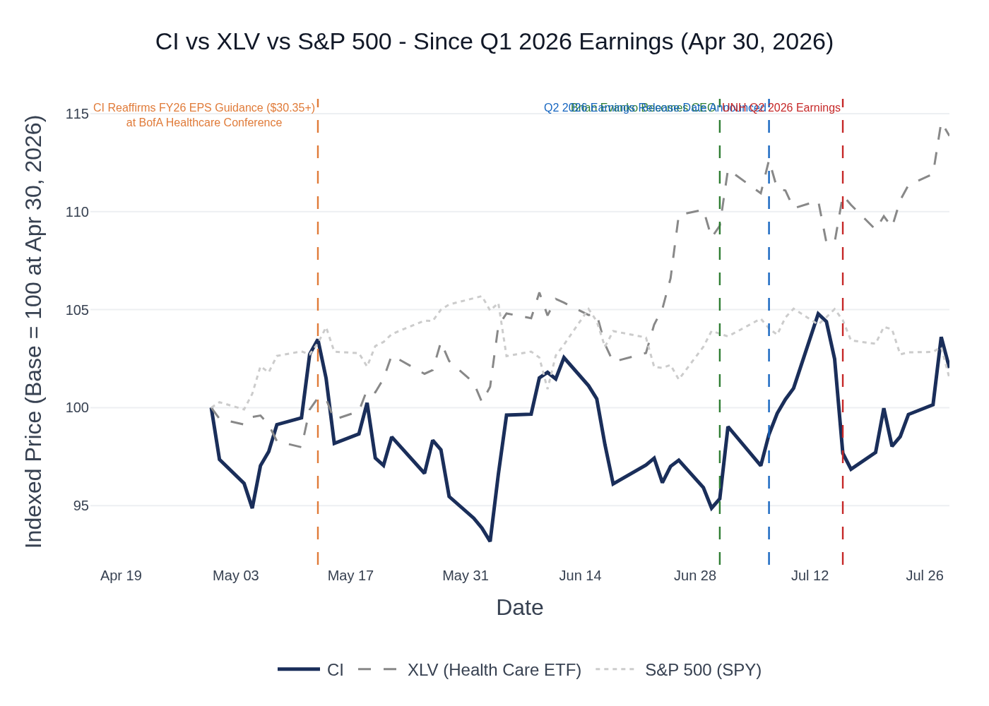
CI vs. XLV (Health Care Select Sector SPDR) vs. S&P 500 (SPY) — Indexed to 100 at Q1 2026 Earnings (April 30, 2026). CI: +2.0%; XLV: +13.9%; SPY: +1.5% through July 29, 2026.
Since Q1 2026 earnings on April 30, CI has returned +2.0% on a price basis, dramatically lagging the XLV health care ETF (+13.9%) and roughly in line with the S&P 500 (+1.5%). The XLV outperformance was driven by Medicare Advantage peers (UNH, ELV, HUM) re-rating sharply higher as Q2 MCR trends came in better than feared. CI did not participate in this re-rating because: (1) it has no Medicare Advantage exposure, (2) the PBS transformation overhang continues to weigh on sentiment, and (3) the September Investor Day is the next catalyst for a long-term growth algorithm refresh. Notable events during the period: CI reaffirmed its $30.35+ FY EPS guide at the BofA Healthcare Conference (May 13), which provided a brief lift to ~$300; the stock then drifted lower through June as sector rotation favored Medicare peers; a partial recovery in July coincided with positive peer read-throughs from UNH (July 16) and ELV (July 15) Q2 earnings, though CI gave back some gains on July 16 as UNH's commercial cost commentary (trends "modestly above 11%") raised questions about CI's commercial book.

6. Peer Commentaries — Q2 2026 Read-Throughs
Key Takeaway: Peer Q2 2026 prints are broadly constructive for CI's MCR and Specialty outlook, but UNH's warning on elevated commercial cost trends is the most important read-through risk — CI's commercial/stop-loss book is more exposed to this dynamic than its Medicare-heavy peers.
Note: Only commentary from peers' Q2 2026 earnings calls (reported July 2026) and post-Q1 2026 conferences is included below, per the user's instruction to exclude prior-quarter retrospective commentary.

UnitedHealth Group (UNH) — Q2 2026 Earnings (July 16, 2026)
Read-through signal: Mixed — Medicare favorable, commercial a headwind.
- Commercial cost trends elevated and rising: UNH flagged commercial medical cost trends "modestly above 11%," driven by the No Surprises Act IDR process (contributing ~50 bps of incremental trend in 2026, totaling at least 100 bps) and provider coding intensity. UNH stated it is "not yielding the full margin expansion for which we planned in 2026" and that "the sticky nature of the persistent and elevated trend is extending the time frame for full margin recovery past 2027." Read-through for CI: CI's commercial employer and stop-loss book faces the same IDR and coding intensity pressures. If UNH is seeing 11%+ commercial trends, CI's stop-loss repricing recovery could face headwinds, and the MCR for CI's commercial book may be under pressure.
- Medicare trends below expectations: UNH's Medicare medical cost trend is "running well above historical levels, but below our expectations so far in 2026," expected to come in below the initial ~10% estimate. Favorable respiratory season and weather patterns contributed. Read-through for CI: CI has no Medicare Advantage exposure, so this is not a direct read-through, but it signals a broadly favorable utilization environment in Q2 that may have benefited CI's commercial book as well.
- PBM transparency model gaining traction: Optum Rx announced a new fee-based, fully transparent PBM model with 100% rebate pass-through by end of 2027 (95%+ of clients on 100% pass-through by end of 2026). UNH noted it won new customers from "some of our larger competitors" with this model. Read-through for CI: Competitive pressure on CI's PBS Signature model intensifies as UNH accelerates its own transparency offering. However, CI's Signature model is differentiated by its rebate-free structure (not just pass-through), which may appeal to a different client segment.
- Full-year EPS guidance raised to $19.50–$20.00; Medicare margins to finish 2026 above 3%. Read-through for CI: Positive sector sentiment; UNH's recovery trajectory validates that managed care fundamentals are improving, which may help CI's multiple.

Elevance Health (ELV) — Q2 2026 Earnings (July 15, 2026)
Read-through signal: Constructive on MCR and commercial; Medicaid-specific issues not relevant to CI.
- Q2 results ahead of outlook on favorable benefit expense: ELV delivered Q2 results "ahead of our outlook, reflecting favorable benefit expense performance, disciplined execution." Strength was concentrated in Medicare Advantage and individual ACA. ELV raised FY 2026 adjusted EPS guidance to "at least $27" and established a $26 earnings baseline for 2027 modeling. Read-through for CI: Broad managed care MCR favorability in Q2 is a positive signal for CI's Cigna Healthcare segment, particularly for the commercial employer book.
- Commercial employer performing "incredibly well": ELV described its commercial fee-based and self-funded business (national accounts and local market) as performing "incredibly well," with persistency and sale rates climbing from prior years. 2026 was a "record year in our national account business." Read-through for CI: CI's commercial employer business is its core franchise; ELV's commentary suggests the commercial market is healthy and that employers are prioritizing integrated medical/pharmacy solutions — directly aligned with CI's value proposition.
- Cost drivers remain elevated in behavioral health, specialty pharmacy, outpatient surgery, and ED: ELV noted these categories "remain elevated and concentrated" and that its outlook "assumes this operating environment persists through the balance of the year." ELV is "not seeing a new stepwise acuity reset." Read-through for CI: Specialty pharmacy cost pressure is a headwind for CI's commercial MCR, though CI's Evernorth platform is positioned to benefit from specialty volume growth on the services side.
- Integrated medical and pharmacy model resonating: ELV (via Carillon) noted "strong demand for our integrated medical and pharmacy offering" and described Carillon as "an increasingly important and durable driver of enterprise growth." Read-through for CI: Validates CI's integrated Evernorth + Cigna Healthcare model as a competitive differentiator in the employer market.

Centene (CNC) — Q2 2026 Earnings (July 28, 2026)
Read-through signal: Limited direct read-through; CNC is Medicaid/Marketplace-focused with no commercial employer or PBM overlap.
- Strong Q2 beat driven by Marketplace risk adjustment favorability: CNC reported Q2 adjusted EPS of $2.51 vs. prior expectations, raising FY 2026 EPS guidance to >$4.80 (from >$3.40). The improvement was driven by a better-than-expected Marketplace pre-tax margin of 4.5%–5% and favorable 2025 CMS risk adjustment reconciliation of $180M. Read-through for CI: CI is exiting the individual exchange business at end of 2026, so Marketplace dynamics are not a direct read-through, but the positive sector sentiment is broadly supportive.
- Medicaid cost trend stable at 5%; behavioral health, home health, and high-cost drugs remain top drivers. Read-through for CI: Not directly relevant — CI has no Medicaid managed care exposure.
- PBM: CNC plans to leverage its $60B+ pharmacy spend through ESI (Express Scripts, a CI/Evernorth subsidiary) to deliver cost savings to state customers. Read-through for CI: Confirms that Evernorth's PBS relationship with Centene (one of the three large client renewals) remains intact and that CNC is actively promoting the partnership.

Humana (HUM) — Q2 2026 Earnings (July 29, 2026)
Read-through signal: Limited direct read-through; HUM is Medicare Advantage-focused. Favorable drug trend commentary is modestly relevant to CI's specialty pharmacy business.
- Cost trends in line with expectations; slight inpatient favorability: HUM's 2026 cost trend assumption is "high single digit range, or 7 to 8%, inclusive of both medical and pharmacy," with medical costs "a little bit lower" and drug costs in the "double digit." Slight favorability in inpatient, concentrated in value-based care members. Read-through for CI: Broadly stable utilization environment in Q2 is supportive of CI's commercial MCR. The inpatient favorability signal is consistent with what CI's stop-loss business would benefit from.
- Drug trend "will tick modestly higher next year" given health technology pipeline: HUM flagged that drug costs are in the double digits and will increase in 2027 due to new drug launches. Read-through for CI: Secular specialty drug volume growth is a tailwind for CI's Evernorth Specialty & Care Services segment, which is growing 8%–12% annually.
- HUM performing as expected in 2026; on track for 3%+ MA margin in 2028. Read-through for CI: Not directly relevant to CI's business mix.

CVS Health (Aetna) — Q1 2026 Earnings (May 6, 2026)
Read-through signal: Constructive on commercial employer and PBM; specialty pharmacy biosimilar commentary directly relevant to CI's Evernorth strategy.
- Commercial employer business "strong" with "nice growth in a very disciplined pricing environment": CVS/Aetna reported strong commercial retention and new wins across local market and national accounts. The pipeline for 2027 "looks strong." Read-through for CI: Validates a healthy commercial employer market heading into Q2, supportive of CI's commercial premium growth and stop-loss repricing.
- Biosimilar strategy accelerating — STELARA exclusion from commercial formularies effective July 1, 2026: CVS/Caremark announced it will exclude branded STELARA from commercial template formularies starting July 1, 2026, replacing with biosimilars, expecting similar conversion rates to HUMIRA (>90% of eligible patients). Read-through for CI: CI's Evernorth already launched STELARA $0 out-of-pocket biosimilar access in May 2025. CVS's move validates the biosimilar conversion strategy and suggests industry-wide adoption will accelerate, benefiting CI's specialty pharmacy economics.
- PBM TrueCost model gaining traction; "over 90% of clients' costs from 10% of branded drugs": CVS highlighted GLP-1s as "one of our clients' biggest trend drivers" and noted that only ~50% of clients cover GLP-1s for weight loss. Read-through for CI: Consistent with CI's commentary that GLP-1 coverage rates are ~50% in the Evernorth book and ~20% in the Cigna Healthcare book. The competitive PBM transparency race (CVS TrueCost, UNH Optum Rx fee-based, CI Signature) is intensifying.
- Medical cost trends "remain above historical levels" but Q1 MBR of 84.6% was better than expectations: CVS raised FY 2026 adjusted EPS guidance to $7.30–$7.50 (from $7.00–$7.20) on Q1 outperformance. Read-through for CI: Q1 MCR favorability across the sector (CVS, CI, UNH) suggests the Q1 2026 environment was broadly benign — the question for Q2 is whether that continues or reverts.
- Tennessee PBM legislation creates "complexity and challenges" for specialty pharmacy: CVS expressed disappointment with Tennessee's PBM legislation (effective mid-2028), which it believes will raise costs and threaten pharmacy access. CVS is evaluating legal action. Read-through for CI: State-level PBM legislation is an emerging risk for CI's Evernorth PBS business, though the Tennessee law's mid-2028 effective date limits near-term impact.
- UNH BofA Healthcare Conference (May 12, 2026): UNH CFO Wayne DeVeydt stated that "if the trends we saw in the first quarter were to continue, this will be a very strong year" and confirmed April trends had continued. He noted that Q2 of 2025 was when "the industry really got a lot of surprises" — implying the base period is favorable. Read-through for CI: Post-Q1 conference commentary from UNH was constructive on trend continuation, which was a positive signal for CI's Q2 MCR heading into the quarter.

7. Material News & Developments
Key Takeaway: The most important development since Q1 earnings is the CEO transition to Brian Evanko on July 1, 2026, which sets the stage for the September Investor Day as the next major catalyst; the May 13 guidance reaffirmation removed downside risk, but the stock needs a new growth narrative to re-rate.
- July 1, 2026 — CEO Transition: Brian Evanko succeeds David Cordani as CEO; Cordani becomes Executive Chair. Implication: Evanko has outlined three areas of intensification — AI/data-driven personalization, affordable care types (generics, biosimilars, cost-effective sites), and upstream preventive care. The transition is orderly and well-telegraphed, but investors will scrutinize Q2 call commentary for any strategic shifts or updated capital allocation priorities.
- May 13, 2026 — 8-K: Cigna reaffirms FY 2026 adjusted EPS outlook of at least $30.35 at BofA Securities 2026 Health Care Conference. Implication: Removes downside guidance risk heading into Q2; confirms management confidence in the full-year trajectory. Stock briefly touched $300 on this news.
- July 7, 2026 — Q2 2026 Earnings Release Details Announced: Cigna confirmed Q2 2026 results will be released July 30, 2026 pre-market (no later than 6:30am ET), with a conference call at 8:30am ET. Implication: Logistical confirmation; no new financial information.
- Q1 2026 Earnings (April 30, 2026) — Portfolio Shaping Actions: Cigna announced (1) exit of individual exchange business at end of 2026 and (2) initiation of strategic review of eviCore (prior authorization services unit). Implication: eviCore strategic review outcome is a potential catalyst — a sale or spin could unlock capital for buybacks or bolt-on M&A. No update expected on Q2 call, but any progress would be a positive surprise.
- Q1 2026 Earnings (April 30, 2026) — Signature PBM Model Launch: Cigna formally named its rebate-free PBM model "Signature," targeting at least 50% of PBS members by end of 2028, with Cigna Healthcare's fully insured customers adopting in 2027. Implication: 2027 PBS selling season tracking ahead of prior years in new business (scripts and lives); retention expected in mid-to-high 90s. Q2 call will be watched for any update on Signature adoption progress and 2027 selling season momentum.
- Ongoing — Investor Day Planned for September 2026: Cigna will host a formal Investor Day in September 2026 to provide a comprehensive refresh of long-term growth expectations across all three core businesses. Implication: This is the most important upcoming catalyst for a re-rating. The market is waiting for a new long-term growth algorithm (post-PBS transformation) before assigning a higher multiple. Any preview commentary on the Q2 call would be a significant positive.
- Sector — UNH Q2 2026 (July 16): UNH flagged commercial medical cost trends "modestly above 11%" driven by No Surprises Act IDR process and provider coding intensity, extending commercial margin recovery timeline past 2027. Implication: Most important peer read-through risk for CI — CI's commercial employer and stop-loss book faces the same pressures. Watch for CI management commentary on commercial trend and stop-loss repricing adequacy.
- Sector — ELV Q2 2026 (July 15): ELV raised FY 2026 EPS guidance to at least $27 and described commercial national accounts as a "record year." Implication: Positive read-through for CI's commercial employer franchise and sector sentiment.
- Sector — Biosimilar Acceleration: CVS/Caremark excluded branded STELARA from commercial formularies effective July 1, 2026; CI's Evernorth launched STELARA $0 out-of-pocket biosimilar access in May 2025. Generic Revlimid supply constraints expected to ease in 2H 2026. Implication: Secular tailwind for CI's Specialty & Care Services segment; biosimilar adoption is a key driver of the 8%–12% annual growth target.
- Regulatory — PBM Legislation: Tennessee enacted PBM legislation (effective mid-2028) that CVS described as creating "complexity and challenges" for specialty pharmacy. Federal PBM transparency push continues. Implication: Emerging risk for CI's PBS business, though CI's Signature model (rebate-free, transparent) is structurally aligned with the regulatory direction. Near-term impact limited.

