Camden Property Trust (CPT) — Q2 2026 Earnings Preview
Ticker: CPT Upcoming Earnings Period: Q2 2026 (period ending June 30, 2026) Expected Earnings Date: Late July / Early August 2026 Prepared: July 29, 2026

1. Earnings Preview
Key Takeaway: The setup into Q2 is a modest bar — consensus Core FFO of $1.67 is essentially flat vs. Q1 actuals and below the FY midpoint, while the June 1 operating update confirmed performance is tracking in-line with guidance. The biggest swing factor is whether blended lease rate improvement (guided ~+100bps sequentially from Q1) and the California portfolio close translate into upside on same-store revenue and capital redeployment optionality.
Consensus Core FFO of $1.67/share represents a modest sequential step-down from Q1’s $1.70 actual, driven by seasonal expense timing and annual merit increases — a low bar that CPT has cleared in each of the last 8 quarters. Management reaffirmed all FY 2026 midpoints at Q1 earnings (SS revenue +0.75%, SS NOI -0.5%, Core FFO $6.75), and the June 1 Nareit REITweek operating update explicitly confirmed Q2 is tracking in-line with guidance, removing meaningful downside risk heading into the print. Estimates have drifted slightly lower since Q1 earnings — FY Core FFO consensus slipped from $6.78 to $6.75 and Q2 SS revenue growth fell from +0.29% to +0.13% — suggesting the Street is not pricing in upside and the bar remains achievable. CPT has rallied ~10.8% since Q1 earnings (vs. REZ +9.6%, SPY +1.5%), driven by the California portfolio sale announcement and sector rotation into residential REITs, so the stock is no longer cheap on a relative basis but still trades at a meaningful discount to management’s stated NAV. The wildcard is the California portfolio sale close (targeted late June/early July) and the pace of Sunbelt concession burn-off — a confirmed close at or above expectations would unlock ~$650M in buyback capacity and validate the NAV thesis, while any delay or pricing disappointment would be the primary downside risk.

2. KPIs & Consensus Expectations
Key Takeaway: Consensus sets a low bar on same-store metrics — SS revenue growth of just +0.13% YoY and SS NOI of -1.48% — while blended lease rates are expected to improve sequentially to ~+0.70%. Occupancy is the steadier anchor, with consensus at 95.4%.
Table 1 — Current Quarter Snapshot (Q2 2026)
KPI | Q1 2026 Actual | Q2 2025 Actual | Q2 2026 Consensus | YoY Change | FY 2026 Guidance | Consensus vs. Guidance
Core FFO/Share (diluted) | $1.70 | $1.70 | $1.67 | -1.8% | $6.55–$6.95 (mid $6.75) | At midpoint
Property Revenues | $388.8M | $396.5M | $391.2M | -1.3% | ~$1,553M | N/A
Same-Store Revenue | $360.0M | $362.1M | $362.3M | +0.1% | N/A | N/A
SS Revenue Growth YoY | +0.2% | +1.0% | +0.13% | N/A | +0.25% to +1.25% (mid +0.75%) | Below midpoint
SS NOI Growth YoY | -0.7% | +0.2% | -1.48% | N/A | -1.0% to 0.0% (mid -0.5%) | Below midpoint
SS Expense Growth YoY | +1.9% | +2.4% | +2.87% | N/A | +2.5% to +3.5% (mid +3.0%) | Near midpoint
Blended Lease Rate (SS) | -1.4% | +0.7% | +0.70% | N/A | N/A | N/A
New Lease Rate (SS) | -5.2% | -2.1% | -2.16% | N/A | N/A | N/A
Renewal Rate (SS) | +2.9% | +3.7% | +3.31% | N/A | N/A | N/A
Same-Store Occupancy | 95.1% | 95.6% | 95.41% | N/A | N/A | N/A
All consensus figures from Visible Alpha. Guidance ranges from Q1 2026 earnings call (April 30, 2026).
Table 2 — Beat/Miss History (Last 8 Quarters, Core FFO/Share & SS Revenue Growth)
Quarter | Core FFO Reported | Core FFO Consensus | Core FFO Surprise | SS Rev Growth Reported | SS Rev Growth Consensus | SS Rev Growth Surprise
1Q 2026 | $1.70 | $1.67 | +$0.03 / +1.8% | +0.2% | +0.35% | -15bps
4Q 2025 | $1.76 | $1.73 | +$0.03 / +1.7% | +0.5% | +0.75% | -25bps
3Q 2025 | $1.70 | $1.69 | +$0.01 / +0.6% | +0.8% | +0.89% | -9bps
2Q 2025 | $1.70 | $1.69 | +$0.01 / +0.6% | +1.0% | +0.70% | +30bps
1Q 2025 | $1.72 | $1.68 | +$0.04 / +2.4% | +0.8% | +0.55% | +25bps
4Q 2024 | $1.73 | $1.70 | +$0.03 / +1.8% | +0.8% | +0.81% | -1bp
3Q 2024 | $1.71 | $1.68 | +$0.03 / +1.8% | +0.6% | +0.63% | -3bps
2Q 2024 | $1.71 | $1.67 | +$0.04 / +2.4% | +1.4% | +1.14% | +26bps
CPT has beaten Core FFO consensus in each of the last 8 quarters, typically by $0.01–$0.04/share. Same-store revenue has been more mixed — beats in 4 of 8 quarters — suggesting the beat pattern on FFO is driven more by expense management and timing items than top-line outperformance.

3. Guidance & Commentary Evolution
Key Takeaway: Management reaffirmed all FY 2026 midpoints at Q1 earnings with no changes; the June 1 operating update confirmed Q2 is tracking in-line. Tone is cautiously optimistic — management sees green shoots in Atlanta, Dallas, Orlando, Nashville, Raleigh, and Southeast Florida, but remains watchful for macro headwinds similar to the 2025 Liberation Day head-fake.
Metric | Initial Guidance (Q1 2026 Earnings, Apr 30) | Revised Guidance | Current Consensus | Note
FY 2026 Core FFO/Share | $6.55–$6.95 (mid $6.75) | — | $6.75 | Reaffirmed; Q2 guide $1.65–$1.69 (mid $1.67)
FY SS Revenue Growth | +0.25% to +1.25% (mid +0.75%) | — | +0.40% | Reaffirmed; consensus slightly below midpoint
FY SS NOI Growth | -1.0% to 0.0% (mid -0.5%) | — | -0.92% | Reaffirmed; consensus slightly below midpoint
FY SS Expense Growth | +2.5% to +3.5% (mid +3.0%) | — | +2.65% | Reaffirmed; consensus below midpoint (expense upside potential)
California Portfolio Sale | Close targeted late June / early July 2026 | — | N/A | One buyer in diligence; ~$650M proceeds modeled for buybacks; ~60% for 1031 exchanges
Acquisitions | ~$1B 1031 exchange target | — | N/A | ~$500M awarded as of Q1 call; Atlanta and Orlando deals closed post-Q1

4. Guidance vs. Estimate Revision Tracker
Key Takeaway: Estimates have drifted modestly lower since Q1 earnings — FY Core FFO consensus fell from $6.78 to $6.75 and Q2 SS revenue growth dropped from +0.29% to +0.13% — suggesting the Street is not pricing in upside and the bar remains achievable. The gap between consensus and guidance midpoints is narrow, leaving little cushion if macro conditions deteriorate.
KPI (Period) | Estimate 5 Days Post Q1 Earnings (May 6, 2026) | Current Consensus | Estimate Delta | Initial Guidance (Q1 Call) | Current Guidance | Guidance Delta | Consensus vs. Guidance
Core FFO/Share — Q2 2026 | $1.67 | $1.67 | 0% | $1.65–$1.69 (mid $1.67) | Unchanged | — | At midpoint
Core FFO/Share — FY 2026 | $6.78 | $6.75 | -0.4% | $6.55–$6.95 (mid $6.75) | Unchanged | — | At midpoint
SS Revenue Growth — Q2 2026 | +0.29% | +0.13% | -16bps | +0.25% to +1.25% (mid +0.75%) | Unchanged | — | Below midpoint
SS NOI Growth — Q2 2026 | -1.04% | -1.48% | -44bps | -1.0% to 0.0% (mid -0.5%) | Unchanged | — | Below midpoint
SS Expense Growth — Q2 2026 | +2.63% | +2.87% | +24bps | +2.5% to +3.5% (mid +3.0%) | Unchanged | — | Near midpoint
Estimate baseline as of May 6, 2026 (5 trading days post Q1 earnings). Source: Visible Alpha.

5. Stock Performance
Key Takeaway: CPT has outperformed both the residential REIT ETF (REZ) and the S&P 500 since Q1 earnings, driven by the California portfolio sale announcement and sector rotation into residential REITs. The ~10.8% gain vs. REZ’s +9.6% suggests modest alpha, but the bulk of the move appears sector-driven rather than CPT-specific.
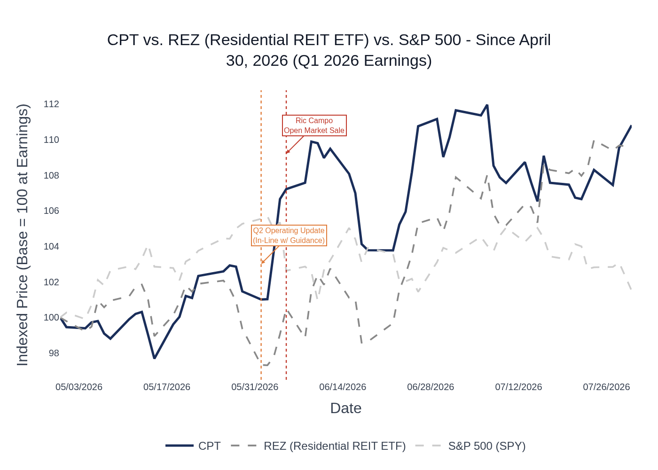
CPT vs. REZ (iShares Residential & Multisector Real Estate ETF) vs. S&P 500 — Indexed to 100 at Q1 2026 Earnings Close (Apr 30, 2026). Source: Yahoo Finance.
CPT gained +10.8% from the Q1 earnings close ($105.02 on Apr 30) to the Jul 28 close ($115.04), outperforming REZ (+9.6%) and significantly outperforming SPY (+1.5%). The stock’s strongest move came in early June, coinciding with the California portfolio sale update and Nareit REITweek conference participation. A pullback in mid-June/early July partially reversed gains before recovering. The stock currently trades at ~$115, still at a meaningful discount to management’s stated NAV.

6. Material News & Developments
Key Takeaway: The California portfolio sale is the dominant catalyst — a confirmed close at or above expectations would unlock ~$650M in buyback capacity and validate management’s NAV thesis. The June 1 in-line operating update removes downside risk from Q2 but provides no upside catalyst.
- June 1, 2026 — Q2 Operating Update (In-Line): CPT confirmed Q2 performance is tracking in-line with guidance provided at Q1 earnings. No changes to guidance. Implication: Removes downside risk; sets a clean, achievable bar for the print.
- April 30, 2026 — Q1 2026 Earnings Beat: Beat Core FFO by ~$0.03 (timing items, bad debt outperformance). All FY 2026 guidance midpoints reaffirmed. California sale in diligence with one buyer targeting late June/early July close. ~$250M in additional acquisitions awarded post-quarter. April occupancy improved to ~95.4% and blended rates up ~100bps vs. Q1.
- April 30, 2026 — ATM Equity Program Renewed: CPT renewed its at-the-market equity program for up to $500M. Implication: Provides capital flexibility but signals potential dilution if used aggressively.
- April 9, 2026 — RealPage Antitrust Settlement ($53M): CPT reached a $53M settlement in the RealPage class action lawsuit, recorded as a non-core charge in Q1 2026 and excluded from Core FFO. Implication: Removes a key legal overhang; management expects to stop discussing within a couple of quarters.
- March 27, 2026 — Leadership Transition Completed: Alex Jessett promoted to CEO, Laurie Baker to President/COO, Ben Fraker to CFO; Ric Campo moves to Executive Chairman. All three new leaders have 25+ years of Camden tenure. Implication: Continuity risk is low; new team has deep institutional knowledge.
- March 19, 2026 — Credit Facility Recast: CPT amended and extended its revolving credit facility to 2030, lowering all-in pricing. Implication: Enhances liquidity and financial flexibility ahead of California sale proceeds deployment.
- February 19, 2026 — $600M Bond Issuance: CPT issued $600M in 4.900% notes due 2036, locking in fixed-rate financing. Implication: Increased leverage to ~4.7x net debt/EBITDAre but secures long-term capital at attractive rates.

7. Peer Commentaries — Q2 2026 Read-Through
Key Takeaway: Peers reporting Q2 2026 results show a bifurcated picture — coastal operators (EQR, ESS, UDR coastal) are seeing strong rent growth and raising guidance, while Sunbelt-focused peers (MAA, UDR Sunbelt) continue to face negative new lease rates and NOI pressure. CPT’s ~75% Sunbelt exposure means the Sunbelt read-through is more relevant, and the data suggests the recovery is real but gradual — blended rates improving sequentially but still negative on new leases.
Note: All peer commentary below is from Q2 2026 earnings releases and transcripts (reported July 22–29, 2026), reflecting current-quarter operating conditions directly relevant to CPT’s Q2 2026 print.

MAA (Mid-America Apartment Communities) — Most Direct Sunbelt Comp
- Q2 2026 SS revenue growth: -0.3% YoY; SS NOI growth: -1.0% YoY — still negative but improving sequentially.
- Blended lease rate growth: +0.7% in Q2 (20bps better YoY, 100bps better sequentially), driven by 170bps improvement in new lease pricing from Q1. New lease rate: -5.3%; Renewal rate: +5.2%. Average physical occupancy: 95.3%.
- CEO Brad Hill: “As steady demand increasingly outweighs the declining pressure from new deliveries more broadly across our footprint, the improved pricing and operating fundamentals we see in a number of our markets should become more broad-based, supporting an accelerating recovery.”
- FY 2026 guidance: SS revenue growth midpoint lowered to +0.10% (from +0.55%); SS NOI midpoint lowered to -0.90% (from -0.70%). Core FFO midpoint unchanged at $8.53.
- CPT Read-Through: MAA’s Sunbelt-heavy portfolio is the closest comp. The sequential improvement in blended rates (+100bps) and the CEO’s “accelerating recovery” language are constructive for CPT’s Q2 narrative, but the FY revenue guidance cut is a caution flag — the recovery is happening but slower than initially expected.

UDR — Sunbelt vs. Coastal Divergence
- Q2 2026 SS revenue growth: +1.8% YoY; SS NOI growth: +1.4% YoY — beat expectations and raised guidance.
- Blended lease rate: +2.1% overall (coastal: +3.8%; Sunbelt: -2.0%). New lease: -0.6% overall; Renewal: +4.2%.
- Sunbelt-specific: Dallas strongest Sunbelt market (97% occupancy, blends ~-1%); Austin showed best momentum; Florida (Orlando/Tampa) improving to ~-1.5% blends from -2.5% to -3% in Q1; Nashville still -2% to -3% blends due to supply.
- July trends: Sunbelt blends improving to ~-1.5% from -2% in Q2. New lease growth expected to be flat across all regions through September.
- CEO Tom Toomey: “The apartment industry is strengthening… For 2027, we won’t be facing that element of supply that we’ve had to deal with in the past.”
- FY 2026 guidance raised: SS revenue growth midpoint +12.5bps to 1.375%; SS NOI growth midpoint +50bps; FFO/share raised $0.01 to $2.53.
- CPT Read-Through: UDR’s Sunbelt commentary (25% of NOI) is directly relevant. The sequential improvement in Florida and Dallas — markets where CPT has significant exposure — is a positive signal. The July improvement to -1.5% in Sunbelt blends is a constructive leading indicator for CPT’s Q3 setup.

EQR (Equity Residential) — Coastal Leader, Limited Sunbelt Read-Through
- Q2 2026 SS revenue growth: +1.9% YoY; SS NOI growth: +1.4% YoY. Raised FY guidance.
- Blended lease rate: +2.8%; New lease: -0.7%; Renewal: +5.2%. Physical occupancy: 96.2%.
- Sunbelt markets: Atlanta revenues -0.3% YoY; Dallas/Austin revenues -1.3% YoY; Denver revenues -6.4% YoY (worst performer).
- COO Michael Manelis: “Positive trends around both supply and demand continue to drive our operating performance during the primary leasing season and we continue to observe growing rents as we work our way through the summer.”
- FY 2026 guidance raised: SS revenue growth midpoint +20bps to 2.4%; SS NOI midpoint +30bps to 1.8%.
- CPT Read-Through: EQR’s coastal strength is less relevant to CPT’s Sunbelt-heavy portfolio. However, EQR’s Sunbelt data (Atlanta -0.3%, Dallas/Austin -1.3%) confirms the Sunbelt is still under pressure YoY. Denver’s -6.4% revenue decline is a caution flag for CPT’s Denver exposure (Camden Baker development on hold).

AVB (AvalonBay Communities) — Coastal/Expansion Market Mix
- Q2 2026 SS residential revenue growth: +1.6% YoY; SS NOI growth: +1.0% YoY. Raised FY SS NOI guidance.
- COO Sean Breslin: “A healthier demand environment, easing new supply, and disciplined execution by our teams delivered strong rent growth and lower operating expenses in the first half of the year, enabling us to increase Same Store NOI guidance for the full year.”
- FY 2026 SS NOI guidance raised: Midpoint now 0% to +1.4% (from -0.7% to +1.3%).
- CPT Read-Through: AVB’s expansion markets (Raleigh-Durham, Charlotte, Southeast Florida, Dallas, Austin, Denver) overlap with CPT’s Sunbelt footprint. The positive tone on “easing new supply” and “healthier demand environment” is broadly constructive for the sector.

ESS (Essex Property Trust) — West Coast Only, Limited Direct Read-Through
- Q2 2026 SS revenue growth: +2.7% YoY; SS NOI growth: +2.6% YoY. Raised FY Core FFO guidance by $0.20/share.
- Blended lease rate: +3.6%; New lease: +1.0%; Renewal: +4.8%. Financial occupancy: 96.3%.
- FY 2026 SS revenue guidance raised to 2.5%–3.1% (mid +2.8%, up +40bps).
- CPT Read-Through: ESS is a West Coast-only operator with no Sunbelt exposure, making it a limited direct read-through. However, ESS’s strong results and guidance raise confirm that the broader apartment demand environment is healthy, and the supply normalization thesis is playing out in markets where supply has already peaked.

Key Themes Across Peers Relevant to CPT
- Supply abatement is real and accelerating: All peers confirm new supply is declining meaningfully, with the sharpest drops in urban markets. CPT’s management guided completions in their markets to fall from 200K in 2025 to 140–150K in 2026.
- Sunbelt recovery is sequential, not yet YoY: MAA and UDR Sunbelt data confirm blended rates are improving sequentially (100bps+ from Q1) but remain negative on new leases. CPT’s guided +0.70% blended rate for Q2 is achievable but requires continued sequential improvement.
- Renewal rates are holding: Across all peers, renewal rates are in the +3% to +5% range, providing a stable floor. CPT’s renewal guidance of mid-3% is consistent with peer experience.
- Occupancy is stable at ~95–96%: All Sunbelt-focused peers report occupancy in the 95–96% range, consistent with CPT’s 95.4% consensus estimate.
- Concessions are burning off: UDR and MAA both note concessions declining as new supply falls. CPT management highlighted this as a key inflection catalyst.
- Houston remains an outlier: UDR did not specifically call out Houston, but CPT management flagged it as underperforming due to immigration-related consumer sentiment headwinds — a CPT-specific risk not visible in peer data.

8. Insider Transaction Activity
Key Takeaway: The only open-market transaction since Q1 earnings was a 30,000-share sale by Executive Chairman Ric Campo on June 5, 2026 — notable given his transition from CEO to Executive Chairman and the stock’s recent rally to multi-month highs. All other transactions were routine equity award grants to directors. No open-market buys were recorded.
Name | Title | Transaction Type | Shares | Approx. Value | Date | Note
Richard J. Campo | Executive Chairman | Open Market Sale | 30,000 | ~$3.4M (at ~$112/share) | June 5, 2026 | Discretionary sale; no 10b5-1 plan indicated. Sold near recent highs following California sale announcement. Remaining position: 297,437 shares.
Kevin J. Necas Jr. | SVP — Chief Accounting Officer | Equity Award Grant | 2,133 | N/A | July 2, 2026 | Routine compensation grant (Code A). Not an open-market transaction.
Multiple Directors (7) | Board of Directors | Equity Award Grant | 2,507 each | N/A | May 8, 2026 | Routine annual director compensation grants (Code A). Not open-market transactions.
The Campo sale is the only discretionary open-market transaction. While the size (~$3.4M) is meaningful in absolute terms, Campo retains a substantial position of 297,437 shares (~$33M at current prices). The sale occurred shortly after the stock rallied on the California portfolio sale update and Nareit conference, which may reflect opportunistic profit-taking rather than a fundamental view change. No open-market buys were recorded by any insider since Q1 earnings.

