Cognizant Technology Solutions (CTSH)

Q2 2026 Earnings Preview
Ticker | CTSH | Upcoming Earnings | Q2 2026 (Late July / Early August 2026)
Last Reported | Q1 2026 (April 29, 2026) | Prepared Date | July 28, 2026

1. Earnings Preview
Key Takeaway: The setup into Q2 is a low bar with cautious guidance, but the real question is whether large deal ramps and Astreya contribution are materializing as promised — bookings momentum is strong but ACV was flat in Q1, and discretionary spend remains stubbornly weak across the peer group.
Heading into Q2 2026, CTSH faces a deliberately conservative bar — management guided Q2 revenue growth of 3.2%–4.7% in constant currency (including ~150bps from Astreya), explicitly citing heightened macro uncertainty and softening discretionary spend. Estimate revisions have been modestly negative since the Q1 print, with consensus revenue for Q2 sitting slightly below the guidance midpoint, suggesting the Street is not pricing in a meaningful beat. The stock has been a significant underperformer since Q1 earnings — down ~8% vs. IGV +8.6% and SPY +4.1% — reflecting both the Q2 guidance disappointment and a broader de-rating as peers like Accenture and Infosys also flagged discretionary headwinds. The wildcard is large deal ramp velocity: management explicitly guided that Q4/Q1 large deal wins would "reach their full potential starting June/July," making Q2 the first quarter where this ramp should be visible in revenue. If large deal ramps are on track and Astreya contributes its budgeted ~1 month of revenue, CTSH could beat the low bar; if discretionary softness deepens (as Infosys's guidance cut and ACN's late-quarter products/resources weakness suggest), the full-year guide becomes at risk.
Factor | Assessment
Bar | Low — Q2 guidance midpoint implies ~3.95% CC growth; consensus sits at ~$5.49B, slightly above the midpoint, suggesting limited expectation for meaningful upside.
Guidance / Tone | Cautious near-term, confident long-term. Management maintained full-year guidance but explicitly flagged discretionary softness and macro uncertainty as Q2 headwinds. At the June 10 Jefferies conference, CFO confirmed no acceleration in demand since Q1 earnings.
Estimate Trajectory | Modestly negative since Q1 print — revenue estimates for Q2 have drifted slightly lower (-0.3%); EPS estimates have been relatively stable (+0.1%) given the margin guidance raise from Project Leap.
Stock Setup | CTSH has significantly underperformed since Q1 earnings (down ~8% vs. IGV +8.6%), suggesting the market has already priced in a weak Q2. The stock trades at a discount to peers, which could limit downside if results are in-line.
Wildcard | Large deal ramp velocity — management guided that Q4/Q1 large deal wins would reach full potential in June/July. If this is visible in Q2 revenue, it could be the positive catalyst the stock needs.

2. KPIs & Consensus Expectations
Key Takeaway: Revenue and EPS are the primary swing factors; consensus is a low bar on revenue but EPS estimates have held up better given the margin guidance raise. Watch bookings and ACV growth as the leading indicator for discretionary recovery.

Table 1 — Current Quarter Snapshot (Q2 2026)
KPI | Q1 2026 Actual | Q2 2025 Actual (Prior Year) | Q2 2026 Consensus | YoY Change | Guidance | Consensus vs. Guidance
Revenue ($B) | $5.413B | $5.245B | $5.487B | +4.6% | $5.38B–$5.54B (3.2%–4.7% CC) | At midpoint
Adj. Operating EPS ($) | $1.40 | $1.31 | $1.378 | +5.2% | N/A (FY guide $5.63–$5.77) | N/A
Adj. Operating Income ($B) | $0.843B | $0.817B | $0.869B | +6.3% | N/A | N/A
Gross Profit ($B) | $1.775B | $1.766B | $1.831B | +3.7% | N/A | N/A
TTM Book-to-Bill (x) | 1.4x | 1.4x | 1.32x | Flat | N/A | N/A
TTM Bookings ($B) | $29.6B | $27.8B | $29.3B | +5.4% | N/A | N/A
Source: Visible Alpha Consensus and Actuals Data. Revenue guidance midpoint based on 3.2%–4.7% CC growth on Q2 2025 base of $5.245B plus FX. Consensus of $5.487B sits slightly above the midpoint.

Table 2 — Beat/Miss History (Last 8 Quarters)

Revenue
Quarter | Reported ($B) | Consensus ($B) | Surprise % | Result
Q2 2024 | $4.850B | $4.802B | +1.0% | Beat
Q3 2024 | $5.044B | $4.988B | +1.1% | Beat
Q4 2024 | $5.082B | $5.069B | +0.3% | Beat
Q1 2025 | $5.115B | $5.063B | +1.0% | Beat
Q2 2025 | $5.245B | $5.192B | +1.0% | Beat
Q3 2025 | $5.415B | $5.323B | +1.7% | Beat
Q4 2025 | $5.333B | $5.311B | +0.4% | Beat
Q1 2026 | $5.413B | $5.412B | +0.0% | In-line

Adjusted Operating EPS
Quarter | Reported ($) | Consensus ($) | Surprise % | Result
Q2 2024 | $1.17 | $1.111 | +5.3% | Beat
Q3 2024 | $1.25 | $1.152 | +8.5% | Beat
Q4 2024 | $1.21 | $1.127 | +7.4% | Beat
Q1 2025 | $1.23 | $1.199 | +2.6% | Beat
Q2 2025 | $1.31 | $1.259 | +4.1% | Beat
Q3 2025 | $1.39 | $1.303 | +6.7% | Beat
Q4 2025 | $1.35 | $1.324 | +2.0% | Beat
Q1 2026 | $1.40 | $1.335 | +4.9% | Beat
Pattern: CTSH has beaten revenue consensus in 7 of the last 8 quarters (Q1 2026 essentially in-line), and has beaten Adj. EPS consensus in all 8 quarters with an average surprise of ~5%. The bar has been consistently beatable, though the Q1 2026 revenue near-miss suggests the cushion is narrowing. Source: Visible Alpha Consensus and Actuals Data.

3. Guidance & Commentary Evolution
Key Takeaway: Full-year guidance was maintained at Q1 earnings, but the margin guide was raised on Project Leap savings. No formal guidance changes since Q1 earnings; the June Jefferies conference confirmed the demand environment is unchanged — no acceleration in discretionary spend observed.
Metric | Initial Guidance (Q1 2026 Earnings, Apr 29) | Revised Guidance | Current Consensus | Note
Q2 2026 Revenue (CC growth) | +3.2% to +4.7% YoY | — | ~+4.6% YoY ($5.487B) | Includes ~150bps from Astreya; cautious near-term view on discretionary spend
FY 2026 Revenue (CC growth) | +4.0% to +6.5% YoY | — | ~+4.5% YoY ($22.3B) | Unchanged; assumes H2 discretionary improvement; ~150bps from acquisitions (3Cloud + Astreya)
FY 2026 Adj. Operating Margin | 16.0%–16.2% (raised from prior range; +20–40bps YoY) | — | ~15.95% | ↑ Raised at Q1 earnings; Project Leap savings enabling reinvestment into AI capabilities
FY 2026 Adj. EPS | $5.63–$5.77 (7%–9% growth) | — | $5.704 | ↑ Raised at Q1 earnings; share count ~473M; supported by Project Leap margin expansion
FY 2026 FCF Conversion | 90%–100% of net income | — | N/A | Unchanged
FY 2026 Tax Rate | 25%–26% | — | N/A | Unchanged
Post-Q1 Developments: At the June 10, 2026 Jefferies conference, CFO Jatin Dalal confirmed no material change in the demand environment since Q1 earnings — no acceleration in discretionary spend observed. Astreya had not yet closed as of June 10 (one month of revenue budgeted into Q2 guidance). The $1B buyback expansion announced May 18, 2026 raised the 2026 total repurchase target to $2B, funded via revolving credit facility draw.

4. Guidance vs. Estimate Revision Tracker
Key Takeaway: Estimates have been remarkably stable since the Q1 print — revenue estimates for Q2 are down just 0.3% and FY is down 0.2%, while EPS is essentially flat. The lack of downward revision despite peer headwinds (Infosys guidance cut, ACN discretionary softness) suggests the Street is giving CTSH credit for its large deal ramp thesis.
KPI | Period | Estimate (May 4, 2026 — ~5 Days Post Q1 Earnings) | Current Consensus | Estimate Δ (%) | Initial Guidance (Q1 Call) | Current Guidance | Guidance Δ | Consensus vs. Guidance
Revenue | Q2 2026 | $5.501B | $5.487B | -0.3% | $5.38B–$5.54B | Unchanged | — | At midpoint
Revenue | FY 2026 | $22.331B | $22.289B | -0.2% | CC +4.0%–+6.5% | Unchanged | — | ~At midpoint
Adj. EPS | Q2 2026 | $1.376 | $1.378 | +0.1% | N/A (FY guide) | N/A | — | N/A
Adj. EPS | FY 2026 | $5.705 | $5.704 | -0.0% | $5.63–$5.77 | Unchanged | — | At midpoint
Source: Visible Alpha Consensus and Actuals Data. Baseline as of May 4, 2026 (~5 trading days post Q1 2026 earnings on April 29, 2026). Estimates have been remarkably stable since the Q1 print, reflecting the market’s acceptance of management’s guidance range as the anchor, with no incremental positive or negative catalysts since Q1 earnings.

5. Stock Performance
Key Takeaway: CTSH has significantly underperformed since Q1 earnings — down ~8% vs. IGV +8.6% and SPY +4.1% — driven by multiple compression rather than estimate cuts, as the Q2 guidance disappointment and macro uncertainty weighed on sentiment. The stock hit a low of ~$38.73 on June 30 before recovering to ~$50 as of July 28.
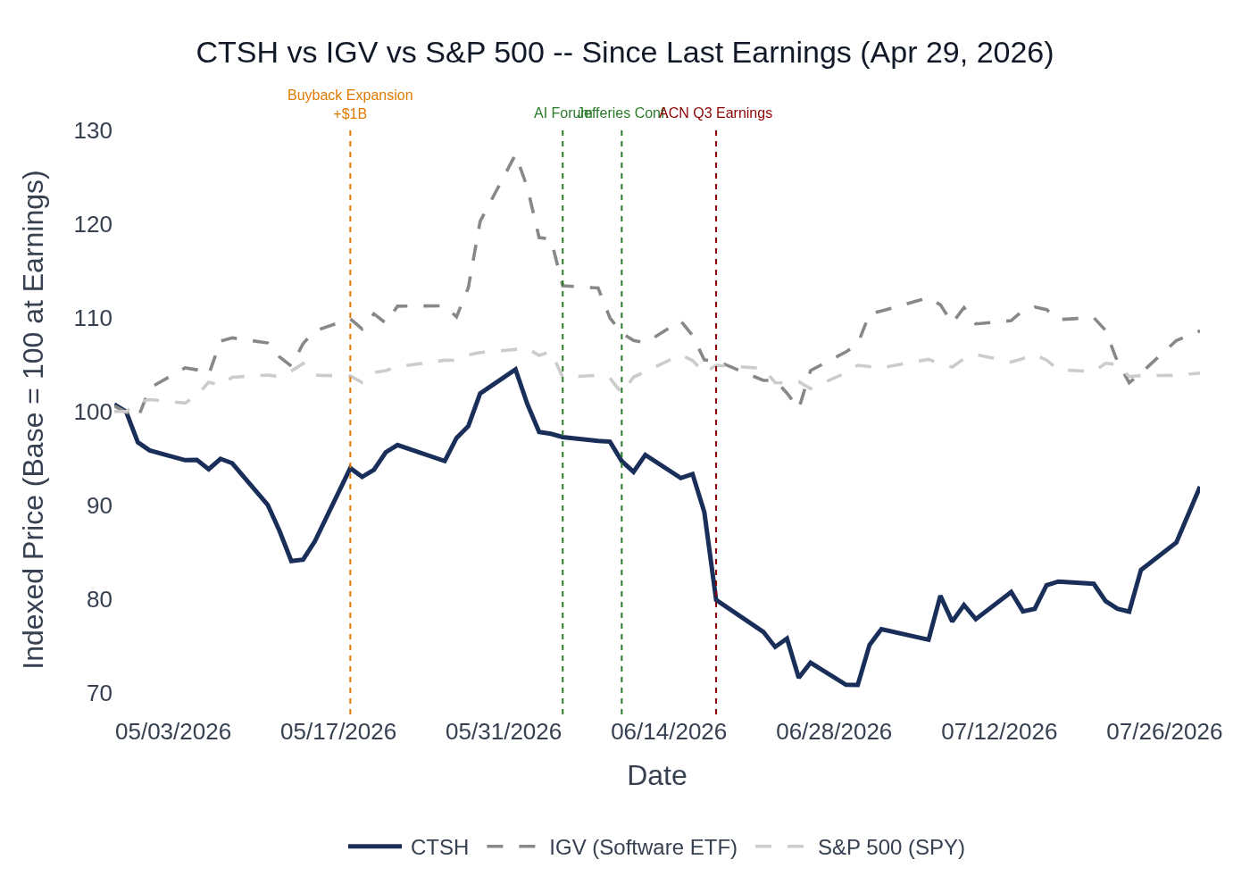
CTSH vs. IGV (iShares Expanded Tech-Software ETF) vs. S&P 500 — Indexed to 100 at Q1 2026 Earnings (April 29, 2026). Source: Stock Price Data.

Key Events Since Q1 2026 Earnings
- April 29, 2026: Q1 2026 earnings — stock fell sharply on Q2 guidance disappointment despite EPS beat. Revenue came in essentially in-line; Q2 guidance midpoint below consensus expectations.
- May 18, 2026: Buyback expansion announced (+$1B to $2B total 2026 target) — stock rallied ~11% that day from ~$45.97 to ~$51.40. Management framed as confidence signal in AI-led growth strategy.
- June 5, 2026: AI Forum — showcased AI Factory, TriZetto Unify headless API, context engineering deployment, and Sovereign Physical AI Platform. Stock declined as broader tech sold off.
- June 10, 2026: Jefferies Investor Conference — CFO confirmed no demand acceleration since Q1 earnings; discretionary recovery characterized as "2–4 quarters away." Stock continued lower.
- June 18, 2026: ACN Q3 FY26 earnings — Accenture flagged late-quarter discretionary weakness in products/resources; CTSH fell ~4.5% in sympathy.
- Late June 2026: Stock hit cycle lows (~$38.73 on June 30) as macro concerns intensified and broader IT services sector sold off.
- July 2026: Recovery to ~$50 as broader market stabilized and CTSH earnings approach. INFY (July 23) and IBM (July 22) earnings provided mixed read-throughs.

6. Material News & Developments
Key Takeaway: The most important development since Q1 earnings is the $1B buyback expansion (May 18), which signals management confidence in the AI strategy and undervalued share price — but the stock’s continued underperformance suggests the market wants revenue proof, not capital return signals.
- May 18, 2026 — Buyback Expansion ($1B to $2B Total 2026 Target): Cognizant raised its 2026 share repurchase target by $1B to $2B total, funded via revolving credit facility draw. Management framed this as a confidence signal in the AI-led growth strategy and a view that the current share price undervalues the opportunity. Incremental repurchases expected to be completed within Q2 2026. Implication: Bullish signal on management conviction, but market reaction was muted beyond the initial day rally; the stock subsequently gave back all gains and more.
- May 18, 2026 — JP Morgan TMT Conference: CEO Ravi Kumar reiterated AI builder strategy, highlighted mainframe migration pipeline, SAP migrations, and vulnerability remediation as new value pools. Confirmed 50% fixed-price / 10% outcome-based pricing mix. No guidance changes. Implication: Reinforces the long-term thesis but no near-term catalysts.
- June 5, 2026 — Cognizant AI Forum: Showcased (1) AI Factory (Dell/NVIDIA partnership with Fractional GPU technology), (2) TriZetto Unify headless API launch (May 29), (3) context engineering deployed across global sales force via Work Fabric (targeting ~$1B pipeline by year-end), (4) Sovereign Physical AI Platform-as-a-Service launch across 8 verticals, (5) Cognizant Secure AI Services (May 7) with expanded CrowdStrike alliance. Key clients including LPL Financial, Elevance Health, Citizens Bank, US Bank, Lineage Logistics, Sysco Foods, and TD Bank participated publicly. Implication: Validates AI strategy execution and client engagement depth, but near-term revenue impact is limited.
- June 10, 2026 — Jefferies Investor Conference: CFO Jatin Dalal confirmed demand environment unchanged since Q1 earnings — no acceleration in discretionary spend observed. Discretionary recovery characterized as "2–4 quarters away." ACV growth cited as the key metric to watch for discretionary recovery signal. Astreya had not yet closed as of this date (one month of revenue budgeted into Q2 guidance). Implication: Removes any hope of a positive demand surprise in Q2; reinforces the cautious near-term setup.
- July 1, 2026 — Q2 2026 Earnings Scheduled: Cognizant formally scheduled Q2 2026 earnings release and conference call (date TBD, expected late July/early August 2026).
- July 10, 2026 — Stockholder Derivative Settlement: Preliminary approval received for settlement of stockholder derivative action. Implication: Removes a legal overhang; modest positive.
- Ongoing — Project Leap Restructuring: $200M–$300M in savings expected in 2026 (full-year benefit in 2027); ~2/3 reinvested into AI capabilities and partnerships, ~1/3 into workforce upskilling. Charges of $230M–$320M expected primarily in 2026 ($200M–$270M employee severance, $30M–$50M other charges). Implication: Margin-accretive and growth-enabling; key driver of the FY 2026 margin guidance raise.

C. IBM — Q2 2026 Earnings (July 22, 2026) — Recent, Partial Read-Through
IBM’s Q2 2026 (April–June 2026) covers the same calendar period as CTSH’s Q2 2026. IBM is less directly comparable (hardware/software mix vs. pure IT services), but the consulting and AI commentary is relevant. IBM reported 1% revenue growth, with consulting +1% and software +5%.
Theme | IBM Commentary | CTSH Read-Through
Large Deal Slippage | "Tens of large deals failed to close on expected timelines" as clients redirected spending toward servers/storage/memory ahead of expected price increases. ~1/3 of slipped deals closed in first 3 weeks of Q3. | Cautionary — Large deal timing risk is real; CTSH’s Q2 revenue thesis depends on large deal ramps from Q4/Q1 wins. If clients are deferring large commitments, ramp assumptions could be at risk.
Consulting Growth | Consulting revenue grew 1% in Q2 2026; consulting signings grew 6% (second consecutive quarter of growth). Driven by application modernization, data transformation, and cybersecurity. | Mixed — Consulting growth is positive but modest; signings growth is encouraging for the pipeline.
GenAI Demand | GenAI represented ~50% of IBM consulting signings in Q2 2026 and now makes up >30% of backlog. "Clients remain in the early stages of AI adoption." | Positive — Validates the AI services demand thesis; enterprise AI adoption is accelerating and driving consulting demand.
Technology Spending Environment | "The technology spending environment remains dynamic." Clients evaluating how and where to deploy AI. Subscription/consumption-based software largely unaffected by CapEx dynamics. | Neutral — Consistent with CTSH’s own macro commentary; dynamic environment with bifurcated demand.
Full-Year Guidance | IBM revised full-year revenue growth guidance to 4%–5% (from "5%+"), citing Q2 software shortfall from large deal slippage. Low end considered base case. | Cautionary — A peer cutting full-year guidance raises the risk that CTSH’s own full-year guide could face pressure if large deal ramps disappoint.

Peer Read-Through Summary
Peer | Report Date | Calendar Period | Key Signal for CTSH | Net Read-Through
Accenture (ACN) | June 18, 2026 | Mar–May 2026 (Q2 2026) | Late-quarter discretionary softness in products/resources; BFSI and managed services strong; AI demand accelerating; fixed-price >60% | Mixed
Infosys (INFY) | July 23, 2026 | Apr–Jun 2026 (Q2 2026) | Guidance cut; soft volumes; AI pricing pressure; BFSI strong; large deal bookings healthy; manufacturing/European weakness | Cautious
IBM | July 22, 2026 | Apr–Jun 2026 (Q2 2026) | Large deal slippage; consulting +1%; GenAI 50% of signings; full-year guidance cut; dynamic spending environment | Cautious
Bottom Line: The peer read-through picture validates CTSH’s cautious Q2 guidance. Discretionary spend remains weak across the board, large deal timing risk is real (IBM), and pricing pressure from AI productivity is a shared headwind (INFY). The one consistent bright spot is BFSI, which is CTSH’s largest and fastest-growing vertical. The key question for CTSH’s Q2 print is whether its large deal ramp thesis — which management explicitly tied to June/July — is visible in the revenue line, or whether the broader industry softness has delayed those ramps.

8. Insider Transaction Activity
Key Takeaway: The standout transaction is Director Stephen Rohleder’s open-market purchase of 4,034 shares on June 10, 2026 — a discretionary buy at ~$51.81/share with no 10b5-1 plan, which is a meaningful bullish signal. All other transactions are routine RSU vesting and tax withholding.
Name | Title | Transaction Type | Shares | Approx. Value | Transaction Date | Note
Stephen J. Rohleder | Director | Open Market Buy | 4,034 | ~$209K | June 10, 2026 | Discretionary purchase; no 10b5-1 plan; occurred same day as Jefferies conference; bullish signal
Alina Kerdman | SVP, Controller & CAO | 10b5-1 Planned Sale | 137 | ~$7K | July 1, 2026 | Small 10b5-1 planned sale; routine; tax withholding related
Alina Kerdman | SVP, Controller & CAO | 10b5-1 Planned Sale | 154 | ~$8K | May 18, 2026 | Small 10b5-1 planned sale; routine; tax withholding related
Ravi Kumar Singisetti | CEO | RSU Vesting / Tax Withholding | 5,987 vested / 3,230 withheld | N/A | June 15, 2026 | Routine RSU vesting; tax withholding shares disposed; not a discretionary sale
Jatin P. Dalal | CFO | RSU Vesting / Tax Withholding | 2,494 vested / 1,346 withheld | N/A | June 15, 2026 | Routine RSU vesting; tax withholding shares disposed; not a discretionary sale
Multiple Directors (9) | Directors | RSU / DSU Grants | Various | N/A | May 27 / June 2, 2026 | Annual director equity grants; routine compensation; not open-market transactions
Notable: The Rohleder open-market buy on June 10 is the only discretionary insider purchase in the period. It occurred the same day as the Jefferies conference, when the CFO was publicly confirming no demand acceleration. A director buying at ~$51.81/share with no pre-planned program is a meaningful vote of confidence in the stock’s long-term value — particularly given the stock subsequently fell to ~$38.73 before recovering. No open-market sales by executives were recorded in the period. Source: SEC Form 4 Filings.

