Generac Holdings Inc. (GNRC) — Q2 2026 Earnings Preview
Earnings Date: July 29, 2026 (Before Market Open) Prepared: July 28, 2026

Earnings Preview
Key Takeaway: The setup is mixed — consensus is a manageable bar after Q1's massive beat, but the stock has given back -22.7% since earnings (vs XLI +7.4%, SPY +4.1%), suggesting the market is skeptical about the pace of data center revenue conversion and residential recovery. The wildcard is whether GNRC can confirm the June 2 hyperscale supply agreement is translating into Q2 revenue and provide an updated backlog figure.
Q2 2026 consensus calls for ~9–10% revenue growth (in line with management's own guide), driven entirely by C&I/data center, with residential roughly flat. After Q1's massive EPS beat (+$0.47 vs consensus), the bar is reset higher and the market will be focused on whether data center revenue is actually flowing through — the June 2 hyperscale supply agreement and the Sussex facility pulling forward to Q3 are key catalysts. Estimate revisions have been minimal since Q1 (revenue consensus barely moved, EPS up slightly), suggesting the Street is waiting for confirmation rather than getting ahead of the story. The stock's -22.7% decline since Q1 earnings (vs XLI +7.4%) reflects a valuation reset and BofA PT cut, not a fundamental deterioration — creating a potentially interesting setup if Q2 confirms the data center ramp. The wildcard is the backlog update: at Q1 it was >$700M (up ~$300M in one quarter); any further acceleration or a formal hyperscale contract announcement would be a significant positive catalyst.
- Bar: Consensus is a moderate bar — management guided Q2 revenue growth of ~9–10%, and consensus is right in line at ~$1.18B. EPS consensus of ~$2.01 is well above Q2 2025's $1.65 but below Q1 2026's $1.80 actual.
- Guidance/Tone: Management was highly confident on the Q1 call — raised FY guidance twice (revenue to mid-to-high teens, EBITDA margin to 18.5–19.5%). Tone was aggressive on the data center opportunity.
- Estimate Trajectory: Estimates have been largely stable since the Q1 print — no meaningful revision up or down, suggesting the Street is in wait-and-see mode.
- Stock Setup: Stock has de-rated sharply (-22.7% since Q1 earnings vs XLI +7.4%), driven by BofA PT cut and pre-earnings risk reduction. Multiple has compressed, creating a lower bar for a positive reaction.
- Wildcard: Backlog update and hyperscale vendor approval status — management said they were in "final stages" with two hyperscale customers at Q1; any formal approval announcement would be a step-change catalyst.

KPIs & Consensus Expectations
Key Takeaway: Consensus is a manageable bar on revenue (in line with guidance), but EPS expectations are elevated vs. prior year. The bigger swing factor is C&I segment revenue and EBITDA margin — both need to confirm the data center ramp is real.

Table 1 — Current Quarter Snapshot (Q2 2026)
KPI | Q1 2026 Actual | Q2 2025 Actual | Q2 2026 Consensus | YoY Change | Guidance | Consensus vs. Guidance
Net Sales ($M) | $1,059.4M | $1,061.2M | $1,180.0M | +11.2% | ~9–10% growth (~$1,165–1,168M) | +1.0% above midpoint
Net Sales — C&I ($M) | $510.1M | $430.6M | $535.4M | +24.3% | Mid-to-high 20% growth | In line
Net Sales — Residential ($M) | $552.2M | $634.7M | $648.5M | +2.2% | ~10% growth | In line
Adj. EBITDA ($M) | $193.5M | $187.6M | $216.9M | +15.6% | ~18% range | In line
Adj. EBITDA Margin (%) | 18.3% | 17.7% | 18.4% | +70bps | ~18% range | +40bps above midpoint
Gross Margin (%) | 38.7% | 39.3% | 38.7% | -60bps | 38.5–39.5% FY range | In range
Diluted EPS — Operating | $1.80 | $1.65 | $2.01 | +21.8% | N/A (no Q2 EPS guide) | N/A
Free Cash Flow ($M) | $89.9M | $14.5M | $65.8M | +354% | ~$350M FY | Tracking
Source: Visible Alpha consensus as of July 28, 2026. Q2 2026 guidance from Q1 2026 earnings call (April 29, 2026).

Table 2 — Beat/Miss History (Last 8 Quarters, Top 2 KPIs)
Quarter | Net Sales Reported | Net Sales Consensus | Revenue Surprise | Revenue Result | EPS Reported | EPS Consensus | EPS Surprise | EPS Result
Q1 2026 | $1,059.4M | $1,047.5M | +1.1% | Beat | $1.80 | $1.33 | +35.3% | Large Beat
Q4 2025 | $1,091.5M | $1,159.9M | -5.9% | Miss | $1.61 | $1.76 | -8.5% | Miss
Q3 2025 | $1,114.4M | $1,192.9M | -6.6% | Miss | $1.83 | $2.22 | -17.6% | Miss
Q2 2025 | $1,061.2M | $1,026.8M | +3.3% | Beat | $1.65 | $1.32 | +25.0% | Beat
Q1 2025 | $942.1M | $919.4M | +2.5% | Beat | $1.26 | $0.99 | +27.3% | Beat
Q4 2024 | $1,234.8M | $1,243.4M | -0.7% | Slight Miss | $2.80 | $2.52 | +11.1% | Beat
Q3 2024 | $1,173.6M | $1,162.5M | +1.0% | Beat | $2.25 | $1.99 | +13.1% | Beat
Q2 2024 | $998.2M | $999.9M | -0.2% | In Line | $1.35 | $1.22 | +10.7% | Beat
Pattern: GNRC has a strong EPS beat history (7 of 8 quarters), but revenue has been more mixed — the Q3/Q4 2025 misses were driven by the weak outage environment. Q1 2026's massive EPS beat (+35%) was driven by cost savings and margin expansion, not just revenue. The Street has historically underestimated GNRC's margin leverage.

Guidance & Commentary Evolution
Key Takeaway: Management raised FY 2026 guidance on the Q1 call and has made no formal revisions since. The June 2 hyperscale supply agreement and June 15 Belvidere facility acquisition are positive incremental developments but did not come with updated financial guidance.
Metric | Initial Guidance (Q1 2026 Call, Apr 29) | Revised Guidance | Current Consensus | Note
FY 2026 Net Sales Growth | Mid-to-high teens % | — | ~$4.93B (+15.5% YoY) | No formal revision since Q1 call
Q2 2026 Net Sales Growth | ~9–10% | — | ~$1.18B (+11.2% YoY) | Consensus slightly above guidance midpoint
FY 2026 Adj. EBITDA Margin | 18.5–19.5% | — | 19.1% | Consensus at midpoint
FY 2026 Gross Margin | 38.5–39.5% | — | 38.9% | In range
FY 2026 Free Cash Flow | ~$350M | — | ~$360M | Consensus slightly above
C&I Segment Growth | Mid-to-high 20% | — | ~$2.21B (+24.5% YoY) | In line with guidance
Residential Segment Growth | ~10% | — | ~$2.73B (+10.0% YoY) | In line with guidance
Q2 2026 Adj. EBITDA Margin | ~18% range | — | 18.4% | Slightly above guidance

Guidance vs. Estimate Revision Tracker
Key Takeaway: Estimates have been remarkably stable since Q1 earnings — the Street is essentially holding guidance midpoints and waiting for Q2 confirmation. The lack of upward revision despite the June 2 hyperscale deal suggests analysts are treating it as a 2027+ revenue event rather than a near-term catalyst.
KPI | Period | Estimate (May 6, 2026) | Current Consensus | Estimate Δ (%) | Initial Guidance (Q1 Call) | Current Guidance | Guidance Δ | Consensus vs. Guidance
Net Sales | Q2 2026 | $1,177.7M | $1,180.0M | +0.2% | ~$1,165–1,168M | Unchanged | — | +1.0% above midpoint
Net Sales | FY 2026 | $4,922.9M | $4,927.2M | +0.1% | Mid-to-high teens | Unchanged | — | In line
Adj. EBITDA Margin | Q2 2026 | 18.3% | 18.4% | +10bps | ~18% range | Unchanged | — | +40bps above midpoint
Adj. EBITDA Margin | FY 2026 | 19.1% | 19.1% | Flat | 18.5–19.5% | Unchanged | — | At midpoint
Diluted EPS — Operating | Q2 2026 | $1.97 | $2.01 | +2.0% | N/A | N/A | — | N/A
Diluted EPS — Operating | FY 2026 | $8.93 | $8.94 | +0.1% | N/A | N/A | — | N/A
The near-zero estimate revisions since Q1 are notable — the June 2 hyperscale supply agreement announcement (which sent the stock up ~8% on the day) did not translate into meaningful estimate upgrades. This suggests the Street is treating the deal as a 2027+ revenue event rather than a Q2/Q3 2026 catalyst, which could create upside if management provides more specific near-term revenue guidance on the Q2 call.
Source: Visible Alpha consensus. Estimate baseline as of May 6, 2026 (5 trading days post Q1 earnings). Current consensus as of July 28, 2026.

Stock Performance
Key Takeaway: GNRC has dramatically underperformed since Q1 earnings (-22.7% vs XLI +7.4%, SPY +4.1%), driven by a valuation reset and pre-earnings risk reduction — not a fundamental deterioration. The stock briefly rallied to +17% above Q1 earnings close on the June 2 hyperscale deal before reversing sharply.
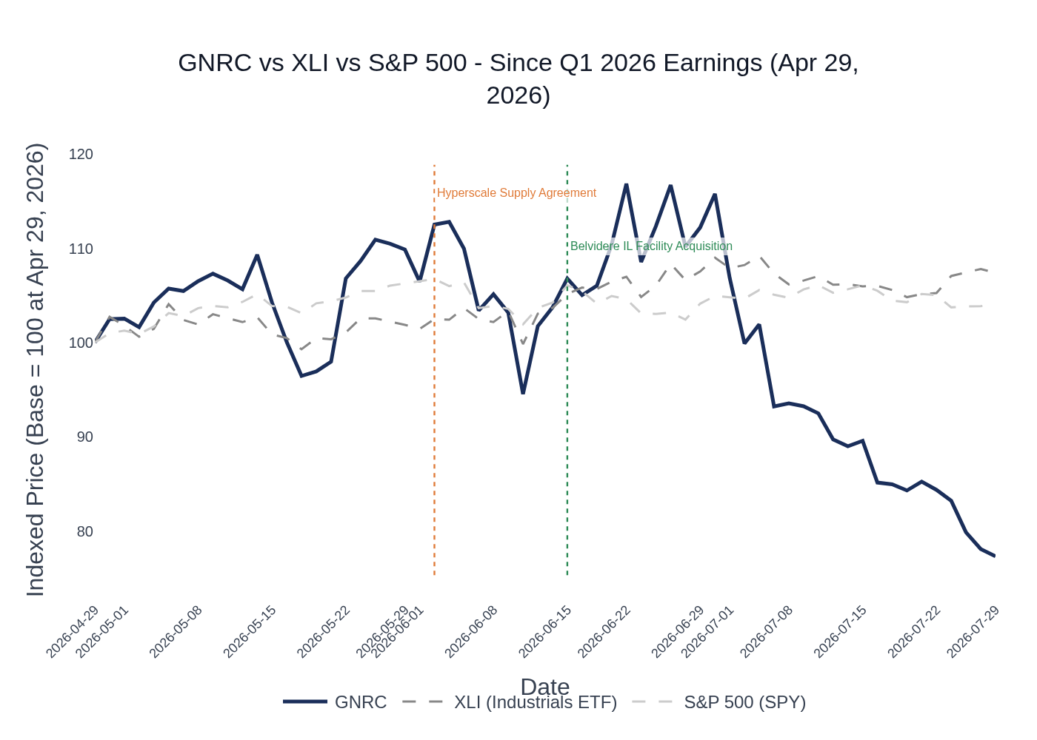
GNRC vs XLI (Industrials ETF) vs S&P 500 — Indexed to 100 at Q1 2026 Earnings (Apr 29, 2026). Key events: June 2 Hyperscale Supply Agreement (orange), June 15 Belvidere IL Facility Acquisition (green). Source: Stock Price Data.
- BofA PT cut (early July): Bank of America lowered its price target to $224 from $236 (maintaining Buy), citing data center strategy concerns — contributed to ~10% single-day decline on July 7.
- Pre-earnings risk reduction: Stock down 3.6% on July 27 alone as investors reduced exposure ahead of the July 29 print.
- Post-Q1 rally then reversal: Stock surged ~17% on Q1 earnings day (Apr 29), then rallied further to ~+17% on the June 2 hyperscale deal before giving back all gains and more.
- Valuation reset: Multiple has compressed significantly from post-Q1 peak; analyst consensus target of ~$285 implies ~45% upside from current ~$197 level.
- Sector ETF used: XLI (Industrial Select Sector SPDR ETF) — appropriate for GNRC's industrial/power equipment sub-sector.

Peer Commentaries — Read-Throughs for Q2 2026
Key Takeaway: Peer commentary from Q1 2026 earnings calls (reported after GNRC's Q1 on April 29) is uniformly bullish on data center power demand — Eaton, Caterpillar, and Cummins all raised their power generation outlooks and described accelerating order activity. This is a strong positive read-through for GNRC's C&I/data center segment. Enphase's Q2 2026 results (reported July 28) show continued pressure in US residential solar/storage, a modest negative read-through for GNRC's residential energy technology segment.

C&I / Data Center Power — Strongly Positive Read-Through

Eaton (ETN) — Q1 2026 Earnings (May 5, 2026)
- Data center orders up 240% on a rolling 12-month basis; Electrical Americas organic sales up 14%, with data centers up ~50%.
- Total data center backlog grew to 228 gigawatts (12 years of backlog at 2025 build rates), up from 11 years previously; book-to-bill ratio increased to 1.2x.
- Raised organic growth outlook by 200bps to 10% midpoint; record backlogs in both Electrical and Aerospace.
- Management quote: "The urgency has increased. The scale of deployments is larger and the technical complexity is creating opportunities for companies that can solve system-level problems."
- GNRC Read-Through: Confirms the data center power infrastructure buildout is accelerating, not decelerating. Eaton's 240% order growth and 12-year backlog validate GNRC's own backlog expansion and hyperscale vendor approval timeline.

Caterpillar (CAT) — Q1 2026 Earnings (April 30, 2026)
- Power generation sales grew 48%, driven by strong demand for large gensets and turbines for data center applications; increasing mix toward prime power.
- Large reciprocating engine backlog has grown more than 3.5x since January 2024; customers committing to orders well into 2028.
- Announced agreement to provide PROPWR up to 2.1 gigawatts of large gas generator sets — sixth agreement with at least 1 gigawatt for prime power applications.
- Increasing large reciprocating engine capacity from 2x to nearly 3x 2024 levels; expects incremental units as early as 2027.
- Management quote: "Not every data center is going to go behind the meter either, and those are going to drive a lot of backup demand."
- GNRC Read-Through: CAT's 48% power generation growth and 3.5x backlog expansion directly validates GNRC's data center opportunity. Critically, CAT notes backup power is growing alongside prime power — not being displaced — which is directly relevant to GNRC's backup generator business model.

Cummins (CMI) — Q1 2026 Earnings (May 5, 2026)
- Global power generation revenues projected to increase 15–25% for FY 2026 (raised from 10–20%), driven by accelerating data center demand.
- Power Systems segment delivered record EBITDA of 29.5% of sales; revenues up 19%.
- China data center demand surging — power generation equipment sales in China up 84% in Q1; full-year China revenue outlook raised to +10% (from -1% prior).
- Management quote: "Robust global demand for power generation equipment throughout the year; investing in raising capacities to meet even stronger demand."
- GNRC Read-Through: CMI's raised power generation guidance and record Power Systems margins confirm the data center demand environment is stronger than expected. The international data center demand validates the global secular trend underpinning GNRC's multi-year growth thesis.

Vertiv (VRT) — Q1 2026 Earnings (April 22, 2026)
- Q2 2026 guidance: net sales of $3.35B (+27% YoY), adjusted EPS of $1.40 (+47% YoY); adjusted operating margins guided to 21.2% (+270bps).
- Backlog "a little bit more elongated," providing good visibility into 2027; pipeline generation described as "robust"; orders expected up year-over-year.
- "We're still in the early stages of the infrastructure build-out for AI" — broad-based strength across hyperscale, colo, and Neo cloud globally.
- Management quote: "The urgency has increased. The scale of deployments is larger."
- GNRC Read-Through: VRT's 27% Q2 revenue growth guidance and elongated backlog (12–18 month delivery windows) directly mirrors GNRC's own backlog dynamics. VRT's commentary that they are "still in early stages" of AI infrastructure buildout is the most important read-through — it suggests GNRC's data center opportunity is multi-year, not a one-time pull-forward.

Residential Energy / Solar & Storage — Cautious Read-Through

Enphase Energy (ENPH) — Q2 2026 Earnings (July 28, 2026)
- US sell-through declined 34% year-over-year in Q2 2026, reflecting continued pressure from higher interest rates and expiration of the 25D tax credit.
- US revenue declined 3% sequentially; distributors remain cautious amid macroeconomic uncertainty including interest rates.
- Stabilization signals emerging: industry-wide permits in June increased 4% from May and upstream sales activity rose 5%, though both remain ~30% below prior year levels.
- Battery attachment near 40% nationally; battery shipments of 113.8 MWh exceeded high end of guidance — storage demand holding up better than solar.
- Q3 2026 guidance: revenue $290–320M (+5% at midpoint); global sell-through expected to increase 10% vs Q2.
- GNRC Read-Through: ENPH's continued US residential solar weakness is a modest negative read-through for GNRC's residential energy technology segment (solar/storage). However, GNRC's residential energy tech is a small part of the business and management has already guided for an "air pocket" through 2026. The stabilization signals (permits up 4% in June) are mildly encouraging for GNRC's 2027 energy tech recovery thesis. Battery attachment near 40% is a positive for the broader home energy ecosystem.

Material News & Developments
Key Takeaway: The June 2 hyperscale supply agreement is the most significant development since Q1 earnings — it validates GNRC's data center pivot and confirms vendor approval progress. The Belvidere facility acquisition (June 15) demonstrates continued capacity investment to meet accelerating demand.
- June 2, 2026 — Hyperscale Supply Agreement: Generac signed a global supply agreement with a leading hyperscale data center operator to supply backup power generators. The agreement followed a rigorous qualification process including factory visits, performance reviews, and audits. Shares surged ~8% on the announcement. Widely speculated to be connected to the Stargate AI data center project (OpenAI/Oracle/SoftBank). Implication: Validates GNRC's vendor approval progress and confirms it is winning hyperscale business — the key debate heading into Q2.
- June 15, 2026 — Belvidere, IL Facility Acquisition: Generac acquired a new facility in Belvidere, Illinois to expand large-megawatt generator packaging capacity. The facility will complement Enercon's operations (acquired April 1) and expand enclosure assembly and final packaging capacity. Expected to add 100+ jobs when it opens in Q1 2027. Implication: Demonstrates management is investing ahead of demand — consistent with the Sussex facility pull-forward to Q3 2026.
- July 15, 2026 — Q2 Earnings Date Announcement: Generac confirmed Q2 2026 earnings release on July 29, 2026 (before market open), with conference call at 10:00 AM EDT.
- Early July 2026 — Bank of America PT Cut: BofA lowered its price target on GNRC to $224 from $236 (maintaining Buy rating), citing data center strategy concerns. Contributed to the stock's ~10% decline on July 7. Implication: Even with a Buy rating, the PT cut reflects analyst caution about the pace of data center revenue conversion — the key question for Q2.
- Analyst Consensus: 11 Buy, 6 Hold, 0 Sell ratings; median price target ~$285 (vs. current ~$197). Significant upside implied if Q2 confirms the data center ramp. Recent upgrades include Jefferies (Hold to Buy, PT $302) and UBS (PT raised to $335).
- Sussex, WI Facility Update: Management pulled forward production start from Q4 to Q3 2026 at Q1 earnings — Q2 call should provide an update on whether this is on track and whether it contributed to Q2 C&I revenue.

Insider Transaction Activity
Key Takeaway: CEO Aaron Jagdfeld has been selling shares on a regular 10b5-1 plan (5,000 shares/month), which is routine and not a signal. No open-market discretionary buys from any insider since Q1 earnings — notable absence given the stock's -22.7% decline.
Name | Title | Transaction Type | Shares | Value (Approx.) | Filing Date | Note
Aaron Jagdfeld | CEO | 10b5-1 Planned Sale | 5,000 | ~$986K | July 2, 2026 | Routine monthly 10b5-1 plan; 3rd consecutive month
Norman P. Taffe | President, Generac Home | Option Exercise + Sale | 550 (net) | ~$109K | July 7, 2026 | Exercise of stock options + sale; 10b5-1 plan
Aaron Jagdfeld | CEO | 10b5-1 Planned Sale | 5,000 | ~$1.43M | June 3, 2026 | Routine monthly 10b5-1 plan
Norman P. Taffe | President, Generac Home | Option Exercise + Sale | 550 (net) | ~$144K | June 8, 2026 | Exercise of stock options + sale; 10b5-1 plan
Aaron Jagdfeld | CEO | 10b5-1 Planned Sale | 5,000 | ~$1.30M | May 5, 2026 | Routine monthly 10b5-1 plan
Multiple Directors (7) | Board | Equity Award | 699–825 each | N/A | May 5, 2026 | Annual director equity compensation grants; not open-market
All insider sales are 10b5-1 planned sales — pre-scheduled and not discretionary. The CEO's consistent 5,000 share/month sales are routine. The notable signal is the absence of any open-market buying despite the stock's -22.7% decline since Q1 earnings — insiders are not stepping in to buy the dip, which is a mild negative signal but not alarming given the 10b5-1 plan context.
Source: SEC Form 4 filings via Insider Transaction Data.

