HUBB — Q2 2026 Earnings Preview
Hubbell Incorporated (HUBB) | Earnings Date: July 28, 2026 | Prepared: July 27, 2026

Earnings Preview
Key Takeaway: The setup into Q2 is constructive — management guided explicitly for high-single-digit organic growth and price/cost neutrality, and the bar appears achievable given strong T&D order momentum and data center demand; the key swing factor is whether Electrical Solutions margins can recover from Q1's restructuring-driven headwind.
Hubbell heads into Q2 2026 with management having explicitly guided for high-single-digit organic growth and price/cost productivity neutrality on a dollar basis — a specific, trackable bar that limits downside surprise risk. The Q1 print beat on both revenue and EPS (adjusted EPS of $3.93, +16% YoY), and the company raised full-year organic growth guidance to 6–9% (from 5–7%) and adjusted EPS to $19.30–$19.85, though the stock fell ~6–7% on the day as investors appeared disappointed by the modest EPS raise (lower end only) and the slightly trimmed full-year margin expansion outlook. Since then, HUBB has underperformed XLI by roughly 7 points, suggesting the stock has de-rated modestly and the bar into Q2 is not elevated. The NSI Industries acquisition (closed June 9, 2026 for ~$3B) adds a new variable — management guided for EPS accretion of ~$0.15–$0.20 in 2026 and margin accretion to the Electrical segment — but integration execution and deal financing costs (new $1.9B senior notes + $900M term loan) will be closely watched. The wildcard is Electrical Solutions margin: Q1 margins were down 30bps YoY due to $6M in restructuring charges (vs. $2M prior year), and management guided for a slight margin headwind in H1 before normalization in H2 — any sign of faster recovery or further pressure will drive the stock reaction.

KPIs & Consensus Expectations
Key Takeaway: Consensus is a moderate bar — high-single-digit organic growth is explicitly guided, and the Street is tracking close to management’s framework; Electrical Solutions margin recovery is the bigger swing factor than revenue.
Table 1 — Current Quarter Snapshot (Q2 2026)
KPI | Q1 2026 Actual | Q2 2025 Actual | Q2 2026 Consensus | YoY Change | Guidance | Consensus vs. Guidance
Net Sales ($M) | $1,516.7M | $1,484.3M | $1,665.3M | +12.2% | High-single-digit organic growth | ~+12% total (incl. NSI acq.)
Net Sales – Utility ($M) | $948.9M | $935.5M | $1,043.7M | +11.6% | High-single-digit organic | In line with guide
Net Sales – Electrical ($M) | $567.8M | $548.8M | $619.0M | +12.8% | Mid-to-high single-digit organic | In line with guide
Adj. Operating Income ($M) | $300.7M | $362.2M | $401.6M | +10.9% | Double-digit adj. op. profit growth | In line
Adj. Operating Margin (%) | 19.8% | 24.4% | 24.1% | -30bps | ~20bps expansion FY; slight H1 headwind | Slight headwind vs. prior year expected
Adj. EPS (Diluted) | $3.93 | $4.93 | $5.38 | +9.1% | FY $19.30–$19.85 | Tracking to midpoint
Total Organic Growth (%) | 8.2% | 2.0% | ~8.8% | +680bps | High-single-digit | In line
Note: Q2 2026 consensus from Visible Alpha as of July 27, 2026. NSI Industries (closed June 9, 2026) adds acquisition revenue to Q2 totals; organic growth guidance of high-single-digit excludes acquisition impact.
Table 2 — Beat/Miss History (Last 8 Quarters)
Net Sales Beat/Miss
Quarter | Reported ($M) | Consensus ($M) | Surprise % | Result
Q2 2024 | $1,452.5M | $1,490.3M | -2.5% | Miss
Q3 2024 | $1,442.6M | $1,480.8M | -2.6% | Miss
Q4 2024 | $1,334.3M | $1,401.2M | -4.8% | Miss
Q1 2025 | $1,365.2M | $1,383.9M | -1.4% | Miss
Q2 2025 | $1,484.3M | $1,513.2M | -1.9% | Miss
Q3 2025 | $1,502.4M | $1,527.2M | -1.6% | Miss
Q4 2025 | $1,492.7M | $1,487.6M | +0.3% | Beat
Q1 2026 | $1,516.7M | $1,504.7M | +0.8% | Beat
Adj. EPS Beat/Miss
Quarter | Reported ($) | Consensus ($) | Surprise % | Result
Q2 2024 | $4.44 | $4.24 | +4.7% | Beat
Q3 2024 | $4.62 | $4.47 | +3.4% | Beat
Q4 2024 | $4.13 | $4.02 | +2.7% | Beat
Q1 2025 | $3.38 | $3.73 | -9.4% | Miss
Q2 2025 | $4.93 | $4.40 | +12.0% | Beat
Q3 2025 | $5.17 | $4.99 | +3.6% | Beat
Q4 2025 | $4.73 | $4.71 | +0.4% | Beat
Q1 2026 | $3.93 | $3.88 | +1.3% | Beat
Pattern: HUBB has beaten adj. EPS consensus in 7 of the last 8 quarters (exception: Q1 2025, a seasonally weak quarter). Revenue has historically run slightly below consensus, with the trend reversing in Q4 2025 and Q1 2026 as destocking headwinds cleared.

Guidance & Commentary Evolution
Key Takeaway: Full-year organic growth guidance was raised at Q1 to 6–9% (from 5–7%), driven by incremental pricing and T&D/data center demand visibility; no post-earnings guidance revision has been issued, but Wells Fargo conference commentary (June 9) confirmed continued order strength and NSI accretion.
Metric | Initial Guidance (Q1 2026 Earnings, Apr 30) | Revised Guidance | Current Consensus | Note
Total Organic Growth (FY) | 6–9% | — | ~8.1% | Raised from 5–7% at Q1; no further revision
Adj. EPS (FY 2026) | $19.30–$19.85 | — | ~$19.84 | Lower end raised at Q1; upper end unchanged
Q2 Organic Growth | High-single-digit | — | ~8.8% | Explicit Q2 guide given on Q1 call
Adj. Operating Margin (FY) | ~20bps expansion | — | ~23.0% | Slightly trimmed vs. initial; H1 headwind, H2 recovery
Utility Solutions Organic (FY) | High-single-digit | — | ~8.8% | Raised from mid-single-digit at Q1
Electrical Solutions Organic (FY) | Mid-to-high single-digit | — | ~8.8% | Unchanged; data center >25% growth FY
NSI EPS Accretion (2026) | ~$0.15–$0.20 (analyst est. confirmed) | — | Included in FY guide | Closed June 9; management confirmed analyst math
Price/Cost (Q2) | Approximately neutral on dollar basis | — | N/A | Explicit Q2 guidance; price actions effective April
No post-earnings 8-K guidance revision has been filed. At the Wells Fargo Industrials & Materials Conference (June 9, 2026), management confirmed orders remain supportive of full-year indications, T&S growth rates are “exceeding high-single digits,” and the latest tariff regime change is “neutral to Hubbell.” NSI closed on June 9, 2026 — the first quarter with NSI contribution will be Q2 2026.

Guidance vs. Estimate Revision Tracker
Key Takeaway: Estimates have moved modestly higher since Q1 earnings — Q2 revenue consensus is up ~$18M and FY EPS is tracking near the top of the guidance range; the revision trend is constructive but not aggressive, suggesting the Street is not pricing in a large beat.
KPI / Period | Estimate (May 7, 2026) | Current Consensus (Jul 27, 2026) | Estimate Δ (%) | Initial Guidance (Q1 Call) | Current Guidance | Guidance Δ | Consensus vs. Guidance
Net Sales – Q2 2026 | $1,647.6M | $1,665.3M | +1.1% | High-single-digit organic | Unchanged | — | In line
Net Sales – FY 2026 | $6,422.4M | $6,574.1M | +2.4% | 8–11% total growth | Unchanged | — | In line
Adj. EPS – Q2 2026 | $5.33 | $5.38 | +0.9% | FY $19.30–$19.85 | Unchanged | — | Tracking to top of range
Adj. EPS – FY 2026 | $19.73 | $19.84 | +0.6% | $19.30–$19.85 | Unchanged | — | Near top of range
Adj. Op. Margin – Q2 2026 | 24.0% | 24.1% | +10bps | Slight H1 headwind | Unchanged | — | Slight improvement vs. initial
Estimates have drifted modestly higher since Q1 earnings, consistent with NSI accretion being incorporated and continued T&D/data center demand visibility. The FY EPS consensus of ~$19.84 sits near the top of the $19.30–$19.85 guidance range, suggesting the Street is already pricing in a clean execution quarter with NSI contribution — leaving limited room for upside surprise on EPS unless margins outperform.

Stock Performance
Key Takeaway: HUBB has underperformed XLI by ~7 points since Q1 earnings, driven by multiple compression following the post-earnings selloff — the stock has de-rated despite constructive fundamentals, suggesting the bar into Q2 is not elevated.
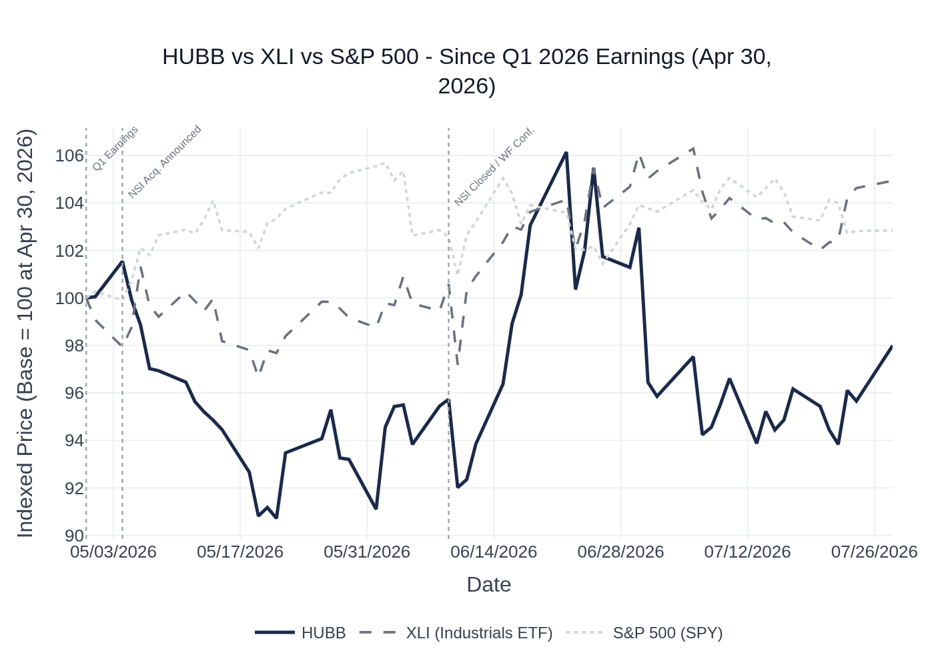
HUBB vs. XLI vs. S&P 500 — Indexed to 100 at Q1 2026 Earnings (April 30, 2026)
HUBB closed at $508.17 on Q1 earnings day (April 30, 2026), fell ~6–7% from the prior close of $545.93, and has since traded in a range of ~$461–$540. As of July 24, 2026, HUBB is indexed at ~98 vs. XLI at ~105 and SPY at ~103 — a meaningful underperformance driven by the post-earnings de-rating. The stock briefly recovered to ~$540 in mid-June (around NSI close) before pulling back. The underperformance vs. XLI suggests HUBB-specific concerns (NSI integration risk, margin trajectory, valuation) rather than sector-wide weakness. XLI (Industrials Select Sector SPDR ETF) is used as the sector benchmark given HUBB’s classification in the Electrical Equipment & Instruments sub-industry.

Material News & Developments
Key Takeaway: The NSI Industries acquisition (closed June 9, 2026) is the dominant post-earnings development — at $3B, it is the largest deal in HUBB’s history and will be the primary focus of Q2 commentary alongside the first look at integration progress.
- June 9, 2026 — NSI Industries acquisition closed for ~$3B in cash. NSI is a leading manufacturer of electrical fittings, connectors, and wire management products (brands: Bridgeport, Polaris, Tork), with 15,000+ branded products across 2,000+ North American distributors. ~10% of NSI revenues are data center-exposed. Management confirmed ~$0.15–$0.20 EPS accretion in 2026 and margin accretion to Electrical Solutions. This is the first quarter with NSI in the P&L — integration execution and revenue synergy commentary will be closely watched.
- June 9, 2026 — Wells Fargo Industrials & Materials Conference. Management confirmed orders remain supportive of full-year guidance, T&S growth rates are “exceeding high-single digits,” grid automation returning to slight growth in Q2, and the latest tariff regime change is “neutral to Hubbell.” Second round of price increases effective April 2026 confirmed. 765kV opportunity sized at ~$1.5B over 10 years; first large-scale project awarded earlier in 2026 with shipments expected early 2027.
- May 15, 2026 — $900M Term Loan Agreement filed (8-K). Hubbell secured a new $900M unsecured term loan to partially finance the NSI acquisition, alongside ~$1.9B in newly issued senior notes. Net leverage will increase meaningfully post-close; management has indicated a commitment to deleveraging.
- May 4, 2026 — NSI Industries acquisition announced ($3B cash). Largest acquisition in HUBB history. Financed via ~$1.9B senior notes + $900M term loan + commercial paper. Management compared strategic significance to the Burndy acquisition.
- May 6, 2026 — Annual Meeting. All director nominees elected, executive pay and auditor approved (8-K).
- July 13, 2026 — Q2 2026 earnings date announced. HUBB confirmed results will be released July 28, 2026.
- Peer Read-Through — Eaton (ETN) Q1 2026: Electrical Americas data center revenues +~50% YoY; guided Q2 organic growth 9–11% and FY organic 9–11% with adj. EPS $13.05–$13.50. Strong read-through for utility/electrical demand.
- Peer Read-Through — ABB Q2 2026 (reported July 16): Record orders of ~$12B (+28% comparable); electrification orders +58% with data center orders up triple digits; revenues +12% comparable; raised FY guidance to low double-digit to low-teens comparable revenue growth. Highly constructive read-through for HUBB’s utility and electrical segments.
- Peer Read-Through — Quanta Services (PWR) Bernstein Conference (May 28): Utility CapEx budgets growing at “plus 20%” vs. 8–9% CAGR just 1–2 years ago; transmission build-out extending “well past 2030”; 765kV projects creating “10x multiplier” for lower-voltage offshoots. Constructive for HUBB’s T&D components demand.

Peer Commentaries — Q2 2026 Read-Throughs (Last 60 Days)
Key Takeaway: Peer commentary from ABB (Q2 actuals), Eaton (Q2 guidance), and Quanta Services (conference) is uniformly constructive for HUBB’s core end markets — data center electrification demand is accelerating, utility T&D CapEx budgets are expanding at 20%+, and pricing is being accepted in the channel.
Note: The following peer commentaries are sourced from events occurring after HUBB’s Q1 2026 earnings (April 30, 2026) and are relevant to HUBB’s Q2 2026 reporting period. Commentary from peers’ own prior-quarter results discussions (i.e., peers talking about their own Q1 results) is excluded; only forward-looking commentary about current market conditions and Q2/H2 2026 outlook is included.

ABB — Q2 2026 Earnings (Reported July 16, 2026)
Most Relevant — Direct Read-Through
ABB reported a record quarter with orders of ~$12B (+28% comparable) and revenues of $9.5B (+12% comparable), with the electrification segment — HUBB’s most direct analog — delivering orders of $7B (+58% comparable) and revenues of $5.2B (+19% comparable) at a record 24.9% operational EBITDA margin. Key read-throughs for HUBB:
- Data Center Demand: “Data center stands out with a triple-digit order increase” in electrification. ABB noted data center orders in the backlog extend into 2028, not just 2027. “The market is clearly very supportive, and we are performing well in this strong market.” Even excluding data centers, electrification orders grew double digits. This is a strong positive read-through for HUBB’s data center-exposed Electrical Solutions segment (~10% of revenues direct, larger indirect via utility T&D).
- Utility Grid: “The utility segment… the market is strong with investments in grid build-out, stability, and reliability.” ABB noted a challenging comparable in utility orders in Q2 but strong sequential improvement vs. Q1. Demand for grid stabilization technologies (synchronous condensers) remains good. Constructive for HUBB’s Grid Infrastructure business.
- Pricing: ABB achieved ~2% pricing contribution in Q2, consistent with HUBB’s framework of price/cost neutrality. “The teams balancing customer relationships and defending our own profitability.”
- Capacity Expansion: ABB is expanding capacity aggressively (US, China, India, $200M Europe expansion announced in Q2), noting “capacity coming online based on previous years’ investments is giving the expected benefits.” This mirrors HUBB’s own capacity investment narrative.
- Q3 Outlook: ABB guided Q3 comparable revenue growth of “low to mid-teens” YoY with sequential margin improvement — a bullish forward signal for the broader electrification/grid infrastructure market heading into HUBB’s Q3.

Eaton (ETN) — Q1 2026 Earnings & Q2 Guidance (Reported May 5, 2026)
Eaton reported Q1 2026 adj. EPS of $2.81 (beat vs. $2.73 consensus) and guided Q2 adj. EPS of $3.00–$3.10 with organic growth of 9–11%. Full-year guidance raised to organic growth of 9–11% and adj. EPS of $13.05–$13.50. Key read-throughs for HUBB:
- Data Center: Electrical Americas data center revenues rose approximately 50% YoY in Q1 2026. Eaton raised its full-year data center outlook, consistent with HUBB’s own >25% data center growth guide. Eaton’s Q2 organic growth guide of 9–11% (above HUBB’s high-single-digit guide) suggests the electrical/utility market is running hot.
- Segment Margins: Eaton guided segment margins of 24.1–24.5% for FY 2026 — above HUBB’s ~23% operating margin — but the directional trend (margin expansion on volume growth) is consistent with HUBB’s framework.
- Pricing: Eaton’s ability to push through price increases in the electrical channel is a positive read-through for HUBB’s own April 2026 price actions.

Quanta Services (PWR) — Bernstein Strategic Decisions Conference (May 28, 2026)
Quanta’s CEO Earl Austin provided extensive commentary on utility infrastructure demand that is highly relevant to HUBB’s Utility Solutions segment:
- Utility CapEx Acceleration: “Multi-year utility CapEx budgets, which were growing at 8–9% CAGR just one or two years ago, are now showing growth rates of plus 20%.” This is a significant acceleration that directly supports HUBB’s T&D components demand.
- Transmission Build-Out: “The bigger projects will start to come in, in ’27 and really stack on and you got 5-, 7-year build on just what you see.” Quanta is already in discussions with utility customers “well past 2030.” This multi-year visibility is highly constructive for HUBB’s Grid Infrastructure business.
- 765kV Opportunity: Austin highlighted 765kV transmission as creating “follow-on spurline opportunities” with a “10x multiplier” for lower-voltage offshoots — directly corroborating HUBB’s own 765kV opportunity sizing of ~$1.5B over 10 years.
- Load Doubling: “We’re going to double the load in the country.” Transmission congestion costs of “$12–15B per year” underscore the urgency of grid investment. Constructive for HUBB’s entire Utility Solutions segment.

Rockwell Automation (ROK) — Conference Commentary (June 2 & June 11, 2026)
Rockwell’s commentary is a partial read-through for HUBB’s Electrical Solutions segment (industrial/commercial end markets):
- Data Center: “Data center business more than doubled for us in Q2.” Data centers are growing at “strong double digits” and are expected to reach ~5% of total revenue “in the not too distant future.” Rockwell’s Cubic power infrastructure products and industrial control products are seeing strong data center demand — consistent with HUBB’s own data center growth narrative.
- Industrial Demand Caution: Rockwell guided 7% top-line growth at the midpoint for FY, but noted “we’re not seeing a broad-based CapEx recovery yet” in food & beverage and automotive — a mild caution for HUBB’s heavy industrial exposure, though HUBB has already flagged softer heavy industrial markets.
- Pricing: Rockwell guided 250bps of price for FY 2026 (100bps tariff-related, 150bps underlying), consistent with HUBB’s own pricing framework.

Insider Transaction Activity
Key Takeaway: No open-market buys or discretionary sells since Q1 earnings; all transactions are routine compensation-related awards and tax withholding — no meaningful insider signal heading into Q2.
Name | Title | Transaction Type | Shares | Date (Effective) | Note
Gerben Bakker | Chairman, President & CEO | Award (A) | 5,781 | May 5, 2026 | Routine equity compensation award
Gerben Bakker | Chairman, President & CEO | Tax Withholding (F) | 2,679 | May 5, 2026 | Shares withheld for tax on vesting — not a discretionary sale
Joseph Capozzoli | SVP, CFO | Award (A) | 310 | May 5, 2026 | Routine equity compensation award
Joseph Capozzoli | SVP, CFO | Tax Withholding (F) | 98 | May 5, 2026 | Shares withheld for tax on vesting
Katherine Lane | EVP, GC & Secretary | Award (A) | 984 | May 5, 2026 | Routine equity compensation award
Katherine Lane | EVP, GC & Secretary | Tax Withholding (F) | 456 | May 5, 2026 | Shares withheld for tax on vesting
Alyssa Flynn | Chief Human Resources Officer | Award (A) | 543 | May 5, 2026 | Routine equity compensation award
Alyssa Flynn | Chief Human Resources Officer | Tax Withholding (F) | 252 | May 5, 2026 | Shares withheld for tax on vesting
Mark Mikes | President, Electrical Solutions | Award (A) | 414 | May 5, 2026 | Routine equity compensation award
Mark Mikes | President, Electrical Solutions | Tax Withholding (F) | 188 | May 5, 2026 | Shares withheld for tax on vesting
Gregory Gumbs | President, Utility Solutions | Tax Withholding (F) | 415 | July 6, 2026 | Shares withheld for tax on vesting — not a discretionary sale
Mark Mikes | President, Electrical Solutions | Tax Withholding (F) | 207 | July 6, 2026 | Shares withheld for tax on vesting — not a discretionary sale
Multiple Directors | Board | Award (A) | 341 each | May 5, 2026 | Routine annual director equity grants
All transactions since Q1 earnings are either routine equity compensation awards (code A) or tax withholding on vesting (code F). There are zero open-market purchases (code P) or discretionary sales (code S). The absence of any open-market buying by insiders at prices ~10% below the pre-earnings high is notable but not alarming given the NSI acquisition financing overhang and typical blackout periods. No 10b5-1 plan initiations or terminations were filed in the period.

