Illinois Tool Works (ITW) — Q2 2026 Earnings Preview
Company | Illinois Tool Works Inc. (ITW)
Upcoming Earnings | Q2 2026 (expected late July / early August 2026)
Last Earnings | Q1 2026 — April 30, 2026
Prepared Date | July 27, 2026
Sector / Peer Group | Specialty Industrial Machinery

1. Earnings Preview
Key Takeaway: The setup into Q2 2026 is modestly constructive — consensus is a manageable bar, management raised full-year EPS guidance at Q1 and expressed increased confidence in organic growth, and the biggest swing factor is whether the CapEx/semi-related momentum (welding +6%, T&M +5% organic in Q1) can offset continued softness in food equipment and specialty products.
Heading into Q2 2026, ITW's consensus bar looks achievable: Street is modeling $2.81 operating EPS and $4.19B in revenue, both only modestly above Q1 actuals and well within the cadence implied by management's 48/52 first-half/second-half EPS split guidance. Management's tone on the Q1 call was notably more confident than prior quarters — CFO Michael Larsen stated the company is "more confident today" in its 1%–3% organic growth range, citing April trends tracking toward the high end and order rates in welding and T&M running meaningfully ahead of reported growth. Estimate revisions since the Q1 print have been essentially flat (operating EPS consensus moved from $2.804 to $2.807, revenue from $4.185B to $4.187B), suggesting the Street has largely digested the Q1 beat and guidance raise without adding incremental optimism — a setup that leaves room for a positive surprise if CapEx-segment momentum sustains. The stock has rallied approximately +9.7% since the Q1 print (vs. XLI +4.6%, S&P 500 +2.8%), suggesting some beat expectation is already priced in, though the multiple remains below ITW's five-year historical average forward P/E. The key wildcard is food equipment: management guided for positive organic growth starting Q2 internationally and gradual improvement in institutional demand — any miss there, combined with a softer-than-expected welding or T&M print, could disappoint a market that has re-rated the stock higher.

2. KPIs & Consensus Expectations
Key Takeaway: Consensus is a manageable bar on both EPS and revenue — the Street is not pricing in an acceleration, which leaves room for upside if CapEx-segment organic growth sustains. Operating EPS is the primary swing factor given ITW’s margin-expansion story; organic growth rate is the secondary read-through for end-market health.

Table 1 — Current Quarter Snapshot (Q2 2026)
KPI | Q1 2026 Actual | Q2 2025 Actual (Prior Year) | Q2 2026 Consensus Estimate | YoY Change | Guidance (FY 2026) | Consensus vs. Guidance
Revenue (Net Sales) | $4.016B | $4.053B | $4.187B | +3.3% YoY | +2% to +4% total growth | In line with guidance midpoint
Operating EPS (Diluted, Adj.) | $2.657 | $2.578 | $2.807 | +8.9% YoY | $11.10–$11.50 (FY); ~25% Q2 contribution | ~$2.78–$2.88 implied; consensus at midpoint
Operating Margin (Adj.) | 25.4% | 26.4% | 26.9% | +50 bps YoY | 26.5%–27.5% (FY) | Consensus at low end of FY range
Organic Growth Rate | +0.4% | -0.4% | +2.0% | +2.4 ppts YoY | +1% to +3% (FY) | Consensus at midpoint of FY range
Free Cash Flow | $528M | $449M | $784M | +74.6% YoY | >100% FCF conversion of net income | Consistent with guidance trajectory
Source: Visible Alpha Consensus and Actuals Data. All consensus figures as of July 27, 2026. Q2 2026 operating EPS implied range based on management’s 48/52 H1/H2 EPS split and FY guidance midpoint of $11.30.

Table 2 — Beat/Miss History (Last 8 Quarters, Top 2 KPIs)
Quarter | KPI | Reported | Consensus | Surprise % | Result
Q1 2026 | Operating EPS | $2.657 | $2.559 | +3.8% | Beat
Q1 2026 | Revenue | $4.016B | $4.008B | +0.2% | Slight Beat
Q4 2025 | Operating EPS | $2.722 | $2.684 | +1.4% | Beat
Q4 2025 | Revenue | $4.093B | $4.064B | +0.7% | Slight Beat
Q3 2025 | Operating EPS | $2.815 | $2.710 | +3.9% | Beat
Q3 2025 | Revenue | $4.059B | $4.092B | -0.8% | Miss
Q2 2025 | Operating EPS | $2.578 | $2.551 | +1.1% | Beat
Q2 2025 | Revenue | $4.053B | $4.017B | +0.9% | Beat
Q1 2025 | Operating EPS | $2.377 | $2.352 | +1.1% | Beat
Q1 2025 | Revenue | $3.839B | $3.836B | +0.1% | Slight Beat
Q4 2024 | Operating EPS | $2.536 | $2.501 | +1.4% | Beat
Q4 2024 | Revenue | $3.932B | $3.989B | -1.4% | Miss
Q3 2024 | Operating EPS | $3.906 | $2.446 | +59.7%* | Beat (incl. one-time item)
Q3 2024 | Revenue | $3.966B | $4.022B | -1.4% | Miss
Q2 2024 | Operating EPS | $2.543 | $2.481 | +2.5% | Beat
Q2 2024 | Revenue | $4.027B | $4.098B | -1.7% | Miss
* Q3 2024 operating EPS includes a non-recurring item; underlying beat was more modest. Source: Visible Alpha Consensus and Actuals Data.
Pattern: ITW has beaten operating EPS consensus in 7 of the last 8 quarters, typically by 1–4%; revenue beats are less consistent, with 4 misses in 8 quarters, reflecting the company’s stronger margin execution vs. top-line predictability.

3. Guidance & Commentary Evolution
Key Takeaway: Guidance has not changed since the Q1 2026 earnings call — no post-earnings 8-K, conference update, or pre-announcement has altered the numbers. Management’s tone, however, shifted meaningfully more confident at Q1: the CFO explicitly stated the company is "more confident today" in the 1%–3% organic growth range than at the prior call, and April trends were tracking toward the high end.
Metric | Initial Guidance (Q1 2026 Call, Apr 30) | Revised Guidance | Current Consensus | Note
Total Revenue Growth (FY 2026) | +2% to +4% | — | ~+3.0% (FY consensus $16.60B vs. FY 2025 ~$16.10B) | Unchanged; consensus at midpoint of range
Organic Growth (FY 2026) | +1% to +3% | — | ~+2.1% | Unchanged; mgmt noted April trending toward high end; tone more confident
Operating Margin (FY 2026, Adj.) | 26.5%–27.5% (+~100 bps YoY) | — | 26.9% | Unchanged; enterprise initiatives expected to contribute ~100 bps; incrementals guided mid-to-high 40s
GAAP EPS (FY 2026) | $11.10–$11.50 (raised $0.10 at Q1 call) | — | $11.32 (operating EPS consensus) | ↑ Raised $0.10 at Q1 call driven by lower tax rate (23%–24%); no further update since
Q2 2026 Operating Margin | ~26.5%–27.0% (>100 bps sequential improvement from Q1’s 25.4%) | — | 26.9% | Mgmt guided “more than 100 bps improvement sequentially from Q1 to Q2”; consensus in line
Free Cash Flow Conversion (FY 2026) | >100% of net income | — | $3.32B (FY consensus) | Unchanged; share repurchases on track for ~$1.5B in 2026
Share Repurchases (FY 2026) | ~$1.5B | — | N/A (not separately tracked in VA) | Unchanged; on track per Q1 commentary
Source: ITW Q1 2026 Earnings Call Transcript (April 30, 2026); Visible Alpha Consensus and Actuals Data. No post-earnings guidance revisions identified between April 30 and July 27, 2026.

4. Guidance vs. Estimate Revision Tracker
Key Takeaway: Estimates have been essentially flat since the Q1 print — operating EPS for Q2 moved only +$0.002 and FY 2026 moved -$0.010 — indicating the Street has absorbed the guidance raise without adding incremental optimism. This flat revision trajectory, combined with management’s more confident tone, represents a modest positive asymmetry: the bar has not risen, but the underlying business signals have improved.
KPI (Period) | Estimate (5 Days Post Q1 Print, ~May 5) | Current Consensus (Jul 27) | Estimate Δ (%) | Initial Guidance (Q1 Call) | Current Guidance | Guidance Δ | Consensus vs. Guidance (%)
Revenue — Q2 2026 | $4.185B | $4.187B | +0.05% | +2%–4% total growth (FY) | Unchanged | — | In line with midpoint
Revenue — FY 2026 | $16.615B | $16.596B | -0.11% | +2%–4% total growth | Unchanged | — | At midpoint
Operating EPS — Q2 2026 | $2.804 | $2.807 | +0.07% | ~$2.78–$2.88 implied (25% of FY) | Unchanged | — | At midpoint of implied range
Operating EPS — FY 2026 | $11.326 | $11.316 | -0.09% | $11.10–$11.50 (midpoint $11.30) | Unchanged | — | +0.1% above midpoint
Operating Margin — Q2 2026 | 26.87% | 26.90% | +3 bps | >100 bps sequential improvement from Q1 (25.4%) | Unchanged | — | Consistent with guidance
Organic Growth — Q2 2026 | +1.99% | +1.98% | -1 bp | +1%–3% (FY) | Unchanged | — | At midpoint; mgmt flagged April trending toward high end
Source: Visible Alpha Consensus and Actuals Data. Baseline as of May 5, 2026 (5 trading days post Q1 print). Current consensus as of July 27, 2026. Estimate revisions are minimal across all KPIs, confirming the Street has not materially re-rated ITW’s Q2 or FY 2026 outlook since the Q1 print — the bar is stable and management’s more confident tone represents unpriced upside optionality.

5. Stock Performance
Key Takeaway: ITW has outperformed both the industrials sector (XLI) and the S&P 500 since the Q1 print, with the stock up ~+9.7% vs. XLI +4.6% and SPY +2.8%, suggesting the market is pricing in continued execution. The outperformance appears driven by multiple re-rating on the back of the EPS guidance raise and management’s more confident tone, rather than estimate revisions (which have been flat).
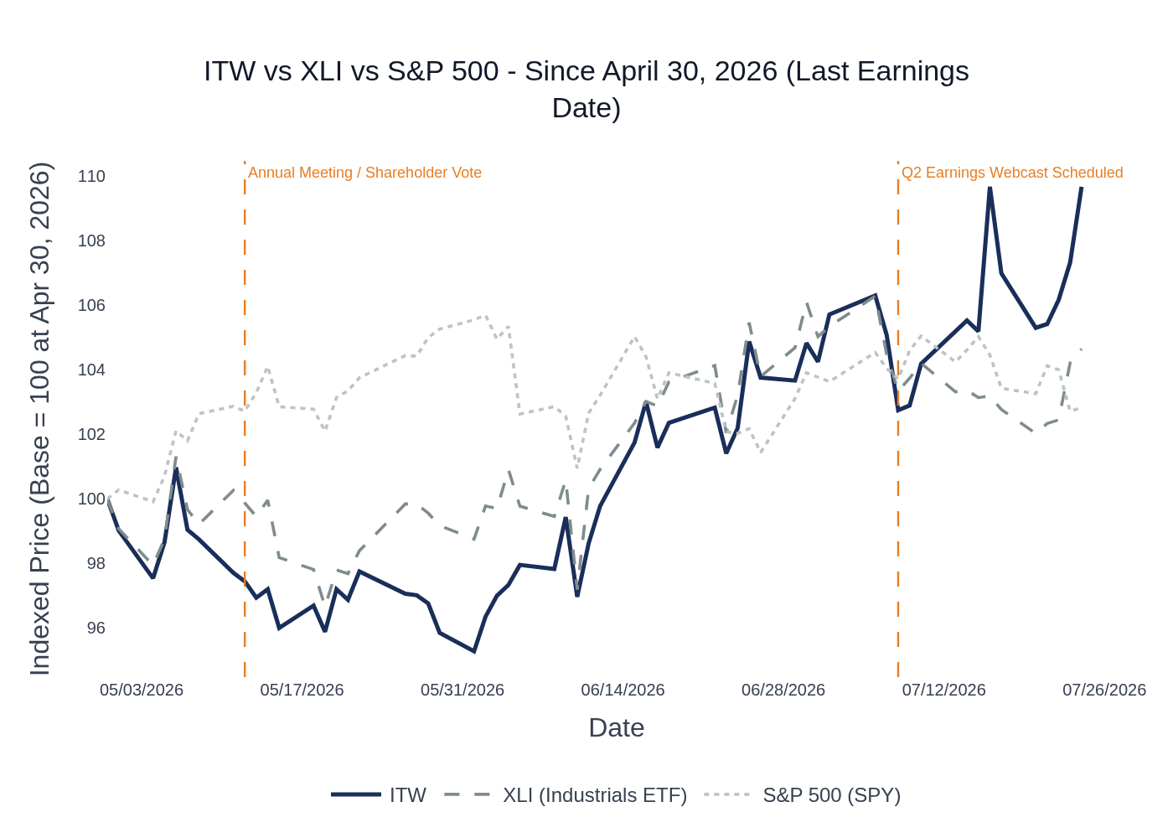
ITW vs. XLI (Industrials ETF) vs. S&P 500 — Indexed to 100 at Q1 2026 Earnings (April 30, 2026). Source: Yahoo Finance / Stock Price Data.
ITW opened lower on April 30 despite the Q1 EPS beat (stock declined on the day, likely on modest organic growth of only +0.4%), but subsequently recovered and re-rated higher as investors digested the raised FY guidance and management’s more confident commentary on April trends. The stock has outpaced XLI by approximately 510 basis points since the print. The sector ETF used is XLI (iShares U.S. Industrials ETF), which is appropriate for ITW’s diversified industrial machinery sub-sector.

7. Material News & Developments
Key Takeaway: The most important development since the Q1 print is the Q2 2026 earnings webcast scheduling announcement (July 8), confirming the print is imminent. No material negative developments (M&A, regulatory, guidance cut) have emerged since April 30 — the absence of bad news is itself a mild positive signal.
- July 8, 2026 — ITW schedules Q2 2026 earnings webcast: ITW issued a press release scheduling its Q2 2026 earnings webcast, confirming the print is imminent (expected late July / early August 2026). No pre-announcement or guidance revision accompanied the scheduling notice. Implication: management is comfortable with current guidance and sees no need to pre-announce.
- May 12, 2026 — Annual Meeting: Shareholders affirm board, executive pay; reject governance proposal: ITW’s annual shareholder meeting resulted in routine affirmation of the board and executive compensation, with a governance-related shareholder proposal rejected. No material business implications. Implication: no activist pressure or governance disruption heading into Q2.
- April 30, 2026 — Q1 2026 Earnings: EPS beat, FY guidance raised $0.10: ITW reported Q1 2026 operating EPS of $2.657 (vs. $2.559 consensus, +3.8% beat) and revenue of $4.016B (vs. $4.008B consensus, slight beat). Full-year GAAP EPS guidance raised $0.10 to $11.10–$11.50, driven by a lower projected tax rate (23%–24%). Management expressed increased confidence in organic growth guidance, noting April trends tracking toward the high end of the 1%–3% range. Implication: sets a constructive baseline for Q2.
- Ongoing — Welding and T&M order momentum: Management flagged on the Q1 call that order rates in welding and T&M are running “meaningfully ahead” of reported organic growth rates — a leading indicator not yet reflected in guidance. Peer commentary from ROK, GGG, EMR, and NDSN all confirm semiconductor and CapEx-related demand is accelerating. Implication: upside risk to welding and T&M organic growth in Q2.
- Ongoing — Food equipment institutional demand recovery: Management noted gradual improvement in institutional demand trends since January, with international food equipment expected to deliver positive organic growth starting Q2. North America food equipment was down 5% in Q1 (education end market weak; QSR up double digits). Implication: food equipment is the key swing factor — any miss vs. the “positive organic growth” guidance could disappoint.
- Ongoing — Tariff environment stabilized: Management characterized tariff impacts as “largely mitigated” given ITW’s produce-where-you-sell philosophy. Price/cost expected to be modestly accretive to margins. Peers (ROK, EMR, ETN) similarly characterized tariff impacts as manageable or immaterial. Implication: tariffs are not a meaningful headwind for Q2.
- Ongoing — CBI (Customer-Backed Innovation) trajectory: CBI revenue contribution tracking at 2.4% in 2025, up from 2.0% in 2024, with patent filings up 9%. Management added CBI metrics to long-term incentive plans, signaling high conviction in the 3%+ target by 2030. Implication: structural growth driver not yet fully priced in by the market.
- Ongoing — China Automotive OEM: Builds in China projected to meaningfully improve sequentially in Q2, including double-digit growth in EVs. ITW outperformed Chinese automotive builds by ~700 bps in Q1 (builds -10%, ITW China -3%). Implication: potential positive surprise in Automotive OEM segment if EV penetration gains accelerate.

8. Insider Transaction Activity
Key Takeaway: Only one open-market transaction was identified in the period since the Q1 print — a discretionary open-market purchase by a director in early June 2026. A single director buy is a mild positive signal but not a strong conviction indicator; the absence of executive-level selling is notable and consistent with management’s confident tone.
Name | Title | Transaction Type | Shares | Date | Note
Jennifer F. Scanlon | Director | Open Market Buy | 806 shares | June 2, 2026 | Discretionary purchase; not a 10b5-1 plan. Post-purchase holding: 1,652 shares. Mild positive signal.
Source: SEC Form 4 Filings Database (Insider Transaction Data). Window: April 30, 2026 – July 27, 2026. Only open-market buys (code P) and sells (code S) included. No open-market sales by executives or directors were identified in the period. No 10b5-1 plan initiations were identified.
The single director purchase by Jennifer F. Scanlon (806 shares, ~$200K at prevailing prices) is a discretionary open-market buy with no 10b5-1 plan, which is a modestly positive signal. The absence of any executive-level selling in the 90 days heading into the print is consistent with management’s expressed confidence in Q2 and full-year guidance. No clustered buying or unusual transaction patterns were identified.

