Old Dominion Freight Line (ODFL) — Q2 2026 Earnings Preview
Ticker: ODFL | Earnings Date: July 29, 2026 (Before Market Open) | Reporting Period: Q2 2026 | Prepared: July 29, 2026

1. Earnings Preview
Key Takeaway: The setup is constructive but not a slam dunk — consensus has moved up ~7% since last earnings on the back of strong May metrics and truckload-to-LTL spillover, and the bar is now a meaningful beat on OR improvement; the wildcard is whether June tonnage inflected enough to drive operating leverage above the guided 300–350bps sequential improvement.
ODFL heads into Q2 2026 earnings with a more constructive setup than Q1, supported by a confirmed May metrics update showing +12.3% revenue per day YoY and improving tonnage trends (tons/day down only 3.8% in May vs. -6.1% in April), alongside a broader truckload market that has tightened sharply — creating meaningful LTL spillover tailwinds. Management guided to 300–350bps of sequential OR improvement from Q1's 76.2% (implying a Q2 OR of roughly 72.9–73.0%), which would mark the fourth consecutive quarter of meeting or beating normal seasonal improvement. Consensus has revised up ~7% on EPS since last earnings (from $1.45 to $1.55), suggesting the street has already partially priced in the improving backdrop, raising the bar for a positive reaction. The stock is up ~8% since Q1 earnings vs. IYT transport ETF up ~9%, meaning ODFL has roughly kept pace with the sector but has not materially outperformed — the stock is not pricing in a blowout. The key wildcard is June tonnage: management flagged April as "a little softer" (tons/day -6.5% YoY) but expected sequential improvement through May and June; if June showed a meaningful inflection (e.g., tonnage turning flat or positive YoY), that would be the catalyst for a positive surprise on OR and EPS.
- Bar: Consensus EPS of ~$1.55 is up ~7% from the post-Q1 baseline of $1.45, representing a high but not extreme bar; the OR guidance midpoint of ~72.9% is the key metric to watch.
- Guidance/Tone: Management was cautiously optimistic at Q1 earnings — guided to normal seasonal OR improvement (300–350bps) while flagging fuel headwinds and geopolitical uncertainty; tone has not materially shifted since.
- Estimate Trajectory: Estimates have moved up ~7% on EPS since Q1 earnings, tracking above the initial guidance midpoint, suggesting the street is pricing in some outperformance.
- Stock Setup: ODFL is up ~8% since Q1 earnings, roughly in line with the transport sector (IYT +9%), suggesting the stock has not materially re-rated and is not pricing in a blowout.
- Wildcard: June tonnage inflection — if tons/day turned flat or positive YoY in June (vs. -6.5% in April and -3.8% in May), that would drive OR outperformance above the guided range and be the key positive surprise.

2. KPIs & Consensus Expectations
Key Takeaway: Consensus expects a strong sequential OR improvement to ~72.4% (vs. 76.2% in Q1 2026), with revenue up ~9% YoY; the bigger swing factor is whether tonnage inflects enough to drive operating leverage above the guided range.

Table 1 — Current Quarter Snapshot (Q2 2026)
KPI | Q1 2026 Actual | Q2 2025 Actual | Q2 2026 Consensus | YoY Change | Guidance | Consensus vs. Guidance
Total Revenue ($M) | $1,334.7M | $1,407.7M | $1,543.8M | +9.7% | N/A | N/A
LTL Tons per Day (KTons) | 30,584 | 33,178 | 31,821 | -4.1% | N/A | N/A
LTL Shipments per Day (K#) | 41,037 | 44,907 | 42,513 | -5.3% | N/A | N/A
LTL Weight per Shipment (lbs) | 1,491 | 1,478 | 1,499 | +1.4% | N/A | N/A
LTL Rev/CWT ex-Fuel ($) | $29.13 | $28.17 | $29.67 | +5.3% | 4.0–4.5% YoY yield growth | Tracking above midpoint
Operating Ratio (%) | 76.2% | 74.6% | 72.4% | -220bps | 300–350bps seq. improvement from Q1 | ~72.9–73.0% implied; consensus slightly better
EPS — Diluted Operating ($) | $1.14 | $1.27 | $1.55 | +22.0% | N/A | N/A
LTL Rev per Shipment ($) | $514.56 | $485.31 | $560.70 | +15.5% | N/A | N/A
Source: Visible Alpha Consensus and Actuals Data. All consensus figures as of July 29, 2026.

Table 2 — Beat/Miss History (Last 8 Quarters, Top 2 KPIs: Operating Ratio & EPS-Diluted Operating)
Quarter | OR Reported | OR Consensus | OR Surprise | OR Result | EPS Reported | EPS Consensus | EPS Surprise | EPS Result
Q2 2024 | 71.9% | 72.0% | +10bps | Beat | $1.48 | $1.46 | +1.4% | Beat
Q3 2024 | 72.7% | 72.5% | -20bps | Miss | $1.43 | $1.42 | +0.7% | Beat
Q4 2024 | 75.9% | 76.0% | +10bps | Beat | $1.23 | $1.16 | +6.0% | Beat
Q1 2025 | 75.4% | 76.3% | +90bps | Beat | $1.19 | $1.14 | +4.4% | Beat
Q2 2025 | 74.6% | 74.4% | -20bps | Miss | $1.27 | $1.29 | -1.6% | Miss
Q3 2025 | 74.3% | 75.7% | +140bps | Beat | $1.28 | $1.22 | +4.9% | Beat
Q4 2025 | 76.7% | 77.2% | +50bps | Beat | $1.09 | $1.06 | +2.8% | Beat
Q1 2026 | 76.2% | 77.8% | +160bps | Beat | $1.14 | $1.05 | +8.6% | Beat
ODFL has beaten on EPS in 7 of the last 8 quarters, with the largest beat in Q1 2026 (+8.6%); OR beats have been consistent, with the notable exception of Q2 2025. Source: Visible Alpha Consensus and Actuals Data.

3. Guidance & Commentary Evolution
Key Takeaway: Management's Q2 OR guidance of 300–350bps sequential improvement from Q1 is unchanged since last earnings; no post-earnings guidance revision has been issued, but the May metrics update confirmed the trajectory is on track.
Metric | Initial Guidance (Q1 2026 Earnings, Apr 29) | Revised Guidance | Current Consensus | Note
Q2 2026 Operating Ratio | 300–350bps sequential improvement from Q1 (implies ~72.9–73.0%) | — | 72.4% | Consensus slightly better than guidance midpoint; May metrics update confirmed improving trajectory
Q2 2026 Yield (Rev/CWT ex-fuel) | 4.0–4.5% YoY increase | — | +5.3% YoY | Consensus tracking above guidance range; fuel tailwind from higher diesel prices
Q2 2026 LTL Tons/Day | Sequential improvement expected from Q1 | — | 31,821 KTons (-4.1% YoY) | May update showed -3.8% YoY; June expected to improve further
FY 2026 Revenue | No explicit FY guidance | — | $5,899M | —
FY 2026 EPS (Diluted Operating) | No explicit FY guidance | — | $5.66 | —

4. Guidance vs. Estimate Revision Tracker
Key Takeaway: EPS estimates for Q2 2026 have risen ~7% since Q1 earnings (from $1.45 to $1.55), tracking above the guidance midpoint; FY 2026 EPS has also been revised up ~5%, suggesting the street is pricing in a recovery trajectory that is ahead of management's conservative framing.
KPI | Period | Estimate (May 4, 2026 — 5 Days Post Q1 Earnings) | Current Consensus | Estimate Δ (%) | Initial Guidance (Q1 Call) | Current Guidance | Guidance Δ | Consensus vs. Guidance
EPS — Diluted Operating ($) | Q2 2026 | $1.45 | $1.55 | +6.9% | N/A | N/A | N/A | N/A
EPS — Diluted Operating ($) | FY 2026 | $5.39 | $5.66 | +5.0% | N/A | N/A | N/A | N/A
Operating Ratio (%) | Q2 2026 | 72.9% | 72.4% | -50bps | ~72.9–73.0% (300–350bps seq. improvement) | Unchanged | — | Consensus 50bps better than guidance midpoint
Operating Ratio (%) | FY 2026 | 74.2% | 73.7% | -50bps | N/A | N/A | N/A | N/A
Total Revenue ($M) | Q2 2026 | $1,489M | $1,544M | +3.7% | N/A | N/A | N/A | N/A
Total Revenue ($M) | FY 2026 | $5,765M | $5,899M | +2.3% | N/A | N/A | N/A | N/A
All data from Visible Alpha Consensus and Actuals Data. Estimate baseline as of May 4, 2026 (5 trading days post Q1 2026 earnings on April 29, 2026).

5. Stock Performance
Key Takeaway: ODFL is up ~8.1% since Q1 earnings (April 29), roughly in line with the IYT transport ETF (+8.7%) and ahead of the S&P 500 (+4.1%); the move has been driven by improving freight market sentiment and the May metrics update, not multiple expansion — suggesting the stock is not pricing in a blowout.
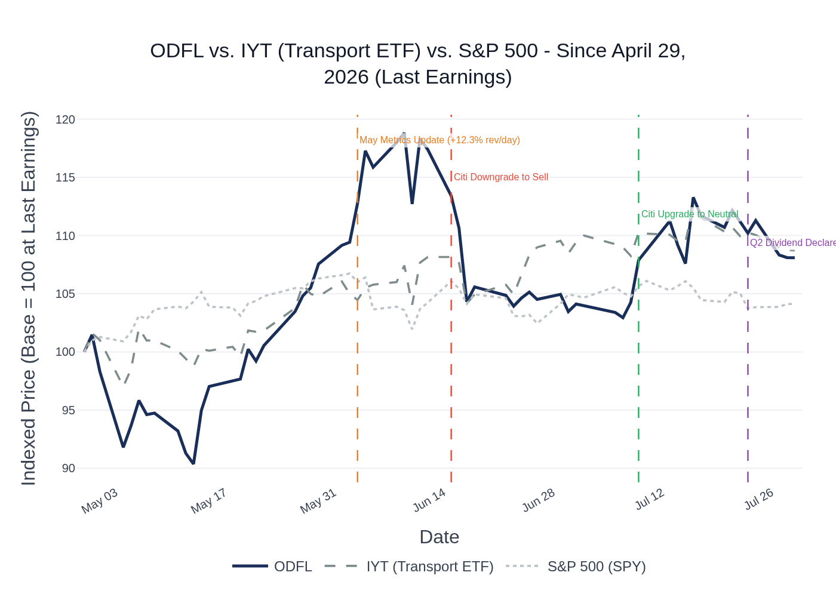
ODFL vs. IYT (Transport ETF) vs. S&P 500 — Indexed to 100 at April 29, 2026 (Last Earnings Date). Source: Stock Price Data.
ODFL rallied sharply from its post-earnings lows (stock initially fell on Q1 results despite the beat, touching ~$192 on May 4) before recovering strongly through late May and early June, peaking near $248 on June 9 as the May metrics update (+12.3% revenue/day) and broader truckload market tightening drove sentiment. The stock then pulled back ~9% from peak through mid-June (Citi downgraded to Sell on June 15), before recovering to the $226–233 range in July after Citi upgraded back to Neutral on July 9. The stock is currently trading at ~$226, roughly flat with where it was in late June, suggesting the market is in a "wait and see" mode ahead of the Q2 print. The transport ETF (IYT) has been a stronger performer in July, driven by truckload names (KNX, WERN) reporting strong Q2 results. Sector ETF used: IYT (iShares Transportation Average ETF) — appropriate for ODFL's LTL trucking sub-sector.

6. Peer Commentaries — Q2 2026 Read-Throughs (Last 60 Days)
Key Takeaway: Peer commentary from Q2 2026 reporters (KNX, WERN) and Q1 2026 reporters with Q2 guidance (XPO, SAIA, ARCB, RXO) is broadly constructive for ODFL — truckload tightening is driving LTL spillover, pricing is accelerating, and the industrial recovery is gaining traction; the key risk is that volume improvement has been gradual rather than sharp.
Note: Peer commentary filtered to Q2 2026 forward-looking statements and current-quarter color only. Q1 2026 backward-looking results excluded.

A. KNX (Knight-Swift) — Q2 2026 Earnings (July 22, 2026)
- LTL volumes: Revenue ex-fuel declined 1.4% YoY in Q2, driven by a 3.7% decrease in shipments per day — but shipments improved sequentially each month (April -6.5% YoY, May -3.2%, June -1.3%), showing clear momentum. Daily tonnage grew 4% YoY, weight per shipment +7.9%, length of haul +5.3% — all pointing to heavier, longer freight returning to LTL.
- Pricing: Rate renewals steady at mid-single digit pace; revenue per shipment ex-fuel +3.4% YoY despite weight mix headwinds.
- OR: LTL adjusted OR improved 100bps YoY to 92.1% in Q2.
- Q3 outlook: Expects to build on Q2 volumes into Q3; fuel will be a QoQ headwind but expects to offset with efficiency gains and volume recovery.
- ODFL Read-Through: Positive — the sequential improvement in shipments per day (from -6.5% in April to -1.3% in June) is a direct read-through for ODFL's June tonnage trajectory. The weight per shipment growth (+7.9%) confirms the truckload-to-LTL spillover thesis that ODFL management highlighted at Q1 earnings.

B. WERN (Werner Enterprises) — Q2 2026 Earnings (July 28, 2026)
- Truckload market: Spot rates trending well ahead of normal seasonality; tender rejection rates at highest levels since 2021; contract rates accelerating with double-digit gains in Q3 bids.
- LTL read-through: Truckload tightening is structural (regulatory enforcement on CDLs, Montgomery ruling, driver market constraints) — this is the supply-side driver of LTL spillover. WERN noted customers are pivoting toward asset-heavy solutions and away from brokers.
- Demand: Customer outlooks are solid near-term; lean retail inventories expected to drive replenishment; strong peak season anticipated in Q4.
- ODFL Read-Through: Highly positive — the structural truckload tightening WERN describes (regulatory enforcement, driver shortages, Montgomery ruling) is the same dynamic ODFL management cited as driving truckload-to-LTL spillover. If truckload rates continue to accelerate into Q3, LTL spillover should persist and potentially accelerate.

C. XPO — Q1 2026 Earnings (April 30, 2026) — Q2 2026 Forward Guidance
- Q2 tonnage guidance: Expects tonnage to improve each month of Q2, with full-quarter tonnage "flattish YoY" — upside if demand environment continues to improve.
- Pricing: Yield expected to be "comfortably in the mid-single-digit range" in Q2; expects to "comfortably outperform the high end" of normal seasonal OR improvement (250–300bps) in Q2; CEO noted "even a path to an OR with a 7 handle" in Q2.
- Customer sentiment: Survey of top customers showed double the number expecting acceleration in H2 vs. H1 — highest optimism since 2021.
- Truckload-to-LTL conversion: Estimates 2–3 points of LTL industry tonnage shifted to truckload during the freight recession; as truckload rates rise, expects this to convert back to LTL.
- ODFL Read-Through: Positive — XPO's Q2 OR guidance (outperforming the high end of 250–300bps seasonal improvement) and customer sentiment data are consistent with ODFL's own guidance. The truckload-to-LTL conversion thesis is directly applicable to ODFL, which has excess capacity to absorb returning freight.

D. SAIA — Q1 2026 Earnings (April 30, 2026) — Q2 2026 Forward Guidance
- Q2 OR guidance: Projects 400–450bps sequential improvement in Q2 (vs. historical 250–300bps), driven by momentum in commercial pipeline, pricing, and fuel. April shipments tracking +5.5% YoY, tonnage +6.5% YoY — a strong start to Q2.
- Pricing: Contract renewals at 6.7% in Q1 (strongest since Q3 2022), with March north of 7%; expects pricing discipline to persist.
- Demand: Legacy facilities showing shipment growth for first time in ~5 quarters; customer sentiment increasingly positive with expectations for better H2.
- ODFL Read-Through: Positive — SAIA's April volume data (+5.5% shipments, +6.5% tonnage YoY) is a strong leading indicator for the broader LTL market. However, SAIA is a share gainer (national network expansion) so its volume growth likely overstates the market; ODFL's volume trends will be more muted but the directional signal is constructive.

E. ARCB (ArcBest) — Q1 2026 Earnings (April 28, 2026) — Q2 2026 Forward Guidance
- Q2 OR guidance: Expects 400–500bps sequential improvement in Q2 (vs. historical 350bps), driven by strength across revenue, shipments, tonnage, weight per shipment, and pricing.
- April trends: Shipments/day -1% YoY, weight per shipment +6%, daily tonnage +5%; revenue per shipment +10% YoY (including fuel).
- Pricing: Deferred price increases averaged 6% in Q1 (strongest since Q3 2022); core LTL pricing improving in a rational market.
- Manufacturing PMI: Moved into expansion for 3 consecutive months — key directional indicator for freight demand.
- ODFL Read-Through: Positive — ARCB's April tonnage growth (+5% YoY) and strong pricing (+6% deferred increases) are consistent with the improving LTL backdrop. The manufacturing PMI expansion is a leading indicator for ODFL's industrial freight recovery, which management noted was lagging retail.

F. RXO — Q1 2026 Earnings (May 7, 2026) — Q2 2026 Forward Guidance
- LTL volume: Q1 LTL volume +5% YoY; expects LTL volume approximately flat YoY in Q2 (due to business transitioning to Managed Transportation); expects LTL to return to YoY growth in H2.
- Pricing: Contract renewal rates up mid-to-high single digits through bid season; recently awarded contracts up low double digits; full-year 2026 contract rates now expected to increase high single digits (raised from low-to-mid single digits).
- Truckload market: Industry-wide line haul rates up ~20% since Q3 2025; tender rejections at 4-year highs; structural supply-side tightening from regulatory enforcement.
- ODFL Read-Through: Positive — RXO's data on industry-wide line haul rate increases (+20% since Q3 2025) and tender rejections at 4-year highs confirms the truckload tightening that drives LTL spillover. The acceleration in contract pricing (raised to high single digits) is consistent with ODFL's own yield guidance.

7. Material News & Developments
Key Takeaway: The May 2026 metrics update was the most material development since Q1 earnings, confirming the Q2 recovery trajectory; the Citi downgrade/upgrade cycle and dividend declaration were secondary.
- June 3, 2026 — May 2026 Operating Metrics Update: Revenue per day +12.3% YoY (accelerating from +7.6% in April); LTL tons/day -3.8% YoY (improving from -6.1% in April); LTL shipments/day -5.3% YoY; weight per shipment +1.6% YoY. QTD (April+May): Rev/CWT +15.6% YoY, Rev/CWT ex-fuel +5.4% YoY. CEO Marty Freeman: "Demand has continued to improve as the quarter has progressed." Implication: Confirms Q2 OR improvement is on track; June data (not yet disclosed) is the remaining unknown.
- July 23, 2026 — Q2 Dividend Declared: Board declared $0.29/share quarterly dividend, a 3.6% increase from the prior year's Q2 dividend. Implication: Routine capital return; no strategic signal.
- July 9, 2026 — Citigroup Upgrade to Neutral (from Sell): Citi upgraded ODFL from Sell to Neutral. Implication: Removes a notable overhang; Citi had downgraded to Sell on June 15 (likely on valuation after the stock peaked near $248), then reversed course as the stock pulled back ~9%.
- June 15, 2026 — Citigroup Downgrade to Sell (from Neutral): Citi downgraded ODFL to Sell. Implication: Likely valuation-driven after the stock peaked near $248; the downgrade coincided with the stock's peak and subsequent pullback.
- Macro — Truckload Market Tightening: Tender rejections at 4-year highs, spot rates well above normal seasonality, regulatory enforcement (CDL crackdowns, Montgomery ruling) driving structural capacity exits. This is the primary driver of LTL spillover and the most important macro tailwind for ODFL heading into Q2.

8. Insider Transaction Activity
Key Takeaway: No open-market buys or discretionary sells of significance since Q1 earnings; the only transactions are routine director compensation grants and trust transfers by the Congdon family — no meaningful insider signal.
Name | Title | Transaction Type | Value / Shares | Filing Date | Note
Greg C. Gantt | Director | Open Market Sale | ~$22,107 (est.) | May 5, 2026 | Small discretionary sale; not 10b5-1; immaterial size
David S. Congdon | Executive Chairman | Gift / Trust Transfer | 295,670 shares | May 28, 2026 | Transfer to Audrey Congdon Irrevocable Trust; estate planning, not a market signal
David S. Congdon | Executive Chairman | Gift / Trust Transfer | 73,730 shares | May 20, 2026 | Transfer via Congdon Revocable Trust; estate planning
Earl E. Congdon | Chair Emeritus & Sr. Advisor | Gift / Trust Transfer | 7,370 shares | May 19, 2026 | Transfer via Earl E. Congdon Trust; estate planning
Multiple Directors (9) | Directors | Compensation Grant (Code A) | 859 shares each | May 20, 2026 | Routine annual director equity compensation; not a market signal
The only open-market transaction is Gantt's small sale on May 4. All Congdon family transactions are trust transfers (Form 4 code G), not open-market sales — these are estate planning moves, not bearish signals. No open-market buys from any insider since Q1 earnings. Source: Insider Transaction Data (SEC Form 4).

