ONEOK, Inc. (OKE) — Q2 2026 Earnings Preview
Company: ONEOK, Inc. (NYSE: OKE) Earnings Date: August 3, 2026 (After Market Close) Conference Call: August 4, 2026 at 11:00 AM ET Reporting Period: Q2 2026 Prepared: August 2, 2026

1. Earnings Preview
Key Takeaway: The setup into Q2 is constructive — management guided Q1 as the trough, implying a sequential EBITDA step-up, and the post-Q1 guidance raise sets a reasonable bar. The biggest swing factor is whether Waha-to-Katy differentials held up through Q2 and whether NGL volumes continued their strong YoY trajectory.
OKE heads into Q2 2026 with a raised full-year EBITDA guidance midpoint of $8.25B (raised from ~$8.0B at Q4 2025 earnings), and management explicitly flagged Q1 as the seasonal trough, implying a meaningful sequential step-up in Q2. Consensus sits at ~$2.09B EBITDA for Q2, roughly flat vs. Q1's $2.0B actual — suggesting the Street may be underestimating the seasonal ramp management telegraphed. The stock has been range-bound since earnings (+1.1% since Apr 28), slightly outperforming midstream peers EPD (-1.1%) and WMB (-2.1%), suggesting neither a beat nor a miss is fully priced in. The key wildcard is the Waha-to-Katy differential: management noted it would normalize in H2 as new egress comes online, but EPD's Q2 call flagged "pretty strong Waha prices" through Q2 — if differentials held wider than expected, OKE's Natural Gas Pipeline segment could again surprise to the upside. Data center pipeline project conversions (from $50M to $400–700M scale) and LPG export dock contracting progress are secondary catalysts to watch.
- Bar: Consensus EBITDA of ~$2.09B is roughly flat vs. Q1 actual of $2.0B — a low bar given management's explicit "Q1 is the trough" guidance.
- Guidance/Tone: Confident and constructive post-Q1 raise; management cited direct producer visibility, accelerating data center project scale, and LNG tailwinds from Middle East conflict.
- Estimate Trajectory: Estimates have risen modestly since the Q1 print (+0.5% for Q2 consensus vs. post-Q1 baseline), tracking guidance.
- Stock Setup: Flat since earnings, trading at ~$90–91, near the RBC price target of $90 (Sector Perform). Multiple analysts have raised PTs but consensus remains Hold.
- Wildcard: Waha-to-Katy differential durability through Q2 — if it held wider than the H2 normalization management guided, the Natural Gas Pipeline segment could again beat.

2. KPIs & Consensus Expectations
Key Takeaway: Adjusted EBITDA is the primary swing factor; consensus at $2.09B implies a modest sequential step-up from Q1's $2.0B actual — a low bar given management's "Q1 is the trough" guidance. NGL fractionation volumes and gathering volumes are the key volume read-throughs.
Table 1 — Current Quarter Snapshot (Q2 2026)
KPI | Q1 2026 Actual | Q2 2025 Actual (Prior Year) | Q2 2026 Consensus Estimate | YoY Change | Guidance | Consensus vs. Guidance
Adjusted EBITDA ($B) | $2.00B | $1.98B | $2.09B | +5.6% | $8.25B FY midpoint | ~+1% above implied quarterly run-rate
Total Revenue ($B) | $9.62B | $7.89B | $9.17B | +16.2% | N/A quarterly | N/A
EPS — Diluted ($) | $1.23 | $1.34 | $1.45 | +8.2% | $5.53 FY midpoint | ~+5% above implied quarterly run-rate
Capital Expenditures ($B) | $0.86B | $0.75B | $0.72B | -3.3% | $2.7–$3.2B FY | On track
NGL Fractionation Volume (Mbpd) | 922,105 | 893,426 | 934,564 | +4.6% | N/A quarterly | N/A
Nat. Gas Gathering Volume (Bcf/d) | 5.96 Bcf/d | 5.86 Bcf/d | 6.05 Bcf/d | +3.2% | N/A quarterly | N/A
Table 2 — Beat/Miss History (Last 8 Quarters, Top 2 KPIs)
Adjusted EBITDA
Quarter | Reported | Consensus | Surprise % | Result
Q2 2024 | $1.624B | $1.512B | +7.4% | Beat
Q3 2024 | $1.545B | $1.589B | -2.8% | Miss
Q4 2024 | $2.174B | $1.993B | +9.1% | Beat
Q1 2025 | $1.775B | $1.939B | -8.5% | Miss
Q2 2025 | $1.981B | $2.010B | -1.4% | Miss
Q3 2025 | $2.119B | $2.107B | +0.6% | Slight Beat
Q4 2025 | $2.145B | $2.160B | -0.7% | Slight Miss
Q1 2026 | $1.997B | $1.961B | +1.8% | Beat
EPS — Diluted
Quarter | Reported | Consensus | Surprise % | Result
Q2 2024 | $1.33 | N/A | N/A | N/A
Q3 2024 | $1.18 | $1.20 | -1.7% | Miss
Q4 2024 | $1.57 | $1.53 | +2.6% | Beat
Q1 2025 | $1.04 | $1.28 | -18.8% | Miss
Q2 2025 | $1.34 | $1.34 | 0.0% | In-line
Q3 2025 | $1.49 | $1.42 | +4.9% | Beat
Q4 2025 | $1.55 | $1.51 | +2.6% | Beat
Q1 2026 | $1.23 | $1.30 | -5.4% | Miss
Pattern note: EBITDA beat/miss history is mixed — OKE has beaten 4 of the last 8 quarters on EBITDA, with the largest beats in Q2 2024 (+7.4%) and Q4 2024 (+9.1%) driven by acquisition synergies and differential opportunities. EPS has been more volatile, with Q1 2025 and Q1 2026 both missing on non-cash items. EBITDA is the more reliable metric to track heading into the print.

3. Guidance & Commentary Evolution
Key Takeaway: OKE raised full-year 2026 EBITDA guidance to an $8.25B midpoint after Q1, driven by stronger volumes and a constructive market environment; no post-earnings guidance revisions since. Tone is confident, with management citing direct producer visibility, accelerating data center project scale, and LNG tailwinds from the Middle East conflict.
Metric | Initial Guidance (Q1 2026 Earnings, Apr 28) | Revised Guidance | Current Consensus | Note
FY 2026 Adjusted EBITDA | $8.25B midpoint (raised from prior ~$8.0B at Q4 2025 earnings) | — | $8.36B | Consensus slightly above midpoint; no post-earnings revision. Street giving credit for H2 ramp.
FY 2026 EPS (Diluted) | $5.53 midpoint | — | $5.68 | Consensus above midpoint; reflects Street optimism on H2 volume ramp.
FY 2026 CapEx | $2.7B–$3.2B (unchanged) | — | $3.03B | Projects on time and on budget; consensus within guidance range.
Q2 2026 Adjusted EBITDA | No specific quarterly guide; Q1 flagged as seasonal trough | — | $2.09B | Implied sequential step-up from Q1 $2.0B actual; consistent with management's cadence commentary.
Leverage Ratio | ~3.5x target by year-end; ~3.8x at Q1 end | — | N/A | Targeting 3.5x or lower; redeemed ~$500M of notes maturing July 2026.

4. Guidance vs. Estimate Revision Tracker
Key Takeaway: Estimates have moved modestly higher since the Q1 print, tracking the guidance raise. The FY 2026 consensus of $8.36B sits slightly above the $8.25B midpoint, suggesting the Street is giving management credit for upside optionality. FY 2027 estimates of $8.70B imply ~4% growth from FY 2026 consensus — below management's mid-to-upper single-digit target, leaving room for positive revision.
KPI / Period | Estimate ~5 Days Post Q1 Earnings (~May 4) | Current Consensus | Estimate Δ (%) | Initial Guidance (Q1 Call) | Current Guidance | Guidance Δ | Consensus vs. Guidance (%)
Adj. EBITDA — Q2 2026 | $2.10B | $2.09B | -0.5% | No specific Q2 guide; Q1 flagged as trough | Unchanged | — | N/A
Adj. EBITDA — FY 2026 | $8.34B | $8.36B | +0.2% | $8.25B midpoint | Unchanged | — | +1.3% above midpoint
Adj. EBITDA — FY 2027 | $8.62B | $8.70B | +0.9% | No FY27 guide | No FY27 guide | — | N/A
EPS (Diluted) — Q2 2026 | $1.49 | $1.45 | -2.7% | No specific Q2 guide | Unchanged | — | N/A
EPS (Diluted) — FY 2026 | $5.73 | $5.68 | -0.9% | $5.53 midpoint | Unchanged | — | +2.7% above midpoint
EPS (Diluted) — FY 2027 | $6.22 | $6.19 | -0.5% | No FY27 guide | No FY27 guide | — | N/A
The slight downward drift in Q2 EPS estimates (from $1.49 to $1.45) likely reflects the US Capital Advisors cut on July 29 (to $1.43), partially offset by upward revisions to Q3 2026 and FY 2027. The EBITDA estimate is essentially unchanged, suggesting the Street is comfortable with the guidance midpoint as the floor.

5. Stock Performance
Key Takeaway: OKE has been essentially flat (+1.1%) since Q1 earnings, modestly outperforming midstream peers EPD (-1.1%) and WMB (-2.1%), suggesting the guidance raise was well-received but the stock has not re-rated. The move appears sentiment/guidance-driven rather than meaningful multiple expansion. Sector ETF used: Midstream peers EPD and WMB (no single midstream ETF captures OKE's multi-molecule profile as cleanly as direct peer comparison).
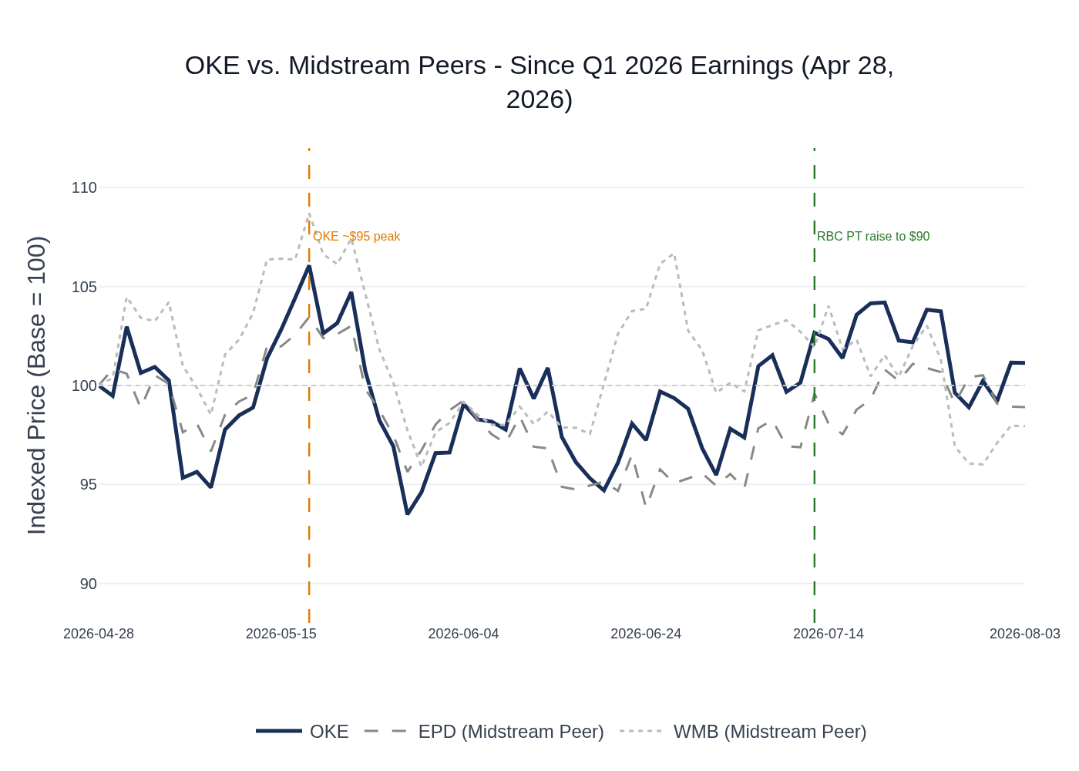
OKE vs. Midstream Peers (EPD, WMB) — Indexed to 100 at Q1 2026 Earnings (Apr 28, 2026). Source: Yahoo Finance.
OKE peaked at ~$95.24 on May 19 (up ~6% from earnings) before pulling back to the $83–$87 range in late May/early June, likely on broader energy sector weakness and Waha normalization concerns. The stock recovered in July, reaching ~$93.52 on July 17, supported by RBC's price target raise to $90 (Sector Perform, July 21) and Morgan Stanley's Overweight with $113 PT (raised April 7). The stock is currently trading at ~$90.81, near the consensus average PT of $92.44. Performance has been driven primarily by sentiment around the guidance raise and data center optionality rather than meaningful multiple expansion.

6. Material News & Developments
Key Takeaway: The most material development since Q1 earnings is the accelerating scale of data center pipeline projects (from $50M to $400–700M per project), representing significant upside optionality not yet in consensus estimates. The Waha-to-Katy differential normalization in H2 is the key risk to watch.
- July 21, 2026 — RBC raised price target on OKE from $84 to $90 (Sector Perform). Reflects improved confidence in FY 2026 EBITDA trajectory post guidance raise, though still cautious on execution risk.
- July 29, 2026 — US Capital Advisors lowered Q2 2026 EPS estimate to $1.43 from $1.46, but raised Q3 2026, FY 2027 ($6.12), and FY 2028 ($6.97) estimates. Implication: near-term EPS headwinds (likely non-cash items) but improving long-term earnings power.
- April 7, 2026 — Morgan Stanley raised price target to $113 (Overweight), the highest on the Street. Reflects DCF-based view of >50% upside to intrinsic value; key bull thesis is operating leverage on Bakken and West Texas LPG pipelines as volumes ramp with no incremental CapEx.
- May 5, 2026 — Freedom Capital upgraded OKE from Strong Sell to Hold. Sentiment shift post guidance raise.
- Q2 2026 (ongoing) — Data center pipeline project scale has grown substantially: projects originally scoped at ~$50M are now $400–700M, with some requests as large as 600 MMcf/d requiring pipelines over 100 miles. OKE is in advanced discussions with AI and power demand counterparts in Oklahoma and Texas. Implication: significant unmodeled CapEx and EBITDA upside if projects convert.
- Q2 2026 (ongoing) — LPG export dock contracting accelerating post-Middle East conflict. Management expressed confidence in completing targeted utilization contracting in the near future. Implication: incremental NGL export volume upside.
- Q2 2026 — Key capital projects on track: Denver area refined products pipeline expansion (35,000 bpd) entered service mid-year as guided. Medford NGL fractionator Phase 1 (100,000 bpd) on track for Q4 2026. Delaware Basin processing expansion (110 MMcf/d) on track for Q3 2026.
- Q2 2026 — Waha-to-Katy differential watch: Management guided normalization in H2 as new Permian egress comes online. EPD's Q2 call noted "pretty strong Waha prices" through Q2, suggesting differentials may have held wider than expected — a potential positive read-through for OKE's Natural Gas Pipeline segment.
- Q1 2026 — OKE redeemed ~$500M of notes maturing July 2026, reducing near-term debt maturities and supporting leverage reduction toward the 3.5x target.

7. Peer Commentaries — Q2 2026 Read-Throughs (Last 60 Days)
Key Takeaway: Peer Q2 2026 earnings calls from KMI and EPD paint a broadly constructive picture for midstream volumes — strong NGL and natural gas transport volumes, robust LNG demand, and continued Permian growth — all direct read-throughs for OKE's Q2 results. The key nuance is that EPD flagged the ~$200M of acute global demand tailwind in April/May has "largely normalized," which may temper OKE's Q2 upside vs. Q1.

Kinder Morgan (KMI) — Q2 2026 Earnings Call (July 22, 2026)
Relevance to OKE: KMI is a major natural gas pipeline operator with significant Permian and Haynesville exposure. Its Q2 results are a direct read-through for OKE's Natural Gas Pipeline segment and NGL volumes.
- Natural gas transport volumes up 7% YoY in Q2 2026, driven by increased LNG feed gas deliveries, incremental power demand, and greater Mexico exports. Strong positive read-through for OKE's Natural Gas Pipeline segment, which benefited from Waha-to-Katy differentials in Q1.
- NGL volumes 9% higher YoY in Q2 2026. KMI's products business benefited from improved commodity pricing and greater butane blending volumes and rates — a direct positive read-through for OKE's NGL segment, which has significant butane blending exposure.
- Natural gas gathering volumes up 26% YoY, with Haynesville up 54%. While OKE has limited Haynesville exposure, broad-based gathering volume growth is constructive for the sector.
- KMI raised full-year 2026 EBITDA guidance to at least 5% above budget and EPS to at least 12% above budget — the strongest guidance raise in the sector this quarter. Sets a positive tone for midstream earnings broadly.
- "The fundamentals supporting our natural gas business have never been stronger" — KMI cited Wood Mackenzie projections of 160 Bcf/d U.S. gas demand by 2035 (+46 Bcf/d vs. 2025). This structural demand backdrop supports OKE's long-term infrastructure investment thesis.
- Permian egress demand remains strong, with KMI noting "lots of interest out of the Permian for additional egress projects." Consistent with OKE's Permian volume growth narrative.
- Supply chain pressures on compression timelines are emerging. KMI noted "starting to see pressures on some of the timelines." OKE has proactively standardized and pre-ordered compression equipment; this is a risk to monitor but OKE appears better positioned than peers.
- Refined product volumes down 5% YoY at KMI — a mild negative read-through for OKE's Refined Products and Crude segment, though OKE's footprint (Denver, Mid-Continent) differs from KMI's.

Enterprise Products Partners (EPD) — Q2 2026 Earnings Call (July 30, 2026)
Relevance to OKE: EPD is the largest NGL pipeline and fractionation operator in the U.S. with significant Permian and Gulf Coast exposure. Its Q2 results are the most direct read-through for OKE's NGL segment, fractionation volumes, and LPG export activity.
- EPD reported record Q2 2026 EBITDA of $2.8B (+17% YoY), with total pipeline volumes up 8% and marine terminals up 33% YoY. Strong positive signal for midstream volume trends broadly.
- Permian Basin inlet volumes increased 14% YoY to 1.1 Bcf/d, bringing total Permian inlet to 4.3 Bcf/d. EPD approved two new 300 MMcf/d processing plants (Plant 11 in Midland, Plant 13 in Delaware). Confirms continued strong Permian producer activity — a direct positive read-through for OKE's Permian gathering and processing volumes.
- Processing capacity in the Permian is "slightly tight" with significant capacity coming online — consistent with OKE's Delaware Basin expansion (110 MMcf/d) entering service in Q3 2026.
- ~$200M of acute global demand tailwind in April/May (split ~1/3 NGL, 1/3 crude, 1/3 petrochemicals), but "those strong cash differentials have largely normalized" in subsequent quarters. Nuanced read-through: OKE likely benefited from the April/May demand surge, but Q3 may see some normalization.
- LPG export capacity ~90% contracted at EPD, with the Houston Ship Channel LPG export terminal expansion expected in service by year-end. EPD noted "strong interest" from countries shifting long-term supply sourcing to the U.S. — positive read-through for OKE's LPG export dock contracting.
- Waha prices "pretty strong" through Q2 as new pipelines came online faster than expected. EPD noted potential for Waha to "tighten again before 2027 as some shut-in gas returns and backloaded production comes online." Positive read-through for OKE's Natural Gas Pipeline segment differential capture in Q2, but suggests H2 normalization risk.
- EPD approved Frac 15 (150,000 bpd at Mont Belvieu, in service Q1 2028), signaling continued confidence in NGL fractionation demand growth. OKE's Medford fractionator Phase 1 (100,000 bpd, Q4 2026) is well-timed to capture this demand.
- Private producers more active than large publics given price volatility — consistent with OKE's commentary on accelerating completion activity among private and single-basin operators.

Antero Midstream (AM) — Q2 2026 Earnings Call (July 30, 2026)
Relevance to OKE: AM is primarily an Appalachian midstream operator with limited direct basin overlap with OKE. However, its commentary on data center and power demand infrastructure is a relevant read-through for OKE's data center pipeline opportunity in Oklahoma and Texas.
- AM reported Q2 natural gas gathering volumes of over 4.1 Bcf/d (+~20% YoY), driven by HG midstream asset integration. While Appalachian-focused, the strong volume growth confirms robust producer activity in gas-focused basins.
- AM is evaluating "several billion dollars of infrastructure opportunities" in Appalachia, including pipelines and laterals to serve data center and power plant construction in West Virginia. AM is contracting with both power producers and data center entities to deliver gas. Validates OKE's data center pipeline opportunity thesis — the scale of demand is real and growing across multiple geographies.
- AM's Eastside Express project (1.5–2 Bcf/d capacity, $200–300M CapEx over 2–3 years) is designed to enhance regional connectivity and capture new market opportunities, phased for 2028–2029 realization. Confirms that data center/power demand is driving large-scale infrastructure investment decisions across the midstream sector.
- Producer curtailments have minimal impact on AM volumes (~1% of gathered volumes) — suggests producer discipline is not materially impacting midstream throughput, a reassuring read-through for OKE's volume outlook.

8. Insider Transaction Activity
Key Takeaway: No open-market buys or sells by insiders since Q1 earnings. All transactions were routine director compensation awards (stock grants) in May 2026 — no discretionary buying or selling signal. The absence of open-market buying at ~$90 is notable given Morgan Stanley's $113 PT, but the absence of selling is also reassuring.
Name | Title | Transaction Type | Shares | Date (Effective) | Note
SPEARS MARY M | See Remarks | Gift / Transfer (Code G) | 1,000 | May 28, 2026 | Non-open-market transfer; not a buy or sell signal
DERKSEN BRIAN L | Director | Award (Code A) | 1,845 phantom shares | May 20, 2026 | Routine director compensation award; not discretionary
EDWARDS JULIE H | Director | Award (Code A) | 1,845 | May 20, 2026 | Routine director compensation award
HELDERMAN MARK W | Director | Award (Code A) | 3,039 | May 20, 2026 | Routine director compensation award
RODRIGUEZ EDUARDO A | Director | Award (Code A) | 1,476 | May 20, 2026 | Routine director compensation award
Multiple Directors (Gobillot, Larson, McCollum, Owodunni, Smith) | Directors | Awards (Code A) | 1,845 each | May 20, 2026 | Routine annual director compensation grants
No open-market buys or sells (Form 4 codes P/S) were filed since Q1 earnings. All transactions are routine director compensation awards or non-market transfers. No 10b5-1 plan initiations were disclosed in the period.

