Public Storage (PSA) — Q2 2026 Earnings Preview
Company | Public Storage
Ticker | PSA (NYSE)
Reporting Period | Q2 2026 (quarter ended June 30, 2026)
Earnings Date | July 30, 2026
Prepared | July 28, 2026
Sector ETF Benchmark | Peers: EXR, CUBE (self-storage sub-sector)

1. Earnings Preview
Key Takeaway: The setup is constructive but not without risk — the biggest swing factor is whether the busy season delivered the move-in rate inflection management telegraphed in April, and whether the NSA acquisition close (July 22) creates any near-term FFO dilution noise.
Heading into the Q2 2026 print, consensus sits at $4.25 Core FFO per share — a modest -0.7% YoY decline versus the $4.28 reported in Q2 2025 — representing a low bar given PSA has beaten Core FFO consensus in 6 of the last 8 quarters and has outperformed same-store revenue growth expectations in all 8. Management reaffirmed full-year guidance at the Q1 2026 earnings call despite a $0.10 beat, citing busy season uncertainty and the pending NSA closing as reasons for caution, which has kept estimates anchored near the guidance midpoint and left room for upside if the summer leasing season delivered. April operating trends were encouraging — management confirmed move-in rates improving to flat to slightly positive YoY and occupancy flat to slightly better YoY — and peer data from CubeSmart (Q1 call, May 2026) and Extra Space Storage (Q2 results, July 28) both confirm the sector recovery is real and broadening, with supply headwinds fading and existing customer churn remaining low. The NSA acquisition closed July 22 — after Q2 end — so the income statement impact is a Q3+ story, but the deal structure, JV economics, and integration timeline will dominate the call narrative and could create noise around reported metrics. The key wildcard is the Los Angeles state of emergency, which management guided would create a worsening YoY drag through Q2 and Q3 due to comp timing — any update on the LA situation or an earlier-than-expected lifting of restrictions could be the single biggest positive surprise on the call.

2. KPIs & Consensus Expectations
Key Takeaway: Consensus is a modest bar on Core FFO ($4.25 vs. $4.28 prior year), but same-store revenue growth consensus of -0.34% YoY is the real swing factor — any positive surprise there would be meaningful given the sector recovery narrative and EXR's +2.4% actual reported today.

Table 1 — Current Quarter Snapshot (Q2 2026)
KPI | Q1 2026 Actual | Q2 2025 Actual | Q2 2026 Consensus | YoY Change | Guidance | Consensus vs. Guidance
Core FFO per Share (diluted) | $4.22 | $4.28 | $4.25 | -0.7% | FY $16.50–$17.00 (mid $16.75, ~$4.19/Q implied) | +1.4% above implied quarterly midpoint
Same-Store Revenue ($M) | $1,000.8M | $1,012.4M | $1,010.5M | -0.2% (consensus) | FY SS rev growth guided -0.15% to +0.24% (mid ~flat) | In-line with guidance range
Same-Store Revenue Growth (%) | -0.02% | +0.2% | -0.34% | N/A | FY guided ~flat (-0.15% to +0.24%) | Slightly below midpoint
Same-Store NOI ($M) | $739.4M | $716.6M | $754.0M | +5.2% (consensus) | FY SS NOI growth guided -0.56% to -0.53% (mid ~-0.55%) | Above FY guidance (consensus implies positive NOI growth)
Same-Store NOI Growth (%) | +0.37% | -0.6% | -1.60% | N/A | FY guided ~-0.55% | In-line with FY guidance
Same-Store Occupancy (%) | 91.5% | 92.3% | 92.4% | +0.1pp (consensus) | N/A (no explicit guidance) | N/A
Non-Same-Store NOI ($M) | $83.0M | $117.4M | $85.3M | -27.3% (consensus)* | FY $340.6M consensus | N/A
Total Revenue ($M) | $1,217.7M | $1,201.1M | $1,226.1M | +2.1% (consensus) | FY $4,972.2M consensus | N/A
* Non-same-store NOI consensus for Q2 2026 ($85.3M) does not include NSA contribution — the deal closed July 22, after Q2 end (June 30). NSA will be a Q3 2026 income statement event.
Source: Visible Alpha Consensus and Actuals Data

Table 2 — Beat/Miss History (Last 8 Quarters)

Core FFO per Share (Diluted)
Quarter | Reported | Consensus | Surprise | Result
Q2 2024 | $4.23 | $4.22 | +0.2% | Beat
Q3 2024 | $4.20 | $4.25 | -1.2% | Miss
Q4 2024 | $4.21 | $4.24 | -0.7% | Miss
Q1 2025 | $4.12 | $4.06 | +1.5% | Beat
Q2 2025 | $4.28 | $4.25 | +0.7% | Beat
Q3 2025 | $4.31 | $4.24 | +1.7% | Beat
Q4 2025 | $4.26 | $4.21 | +1.2% | Beat
Q1 2026 | $4.22 | $4.12 | +2.4% | Beat

Same-Store Revenue Growth (%)
Quarter | Reported | Consensus | Surprise | Result
Q2 2024 | -1.0% | -1.2% | +0.2pp | Beat
Q3 2024 | -1.3% | -1.6% | +0.3pp | Beat
Q4 2024 | -0.6% | -1.3% | +0.7pp | Beat
Q1 2025 | +0.06% | -0.79% | +0.85pp | Beat
Q2 2025 | +0.2% | -0.28% | +0.48pp | Beat
Q3 2025 | +0.02% | -0.51% | +0.53pp | Beat
Q4 2025 | -0.2% | -0.35% | +0.15pp | Beat
Q1 2026 | -0.02% | -0.08% | +0.06pp | Beat
PSA has beaten Core FFO consensus in 6 of the last 8 quarters and has consistently beaten same-store revenue growth expectations in all 8 quarters, suggesting consensus tends to be set conservatively — a pattern that favors the bull case heading into Q2 2026.
Source: Visible Alpha Consensus and Actuals Data

3. Guidance & Commentary Evolution
Key Takeaway: Full-year guidance was reaffirmed at Q1 2026 earnings despite a beat, with management citing busy season uncertainty and the pending NSA closing as reasons for caution; no post-earnings guidance revision has been disclosed, leaving consensus above the guidance midpoint on Core FFO and at the low end on same-store revenue growth.
Metric | Initial Guidance (Q1 2026 Earnings, Apr 27) | Revised Guidance | Current Consensus | Note
Core FFO per Share (FY 2026) | $16.50–$17.00 (midpoint $16.75) | — | $16.94 | Reaffirmed; consensus sits above midpoint, implying market expects a raise post busy season
Same-Store Revenue Growth (FY 2026) | -0.15% to +0.24% (midpoint ~flat) | — | -0.15% | Consensus at low end of guidance range; LA headwind and busy season uncertainty cited
Same-Store NOI Growth (FY 2026) | -0.56% to -0.53% (midpoint ~-0.55%) | — | -0.56% | Consensus at low end; expense discipline has been a positive offset
Same-Store Expenses Growth (FY 2026) | ~2.0%–2.5% (implied) | — | 2.04% | In-line; property tax wins and payroll declines have been favorable
Non-Same-Store NOI (FY 2026) | Not explicitly guided | — | $340.6M | Significant step-up expected as NSA integrates in H2 2026; Q3+ income statement event

4. Guidance vs. Estimate Revision Tracker
Key Takeaway: Core FFO estimates for Q2 2026 have been essentially flat since Q1 earnings (from $4.26 to $4.25), while same-store revenue growth estimates have drifted lower (-65bps for Q2 2026), suggesting the market is waiting for busy season confirmation before revising higher.
KPI (Period) | Estimate 5 Days Post Q1 Earnings (May 2, 2026) | Current Consensus | Estimate Δ (%) | Initial Guidance (Q1 Call) | Current Guidance | Guidance Δ | Consensus vs. Guidance
Core FFO/Share (Q2 2026) | $4.26 | $4.25 | -0.2% | ~$4.19 implied (FY mid / 4) | Unchanged | 0% | +1.4% above implied quarterly guidance
Core FFO/Share (FY 2026) | $16.93 | $16.94 | +0.1% | $16.50–$17.00 | Unchanged | 0% | +1.1% above midpoint
SS Revenue Growth (Q2 2026) | +0.31% | -0.34% | -65bps | ~flat | Unchanged | 0% | Below guidance midpoint
SS Revenue Growth (FY 2026) | +0.24% | -0.15% | -39bps | -0.15% to +0.24% | Unchanged | 0% | At low end of range
SS NOI Growth (Q2 2026) | -1.24% | -1.60% | -36bps | N/A | N/A | N/A | N/A
SS NOI Growth (FY 2026) | -0.53% | -0.56% | -3bps | -0.56% to -0.53% | Unchanged | 0% | At low end of range
The divergence between Core FFO estimates (stable/slightly up) and same-store revenue growth estimates (revised lower by 65bps for Q2) reflects the market’s view that expense discipline and non-same-store NOI growth can offset top-line softness — a dynamic that has played out for several quarters and is supported by EXR’s Q2 2026 results showing -0.5% expense growth alongside +2.4% revenue growth.
Source: Visible Alpha Consensus and Actuals Data

5. Stock Performance
Key Takeaway: PSA has outperformed on an absolute basis since Q1 earnings (+6.1%), broadly in-line with peers EXR (+6.3%) and CUBE (+8.3%), with the NSA acquisition close on July 22 acting as a near-term catalyst; EXR’s strong Q2 2026 results reported today (post-market +2.6%) provide an additional positive read-through heading into PSA’s July 30 print.
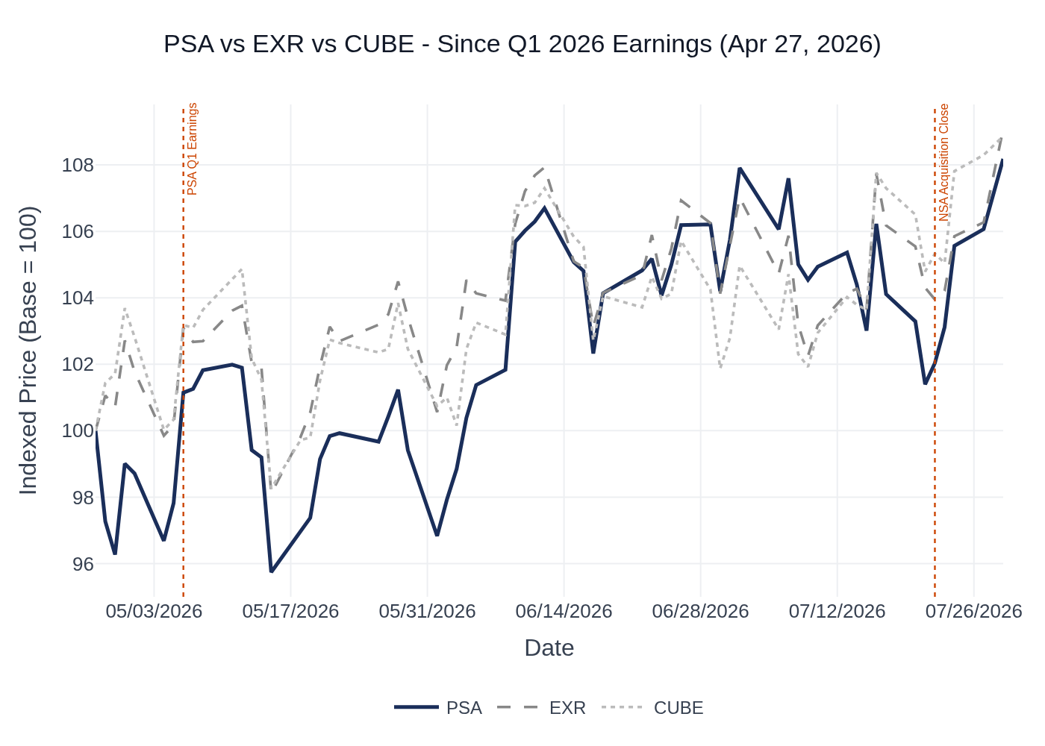
PSA vs. EXR vs. CUBE — Indexed Price Performance Since Q1 2026 Earnings (Apr 27, 2026 = 100). Key events: May 6 — PSA Q1 2026 Earnings; July 22 — NSA Acquisition Close. Source: Stock Price Data.
Ticker | Apr 27 Close (Base) | Jul 27 Close | $ Change | % Change
PSA | $305.48 | $324.02 | +$18.54 | +6.1%
EXR | $139.54 | $148.29 | +$8.75 | +6.3%
CUBE | $39.04 | $42.28 | +$3.24 | +8.3%
Note: EXR reported Q2 2026 results after market close on July 28, 2026. EXR post-market price: $152.11 (+2.6% vs. prior close of $148.29), reflecting a strong beat and guidance raise. This is a positive read-through for PSA’s Q2 print on July 30. Source: Stock Price Data.

6. Peer Commentary — Read-Through for Q2 2026
Key Takeaway: Both EXR (Q2 2026 actual results, reported today) and CUBE (Q1 2026 earnings, May 2026) provide constructive read-throughs for PSA’s Q2 print — the sector recovery is broadening, busy season trends are positive, supply headwinds are fading, and existing customer churn remains low. Only commentary about Q2 2026 conditions or forward-looking statements made after Q1 earnings is included below.

A. Extra Space Storage (EXR) — Q2 2026 Results (Reported July 28, 2026)
[Most Direct Read-Through — Same Reporting Quarter]
EXR reported Q2 2026 results today, providing the most direct and timely read-through for PSA’s Q2 print:
- Same-store revenue grew +2.4% YoY in Q2 2026 (vs. PSA consensus of -0.34%) — EXR’s portfolio skews toward higher-quality urban markets, but the direction is clearly positive and well above expectations.
- Same-store NOI grew +3.5% YoY in Q2 2026, driven by +2.4% revenue growth and a -0.5% decline in same-store expenses — expense discipline is a key theme across the sector.
- Ending same-store occupancy of 94.2% as of June 30, 2026 (vs. 94.4% prior year) — slight YoY decline but still very high; average Q2 occupancy of 94.0%.
- CEO Joe Margolis: “Our operating systems and platform continue to optimize performance as we get deeper into the storage sector’s recovery.”
- Core FFO grew 4.9% in Q2 2026, driven by “strong occupancy, improving store performance, and smart expense control — with meaningful contributions from ancillary businesses.”
- EXR raised FY 2026 guidance: Core FFO raised to $8.25–$8.40/share (from $8.05–$8.35); same-store revenue growth raised to 1.0%–2.0% (from -0.5% to +1.5%); same-store NOI growth raised to 0.5%–2.5% (from -2.25% to +1.25%).
- Acquisition guidance raised to $300M (from $200M), reflecting an improving transaction market.
- Implication for PSA: EXR’s guidance raise and strong Q2 results are a clear positive read-through. PSA’s same-store revenue consensus of -0.34% looks conservative relative to EXR’s +2.4% actual — though PSA’s portfolio has more Sunbelt exposure and the LA state of emergency is a unique headwind not present at EXR.

B. CubeSmart (CUBE) — Q1 2026 Earnings Call (May 1, 2026)
[Forward-Looking Commentary About Q2 2026 / Busy Season — Made After Q1 Earnings]
CUBE’s Q1 2026 earnings call (May 2026) contained significant forward-looking commentary about Q2 2026 conditions and the busy season that is directly relevant to PSA’s setup:
- Move-in rates ended Q1 up 2% YoY, and this +2% spread held through April: “The average rent rate on rentals in April was plus 2%.” — a meaningful positive signal for Q2 pricing.
- Occupancy gap narrowed to just 20 basis points YoY by end of April (from -70bps at year-end 2025): “putting us in a good position entering the spring/summer busy season.”
- Net rentals surged 240% in Q1 due to steady demand combined with fewer vacates — existing customer base described as “particularly sticky, staying longer than certainly pre-COVID historical trends.”
- Vacates were down 3.9% in Q1; April rentals were up ~1% YoY: “Good top-funnel demand in April at good prices.”
- Supply headwinds are fading: “The impact of supply has certainly been felt on the move-in side... that impact continues to decline, and we expect it to continue to decline. So that’s been a bit now more of a helpful tailwind than a headwind.”
- Sunbelt green shoots: Miami swung to positive same-store revenue growth; Phoenix and Atlanta making “meaningful progress in their recovery from the influx of new supply.”
- CUBE entered busy season “well positioned to capitalize on the opportunities presented” and was “very enthusiastic by how the spring has started.”
- Implication for PSA: CUBE’s April data points (move-in rates +2%, occupancy gap nearly closed, vacates down) are highly relevant for PSA’s Q2 setup. PSA management also noted in April that move-in rates were improving to flat to slightly positive — CUBE’s data suggests the broader sector saw a meaningful improvement through the busy season, supporting the case for a same-store revenue beat.

Key Themes Across Peers
Theme | Evidence | PSA Implication
Sector recovery is real and broadening | EXR Q2 beat + guidance raise; CUBE inflection in SS revenue growth | Positive — recovery not PSA-specific; supports upside to PSA consensus
Supply headwinds fading | Both peers confirm new supply wave being absorbed; forward pipeline lighter | Positive — supports pricing power recovery, especially in Sunbelt
Existing customer health strong | CUBE vacates -3.9%; EXR “strong occupancy”; sticky customer base | Positive — mirrors PSA’s Q1 experience; supports occupancy and pricing
Sunbelt showing green shoots | CUBE: Miami positive; Phoenix/Atlanta improving; EXR: sector recovery deepening | Positive for PSA given Sunbelt exposure; LA remains unique headwind
Expense discipline is a key offset | EXR SS expenses -0.5% in Q2; CUBE expects expense growth to taper in H2 | Positive — PSA has also shown strong expense control; supports NOI beat

7. Material News & Developments
Key Takeaway: The NSA acquisition closing on July 22 is the dominant development since Q1 earnings — it transforms PSA’s scale and will be the central topic on the Q2 call, though the financial impact will be primarily a Q3 2026 story.
- July 22, 2026 — NSA Acquisition Closed (Most Material): Public Storage completed the all-stock acquisition of National Storage Affiliates Trust, expanding its portfolio to over 4,500 properties and 327 million rentable square feet. Exchange ratio: 0.14 PSA shares per NSA share. A JV was formed with legacy NSA limited partners (313 properties, ~80% owned by legacy LPs, PSA managing exclusively). JV secured ~$2B in mortgage financing from Goldman Sachs and Wells Fargo plus $237M in mezzanine financing from PSA. Accretion expected within first year; $0.35–$0.50/share accretion at full synergy realization ($110–$130M run-rate synergies over 3–4 years). Implication: NSA closed after Q2 end (June 30) so income statement impact is Q3+; however, deal structure, JV economics, and integration timeline will dominate the Q2 call.
- July 20, 2026 — PSA Unit Raised $900M in Debt: Public Storage’s operating unit raised $900M in debt financing tied to the NSA acquisition. Implication: Leverage will increase; watch for management commentary on balance sheet capacity and future capital allocation priorities.
- July 14, 2026 — NSA Shareholders Approved Merger: NSA shareholders voted to approve the Public Storage merger, clearing the final major hurdle before closing. Implication: Removed deal uncertainty; stock reacted positively in the days following.
- July 28, 2026 — EXR Reports Strong Q2 2026 (Today): Extra Space Storage reported Q2 2026 Core FFO growth of 4.9%, raised FY 2026 guidance across all metrics (Core FFO, SS revenue growth, SS NOI growth). Post-market +2.6%. Implication: Positive sector read-through heading into PSA’s print on July 30; sector recovery is confirmed.
- May 6, 2026 — PSA Q1 2026 Earnings Beat: Core FFO of $4.22 beat consensus of $4.12 by $0.10 (+2.4%). Same-store NOI beat driven by lower churn, improving move-in rates, and expense discipline. Full-year guidance reaffirmed despite beat. Stock edged modestly higher on the day. Implication: Established a positive operational trajectory heading into Q2; management’s conservative guidance posture sets up potential for another raise.

8. Insider Transaction Activity
Key Takeaway: All insider activity since Q1 earnings consists of equity award grants (transaction code ‘A’) — no open-market buys or sells have been filed. The absence of discretionary selling is a mild positive signal, though the lack of open-market buying means insiders are not making a strong directional statement. Notably, Board Chairman Shankh Mitra previously purchased out-of-the-money options at the time of the leadership transition — that earlier purchase was a notable signal of conviction.
Name | Title | Transaction Type | Units / Value | Effective Date | Filing Date | Note
Shankh Mitra | Board Chairman | Equity Award Grant | 305 Common Shares | Jun 30, 2026 | Jul 2, 2026 | Equity compensation grant; not a discretionary purchase
Ronald L. Havner Jr. | Director | Equity Award Grant | 147,794 LTIP Units + 3.95 Common Shares | Jun 30, 2026 | Jul 2, 2026 | Equity compensation grant; not a discretionary purchase
Ronald P. Spogli | Director | Equity Award Grant | 145 LTIP Units + 5.58 Common Shares | Jun 30, 2026 | Jul 2, 2026 | Equity compensation grant; not a discretionary purchase
Luke J. Petherbridge | Director | Equity Award Grant | 126 LTIP Units | Jun 30, 2026 | Jul 2, 2026 | Equity compensation grant; not a discretionary purchase
Paul S. Williams | Director | Equity Award Grant | 46 Common Shares | Jun 30, 2026 | Jul 2, 2026 | Equity compensation grant; not a discretionary purchase
Multiple Directors (11 directors incl. Mitra, Havner, Hawthorne, Owen, Petherbridge, Pipes, Poladian, Shaukat, Spogli, Williams, Gustavson) | Directors | AO LTIP Unit / Stock Option Grant | 3,232 units each | May 6, 2026 | May 8, 2026 | Annual equity compensation grants; not discretionary purchases
Note: All transactions above are equity award grants (Form 4 code ‘A’) — these are compensation-related and not open-market purchases or sales. No Form 4 open-market buys (code ‘P’) or open-market sells (code ‘S’) have been filed since Q1 2026 earnings. Shankh Mitra (Board Chairman, Welltower CEO) previously purchased out-of-the-money options at the time of the PS 4.0 leadership transition — that earlier purchase was a notable signal of conviction in the new strategic direction. Source: Insider Transaction Data (Form 4 filings).

