Quanta Services (PWR) — Q2 2026 Earnings Preview
Reporting: July 30, 2026 (Before Market Open) | Prepared: July 29, 2026 | Ticker: PWR (NYSE)

Earnings Preview
Key Takeaway: The setup into Q2 is constructive — consensus is a manageable bar given PWR's track record of organic beats, and the structural demand backdrop (grid, data centers, gas generation) has only strengthened since Q1; the key wildcard is whether Underground & Infrastructure margin momentum can sustain the Q1 inflection.
Quanta heads into Q2 2026 with consensus expecting revenues of ~$8.53B and operating EPS of ~$3.28, both representing meaningful year-over-year growth against a Q2 2025 comp of $6.77B revenue and $2.48 EPS. The bar is not particularly stretched — management raised FY2026 guidance by $50M above the Q1 beat, signaling genuine back-half confidence rather than a one-time pull-forward, and the company has beaten EPS consensus in 7 of the last 8 quarters. Estimate revisions since Q1 earnings have been modestly positive, with FY2026 EPS consensus moving from ~$14.03 to ~$14.04, suggesting the Street has largely absorbed the guidance raise without getting ahead of itself. The stock, however, has given back all of its post-earnings gains and then some — down ~23% from the Q1 earnings close of $727.77 to ~$561 today — meaning the multiple has compressed significantly even as the fundamental story has improved, creating a potentially attractive setup if Q2 delivers another organic beat. The wildcard is Underground & Infrastructure margin: Q1 saw a meaningful inflection driven by DSI mix and execution, and whether that sustains at or above the ~7.5% consensus for Q2 will be the key swing factor for EPS.

KPIs & Consensus Expectations
Key Takeaway: Consensus is a manageable bar on revenue (~$8.53B, +26% YoY) and EPS (~$3.28, +32% YoY); the bigger swing factor is Underground & Infrastructure margin, where Q1 surprised materially to the upside.

Table 1 — Current Quarter Snapshot (Q2 2026)
KPI | Q1 2026 Actual | Q2 2025 Actual | Q2 2026 Consensus | YoY Change | FY2026 Guidance | Cons vs. Guidance
Revenue (Total) | $7.87B | $6.77B | $8.53B | +26.0% | $34.7B–$35.2B | ~+2% above midpoint
Revenue – Electric Infra | $6.47B | $5.46B | $6.86B | +25.7% | $28.4B (FY cons) | N/A
Revenue – Underground & Infra | $1.41B | $1.31B | $1.66B | +26.3% | $6.63B (FY cons) | N/A
Operating EPS (Diluted) | $2.68 | $2.48 | $3.28 | +32.3% | $13.55–$14.25 | ~+1% above midpoint
Operating EBITDA | $686M | $669M | $866M | +29.5% | $3.49B–$3.65B | ~+1% above midpoint
Operating EBITDA Margin | 8.7% | 9.9% | 10.2% | +30bps | ~10.3% (FY cons) | N/A
Electric Infra Op. Margin | 8.7% | 10.1% | 10.3% | +20bps | ~10.4% (FY cons) | N/A
Underground & Infra Op. Margin | 7.5% | 6.9% | 8.2% | +130bps | ~8.4% (FY cons) | N/A
Total Backlog | $48.47B | $35.84B | $49.22B | +37.4% | N/A | N/A
Free Cash Flow | $184M | $170M | $418M | +146% | $1.94B (FY cons) | N/A
Source: All consensus figures from Visible Alpha as of July 29, 2026. Q1 2026 and Q2 2025 actuals from Visible Alpha. FY2026 guidance from Q1 2026 earnings call (April 30, 2026).

Table 2 — Beat/Miss History (Last 8 Quarters, Top 2 KPIs: Revenue & Operating EPS)
Quarter | Revenue Reported | Revenue Consensus | Rev. Surprise | Rev. Result | Op. EPS Reported | Op. EPS Consensus | EPS Surprise | EPS Result
Q2 2024 | $5.59B | $5.52B | +1.4% | Beat | $1.90 | $1.93 | -1.6% | Miss
Q3 2024 | $6.49B | $6.57B | -1.1% | Miss | $2.72 | $2.66 | +2.2% | Beat
Q4 2024 | $6.55B | $6.62B | -1.0% | Miss | $2.94 | $2.63 | +11.8% | Beat
Q1 2025 | $6.23B | $5.86B | +6.4% | Beat | $1.78 | $1.67 | +6.6% | Beat
Q2 2025 | $6.77B | $6.55B | +3.4% | Beat | $2.48 | $2.42 | +2.5% | Beat
Q3 2025 | $7.63B | $7.42B | +2.8% | Beat | $3.33 | $3.25 | +2.5% | Beat
Q4 2025 | $7.84B | $7.37B | +6.4% | Beat | $3.16 | $3.01 | +5.0% | Beat
Q1 2026 | $7.87B | $7.06B | +11.5% | Beat | $2.68 | $2.07 | +29.5% | Beat
Pattern: PWR has beaten EPS consensus in 7 of the last 8 quarters, with the magnitude of beats accelerating — the Q1 2026 EPS beat of ~29.5% was the largest in recent history, driven entirely by organic execution with no acquisitions in the quarter.

Guidance & Commentary Evolution
Key Takeaway: Management raised substantially all FY2026 guidance at Q1 earnings, carrying forward the beat AND raising the back half — a signal of genuine demand confidence, not a one-time pull-forward. No post-earnings guidance revisions since April 30.
Metric | Initial Guidance (Q1 2026 Earnings, Apr 30) | Revised Guidance | Current Consensus | Note
FY2026 Revenue | $34.7B–$35.2B | — | $35.0B | Raised from prior $33.0B–$33.6B range at Q1 earnings
FY2026 Operating EPS | $13.55–$14.25 | — | $14.04 | Raised from prior $12.45–$13.15; raised $50M above Q1 beat
FY2026 Operating EBITDA | $3.49B–$3.65B | — | $3.60B | Raised from prior $3.25B–$3.41B
FY2026 Free Cash Flow | Unchanged (prior range) | — | $1.94B | CFO expressed greater confidence in hitting high end of range
Technology/Load Center Revenue Growth | 70% → raised to 110% | — | N/A | Substantially raised at Q1 earnings; fast-paced market
Large Transmission Bookings | Expected late 2026/early 2027 | — | N/A | 765kV first meaningful project entered backlog in Q1
Management tone on the Q1 call was notably confident — CEO Earl Austin stated guidance is “prudent” and raised it $50M above the Q1 beat, signaling back-half visibility. CFO Jayshree Desai expressed greater confidence in hitting the high end of the free cash flow range. No post-earnings 8-K or conference guidance updates have been filed since April 30, 2026.

Guidance vs. Estimate Revision Tracker
Key Takeaway: Estimates have been essentially flat since Q1 earnings — the Street absorbed the guidance raise without getting ahead of itself, leaving limited risk of a ‘buy the rumor, sell the news’ dynamic if Q2 delivers another organic beat.
KPI / Period | Estimate (May 5, 2026 — 5 days post Q1) | Current Consensus | Estimate Δ | Initial Guidance (Q1 Call) | Current Guidance | Guidance Δ | Cons vs. Guidance
Revenue — Q2 2026 | $8.56B | $8.53B | -0.3% | No specific Q2 guide | No specific Q2 guide | — | N/A
Revenue — FY2026 | $35.01B | $35.02B | +0.0% | $34.7B–$35.2B | $34.7B–$35.2B | Unchanged | ~+1% above midpoint
Op. EPS — Q2 2026 | $3.28 | $3.28 | +0.0% | No specific Q2 guide | No specific Q2 guide | — | N/A
Op. EPS — FY2026 | $14.03 | $14.04 | +0.1% | $13.55–$14.25 | $13.55–$14.25 | Unchanged | ~+1% above midpoint
Op. EBITDA — Q2 2026 | $862M | $866M | +0.5% | No specific Q2 guide | No specific Q2 guide | — | N/A
Op. EBITDA — FY2026 | $3.58B | $3.60B | +0.5% | $3.49B–$3.65B | $3.49B–$3.65B | Unchanged | ~+1% above midpoint
Total Backlog — Q2 2026 | $49.90B | $49.22B | -1.4% | N/A | N/A | — | N/A
Estimates have been remarkably stable since Q1 earnings — the Street has essentially taken the guidance raise at face value without adding incremental upside. This is a relatively clean setup: if PWR delivers another organic beat (as it has in 7 of the last 8 quarters), there is room for meaningful upward revision to both Q3 and FY2026 estimates.

Stock Performance
Key Takeaway: PWR has dramatically underperformed the S&P 500 since Q1 earnings (-23% vs. +1.5% for SPY), driven entirely by multiple compression — the fundamental story has improved but the stock has re-rated lower, creating a potentially attractive entry point ahead of Q2.
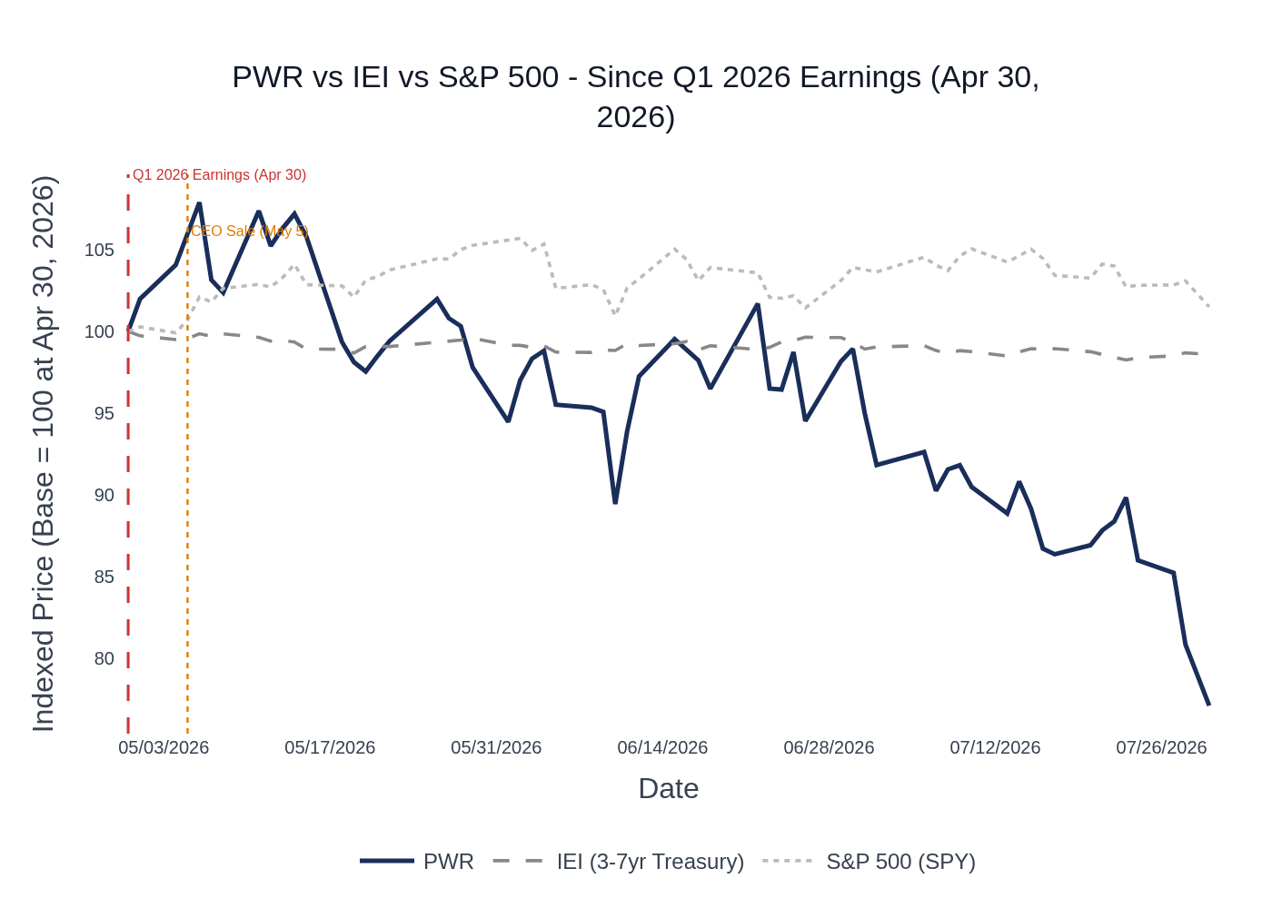
PWR vs. IEI (3-7yr Treasury) vs. S&P 500 — Indexed to 100 at Q1 2026 Earnings (April 30, 2026). Source: Stock Price Data.
Note on ETF: IEI (iShares 3-7 Year Treasury Bond ETF) is used as a rate/macro reference rather than a direct sector ETF. PWR closed at $727.77 on Q1 earnings day (April 30, 2026) and has declined to ~$561 as of July 28, 2026 — a loss of ~$166.63 / -22.9% — while the S&P 500 gained ~+1.5% over the same period. The underperformance is notable given the strong Q1 beat and guidance raise, suggesting the market has been pricing in macro/rate concerns or sector rotation rather than company-specific deterioration. The stock peaked at ~$785 in mid-May before a sustained selloff through July. The CEO’s open-market sale of ~156,000 shares on May 5 at ~$771 coincided with the peak and may have contributed to the subsequent decline.

Material News & Developments
Key Takeaway: No major company-specific negative catalysts since Q1 earnings; the most notable development is the CEO’s open-market sale of 130,000 shares on May 5 at ~$771, which may have contributed to the stock’s subsequent underperformance. Peer read-throughs are uniformly positive.
- July 10, 2026 — Q2 Earnings Date Announced: Quanta confirmed Q2 2026 results will be released July 30, 2026 before market open, with a 9:00 a.m. ET webcast. Management will post supplemental Operational and Financial Commentary to largely replace prepared remarks, allowing more Q&A time.
- May 19, 2026 — Investor Conference Participation: Quanta announced participation in several institutional investor conferences in May and June, providing management access to the buy-side during the quarter.
- May 5, 2026 — CEO Open-Market Sale: CEO Earl Austin sold 130,000 shares (plus 25,992 shares via C4M3 LLC) at approximately $771/share — the largest insider sale in the post-earnings window. This was not a 10b5-1 plan sale. The stock peaked around this time (~$785) and has declined ~27% since. Implication: warrants monitoring but does not change the fundamental thesis.
- Peer Read-Through — FIX (July 24, 2026): Comfort Systems USA reported a blowout Q2 2026 — revenue exceeded $3B for the first time (+51% YoY), EPS +92% YoY, backlog hit a record $14.1B (+73% YoY same-store). Technology sector demand described as showing “no letdown whatsoever.” Highly positive read-through for PWR’s data center and technology infrastructure exposure.
- Peer Read-Through — MTZ (May 1, 2026): MasTec reported strong Q1 2026 results and raised FY2026 guidance, with Power Delivery backlog hitting a record $6.2B at 1.6x book-to-bill. CEO Jose Mas: “I can’t remember a time where every business was just humming.” Positive read-through for PWR’s Electric segment.
- Peer Read-Through — STRL (May 5, 2026): Sterling Infrastructure reported Q1 2026 revenue +92% YoY and raised FY2026 guidance substantially, with E-Infrastructure (data center) revenue +174% YoY. Data center demand described as “unprecedented.” Positive read-through for PWR’s technology/data center exposure.
- Peer Read-Through — DY (May 27, 2026): Dycom Industries reported record backlog of $11.9B (+25% sequentially, 2.2x book-to-bill). Power Solutions delivered $395M revenue at 17.7% EBITDA margin. Fiber and data center connectivity demand described as “stronger today than we have ever seen.” Positive read-through for PWR’s communications and data center work.
- Structural Demand Tailwinds: MasTec’s May 12 Investor Day projected a $1 trillion 5-year TAM for power delivery infrastructure, with 75% flowing to work MasTec and PWR specialize in. AI-driven data center demand could drive up to 12% of total U.S. electricity consumption by end of decade. These macro tailwinds are directly supportive of PWR’s multi-year backlog growth thesis.

Peer Commentaries — Read-Through for Q2 2026
Key Takeaway: Every major peer that has reported since PWR’s Q1 earnings has described demand as at or above prior expectations — the infrastructure cycle is accelerating, not decelerating, and the read-through for PWR’s Q2 is unambiguously positive.

Comfort Systems USA (FIX) — Q2 2026 Earnings (July 24, 2026)
[MOST RELEVANT — SAME QUARTER] FIX reported Q2 2026 results on July 24, making it the most timely and directly relevant read-through for PWR’s Q2.
- Revenue exceeded $3B for the first time, reaching $3.3B (+51% YoY). EBITDA +80% to $600M. EPS +92% YoY. Free cash flow of $999M in Q2.
- Backlog hit a record $14.1B, up $5.9B or 73% YoY same-store, and up $1.6B or 13% sequentially. Entered Q3 with same-store backlog 69% higher than prior year.
- Technology sector represented 58% of revenue (up from 40% prior year). Q2 bookings “especially strong in the technology sector.”
- Management described “no letdown whatsoever” in data center demand. Hyperscalers providing “deep and calm certainty” that they will continue to build.
- Modular operations growing rapidly — $510M of modular bookings in Q2, capacity expanding to 4M+ sq ft by year-end and ~5M sq ft by late summer 2027.
- Full-year 2026 same-store revenue growth expected in “mid to high 30% range.” Expects “strong, strong results for the rest of 2026 and continuing success into 2027.”
- Gross margin expanded to 25.9% (from 23.5% in Q2 2025). Operating income +86% to $558M (17.1% margin vs. 13.8% prior year).
- PWR Read-Through: Directly positive for PWR’s technology/data center and MEP platform. FIX’s blowout Q2 confirms the data center construction cycle is accelerating into Q2 2026. PWR’s technology and large load center revenue growth outlook (raised to 110% at Q1 earnings) appears well-supported.

MasTec (MTZ) — Q1 2026 Earnings (May 1, 2026) + Investor Day (May 12, 2026)
- Power Delivery backlog hit a record $6.2B with a 1.6x book-to-bill in Q1 — “broad-based, no major projects kind of pushed that way.” Expects 60–70bps of margin expansion in Power Delivery for Q2 specifically.
- Raised FY2026 guidance: revenue to $17.5B (+22% YoY), EBITDA to $1.5B, EPS to $8.79 (+35% YoY).
- CEO Jose Mas: “I can’t remember a time where every business was just humming, right, where everything just had great opportunities in front of it, where we see backlog growing across the board, where we see momentum actually increasing.”
- Renewables backlog extended to 11 consecutive quarters of growth. Data center connectivity TAM described as “tens of billions of dollars” and “just starting.”
- Investor Day: Projected $1 trillion 5-year TAM for power delivery, with 75% flowing to MTZ/PWR-type work. Power Delivery grew from ~$600M revenue in 2021 to ~$5B in 2026 (10% organic CAGR). Targets at least 10% EBITDA on $22B revenue by 2028.
- PWR Read-Through: Strongly positive for PWR’s Electric segment. MTZ’s Power Delivery record backlog and margin expansion trajectory directly validates PWR’s own backlog growth and margin improvement narrative. The Investor Day’s $1T TAM framing reinforces the multi-year demand visibility PWR management has articulated.

Sterling Infrastructure (STRL) — Q1 2026 Earnings (May 5, 2026)
- E-Infrastructure revenue +174% YoY (organic +100%+). Data center market was “again the primary growth driver.” Anticipates “current strength in data center demand will continue for the foreseeable future.”
- Raised FY2026 guidance: revenue to $3.7B–$3.8B (midpoint +20% vs. prior guide, +50%+ vs. 2025). Adjusted EPS midpoint +36% vs. prior guide.
- Being pulled into new geographies (Texas, Pacific Northwest, Midwest) with urgency. Texas market “exceptionally strong with robust award activity in early 2026.”
- CEO: “Our outlook is stronger than ever and continues to surpass our expectations.” Customers requesting larger, more complex, longer-duration projects.
- Combined backlog grew 131% to $5.2B. Book-to-burn ratio of 2.1x for backlog and 3.5x for combined backlog in Q1. E-Infrastructure margins expected in mid-20% range for FY2026.
- PWR Read-Through: Positive for PWR’s technology/data center exposure. STRL’s data center demand commentary (unprecedented, pulling into new geographies, customers requesting larger/longer projects) is consistent with PWR’s own technology and large load center outlook.

Dycom Industries (DY) — Fiscal Q1 2027 Earnings (May 27, 2026)
- Record total backlog of $11.9B, +25% sequentially, 2.2x book-to-bill. “Momentum behind fiber deployments and data center builds is stronger today than we have ever seen.”
- Power Solutions (Building Systems segment) delivered $395M revenue at 17.7% EBITDA margin — “eclipsed expectations right out of the gate.”
- Announced acquisition of National Technology Integrators (NTI), specializing in inside-plant structured cabling for data centers — described as a “critical step” to offer complete fiber infrastructure.
- Data center demand on the local loop: “has not abated whatsoever. In fact, it’s only increasing.” Long-haul/middle-mile fiber builds still in “early innings” with significant ramp expected in calendar 2027–2028.
- BEAD program progressing through state pipelines — potential uplift for H2 2026 and 2027. Not included in current outlook; considered “potential uplift.”
- PWR Read-Through: Positive for PWR’s communications and data center connectivity work. DY’s record backlog and accelerating data center demand commentary supports PWR’s own technology/data center growth narrative. The BEAD program commentary is a potential incremental positive for PWR’s telecom segment.

Peer Read-Through Summary
Peer | Report Date | Key Signal | PWR Read-Through | Direction
FIX | Jul 24, 2026 (Q2 2026) | Revenue +51% YoY; backlog +73% YoY; “no letdown” in data center demand | Technology/data center, MEP platform | Strongly Positive
MTZ | May 1, 2026 (Q1 2026) | Power Delivery backlog record $6.2B; 1.6x book-to-bill; raised FY guide | Electric segment, grid modernization | Strongly Positive
STRL | May 5, 2026 (Q1 2026) | E-Infra revenue +174% YoY; data center demand “unprecedented”; raised FY guide | Technology/data center exposure | Positive
DY | May 27, 2026 (FY Q1 2027) | Record backlog $11.9B; 2.2x book-to-bill; data center demand “only increasing” | Communications, data center connectivity | Positive

Insider Transaction Activity
Key Takeaway: The CEO’s open-market sale of ~156,000 shares (~$120M) at ~$771 on May 5 — just 5 days after the Q1 earnings beat — is the most notable signal and warrants attention; it was not a 10b5-1 plan sale. All other activity is routine director RSU grants and compensation-related.
Name | Title | Transaction Type | Shares | Est. Value | Transaction Date | Note
Austin Earl C. Jr. | President & CEO | Open Market Sale | 130,000 | ~$100.2M | May 5, 2026 | Discretionary sale, NOT 10b5-1; filed May 7
Austin Earl C. Jr. | President & CEO | Open Market Sale (indirect) | 25,992 | ~$20.0M | May 5, 2026 | Via C4M3 LLC; filed May 7
NOBEL PAUL | Chief Accounting Officer & SVP | Open Market Sale | 4,000 | ~$3.1M | May 4, 2026 | Filed May 6
WYRSCH MARTHA B | Director | Gift / Disposition (Code G) | 2,500 | N/A | May 11, 2026 | Non-market transfer; not a sale
Multiple Directors | Directors (8 individuals) | RSU Grant (Award) | 249–387 each | N/A | May 21, 2026 | Routine annual RSU grants to board
Multiple Directors | Directors (6 individuals) | Option Exercise / Award (Code M) | 559–870 each | N/A | June 1, 2026 | Routine compensation-related exercises
Commentary: The CEO’s combined sale of ~156,000 shares (~$120M) just 5 days after the Q1 earnings beat is the most notable insider signal. This was a discretionary open-market sale (not a 10b5-1 plan), which carries more informational weight than a pre-planned sale. The stock peaked around this time (~$785) and has declined ~27% since. The CAO also sold 4,000 shares the day before. All other activity is routine director compensation (RSU grants, option exercises). No open-market buys have been filed in the period.

