Regeneron Pharmaceuticals (REGN)

Q2 2026 Earnings Preview
Prepared: | July 29, 2026 | Next Earnings: | Expected Late July / Early August 2026

Earnings Preview
Key Takeaway: REGN heads into Q2 with a manageable bar on DUPIXENT (consensus ~$5.37B global, +23% YoY) but a known $127M IPR&D charge (~$1.00/share EPS headwind) already flagged via 8-K; the setup is moderately constructive if DUPIXENT delivers and EYLEA HD demand growth (~10% sequential) holds, but the stock's -12.5% underperformance vs. XBI since earnings reflects lingering pipeline skepticism post-fianlimab failure.
The bar heading into Q2 is achievable but not low. Consensus DUPIXENT at ~$5.37B global (+23% YoY) is a high absolute number, but Sanofi's Q1 2026 earnings call confirmed volume-driven growth is continuing across all indications, and advanced therapy penetration in atopic dermatitis remains barely above 18% — leaving a long runway for market expansion. Management guided Q2 EYLEA HD demand growth consistent with Q1's 10% sequential increase, EYLEA 2mg demand decline in the mid-to-high teens, and confirmed the Sanofi development balance will be fully repaid by end of Q2, unlocking REGN's full share of collaboration profits starting Q3 — a meaningful structural earnings inflection. Estimate revisions have been broadly stable since the Q1 print, with the only material change being the ~$1.00/share Q2 EPS headwind from the $127M IPR&D charge flagged in the July 6 8-K, which is already absorbed into the $10.10 consensus. The stock is down ~12.5% relative to XBI since Q1 earnings, trading at a discount to large-cap biotech peers, suggesting the market is not pricing in a beat — the fianlimab Phase 3 failure (May 15) drove the underperformance, not fundamental deterioration in the core business. The single biggest wildcard is the
EYLEA HD prefilled syringe FDA decision — management guided for a decision on one or both applications by end of Q2, and approval would be a meaningful positive catalyst given that ~95% of EYLEA 2mg use is via prefilled syringe; if the decision has been received but not yet announced, it could move the stock materially on earnings day.

KPIs & Consensus Expectations
Key Takeaway: DUPIXENT is the primary swing factor; consensus at ~$5.37B global implies ~23% YoY growth, consistent with Sanofi's volume-driven growth commentary. EYLEA HD at ~$527M consensus is the secondary watch item given management's 10% sequential demand growth guide.

Table 1 — Current Quarter Snapshot (Q2 2026)
KPI | Q1 2026 Actual | Q2 2025 Actual | Q2 2026 Consensus | YoY Change | Guidance | Consensus vs. Guidance
Total Revenue | $3,605M | $3,676M | $3,818M | +3.9% | No specific Q2 guide | N/A
DUPIXENT Global Sales | $4,880M | $4,345M | $5,367M | +23.5% | Volume-driven growth to continue | Above guidance tone
EYLEA HD US Net Sales | $468M | $393M | $527M | +34.1% | ~10% sequential demand growth | Consistent
EYLEA US Net Sales (2mg) | $942M | $1,148M | $909M | -20.8% | Mid-to-high teens demand decline | Consistent
Non-GAAP EPS (Diluted) | $9.47 | $12.90 | $10.10 | -21.7% | Includes ~$1.00 IPR&D headwind | Reflects charge
R&D Expense | $1,544M | $1,422M | $1,620M | +13.9% | Continued pipeline investment | Consistent
SG&A | $648M | $634M | $709M | +11.8% | No specific guide | N/A
Note: DUPIXENT Global Sales is a Sanofi collaboration metric; REGN's share of collaboration profits will step up in Q3 2026 following full repayment of Sanofi development balance by end of Q2. Non-GAAP EPS consensus of $10.10 reflects the $127M (~$1.00/share) IPR&D charge flagged in the July 6, 2026 8-K. Source: Visible Alpha consensus data.

Table 2 — Beat/Miss History (Last 4 Reported Quarters, Top 2 KPIs)
Quarter | DUPIXENT Reported | DUPIXENT Consensus | DUPIXENT Surprise | EPS Reported | EPS Consensus | EPS Surprise | Result
Q1 2026 | $4,880M | $4,782M | +2.1% | $9.47 | $8.88 | +6.6% | Beat
Q4 2025 | $4,940M | $4,870M | +1.4% | $11.44 | $10.89 | +5.1% | Beat
Q3 2025 | $4,857M | $4,614M | +5.3% | $11.83 | $9.58 | +23.5% | Beat
Q2 2025 | $4,345M | $4,213M | +3.1% | $12.90 | $8.37 | +54.1% | Beat
REGN has beaten DUPIXENT consensus in each of the last 4 reported quarters, with a consistent 2–5% beat pattern on the product line. EPS beats have been more variable, partly reflecting one-time items; the Q2 2025 EPS beat was unusually large due to non-recurring items. Source: Visible Alpha consensus and actuals data.

Guidance & Commentary Evolution
Key Takeaway: Guidance is largely unchanged since Q1 earnings; the key new development is the $127M IPR&D charge flagged July 6 via 8-K, which is a known Q2 headwind. The Sanofi development balance repayment by end of Q2 is the most important structural positive — it unlocks full profit share from Q3 onward.
Metric | Initial Guidance (Q1 2026 Earnings, Apr 29) | Revised Guidance | Current Consensus | Note
EYLEA HD Demand Growth (Q2) | ~10% sequential (consistent with Q1) | Unchanged | ~$527M net sales | Confirmed at BofA (May 12) and Goldman (Jun 8) conferences
EYLEA 2mg Demand (Q2) | Mid-to-high teens decline | Unchanged | ~$909M net sales | Consistent with biosimilar pressure narrative
GAAP Gross Margin (FY 2026) | 77–78% (updated from prior 83–84%) | Unchanged | ~77–78% | Reflects Limerick manufacturing disruption costs; full production resumes end of Q2
Non-GAAP Gross Margin | ~86% (Q1 actual) | Unchanged | N/A | Limerick disruption is GAAP-only impact
Sanofi Dev Balance Repayment | Fully repaid by end of Q2 2026 | Unchanged | N/A | Unlocks full collaboration profit share from Q3 2026; confirmed by Sanofi Q1 earnings
Q2 Non-GAAP EPS | Not explicitly guided | $127M IPR&D charge flagged (Jul 6 8-K) | ~$10.10 | ~$1.00/share headwind from collaboration/licensing payments; already absorbed by consensus
FY 2026 R&D | Mid-teens % increase YoY | Unchanged | ~$6.60B | Reflects 18 new Phase III initiations

Guidance vs. Estimate Revision Tracker
Key Takeaway: Estimates have been broadly stable since Q1 earnings, with the $127M IPR&D charge (flagged July 6) already absorbed into Q2 EPS consensus. FY 2026 revenue and DUPIXENT estimates are essentially flat vs. the post-Q1 baseline, suggesting the Street is not pricing in meaningful upside or downside beyond what management guided.
KPI | Estimate (May 4, 2026) | Current Consensus | Estimate Δ | Initial Guidance (Q1 Call) | Current Guidance | Guidance Δ | Consensus vs. Guidance
Q2 2026 Total Revenue | $3,819M | $3,818M | -0.0% | No specific guide | No change | N/A | N/A
Q2 2026 DUPIXENT Global | $5,340M | $5,367M | +0.5% | Volume-driven growth | Unchanged | N/A | Above guidance tone
Q2 2026 Non-GAAP EPS | $10.85 | $10.10 | -6.9% | Not guided | $127M IPR&D charge flagged | Known headwind | Reflects charge
FY 2026 Total Revenue | $15,955M | $15,914M | -0.3% | No specific guide | No change | N/A | N/A
FY 2026 DUPIXENT Global | $21,667M | $21,745M | +0.4% | Volume-driven growth | Unchanged | N/A | Consistent
FY 2026 Non-GAAP EPS | $46.24 | $45.61 | -1.4% | Not guided | No change | N/A | N/A
The -6.9% revision in Q2 EPS from the post-Q1 baseline to current consensus is almost entirely explained by the $127M IPR&D charge (~$1.00/share) flagged in the July 6 8-K. Stripping this out, the underlying Q2 EPS estimate is essentially flat. FY estimates are unchanged, consistent with management's stable guidance posture. Source: Visible Alpha consensus data.

Stock Performance
Key Takeaway: REGN has significantly underperformed XBI by -12.5% since Q1 earnings, driven by the fianlimab Phase 3 failure (May 15) rather than fundamental deterioration — DUPIXENT and EYLEA HD trends remain intact. The stock's discount to large-cap biotech peers suggests the bar heading into Q2 is not elevated.
Sector ETF: XBI (SPDR S&P Biotech ETF) — appropriate for REGN's large-cap biotech sub-sector. Chart indexed to 100 at Q1 2026 earnings date (April 29, 2026).
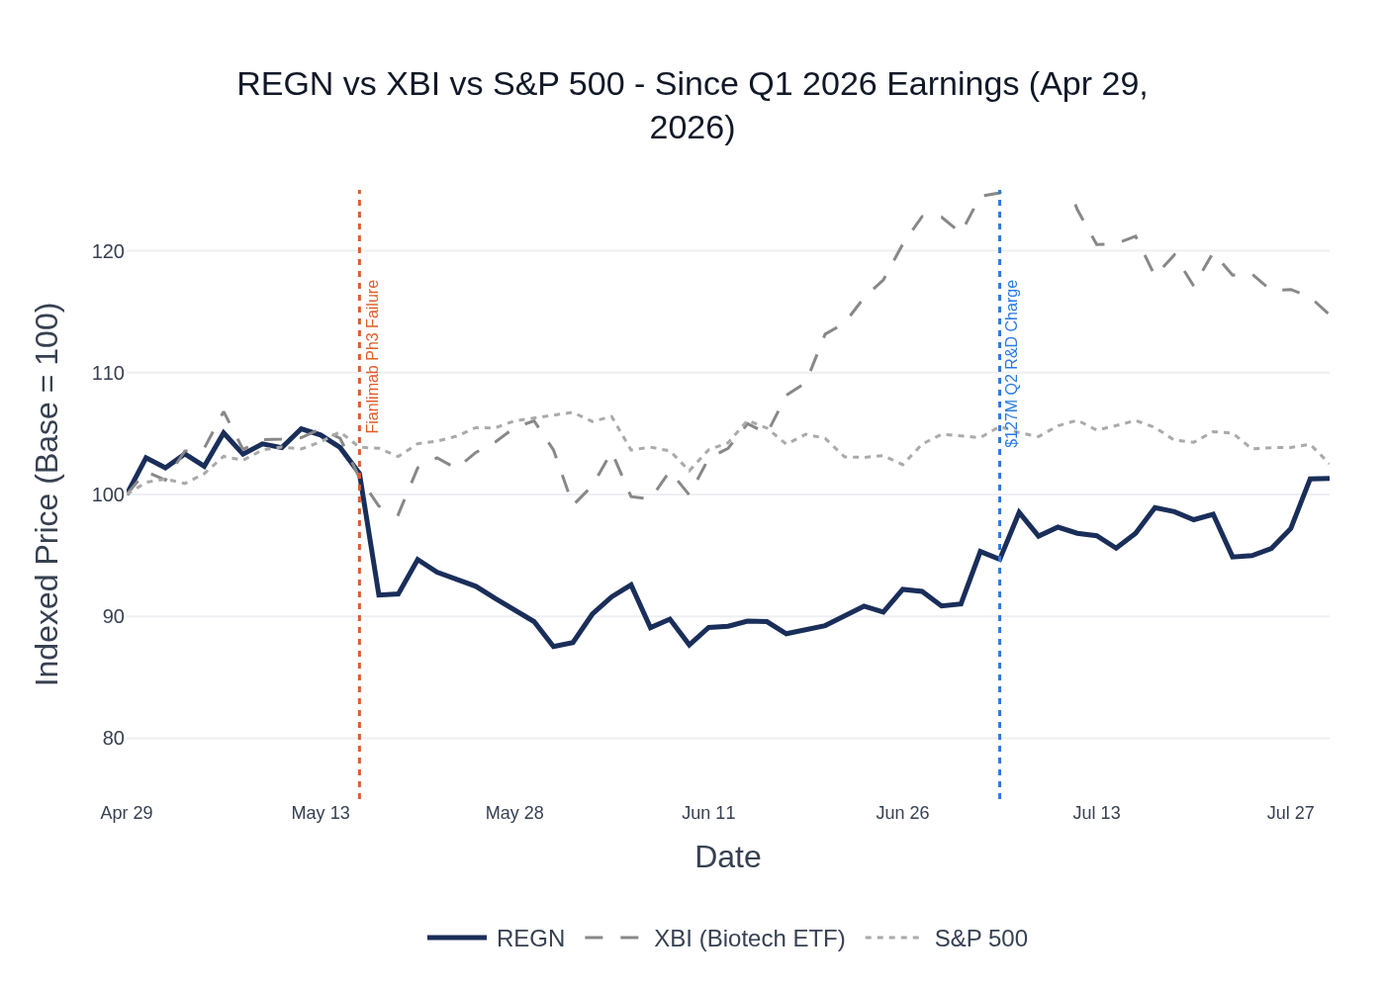
REGN vs. XBI vs. S&P 500 — Indexed to 100 at Q1 2026 Earnings (Apr 29, 2026). Source: Yahoo Finance.
Metric | REGN | XBI (Biotech ETF) | S&P 500
Return Since Q1 Earnings (Apr 29) | +1.3% | +14.7% | +2.5%
Relative to XBI | -12.5% | — | —
Period Trough | -12.5% on Jun 1, 2026 | — | —
Recovery from Trough to Jul 29 | +9.5% | — | —
The stock peaked at +5.4% on May 12 before the fianlimab Phase 3 failure announcement on May 15 sent shares down ~10% in a single session. The stock bottomed at -12.5% on June 1 and has since recovered as investors refocused on DUPIXENT growth and the upcoming Q3 profit share inflection. The $127M IPR&D charge (8-K, July 6) caused a brief ~2% dip but was quickly absorbed. XBI's +14.7% gain over the same period reflects broad biotech sector strength, making REGN's underperformance entirely idiosyncratic (fianlimab-driven). Source: Yahoo Finance.

Material News & Developments
Key Takeaway: The fianlimab Phase 3 failure (May 15) was the dominant negative event; the MFN pricing agreement and Sanofi development balance repayment are the key structural positives heading into Q2.
- May 15, 2026 — Fianlimab Phase 3 FAILED vs. pembrolizumab in 1L metastatic melanoma. Primary PFS endpoint missed statistical significance; high-dose arm showed numerically meaningful PFS improvement but HR did not achieve significance; late curve separation cited. Stock fell ~10% on the day. Head-to-head Phase 3 vs. Opdualag remains ongoing as primary remaining path. Sell-side analysts removed fianlimab from models. Implication: Removes a key near-term catalyst; shifts focus to ongoing head-to-head trial and adjuvant melanoma interim (expected H2 2026).
- April 29, 2026 — MFN Pricing Agreement signed with US government. Medicaid pricing benchmarked to other developed nations, tariff relief through January 2029, Praluent offered via TrumpRx at reduced price, Otarmeni (gene therapy for hearing loss) offered free in US. In exchange, Regeneron committed to ~$9B in domestic R&D and manufacturing investment through ~2030. Implication: Removes regulatory pricing overhang; provides tariff certainty for 3 years.
- July 6, 2026 — 8-K filed flagging ~$127M Q2 IPR&D charge (~$1.00/share EPS impact). Relates to up-front and opt-in payments in connection with collaboration and licensing agreements. Implication: Known Q2 headwind already absorbed by consensus; signals active business development activity.
- April 2026 — FDA approved extended dosing interval of up to every 20 weeks for EYLEA HD in nAMD and DME. Implication: Broadens EYLEA HD's label advantage vs. competitors; supports physician adoption.
- June 2026 — Long-acting IL-13 antibody dosed first patient in Phase 1 (healthy volunteers), confirming entry into clinic. Wholly owned by REGN outside Sanofi collaboration. Implication: Key next-gen DUPIXENT lifecycle asset entering clinical development; REGN wholly owns this program.
- May 2026 — Collaboration with Parabilis Medicines announced (antibody-Helicon conjugates). Implication: Expands platform into intracellular targets; modest near-term financial impact.
- June 17, 2026 — Annual meeting: shareholders backed board and executive compensation. No governance concerns flagged.
- EYLEA HD Prefilled Syringe — FDA decision pending. Management guided for a decision on one or both applications (Catalent Indiana + alternate manufacturer) by end of Q2. As of July 29, no public announcement of approval. Implication: Approval would be a meaningful positive for EYLEA HD adoption (95% of EYLEA 2mg use is prefilled syringe); this remains a key pending catalyst.

Peer Commentaries — Read-Through for Q2 2026
Key Takeaway: Peer commentary from the last 60 days is broadly constructive for REGN's Q2 setup — the atopic dermatitis market remains deeply underpenetrated (8–20% advanced therapy penetration), DUPIXENT's competitive position appears intact, and the myasthenia gravis market is showing strong launch dynamics. The main risk flagged by peers is increasing competition in the IL-13/IL-4 space longer-term.

DUPIXENT / Atopic Dermatitis Market (Positive Read-Through)
- Sanofi Q1 2026 Earnings (Apr 23, 2026) — Sanofi confirmed DUPIXENT Q1 global sales approaching EUR 4.2B (+31% YoY), driven by strong underlying volume growth across indications. Sanofi guided for "volume-driven growth to continue" with some moderation in H2 as new launches annualize and comparisons get tougher. Advanced therapy penetration in atopic dermatitis is "barely above 18%" — confirming the market remains deeply underpenetrated. Sanofi also confirmed the Sanofi development balance will be "fully reimbursed around Q2 2026," consistent with REGN's guidance. Read-through: Constructive for DUPIXENT Q2 — volume momentum intact, and the profit share inflection in Q3 is confirmed by both partners.
- Sanofi Jefferies Healthcare Conference (Jun 3, 2026) — Sanofi noted advanced therapy penetration in atopic dermatitis is "still 20%," with "eight out of ten patients who are actually eligible not on an advanced therapy." Sanofi is studying patient journey barriers to understand why eligible patients aren't converting. Read-through: Confirms the long runway for DUPIXENT market expansion; no signs of market saturation.
- AbbVie Acquisition of Apogee Therapeutics (Jun 22, 2026) — AbbVie acquired Apogee for its extended half-life anti-IL-13 antibody ("Zoomy") targeting atopic dermatitis, describing the AD market as "growing at over 15% per year" and "two to two-and-a-half times larger than psoriasis" with only ~8% advanced therapy penetration. AbbVie explicitly acknowledged REGN's next-gen IL-4/IL-13 molecules ("super duper") as part of the competitive landscape. Phase 3 for Zoomy expected to start H2 2026 with readouts in 2028 and approval in early 2030. Read-through: Validates the AD market opportunity and DUPIXENT's dominant position; Zoomy is a longer-term competitive threat (2030+) but not a near-term Q2 headwind. AbbVie's willingness to pay a premium for an IL-13 asset validates REGN's next-gen IL-13 antibody program.
- AbbVie BofA Healthcare Conference (May 13, 2026) — AbbVie noted that oral competitor ICOTYDE (J&J) is "more market expanding than competing with the biologics, particularly in psoriasis," with only "very modest" share impact on SKYRIZI. Read-through: Oral competition in immunology is market-expanding rather than market-taking — positive read for DUPIXENT's biologic franchise.

Myasthenia Gravis / Complement (Positive Read-Through for Cemdisiran Launch Setup)
- Amgen Goldman Sachs Healthcare Conference (Jun 9, 2026) — Amgen's UPLIZNA (anti-CD19) is "building momentum" in generalized myasthenia gravis, with launch dynamics described as "a little quicker" than expected. Amgen noted SWITCH patients are "coming from multiple places, not just one specific product or product category." When asked about REGN's cemdisiran (C5 siRNA) entering the market, Amgen said it "doesn't see that as a direct competitive threat" given UPLIZNA's differentiated mechanism, but acknowledged "the experience in complement inhibition in general has been mixed." Read-through: The gMG market is showing strong launch dynamics and bio-naive patient uptake — positive for cemdisiran's upcoming launch (FDA decision expected Q4 2026). Amgen's dismissal of cemdisiran as a direct threat may be premature given cemdisiran's differentiated quarterly SC dosing and rapid onset data from the NIMBLE study.

Longer-Term Competitive Risks (Neutral / Watch)
- AbbVie Apogee Acquisition (Jun 22, 2026) — AbbVie's Zoomy (extended half-life anti-IL-13) showed "Dupixent-plus efficacy" in Phase 2 with every 3–6 month dosing. AbbVie aims to launch "prior to Dupixent's IP expiration in 2031." AbbVie explicitly noted it has "not ruled out head-to-head" trials vs. DUPIXENT. Read-through: Zoomy is the most credible longer-term competitive threat to DUPIXENT in AD, but the 2030 launch timeline means no Q2 2026 impact. REGN's own next-gen IL-13 antibody (first patient dosed June 2026) is racing to establish a position before Zoomy.
- Sanofi Q1 2026 Earnings (Apr 23, 2026) — Sanofi is developing amlitelimab (anti-OX40L) for AD with regulatory submission expected H2 2026. Phase 3 data showed "continuous improvement with no evidence of plateau" through week 24. Sanofi also developing a Q4W DUPIXENT formulation (hyaluronidase co-formulation) with clinical studies starting H2 2026. Read-through: Sanofi's own pipeline could eventually compete with DUPIXENT in AD, but the Q4W formulation is a lifecycle extension that benefits REGN's collaboration economics. Amlitelimab is a longer-term watch item.

Insider Transaction Activity
Key Takeaway: Only one insider (Director Arthur F. Ryan) has transacted since Q1 earnings, with two small planned sales under a 10b5-1 program. No open-market buys or discretionary sells — no meaningful signal.
Name | Title | Transaction Type | Value | Transaction Date | Filing Date | Note
Arthur F. Ryan | Director | 10b5-1 Planned Sale | ~$131K (200 shares) | July 2, 2026 | July 7, 2026 | Pre-planned 10b5-1 sale; routine
Arthur F. Ryan | Director | 10b5-1 Planned Sale | ~$71K (100 shares) | May 1, 2026 | May 4, 2026 | Pre-planned 10b5-1 sale; routine
Both transactions are 10b5-1 planned sales by a single director. No open-market buys or discretionary sells by executives or other directors. Insider activity is not a meaningful signal for the Q2 print. Source: SEC Form 4 filings.

