Regeneron Pharmaceuticals (REGN) — Q2 2026 Earnings Preview
Earnings Date: July 30, 2026 | Prepared: July 29, 2026 | Reporting Period: Q2 2026 (quarter ended June 30, 2026)

1. Earnings Preview
Key Takeaway: Setup is modestly constructive — consensus is a manageable bar after post-Q1 estimate cuts, but the single biggest swing factor is whether EYLEA HD net sales can overcome inventory headwinds and deliver the guided ~10% sequential unit demand growth, with the Sanofi development balance repayment unlocking full profit share from Q3 as the key earnings-quality catalyst.
Heading into Q2 2026, REGN's bar looks achievable but not easy. Consensus revenue of ~$3.82B implies modest sequential growth off a Q1 that beat by a mid-single-digit percentage, and non-GAAP EPS of ~$10.10 reflects the known headwind from a $127M IPR&D charge (~$1.00/share impact) disclosed via 8-K on July 6. DUPIXENT global sales consensus of ~$5.37B represents the primary growth engine and is the most important KPI — Sanofi's Q2 commentary confirmed continued strong volume momentum with only 20% advanced-therapy penetration in atopic dermatitis, suggesting the bar is achievable. Management guided EYLEA HD sequential unit demand growth of ~10% (consistent with Q1) and EYLEA 2mg demand decline of mid-to-high teens, with ~$20M of residual inventory absorption still weighing on net sales. The Limerick, Ireland manufacturing disruption is expected to resolve by end of Q2, removing a GAAP gross margin headwind that compressed margins in Q1. The most important structural catalyst is the full repayment of the Sanofi development balance by end of Q2, which unlocks REGN's full share of Dupixent collaboration profits starting Q3 — a meaningful earnings-quality inflection. The wildcard is the EYLEA HD prefilled syringe (PFS) regulatory decision: management guided for a decision on one or both pending FDA applications during Q2, and approval would be a meaningful positive catalyst for the franchise, while continued delay would weigh on sentiment. The stock has recovered ~1.3% since the Q1 print (April 29) but significantly underperformed XBI (+14.7%) over the same period, suggesting the market has not priced in a beat.

2. KPIs & Consensus Expectations
Key Takeaway: Consensus is a manageable bar — DUPIXENT global sales (~$5.37B) is the primary swing factor, while EYLEA HD net sales will be closely watched for evidence that the franchise is inflecting despite the PFS delay. The $127M IPR&D charge is already known and should be looked through by the market.

Table 1 — Q2 2026 Current Quarter Snapshot (Key KPIs)
KPI | Q1 2026 Actual | Q2 2025 Actual | Q2 2026 Consensus Est. | YoY Change | Guidance (Q2 2026) | Cons. vs. Guidance
Total Revenue ($M) | $3,605 | $3,676 | $3,818 | +3.9% | No specific Q2 guidance | N/A
Non-GAAP EPS (Diluted, $) | $9.47 | $12.90 | $10.10 | -21.7% | No specific Q2 guidance; $127M IPR&D charge (~$1.00/share) disclosed July 6 | N/A
DUPIXENT Global Sales ($M) | $4,880 | $4,345 | $5,367 | +23.5% | No specific Q2 guidance; strong momentum cited | N/A
EYLEA Global Sales ($M) | $1,670 | $2,125 | $1,664 | -21.7% | EYLEA 2mg demand -mid/high teens; ~$20M inventory headwind | Broadly in line
EYLEA HD (8mg) US Sales ($M) | $468 | $393 | $527 | +34.2% | ~10% sequential unit demand growth guided | ~+13% above implied guidance
R&D Expense ($M) | $1,544 | $1,422 | $1,620 | +13.9% | FY2026: $5.90–$6.10B (non-GAAP); $6.45–$6.68B (GAAP) | In line with FY run-rate
COGS – Operating ($M) | $490 | $477 | $495 | +3.8% | Non-GAAP gross margin 83–84%; GAAP 77–78% (updated for Limerick) | In line
Source: Visible Alpha consensus and actuals data. Note: Q2 2026 consensus estimates as of July 29, 2026. Non-GAAP EPS consensus of ~$10.10 reflects the known $127M IPR&D charge (~$1.00/share impact) disclosed via 8-K on July 6, 2026. YoY change for Non-GAAP EPS reflects the unusually high Q2 2025 actual ($12.90) driven by favorable collaboration profit timing.

Table 2 — Beat/Miss History (Last 8 Quarters, Top 2 KPIs)
Quarter | KPI | Reported | Consensus | Surprise % | Result
Q1 2026 | Total Revenue | $3,605M | $3,475M | +3.7% | Beat
Q1 2026 | Non-GAAP EPS | $9.47 | $8.88 | +6.6% | Beat
Q4 2025 | Total Revenue | $3,884M | $3,790M | +2.5% | Beat
Q4 2025 | Non-GAAP EPS | $11.44 | $10.89 | +5.1% | Beat
Q3 2025 | Total Revenue | $3,754M | $3,572M | +5.1% | Beat
Q3 2025 | Non-GAAP EPS | $11.83 | $9.58 | +23.5% | Beat
Q2 2025 | Total Revenue | $3,676M | $3,302M | +11.3% | Beat
Q2 2025 | Non-GAAP EPS | $12.90 | $8.37 | +54.1% | Beat
Q1 2025 | Total Revenue | $3,029M | $3,227M | -6.1% | Miss
Q1 2025 | Non-GAAP EPS | $8.22 | $8.21 | +0.1% | In Line
Q4 2024 | Total Revenue | $3,789M | $3,751M | +1.0% | Beat
Q4 2024 | Non-GAAP EPS | $12.07 | $11.41 | +5.8% | Beat
Q3 2024 | Total Revenue | $3,721M | $3,669M | +1.4% | Beat
Q3 2024 | Non-GAAP EPS | $12.46 | $11.81 | +5.5% | Beat
Source: Visible Alpha consensus and actuals data. REGN has beaten revenue consensus in 7 of the last 8 quarters, with the sole miss in Q1 2025 driven by a one-time EYLEA inventory destocking event. Non-GAAP EPS beats have been consistent, though the magnitude varies significantly with collaboration profit timing. The pattern strongly favors a beat, but the Q2 2025 EPS comp is distorted by an unusually large collaboration profit step-up.

3. Guidance & Commentary Evolution
Key Takeaway: Management's tone has been constructive since the Q1 print — EYLEA HD demand trajectory is on track, Dupixent momentum is intact, and the Sanofi development balance repayment is the most important near-term financial catalyst. The only meaningful guidance change since Q1 earnings was a downward revision to GAAP gross margin (77–78% vs. prior 79–80%) due to the Limerick manufacturing disruption, which is expected to resolve by end of Q2.
Metric | Initial Guidance (Q1 2026 Earnings Call, Apr 29) | Revised Guidance | Current Consensus | Note
GAAP Gross Margin on Net Product Sales | 79%–80% | 77%–78% | ~77–78% (in line) | ↓ Lowered at Q1 earnings Apr 29; reflects Limerick manufacturing disruption costs; expected to normalize by end of Q2
Non-GAAP Gross Margin on Net Product Sales | 83%–84% | Unchanged | ~83–84% (in line) | No change; non-GAAP margin unaffected by Limerick disruption
GAAP R&D | $6.45–$6.68B | Unchanged | $6.60B (in line) | No change; mid-teens growth reflects 18 new Phase III initiations
Non-GAAP R&D | $5.90–$6.10B | Unchanged | $6.60B (GAAP basis; non-GAAP in line) | No change
GAAP SG&A | $2.86–$3.04B | Unchanged | In line | No change
Capital Expenditures | $1.10–$1.30B | $1.10–$1.20B | In line | ↓ Narrowed at Q1 earnings; lower end of range
EYLEA HD Q2 Unit Demand Growth | ~10% sequential growth (consistent with Q1) | Unchanged (confirmed at Goldman Sachs conference Jun 8) | ~$527M US HD sales consensus | Confirmed at Goldman Sachs Healthcare Conference Jun 8; PFS decision still pending
EYLEA 2mg Q2 Demand Decline | Mid-to-high teens decline; ~$20M inventory headwind | Unchanged | ~$1.66B global EYLEA consensus | Consistent with biosimilar pressure ahead of additional launches in H2 2026
Sanofi Development Balance Repayment | Fully repaid by end of Q2 2026; full profit share from Q3 | Unchanged (confirmed at Goldman Sachs Jun 8) | N/A (structural P&L inflection) | Most important near-term financial catalyst; unlocks full Dupixent profit share from Q3 2026
EYLEA HD PFS Regulatory Decision | Decision on one or both applications expected during Q2 2026 | No update as of Jun 8 (Goldman Sachs); both applications still pending | N/A | Key wildcard; Catalent site addressing April inspection observations; alternate manufacturer in continued FDA dialogue

5. Stock Performance
Key Takeaway: REGN has significantly underperformed XBI (+14.7%) and the S&P 500 (+2.5%) since the Q1 earnings print on April 29, 2026, with the stock essentially flat (+1.3%) over the period. The underperformance is driven by multiple compression (EV/EBITDA contracted ~10% over 3 months) rather than estimate cuts, suggesting the market is applying a lower valuation multiple to REGN's earnings power — likely reflecting the fianlimab Phase 3 failure (May 15), continued EYLEA HD PFS uncertainty, and the stock's relative defensiveness vs. a risk-on biotech tape.
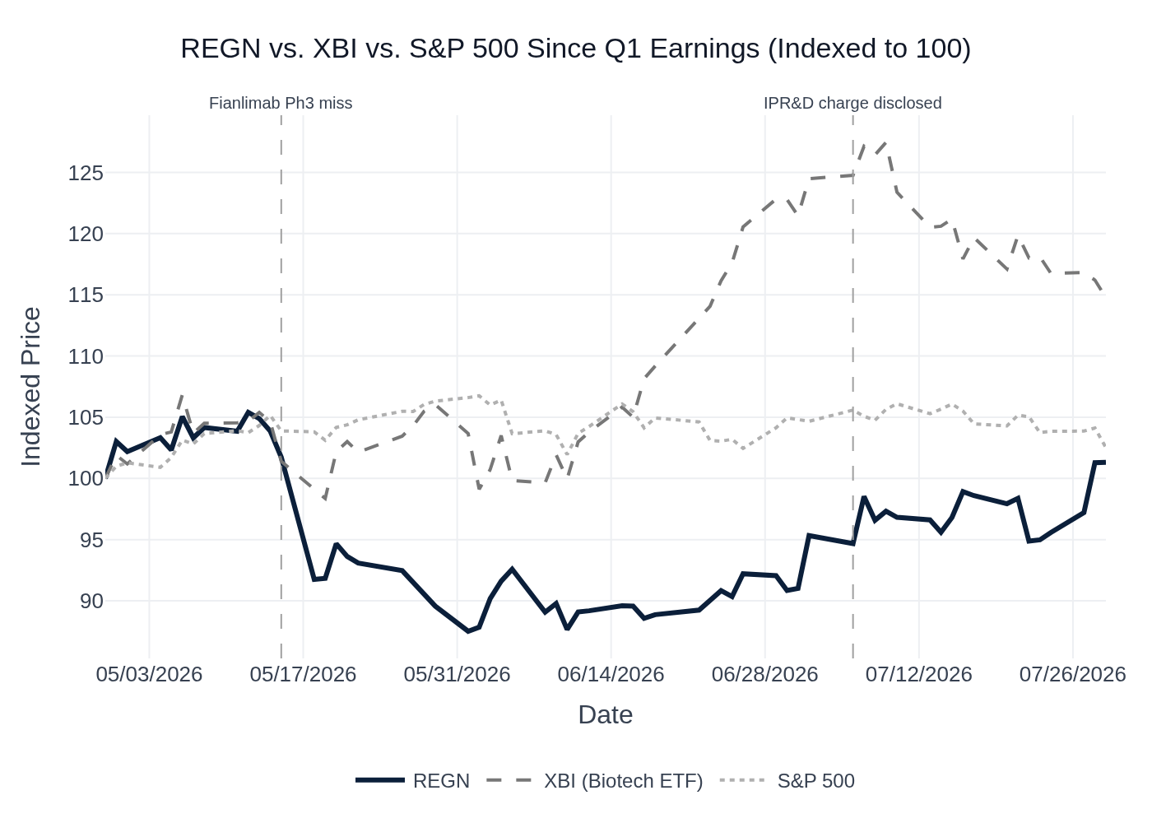
REGN vs. XBI vs. S&P 500 — Indexed to 100 at Q1 2026 Earnings (April 29, 2026). Source: Yahoo Finance.
Key observations: (1) REGN dropped sharply on May 15 following the fianlimab Phase 3 failure in first-line metastatic melanoma, falling from ~$714 to ~$629 (-12%) over the subsequent week. (2) The stock found a floor near $600 in early June and has since recovered to ~$695, but remains well below the XBI's trajectory. (3) The stock's 1-month performance (+10.1%) has recently converged with the market, suggesting some mean-reversion buying ahead of earnings. (4) At current levels, REGN trades at ~13.9x NTM P/E and ~10.4x NTM EV/EBITDA — a significant discount to large-cap biotech peers, consistent with the market pricing in EYLEA erosion risk and requiring pipeline proof points before re-rating.

6. Material News & Developments
Key Takeaway: The most important development since Q1 earnings is the $127M IPR&D charge disclosed July 6 (known, ~$1.00/share EPS impact), which is already in consensus. The fianlimab Phase 3 failure (May 15) was the most market-moving event of the period and has been fully absorbed. The EYLEA HD PFS regulatory decision remains the key pending catalyst.
- July 6, 2026 — $127M IPR&D Charge Disclosed (8-K): Regeneron disclosed a ~$127M pre-tax IPR&D charge for Q2 2026 (~$1.00/share non-GAAP EPS impact) related to up-front and opt-in payments for collaboration and licensing agreements. Already reflected in current consensus; market should look through this.
- June 17, 2026 — Annual Meeting: Board and Executive Compensation Approved (8-K): Shareholders backed the board and executive compensation at the annual meeting. Routine; no material implications.
- June 8, 2026 — Goldman Sachs Global Healthcare Conference: Management confirmed EYLEA HD demand trajectory on track (~10% sequential unit growth), Sanofi development balance repayment on track for end of Q2, and PFS applications still pending with no update. Tone was constructive on Dupixent and pipeline. Confirmed long-acting IL-13 antibody dosed its first patient in late May/early June.
- May 15, 2026 — Fianlimab Phase 3 Failure in Metastatic Melanoma: The Phase 3 trial of fianlimab + cemiplimab vs. pembrolizumab in first-line unresectable/metastatic melanoma failed to reach statistical significance on PFS. High-dose arm showed numerically meaningful improvement but HR did not achieve significance. Stock fell ~12% over the subsequent week. Implication: Sell-side removed fianlimab from models; head-to-head Phase 3 vs. Opdualag remains ongoing as the primary remaining path. Adjuvant melanoma study continues with second interim analysis expected H2 2026.
- May 12, 2026 — Bank of America Global Healthcare Conference: Management provided detailed EYLEA HD commercial update ("almost half" of combined EYLEA/EYLEA HD net sales), confirmed COPD launch "going very, very well," and reiterated M&A flexibility ("nothing is off the table"). Tone was constructive.
- April 29, 2026 — Q1 2026 Earnings Beat; Stock -8%: Revenue and non-GAAP EPS both beat consensus, but stock fell ~8% on the day due to Limerick manufacturing disruption weighing on GAAP margins, EYLEA HD PFS missing its April PDUFA date, and continued EYLEA inventory headwinds. Sanofi development balance repayment guided for end of Q2.
- April 29, 2026 — $3.0B Share Repurchase Authorization: Board authorized a new $3.0B buyback program with no time limit. Positive capital return signal.
- April 29, 2026 — MFN Pricing Agreement with US Government: Regeneron signed a Most-Favored-Nation pricing agreement covering Medicaid pricing benchmarked to other developed nations, future medicines, and Praluent via TrumpRx at reduced price. In exchange: tariff relief for three years and no future government pricing mandates. Removes a key regulatory overhang.
- April 2026 — EYLEA HD Extended Dosing Interval Approved: FDA approved extended dosing interval of up to every 20 weeks for EYLEA HD in nAMD and DME. Positive label enhancement supporting physician confidence in the product.
- April 2026 — Otarmeni (Gene Therapy) Approved: FDA approved Otarmeni (lunsotogene parvec) as the first gene therapy for OTOF-related genetic hearing loss. To be provided free in the US. Regeneron's first gene therapy approval — pipeline milestone, limited near-term revenue impact.

7. Peer Commentary Read-Through (Last 60 Days, Q2 2026 Relevant)
Key Takeaway: The most actionable peer read-throughs for REGN's Q2 2026 print come from (1) J&J's myeloma bispecific results validating the LYNOZYFIC opportunity, (2) Sanofi's Jefferies conference commentary confirming Dupixent volume momentum and pricing dynamics, and (3) Novo Nordisk's R&D Day framing the competitive obesity landscape that REGN's olatorepatide program will enter. All commentary below is from the past 60 days and explicitly concerns the Q2 2026 commercial environment.

A. Johnson & Johnson (JNJ) — Q2 2026 Earnings Call (July 15, 2026)
REGN Relevance: Multiple myeloma bispecific antibody market validation for LYNOZYFIC (odronextamab)
- Darzalex delivered >$4B in Q2 2026 sales, growing ~17.6%, driven by 11-point frontline share gains. Read-through: The myeloma market continues to expand rapidly, validating REGN's eight-trial LYNOZYFIC strategy targeting a $30B market.
- Tecvayli (BCMA×CD3 bispecific) grew 56.1% YoY to $260M in Q2, with US sequential growth of 46.2% driven by the Tecvayli + Darzalex Faspro approval and community setting expansion. JNJ noted 25% QoQ increase in community site expansion. Read-through: Bispecific antibodies are penetrating beyond academic centers into community oncology — a critical market access dynamic for REGN's odronextamab launch planning.
- Talvey (GPRC5D×CD3 bispecific) grew 62.6% YoY driven by increased depth of prescribing in the community setting. New data showed >80% of patients progression-free at two years with Talvey + Darzalex. Read-through: Bispecific + Darzalex combinations are becoming the standard of care in relapsed/refractory myeloma, which is the competitive landscape REGN's odronextamab will enter.
- JNJ stated: "We have treatments in every line of therapy, with 80% of patients receiving one or more of our medicines during the treatment journey." Read-through: The myeloma market is increasingly dominated by JNJ's portfolio, raising the bar for REGN's odronextamab to demonstrate differentiated efficacy (particularly the unprecedented complete response rates and MRD negativity data management has highlighted).
- Tecvayli + Darzalex 3-year data: 83% of patients remained alive and progression-free. Read-through: Durability data is becoming a key competitive differentiator in myeloma — REGN will need to demonstrate comparable or superior long-term outcomes for LYNOZYFIC.

B. Sanofi (SAN FP) — Jefferies Global Healthcare Conference (June 3, 2026)
REGN Relevance: DUPIXENT co-commercialization partner; direct read-through to REGN's largest revenue driver
- Atopic dermatitis advanced therapy penetration remains only ~20% — "eight out of ten patients who are actually eligible... are not on an advanced therapy." Read-through: Dupixent's volume growth runway remains substantial; the market is far from saturation.
- Sanofi confirmed it is navigating MFN pricing pressure and PBS reform, having signed the MFN agreement with the US government. Management noted the objective is to "protect the value in the markets" while ensuring "optimal access." Read-through: Gross-to-net dynamics for Dupixent may face incremental pressure, but management is actively managing the balance.
- Sanofi highlighted a "truly transformative" shift in physician engagement — 50% of US physicians now consult LLMs (large language models) before prescribing. Management is adapting data dissemination strategies accordingly. Read-through: Dupixent's strong clinical data profile should benefit from AI-assisted prescribing tools, but Sanofi/REGN must ensure data is optimally formatted for these platforms.
- Sanofi described Dupixent as a "lead asset" within the alliance and confirmed continued strong commercial execution. Read-through: No negative signals on Dupixent's Q2 trajectory from REGN's most important commercial partner.

C. Novo Nordisk (NVO) — R&D Day (June 7, 2026)
REGN Relevance: GLP-1/obesity market dynamics for REGN's olatorepatide (GLP-1/GIP agonist) program
- Wegovy pill reached >3 million prescriptions by week 22, with 2 million additional prescriptions in the last 10 weeks — described as "the best product launch within the category of GLP-1 and perhaps within the whole category of launches in the US." Read-through: The oral GLP-1 channel is growing explosively, validating the market opportunity REGN is targeting with olatorepatide.
- Wegovy brand now accounts for ~60% of new-to-brand prescriptions in the US despite competition. Read-through: The GLP-1/GIP obesity market is highly competitive; REGN's olatorepatide will need to demonstrate differentiated tolerability and/or efficacy to gain share.
- NVO emphasized that patients prioritize "the magnitude of weight loss, tolerability, and speed of weight loss" as the key decision drivers. Read-through: REGN's strategy of co-formulating olatorepatide with alirocumab (Praluent) to address hypercholesterolemia in obesity patients is a differentiated approach that goes beyond weight loss alone — consistent with NVO's framing of the competitive landscape.
- NVO noted that less than 1 in 10 eligible patients are currently on GLP-1 therapy globally, with ~100M+ eligible in the US alone. Read-through: The market is massively underpenetrated, supporting REGN's decision to invest in olatorepatide Phase 3 programs.
- NVO's commentary on a competitor's once-monthly injectable: "not as compelling as we had hoped for, in particular, on the tolerability side." Read-through: Tolerability is a critical differentiator in the obesity space — REGN's olatorepatide showed favorable GI tolerability in Hansoh's Chinese Phase 3 data, which management is seeking to replicate in a US Phase 2 study.

D. Eli Lilly (LLY) — ADA Cardiometabolic Health Portfolio Investor Event (June 6, 2026)
REGN Relevance: GLP-1/GIP obesity market competitive dynamics and payer access environment for REGN's olatorepatide program
- Orforglipron (oral GLP-1) received US marketing authorization in April 2026 and is seeing "strong use" in the "earlier in the obesity journey, lower BMI population." LLY has "not even begun to turn on the full promotional levers." Read-through: The oral GLP-1 channel is accelerating rapidly, raising the competitive bar for REGN's injectable olatorepatide program.
- LLY aims to launch 4-5 obesity medicines by end of the decade, recognizing that "not everyone is going to be well served by a single medicine." Read-through: The obesity market is evolving toward a multi-product, multi-mechanism paradigm — consistent with REGN's strategy of combining olatorepatide with alirocumab to address a specific patient subset (obesity + hypercholesterolemia).
- Retatrutide (triple agonist) submission for weight loss on track for H2 2026 with 28.3% weight loss in obesity studies. Read-through: The efficacy bar in obesity is rising rapidly; REGN's olatorepatide will need to demonstrate competitive weight loss alongside its tolerability advantage.
- LLY confirmed obesity is a "chronic disease that requires chronic treatment" — patients who discontinue return to baseline within 9-12 months. Read-through: The chronic treatment paradigm supports REGN's combination strategy (olatorepatide + alirocumab) as a differentiated long-term solution for a specific patient population.
- Medicare coverage for GLP-1 obesity drugs launched July 1, 2026 at $50/month via a new pilot program. Read-through: Expanding payer access is a significant positive for the overall obesity market that REGN's olatorepatide will eventually enter.

