Trane Technologies (TT) — Q2 2026 Earnings Preview
Prepared: July 29, 2026 | Earnings Date: July 30, 2026 | Reporting Period: Q2 2026 (ended June 30, 2026) | Sector ETF: XLI (Industrials)

1. Earnings Preview
Key Takeaway: Setup leans toward a beat — consensus is a manageable bar given record backlog and strong peer data-center read-throughs — but the stock has already given back its post-Q1 gains, so the swing factor is whether Applied bookings momentum continues above 100% growth and whether management raises full-year guidance again.
Heading into Q2 2026, Trane Technologies carries a record $10.7 billion backlog (up ~70% YoY as of Q1) and management-issued guidance of ~5% organic revenue growth and adjusted EPS of $4.20–$4.25 for the quarter — a bar that looks achievable given the backlog conversion cadence and strong peer signals. Carrier (CARR) reported Q2 commercial HVAC orders up ~65% with data center orders up 4x YoY and raised its full-year data center revenue outlook to $2 billion, a direct positive read-through for TT's Applied business; JCI similarly reported 30% order growth and raised full-year EPS guidance to ~$4.85, reinforcing broad-based commercial HVAC demand. Management's tone since the April 30 print has been constructive — the AI Lab opening in May and continued NVIDIA reference design partnerships signal confidence in the data center positioning — though the July 22 departure of Chief Supply Chain Officer Gary Guo introduces a modest execution uncertainty heading into a high-growth capacity ramp. Estimate revisions have been modestly positive since Q1 earnings, with Q2 EPS consensus moving from $4.259 to $4.264 and FY2026 EPS from $14.897 to $14.914, suggesting the Street is not aggressively front-running a beat. The stock has underperformed sharply since the Q1 print — down ~9.3% vs. XLI +1.2% and SPY +1.5% — unwinding the pre-earnings run-up and resetting the multiple to a more neutral setup. The key wildcard is the pace of Applied bookings: a fourth consecutive quarter above 100% growth would be a powerful signal of multi-year demand durability and could re-rate the stock; any deceleration, even to strong-but-below-100% levels, risks disappointing a market that has priced in exceptional momentum.

2. KPIs & Consensus Expectations
Key Takeaway: Consensus sits at $4.26 adjusted EPS and $6.21B revenue for Q2 2026 — a manageable bar given the backlog and peer read-throughs. Organic revenue growth rate (~5.4% consensus) is the bigger swing factor; any acceleration toward the high single digits would signal upside to the full-year guide.

Table 1 — Q2 2026 Current Quarter Snapshot
KPI | Q1 2026 Actual (Last Quarter) | Q2 2025 Actual (Prior Year) | Q2 2026 Consensus Estimate | YoY Change | Guidance (Q1 Call) | Consensus vs. Guidance
Net Revenue ($B) | $4.97B | $5.75B | $6.21B | +8.1% | ~10% total rev growth; ~5% organic | +0.3% above organic guide midpoint
Adj. EPS (Diluted - Operating) | $2.63 | $3.88 | $4.26 | +9.8% | $4.20–$4.25 | +0.3% above midpoint ($4.225)
Operating Income - Operating ($B) | $0.795B | $1.166B | $1.239B | +6.2% | N/A (EPS guided) | N/A
Operating Margin - Operating (%) | 16.0% | 20.3% | 19.9% | -40 bps YoY | N/A (EPS guided) | N/A
Organic Revenue Growth (%) | 3.5% | 6.6% | 5.4% | -120 bps YoY | ~5% organic | +40 bps above guide
Revenue - Americas ($B) | $3.998B | $4.692B | $5.138B | +9.5% | N/A (segment not guided) | N/A
Revenue - EMEA ($B) | $0.640B | $0.708B | $0.722B | +2.0% | ~$50M headwind from Middle East | Consensus reflects headwind
Revenue - Asia Pacific ($B) | $0.332B | $0.346B | $0.358B | +3.5% | Flattish for FY2026 | Slightly above flat guide
Free Cash Flow ($B) | $0.547B | $0.602B | $0.745B | +23.7% | ≥100% FCF conversion (FY) | N/A (quarterly not guided)
Source: Visible Alpha Consensus and Actuals Data. Q2 2026 Actual column is blank as earnings have not yet been reported (report date July 30, 2026). All consensus figures as of July 29, 2026.

Table 2 — Beat/Miss History (Last 8 Quarters, Top 2 KPIs)
Top 2 KPIs: (1) Adjusted EPS (Diluted - Operating) | (2) Net Revenue
Quarter | KPI | Reported | Consensus | Surprise % | Result
Q1 2026 | Adj. EPS | $2.63 | $2.54 | +3.5% | Beat
Q1 2026 | Net Revenue | $4.97B | $4.82B | +3.1% | Beat
Q4 2025 | Adj. EPS | $2.86 | $2.83 | +1.1% | Beat
Q4 2025 | Net Revenue | $5.14B | $5.11B | +0.7% | Beat
Q3 2025 | Adj. EPS | $3.88 | $3.78 | +2.6% | Beat
Q3 2025 | Net Revenue | $5.74B | $5.79B | -0.9% | Miss
Q2 2025 | Adj. EPS | $3.88 | $3.78 | +2.6% | Beat
Q2 2025 | Net Revenue | $5.75B | $5.76B | -0.2% | Slight Miss
Q1 2025 | Adj. EPS | $2.45 | $2.20 | +11.4% | Beat
Q1 2025 | Net Revenue | $4.69B | $4.46B | +5.0% | Beat
Q4 2024 | Adj. EPS | $2.61 | $2.52 | +3.6% | Beat
Q4 2024 | Net Revenue | $4.87B | $4.78B | +1.9% | Beat
Q3 2024 | Adj. EPS | $3.37 | $3.22 | +4.7% | Beat
Q3 2024 | Net Revenue | $5.44B | $5.30B | +2.6% | Beat
Q2 2024 | Adj. EPS | $3.30 | $3.08 | +7.1% | Beat
Q2 2024 | Net Revenue | $5.31B | $5.13B | +3.5% | Beat
Pattern: TT has beaten adjusted EPS consensus in all 8 of the last 8 quarters, with an average EPS surprise of ~4.6%. Revenue beats are more mixed — two slight misses in Q2 and Q3 2025 — but the EPS beat streak is consistent and reflects strong operational leverage. The bar for Q2 2026 EPS ($4.26 consensus vs. $4.20–$4.25 guidance midpoint) is modest, consistent with the historical pattern of management guiding conservatively. Source: Visible Alpha Consensus and Actuals Data.

3. Guidance & Commentary Evolution
Key Takeaway: Management raised both revenue and EPS guidance at the Q1 2026 earnings call (April 30) and has not issued any formal revision since. Tone has been constructive at conferences, with the AI Lab opening in May reinforcing the data center strategy. The
Key Takeaway: Management raised both revenue and EPS guidance at the Q1 2026 earnings call (April 30) and has not issued any formal revision since. Tone has been constructive at conferences, with the AI Lab opening in May reinforcing the data center strategy. The only notable post-earnings development is the July 22 departure of the Chief Supply Chain Officer, which introduces a modest execution risk but was characterized as unrelated to business disagreements.
Metric | Initial Guidance (Q1 2026 Earnings Call, Apr 30) | Revised Guidance | Current Consensus | Note
Q2 2026 Organic Revenue Growth | ~5% | — | ~5.4% | No post-earnings revision; consensus slightly above guide
Q2 2026 Adjusted EPS | $4.20–$4.25 | — | $4.26 | No post-earnings revision; consensus at top of range
FY2026 Organic Revenue Growth | ~7% (raised from 6–7% range) | — | ~7.2% | No post-earnings revision; consensus slightly above guide
FY2026 Adjusted EPS | $14.75–$14.95 (raised from $14.65–$14.85) | — | $14.91 | No post-earnings revision; consensus near midpoint ($14.85)
FY2026 Reported Revenue Growth | ~9.5% (incl. ~2pts M&A, ~50bps FX) | — | N/A (organic guided) | No post-earnings revision
Residential Revenue (FY2026) | ~Flat (raised from flat-to-down 5%) | — | N/A (not separately tracked in VA) | Improved from Jan guide; Q2 expected flattish, H2 growth
Transport Revenue (FY2026) | Mid-single-digit decline | — | N/A (not separately tracked in VA) | Q2 expected down ~mid-teens; recovery expected H2 2026 / 2027
CapEx (FY2026) | 2%–3% of revenue (raised from 1%–2%) | — | N/A | Raised to fund Applied + Stellar capacity expansion
Pricing Assumption (FY2026) | ~2 pts enterprise (raised from ~1.5 pts in Jan) | — | N/A | Tariff/inflation pass-through; baked into raised EPS guide
Source: TT Q1 2026 Earnings Call Transcript (April 30, 2026); Visible Alpha Consensus Data.

4. Guidance vs. Estimate Revision Tracker
Key Takeaway: Estimates have moved modestly higher since the Q1 2026 print — Q2 EPS consensus up ~$0.005 and FY2026 EPS up ~$0.017 — suggesting the Street is not aggressively front-running a beat. Consensus tracks just above the guidance midpoint on both EPS and organic revenue, which is a healthy setup: the bar is not elevated, and any upside to bookings or margin would drive meaningful estimate revisions.
KPI (Period) | Estimate ~5 Days Post Q1 Earnings (as of May 5, 2026) | Current Consensus (Jul 29, 2026) | Estimate Δ (%) | Initial Guidance (Q1 Call) | Current Guidance | Guidance Δ | Consensus vs. Guidance (%)
Adj. EPS — Q2 2026 | $4.259 | $4.264 | +0.1% | $4.20–$4.25 | Unchanged | — | +0.3% above midpoint
Net Revenue — Q2 2026 | $6.194B | $6.210B | +0.3% | ~10% total / ~5% organic | Unchanged | — | Consistent with guide
Organic Growth % — Q2 2026 | 5.23% | 5.42% | +19 bps | ~5% | Unchanged | — | +40 bps above guide
Adj. EPS — FY2026 | $14.897 | $14.914 | +0.1% | $14.75–$14.95 | Unchanged | — | +0.2% above midpoint ($14.85)
Net Revenue — FY2026 | $23.366B | $23.389B | +0.1% | ~9.5% reported growth | Unchanged | — | Consistent with guide
Organic Growth % — FY2026 | 7.10% | 7.18% | +8 bps | ~7% | Unchanged | — | +18 bps above guide
Adj. EPS — FY2027 | $16.877 | $17.040 | +1.0% | No FY2027 guidance issued | — | — | N/A
Net Revenue — FY2027 | $25.207B | $25.354B | +0.6% | No FY2027 guidance issued | — | — | N/A
Source: Visible Alpha Consensus and Actuals Data. Baseline as of May 5, 2026 (~5 trading days post Q1 2026 earnings on April 30, 2026).
Estimates have been remarkably stable since the Q1 print, with virtually no revision in either direction. The FY2027 EPS estimate has moved up +1.0% since the Q1 print, suggesting the Street is beginning to price in stronger out-year growth from the data center backlog build. The tight consensus-vs-guidance spread on both EPS and revenue means any upside surprise on bookings or margin could drive a meaningful step-up in estimates.

5. Stock Performance
Key Takeaway: TT has significantly underperformed since the Q1 2026 earnings print — down ~9.3% vs. XLI +1.2% and SPY +1.5% through July 30 — unwinding the sharp pre-earnings run-up. The underperformance is driven by multiple compression rather than estimate cuts (estimates barely moved), suggesting the market is digesting the valuation premium after the stock hit all-time highs near $503 in late June.
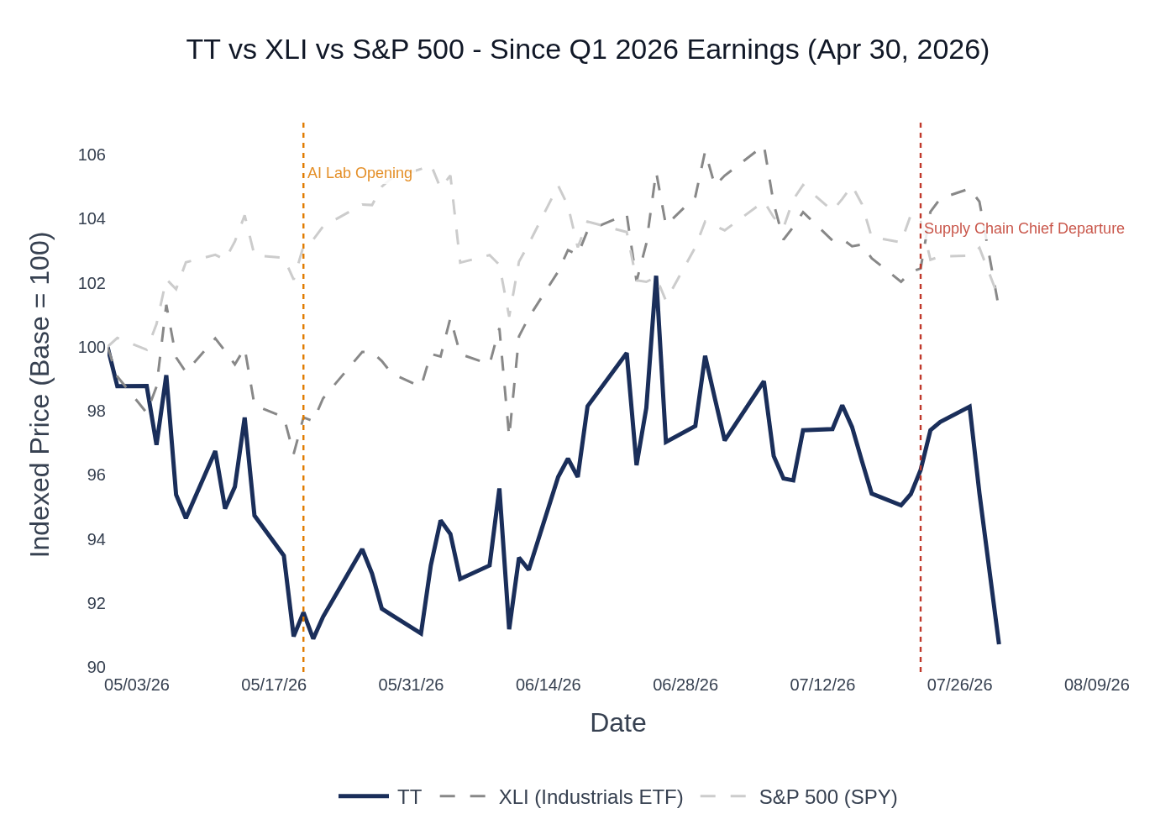
TT vs. XLI (Industrials ETF) vs. S&P 500 — Indexed to 100 at Q1 2026 Earnings (April 30, 2026). Source: Stock Price Data.
- April 30, 2026 (Q1 Earnings): TT opened at $492.54 on earnings day, gaining ~2.7% on the day after beating on both EPS and revenue. Stock had already rallied ~18% in the 30 days prior to the print.
- May 2026: Stock pulled back from the $486–$492 range to the $448–$470 range as the market digested the valuation premium. The AI Lab opening on May 20 provided a brief positive catalyst but did not reverse the trend.
- June 2026: Stock recovered to a new all-time high of ~$503 on June 25, driven by continued strong industrial sentiment and data center enthusiasm, before pulling back to the $477–$491 range into month-end.
- July 2026: Stock declined from ~$487 to ~$447 through July 30, with the July 22 announcement of the Chief Supply Chain Officer departure adding to selling pressure. The stock is now down ~9.3% since the Q1 print vs. XLI +1.2% and SPY +1.5%.
- Sector ETF: XLI (iShares U.S. Industrials ETF) was selected as the benchmark, appropriate for TT's industrial HVAC and climate solutions sub-sector.

7. Material News & Developments
Key Takeaway: The most important development since the Q1 print is the July 22 departure of Chief Supply Chain Officer Gary Guo, which introduces execution risk during a critical capacity ramp. The AI Lab opening and NVIDIA reference design partnerships are positive strategic signals, but the supply chain leadership gap is the key watch item heading into the print.
- July 22, 2026 — Chief Supply Chain Officer Gary Guo Departure (8-K): Trane Technologies announced that Mingxiao (Gary) Guo, SVP and Chief Global Integrated Supply Chain Officer, will depart effective August 1, 2026. The company waived clawback of certain sign-on bonus payments. The 8-K explicitly stated the departure is
- not due to any disagreement on operations, policies, or financial affairs. Implication: The timing is notable — Guo is departing during a critical period when TT is ramping Applied and Stellar Energy capacity across multiple facilities (Florida, Texas, Longview). Supply chain execution is a key risk for the data center growth story; the market will want clarity on succession and continuity.
- May 20, 2026 — BrainBox AI Trane Technologies Global AI Lab Opening (Press Release): TT unveiled its AI Lab and showroom in Montréal, Canada, focused on developing next-generation AI-driven solutions for autonomous HVAC and transport refrigeration. The lab is supported by AWS, IVADO, and Concordia University. Implication: Reinforces TT's digital/AI strategy and the BrainBox AI acquisition thesis; positive for the services growth narrative and long-term margin expansion story.
- May 5, 2026 — Conference Presentations (Wolfe Research & BofA): TT presented at the Wolfe Research Global Transportation & Industrials Conference and the Bank of America Industrials, Transportation & Airlines Key Leaders Conference. Management reiterated confidence in the data center positioning, NVIDIA reference design partnerships (two published designs), and Stellar Energy ramp. Implication: No guidance changes; constructive tone reinforced the Q1 earnings message.
- April 30, 2026 — Q1 2026 Earnings Beat & Guidance Raise: TT beat on both adjusted EPS and revenue; raised FY2026 organic revenue guidance to ~7% (high end of prior range) and EPS guidance to $14.75–$14.95. Record backlog of $10.7B, up 70% YoY. Applied bookings up 160%+ for third consecutive quarter. Residential outlook upgraded to ~flat. Implication: This is the baseline from which Q2 2026 is being evaluated; the raised guidance sets the bar for the upcoming print.
- Peer Read-Through — CARR Q2 2026 (July 28, 2026): Carrier raised full-year data center revenue outlook to $2B (from $1.5B), with commercial HVAC orders up 65% and data center orders up 4x YoY. Total backlog over $8B, up 40% YoY. Implication: Strongest possible positive read-through for TT's Applied bookings and data center positioning heading into the Q2 print.
- Peer Read-Through — JCI Q3 FY2026 (July 29, 2026): Johnson Controls reported orders up 27%, backlog at record $21B (+30% YoY), and raised full-year EPS guidance to ~$5.05 (~35% growth). CDU pipeline exceeded $1B. Implication: Confirms broad-based commercial HVAC and data center demand acceleration; positive read-through for TT's Applied business and LiquidStack CDU strategy.
- Peer Read-Through — LII Q2 2026 (July 29, 2026): Lennox cut full-year residential guidance (HCS revenue growth to ~1% from 4%) citing muted recovery and consumer confidence headwinds. Building Climate Solutions (commercial) raised to ~20% growth. Implication: Mixed — residential weakness is a modest headwind for TT's ~flat residential guide, but commercial strength is a positive read-through.

8. Insider Transaction Activity
Key Takeaway: No open-market buys or discretionary sells since the Q1 2026 earnings print. All director transactions in June were routine annual equity award grants (code A) with associated tax-withholding disposals (code F). The only notable item is a 10b5-1 plan sale by Donald Simmons (EVP & COO) on July 1 — a pre-planned transaction, not a discretionary signal. Overall, the insider picture is neutral.
Name | Title | Transaction Type | Shares | Date | Note
Simmons, Donald E. | EVP & Chief Operating Officer | Award Grant (A) | 826 shares + 3,085 options | Jul 1, 2026 | Routine equity award; not a market purchase
Simmons, Donald E. | Group President, Americas | 10b5-1 Planned Sale (S) | 4,593 shares | Apr 30, 2026 | Pre-planned 10b5-1 sale; executed same day as Q1 earnings; not a discretionary signal
Arnold, Kirk E. | Director | Award Grant (A) / Tax Withholding (F) | 438 granted / 112 withheld | Jun 5, 2026 | Routine annual director equity grant; F code = tax withholding, not a discretionary sale
Berzin, Ann C. | Director | Award Grant (A) / Tax Withholding (F) | 438 granted / 112 withheld | Jun 5, 2026 | Routine annual director equity grant; tax withholding disposal
Hayes, John A. | Director | Open Market Buy (P) | 400 shares (Trust) | Mar 5, 2026 | Open market purchase by revocable trust; modest size but directionally positive signal pre-Q1 earnings
de Jesus Assis, Ana Paula | Director | Award Grant (A) / Tax Withholding (F) | 438 granted / 224 withheld | Jun 5, 2026 | Routine annual director equity grant; tax withholding disposal
Multiple Directors (George, Lee, Miller, Pine, Schaeffer, Surma, Hudson) | Directors | Award Grant (A) / Tax Withholding (F) | 438 granted / 112–224 withheld each | Jun 4–5, 2026 | Routine annual director equity grants; all F codes are tax withholding, not discretionary sales
Source: Insider Transaction Data (SEC Form 4 filings). Transaction codes: A = Award/Grant, F = Tax Withholding Disposal, S = Open Market Sale, P = Open Market Purchase, M = Option Exercise.
Summary: The only open-market transaction since the Q1 2026 earnings print is Director John Hayes' purchase of 400 shares in March 2026 (pre-Q1 earnings, via revocable trust). All June transactions are routine annual director equity grants with associated tax withholding. The April 30 Simmons sale was a pre-planned 10b5-1 transaction. There are no discretionary open-market sells by executives since the Q1 print, and no clustered buying activity. The insider picture is neutral — no red flags and no strong bullish signal.

