Corpay, Inc. (CPAY) — Q2 2026 Earnings Preview
Ticker: CPAY Upcoming Earnings: August 5, 2026 (Q2 2026) Prepared: August 4, 2026

Earnings Preview
Key Takeaway: Setup leans toward a beat — consensus sits at the low end of guidance, the macro backdrop (higher fuel prices, FX volatility) has been a tailwind all quarter, and the Alpha platform migration completing in July/August is the key wildcard for corporate payments acceleration.
CPAY heads into Q2 2026 earnings with a low bar — consensus EPS of $6.60 sits near the bottom of the $6.30–$6.80 guidance range, and the company has beaten on both revenue and EPS in each of the last four quarters. The macro backdrop has been constructive: fuel prices remained elevated through Q2 (a tailwind for Vehicle Payments), FX volatility was elevated (a tailwind for cross-border), and the weaker USD benefited international revenue translation. Corporate Payments, now 40%+ of revenue, is the key swing factor — the Alpha platform migration was targeted for completion in July/August, which should unlock cost synergies and geographic revenue expansion in the back half. Lodging is the one segment to watch for upside surprise, given Q1 same-store sales turned positive for the first time in many quarters and management guided to mid-to-high single digit H2 growth. The stock has already re-rated +30% since Q1 earnings, so the bar for a positive reaction is higher — a guidance raise and Corporate Payments organic growth above 15% are likely needed to sustain momentum.

KPIs & Consensus Expectations
Key Takeaway: Consensus sits at the low end of guidance on both revenue and EPS, suggesting a low bar. Corporate Payments organic growth (guided mid-teens) and Spend Volume are the biggest swing factors heading into the print.
Table 1 — Current Quarter Snapshot (Q2 2026)
KPI | Q1 2026 Actual | Q2 2025 Actual | Q2 2026 Consensus | YoY Change | Guidance | Consensus vs. Guidance
Revenue | $1,261M | $1,102M | $1,302M | +18.1% | ~$1,295M midpoint | +0.5% above midpoint
Adj. EPS (Diluted Operating) | $5.80 | $5.13 | $6.60 | +28.7% | ~$6.55 midpoint | +0.8% above midpoint
Corporate Payments Revenue | $503.9M | $387M | $529.5M | +36.8% | N/A | N/A
Vehicle Payments Revenue | $563.9M | $512M | $570.6M | +11.4% | N/A | N/A
Lodging Revenue | $111M | $120M | $121.5M | +1.3% | N/A | N/A
Corp. Payments Organic Growth | 16% | 19% | 15.2% | N/A | Mid-teens | At guidance midpoint
Vehicle Payments Organic Growth | 10% | 9% | 8.2% | N/A | ~9–10% | Slightly below
Total Organic Revenue Growth | 11% | 11% | 10.2% | N/A | 9–11% | At midpoint
Spend Volume | $81.85B | $55.67B | $82.2B | +47.6% | N/A | N/A
EBITDA (Company Defined) | $636.9M | $570.7M | $658.7M | +15.4% | N/A | N/A
Source: Visible Alpha Consensus and Actuals Data. All actuals from Visible Alpha.
Table 2 — Beat/Miss History (Last 8 Quarters) — Revenue
Quarter | Reported | Consensus | Surprise % | Result
Q2 2024 | $975.7M | $973.7M | +0.2% | Beat
Q3 2024 | $1,029.2M | $1,025.9M | +0.3% | Beat
Q4 2024 | $1,034.4M | $1,063.2M | -2.7% | Miss
Q1 2025 | $1,005.7M | $1,012.0M | -0.6% | Miss
Q2 2025 | $1,102.0M | $1,099.9M | +0.2% | Beat
Q3 2025 | $1,172.5M | $1,165.4M | +0.6% | Beat
Q4 2025 | $1,248.2M | $1,239.0M | +0.7% | Beat
Q1 2026 | $1,261.0M | $1,213.8M | +3.9% | Beat
Table 2 — Beat/Miss History (Last 8 Quarters) — Adj. EPS (Diluted Operating)
Quarter | Reported | Consensus | Surprise % | Result
Q2 2024 | $4.54 | $4.51 | +0.7% | Beat
Q3 2024 | $5.01 | $4.97 | +0.8% | Beat
Q4 2024 | $5.36 | $5.48 | -2.2% | Miss
Q1 2025 | $4.51 | $4.51 | 0.0% | In-line
Q2 2025 | $5.13 | $5.12 | +0.2% | Beat
Q3 2025 | $5.70 | $5.64 | +1.1% | Beat
Q4 2025 | $6.04 | $5.96 | +1.3% | Beat
Q1 2026 | $5.80 | $5.48 | +5.8% | Beat
CPAY has beaten on revenue in 6 of the last 8 quarters and on EPS in 7 of 8, with the Q1 2026 beat being the largest in recent history (+3.9% revenue, +5.8% EPS). The trend of accelerating beats is notable heading into Q2.
Source: Visible Alpha Consensus and Actuals Data.

Guidance & Commentary Evolution
Key Takeaway: No formal guidance revision since Q1 earnings, but management tone at conferences has been consistently bullish — macro tailwinds (fuel, FX) have persisted and the Alpha integration is tracking ahead of schedule.
Metric | Initial Guidance (Q1 2026 Earnings, May 7) | Revised Guidance | Current Consensus | Note
Q2 2026 Revenue | ~$1.295B midpoint ($1.270B–$1.320B) | — | $1.302B | Consensus +0.5% above midpoint; unchanged since Q1 call
Q2 2026 Adj. EPS | ~$6.55 midpoint ($6.30–$6.80) | — | $6.60 | Consensus +0.8% above midpoint; unchanged since Q1 call
FY 2026 Revenue | ~$5.290B midpoint | — | $5.301B | Consensus +0.2% above midpoint; raised from prior guide at Q1
FY 2026 Adj. EPS | ~$26.70 midpoint | — | $26.79 | Consensus +0.3% above midpoint; raised from $26.35 prior guide
FY 2026 Organic Growth | ~10% | — | 10.0% | Consensus at guidance; management reiterated at conferences
Corp. Payments Organic Growth | Mid-teens | — | 15.2% | At low end of mid-teens; Alpha synergies expected to accelerate H2
At the JPMorgan TMC Conference (May 18) and Morgan Stanley Financials Conference (June 9), CFO Peter Walker reiterated confidence in the full-year outlook, noting macro tailwinds (fuel prices, FX volatility, weaker USD) remain supportive. Alpha platform migration targeted for July/August completion — a key catalyst for H2 synergy realization. No formal guidance revision has been issued since the Q1 2026 earnings call.
Source: CPAY Q1 2026 Earnings Call (May 7, 2026); JPMorgan TMC Conference (May 18, 2026); Morgan Stanley U.S. Financials Conference (June 9, 2026).

Guidance vs. Estimate Revision Tracker
Key Takeaway: Estimates have moved modestly higher since Q1 earnings, tracking guidance closely. The Q2 EPS estimate is up ~+0.5% since the post-Q1 baseline, suggesting the Street has absorbed the guidance raise without significant incremental upside being priced in — leaving room for a beat if macro tailwinds persist.
KPI | Estimate (May 12, 2026 — 5 Days Post Q1) | Current Consensus | Estimate Δ (%) | Initial Guidance (Q1 Call) | Current Guidance | Guidance Δ | Consensus vs. Guidance
Q2 2026 Revenue | $1,297.7M | $1,301.8M | +0.3% | ~$1,295M | Unchanged | — | +0.5% above
Q2 2026 Adj. EPS | $6.57 | $6.60 | +0.5% | ~$6.55 | Unchanged | — | +0.8% above
FY 2026 Revenue | $5,302.0M | $5,301.0M | -0.02% | ~$5,290M | Unchanged | — | +0.2% above
FY 2026 Adj. EPS | $26.79 | $26.79 | 0.0% | ~$26.70 | Unchanged | — | +0.3% above
Estimates have been remarkably stable since Q1 earnings, with minimal revision activity. This suggests the Street is comfortable with guidance but not pricing in incremental upside — leaving room for a beat if macro tailwinds (fuel, FX) persisted into Q2.
Source: Visible Alpha Consensus and Actuals Data (as-of date: May 12, 2026 and current).

Stock Performance
Key Takeaway: CPAY has massively outperformed since Q1 earnings (+29.7% vs. SPY +5.4% and IPAY +10.0%), driven by a combination of multiple re-rating and estimate revisions. The stock’s strong run raises the bar for a positive reaction on Q2 results.
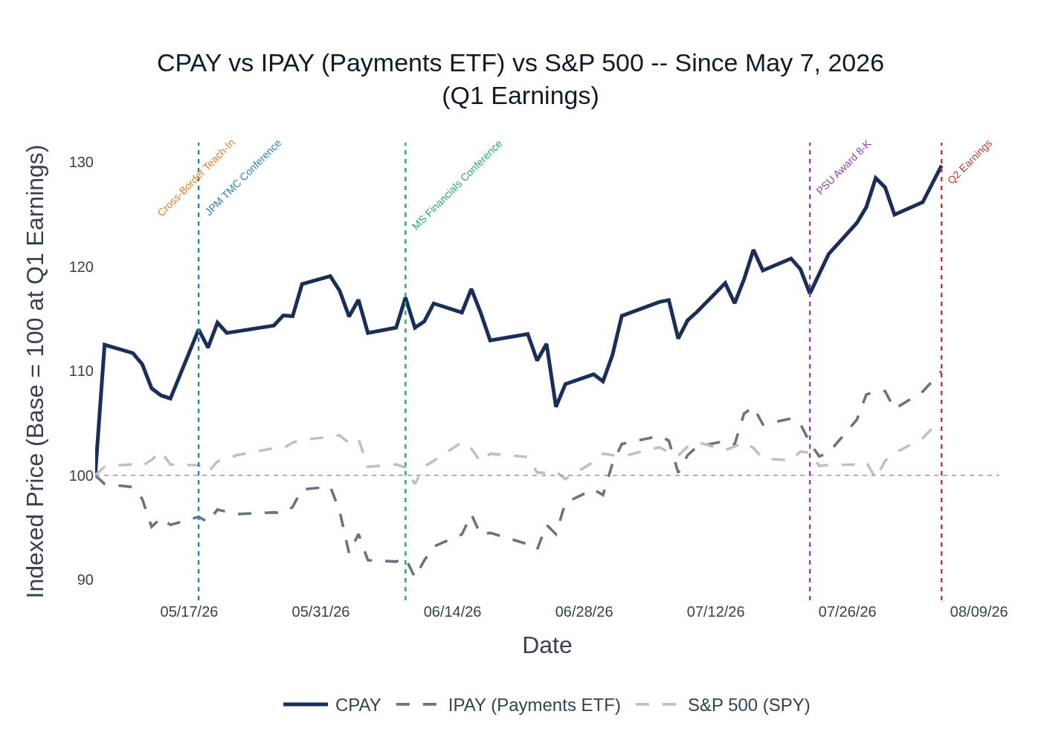
CPAY vs. IPAY (Payments ETF) vs. S&P 500 (SPY) — Indexed to 100 at Q1 2026 Earnings (May 7, 2026). Source: Yahoo Finance / Stock Price Data.
CPAY has surged +29.7% since Q1 earnings (May 7, 2026) vs. +5.4% for the S&P 500 (SPY) and +10.0% for the payments sector ETF (IPAY), a remarkable outperformance driven by the Q1 beat-and-raise, the Cross-Border Teach-In (May 13), and continued conference appearances reinforcing the corporate payments transformation narrative. The stock’s re-rating from ~12–13x NTM EPS to ~16x reflects improved sentiment around the portfolio rotation and Alpha integration progress. With the stock up 30% in 3 months, the market has already priced in significant execution — a guidance raise and Corporate Payments organic growth above 15% are likely needed to sustain the momentum.
Sector ETF used: IPAY (ETFMG Prime Mobile Payments ETF) — tracks the payments/fintech sub-sector, appropriate for CPAY’s B2B payments and fleet card business mix. Source: Yahoo Finance / Stock Price Data.

Material News & Developments
Key Takeaway: The most important development since Q1 earnings is the Cross-Border Business Teach-In (May 13), which provided detailed investor education on the $161B TAM opportunity and reinforced the long-term growth algorithm. The PSU award (July 22) with price targets of $425/$450/$475 signals strong management conviction in the stock.
- July 22, 2026 — PSU Award 8-K: Board approved special performance-based RSU grants to CEO Ron Clarke (300,000 PSUs) and President Armando Netto (28,213 PSUs) with stock price hurdles of $425, $450, and $475 (vs. current ~$370–396 range). Performance period runs through August 31, 2028. Implication: Strong management conviction signal — these are ambitious targets representing 7–20% upside from current levels; aligns executive compensation directly with shareholder value creation.
- July 22, 2026 — Q2 Earnings Date Announced: Corpay confirmed Q2 2026 results will be reported on August 5, 2026.
- June 9, 2026 — Morgan Stanley U.S. Financials Conference: CFO Peter Walker reiterated the updated EPS growth algorithm (10–13–24%), confirmed cross-border revenue on track for ~$1.5B in 2026, and noted the stock trades at 12–13x NTM EPS — viewed as significantly undervalued. Mastercard FI channel partnership progressing with 3 clients closed and strong pipeline.
- May 18, 2026 — JPMorgan TMC Conference: Management confirmed macro tailwinds (fuel prices, FX volatility, weaker USD) are supportive, Vehicle Payments tracking expectations across all three geographies, and Alpha integration ahead of schedule with ~15% of clients migrated to Corpay platform.
- May 13, 2026 — Cross-Border Business Teach-In: Detailed investor education on the cross-border business — $161B TAM with less than 1% market share, 97–98% revenue retention, 20%+ new sales growth annually, and high-teens organic growth algorithm. Blockchain rails (JPMorgan Kinexys + BVNK) positioned as additive, not disruptive. Implication: Significant investor education event that likely contributed to the stock’s re-rating post-Q1.
- May 7, 2026 — Q1 2026 Earnings Beat-and-Raise: Revenue beat by ~$50M (+3.9%), EPS beat by $0.35 (+5.8%). Full-year guidance raised on both revenue ($5.29B midpoint) and EPS ($26.70 midpoint). PayByPhone divestiture completed. Two additional businesses in market (~$1B proceeds). Board approved additional $1B share repurchase authorization.

Insider Transaction Activity
Key Takeaway: Only open-market sales since Q1 earnings, all from Group President Armando Netto and one Director. No open-market buys. The PSU award (July 22) with ambitious price targets ($425/$450/$475) is the more meaningful insider signal — it reflects management conviction in the stock’s upside.
Name | Title | Transaction Type | Value | Disclosure Date | Effective Date | Note
Armando Lins Netto | Group President, Brazil & US Vehicle Payments | Open Market Sale | ~$26.7M (70,476 shares) | June 16, 2026 | June 15, 2026 | Discretionary; largest single transaction in the period
Armando Lins Netto | Group President, Brazil & US Vehicle Payments | Open Market Sale | ~$1.6M (4,560 shares) | June 12, 2026 | June 11, 2026 | Discretionary sale
Armando Lins Netto | Group President, Brazil & US Vehicle Payments | Open Market Sale | ~$151K (418 shares) | May 29, 2026 | May 27, 2026 | Discretionary sale
Steven T. Stull | Director | Open Market Sale | ~$360K (1,000 shares) | June 15, 2026 | June 2, 2026 | Discretionary sale
All transactions are open-market sales with no 10b5-1 plan indicated. Netto’s sales are notable in size but should be viewed in context of the PSU award granted July 22 — management is simultaneously selling existing shares while receiving new performance-based equity tied to ambitious price targets ($425–$475), suggesting the sales may reflect portfolio rebalancing rather than a bearish view.
Source: SEC Form 4 Filings Database / Insider Transaction Data.

Peer Commentaries — Q2 2026 Read-Throughs
Key Takeaway: Peer commentary from Q2 2026 earnings (reported in the last 60 days) is broadly constructive for CPAY — cross-border volumes accelerating, B2B/AP payments demand healthy, and fuel price tailwinds benefiting fleet payments. WEX’s same-store sales weakness in North American mobility is the one cautionary data point to watch.

WEX (WEX) — Q2 2026 Earnings (July 23, 2026) — Fleet/Vehicle Payments Read-Through
Relevance: WEX is CPAY’s closest peer in fleet/vehicle payments. WEX Q2 results are a direct read-through for CPAY’s Vehicle Payments segment.
- WEX Q2 revenue grew 14.2% YoY (4.2% ex-fuel/FX), at the midpoint of guidance — solid execution in a challenging macro environment.
- Fuel prices were a significant tailwind: fuel/FX contributed 10 percentage points of revenue growth and 25.4 percentage points of EPS growth. Higher fuel prices drove higher credit demand, which WEX managed well with AI-powered credit tools. This is a direct positive read-through for CPAY’s Vehicle Payments segment, where fuel prices drive revenue per transaction.
- Same-store sales weakness persists in North American mobility: WEX noted “pretty consistent” same-store sales weakness across the portfolio, with demand-side volumes still constrained by broader economic conditions despite supply-side recovery in trucking. This is a cautionary read-through for CPAY’s US fleet business, though CPAY’s US same-store sales already turned positive (+1%) in Q1.
- Direct AP volume growth accelerated to 20% in Q2, expected to continue at mid-teens for the rest of the year — a positive read-through for CPAY’s payables/AP automation business within Corporate Payments.
- WEX raised full-year guidance, driven by Q2 outperformance and higher fuel price assumptions — consistent with CPAY’s constructive macro backdrop.

Mastercard (MA) — Q2 2026 Earnings (July 30, 2026) — Cross-Border & B2B Payments Read-Through
Relevance: MA’s cross-border volume trends and B2B commentary are direct read-throughs for CPAY’s Corporate Payments (cross-border) segment.
- Cross-border volume grew 12% globally in Q2, with cross-border card-not-present ex-travel up 20% — strong underlying demand for cross-border payments. This is a positive read-through for CPAY’s cross-border business, which benefits from elevated FX transaction volumes.
- Commercial debit and credit volumes grew 12% in Q2 — healthy B2B spending environment supportive of CPAY’s corporate payments spend volumes.
- Macro environment described as “supportive” — consumers and businesses healthy, positive job growth, low unemployment. No signs of demand deterioration heading into Q3.
- FX volatility was a modest headwind to MA’s yields (lapping peak volatility from Q3 2025), but the underlying cross-border volume growth was strong. For CPAY, FX volatility is a revenue driver (not a yield headwind), so this is a net positive for CPAY’s FX risk management business.
- Middle East instability moderated through Q2 and was less severe than anticipated — a positive for global cross-border volumes and CPAY’s international business.
- Mastercard’s FI channel partnership with CPAY is progressing — MA noted Truist Bank chose Mastercard virtual card capabilities for corporate clients, consistent with CPAY’s commentary about FI channel pipeline building.

Visa (V) — Fiscal Q3 2026 (Calendar Q2 2026) Earnings (July 28, 2026) — Cross-Border & Commercial Payments Read-Through
Relevance: Visa’s cross-border and commercial payment volume trends corroborate the macro backdrop for CPAY’s cross-border business.
- Cross-border volume (ex-Intra-Europe) grew 12% YoY in constant dollars, accelerating more than a point from Q2. Cross-border e-commerce up 16% — strong underlying demand.
- Commercial payment volume grew 13% YoY in constant dollars, accelerating 2 points from Q2 — the strongest commercial payment growth in recent quarters. This is a strong positive read-through for CPAY’s corporate payments spend volumes.
- U.S. payments volume grew 10% YoY — a growth rate not seen since fiscal 2019 (ex-COVID recovery). Both discretionary and non-discretionary spend remain strong with no signs of lower-spend consumer weakening.
- FIFA World Cup boosted cross-border spend in June — inbound North America cross-border card-present spend up nearly 25% YoY in host cities. This is a one-time tailwind that may have benefited CPAY’s cross-border volumes in June.
- Through July 21, cross-border volume grew 14% YoY (e-commerce +18%, travel +12%) — momentum has continued into Q3, supportive of CPAY’s H2 outlook.
- FX volatility is lapping peak levels from Q3 2025, which creates a modest yield headwind for Visa but is a revenue tailwind for CPAY’s FX risk management business (CPAY earns on volatility, not just volume).

FIS — Q2 2026 Earnings (August 4, 2026) — B2B/Banking Payments Read-Through
Relevance: FIS’s banking payments commentary provides context on enterprise B2B payment demand and AP automation trends.
- Banking payments revenue grew 6.4% in Q2, with banking solutions overall up 6.1% — healthy demand for financial institution payment infrastructure, supportive of CPAY’s FI channel strategy.
- Sales performance described as “super strong” with high double-digit ACV growth in banking solutions for three consecutive quarters — strong pipeline building in enterprise payments, consistent with CPAY’s commentary on payables and AP automation demand.
- Capital markets segment faced headwinds from interest rate pressure on lending volumes — not directly relevant to CPAY but reflects the broader rate environment that has compressed CPAY’s float revenue.
- Strong demand for fraud and data capabilities, with AI adoption accelerating across the business — consistent with CPAY’s AI investment narrative and product roadmap.
- FIS evaluating strategic alternatives for select capital markets products — ongoing industry consolidation/rationalization in financial technology; could create M&A opportunities for CPAY in corporate payments.
Sources: WEX Q2 2026 Earnings Call (July 23, 2026); Mastercard Q2 2026 Earnings Call (July 30, 2026); Visa Fiscal Q3 2026 Earnings Call (July 28, 2026); FIS Q2 2026 Earnings Call (August 4, 2026).

