DoorDash, Inc. (DASH) — Q2 2026 Earnings Preview
Company | DoorDash, Inc.
Ticker | DASH (NYSE)
Reporting Period | Q2 2026 (quarter ended June 30, 2026)
Earnings Date | August 5, 2026 (after U.S. market close)
Prepared | August 4, 2026

1. Earnings Preview
Key Takeaway: The setup into Q2 2026 is constructive — consensus sits near the Q2 guidance midpoint on GOV and slightly above on EBITDA, the stock has recovered sharply from post-Q1 lows, and management's tone has been consistently confident. The biggest swing factor is whether the Dasher gas relief program (~$50M+ gross cost) is fully offset by investment pushouts, or whether it pressures EBITDA more than the Street expects.
Heading into Q2 2026 results, DoorDash presents a moderately favorable risk/reward setup. Management guided Q2 Marketplace GOV to $32.4B–$33.4B (midpoint $32.9B) and Adjusted EBITDA to $770M–$870M (midpoint $820M); current consensus sits at $32.9B GOV and $843M EBITDA, implying the Street is pricing in a slight EBITDA beat relative to the guidance midpoint. The estimate trajectory has been stable-to-slightly-rising since the Q1 print on May 6, with no material post-earnings guidance revision — management explicitly reaffirmed full-year EBITDA margin guidance (slightly above 2025 ex-Deliveroo, plus ~$200M Deliveroo contribution) and noted Q2 was "off to a good start." The stock has rallied ~20% from its post-Q1 lows, trading at ~19.6x NTM EV/EBITDA, a meaningful compression from the 30x+ level a year ago, suggesting the multiple is no longer a headwind. The key wildcard is the Uber/Delivery Hero acquisition ($14.8B, announced July 16) — a transformative competitive event that reshapes the international delivery landscape and could prompt investors to reassess DASH's international growth premium heading into the print.

2. KPIs & Consensus Expectations
Key Takeaway: Consensus is a manageable bar — GOV estimates are essentially in line with the guidance midpoint, while EBITDA consensus sits modestly above the midpoint, reflecting the Street's confidence that investment pushouts will offset the gas relief program cost. Marketplace GOV is the primary volume swing factor; Adjusted EBITDA is the profitability swing factor given the gas relief program uncertainty.

Table 1 — Q2 2026 Current Quarter Snapshot (All Key KPIs)
KPI | Q1 2026 Actual | Q2 2025 Actual (Prior Year) | Q2 2026 Consensus Estimate | YoY Change | Q2 2026 Guidance | Consensus vs. Guidance Midpoint
Marketplace GOV ($B) | $31.6B | $24.2B | $32.9B | +35.7% YoY | $32.4B – $33.4B | +0.0% (at midpoint)
Revenue ($B) | $4.04B | $3.28B | $4.35B | +32.5% YoY | Not provided | N/A
Adjusted EBITDA ($M) | $754M | $655M | $843M | +28.7% YoY | $770M – $870M | +2.8% above midpoint
EPS – Diluted Operating ($) | $1.17 | $1.41 | $1.34 | -4.8% YoY | Not provided | N/A
Monthly Active Customers (M) | 52.9M | 45.0M | 54.7M | +21.6% YoY | Not provided | N/A
Total Orders (M) | 933M | 761M | 968M | +27.2% YoY | Not provided | N/A
Source: Visible Alpha Consensus and Actuals Data; DoorDash Q1 2026 Earnings Release (May 6, 2026). All consensus figures as of August 4, 2026.

Table 2 — Beat/Miss History: Last 8 Quarters (Top 2 KPIs: Marketplace GOV & Adjusted EBITDA)
Quarter | KPI | Reported | Consensus Est. | Surprise % | Result
Q1 2026 | Marketplace GOV | $31.6B | $31.4B | +0.5% | BEAT
Q1 2026 | Adj. EBITDA | $754M | $744M | +1.3% | BEAT
Q4 2025 | Marketplace GOV | $29.7B | $29.3B | +1.3% | BEAT
Q4 2025 | Adj. EBITDA | $780M | $773M | +0.9% | BEAT
Q3 2025 | Marketplace GOV | $25.0B | $24.6B | +1.8% | BEAT
Q3 2025 | Adj. EBITDA | $754M | $748M | +0.9% | BEAT
Q2 2025 | Marketplace GOV | $24.2B | $23.6B | +2.7% | BEAT
Q2 2025 | Adj. EBITDA | $655M | $637M | +2.8% | BEAT
Q1 2025 | Marketplace GOV | $23.1B | $22.9B | +0.9% | BEAT
Q1 2025 | Adj. EBITDA | $590M | $586M | +0.6% | BEAT
Q4 2024 | Marketplace GOV | $21.3B | $20.9B | +1.9% | BEAT
Q4 2024 | Adj. EBITDA | $566M | $564M | +0.4% | BEAT
Q3 2024 | Marketplace GOV | $20.0B | $19.8B | +1.1% | BEAT
Q3 2024 | Adj. EBITDA | $533M | $514M | +3.7% | BEAT
Q2 2024 | Marketplace GOV | $19.7B | $19.4B | +1.7% | BEAT
Q2 2024 | Adj. EBITDA | $430M | $395M | +8.9% | BEAT
Source: Visible Alpha Consensus and Actuals Data.
Pattern: DASH has beaten consensus on both Marketplace GOV and Adjusted EBITDA in each of the last 8 reported quarters, with EBITDA surprises ranging from +0.4% to +8.9% — a consistent track record that sets a high bar for the Street's expectations but also validates management's conservative guidance posture.

3. Guidance & Commentary Evolution
Key Takeaway: Guidance has been unchanged since the Q1 2026 earnings call — management reaffirmed full-year EBITDA margin trajectory and Deliveroo contribution at every opportunity. The only notable post-earnings development is the extension of the Dasher gas relief program into Q2 with a gross cost of "over $50M," which management committed to offset via investment pushouts, leaving the full-year EBITDA outlook intact.

Table 3 — Guidance & Commentary Evolution
Metric | Initial Guidance (Q1 2026 Earnings Call, May 6, 2026) | Revised Guidance | Current Consensus | Note
Q2 2026 Marketplace GOV | $32.4B – $33.4B | — | $32.9B | Unchanged; consensus at midpoint. Management noted Q2 "off to a good start" and demand "continues to be quite strong."
Q2 2026 Adjusted EBITDA | $770M – $870M | — | $843M | Unchanged. Gas relief program gross cost "over $50M" in Q2, to be funded "at least partially by adjusting investment in other areas."
FY2026 Adj. EBITDA Margin | Slightly above FY2025 (ex-Deliveroo) | — | Tracking to guidance | Reaffirmed multiple times post-Q1. "My broader view on EBITDA for the full year has not changed."
FY2026 Deliveroo EBITDA Contribution | ~$200M | — | ~$200M | Unchanged. "We continue to expect Deliveroo to contribute approximately $200 million to our Adjusted EBITDA in 2026."
Dasher Gas Relief Program | ~$50M gross cost in Q1; extended to Q2 | Q2 gross cost "over $50M"; no decision on Q3 extension | N/A | Key cost headwind; management committed to finding offsets. H2 investments deferred to fund program. No Q3 decision yet.
New Verticals Gross Profit | Gross profit positive in H2 2026 | — | Tracking to target | Unchanged. "Expect the overall new vertical portfolio to be gross profit positive in the second half."
Source: DoorDash Q1 2026 Earnings Call Transcript and Earnings Release (May 6, 2026).

4. Guidance vs. Estimate Revision Tracker
Key Takeaway: Estimates have been broadly stable since the Q1 print, with GOV and EBITDA consensus tracking closely to guidance. The FY2026 EBITDA estimate has drifted only marginally from the post-Q1 baseline, suggesting the Street has largely accepted management's full-year framework. The gap between consensus and guidance midpoint on EBITDA (+2.8%) represents a modest cushion, not a stretched bar.

Table 4 — Guidance vs. Estimate Revision Tracker
KPI & Period | Estimate (5 Days Post Q1 Earnings, ~May 13, 2026) | Current Consensus (Aug 4, 2026) | Estimate Δ (%) | Initial Guidance (Q1 Call) | Current Guidance | Guidance Δ | Consensus vs. Guidance (%)
Marketplace GOV — Q2 2026 | $32.9B | $32.9B | +0.1% | $32.4B – $33.4B | Unchanged | — | 0.0% (at midpoint)
Adj. EBITDA — Q2 2026 | $841M | $843M | +0.3% | $770M – $870M | Unchanged | — | +2.8% above midpoint
Revenue — Q2 2026 | $4.34B | $4.35B | +0.1% | Not provided | N/A | — | N/A
Marketplace GOV — FY2026 | $133.5B | $133.6B | +0.1% | Slightly above FY2025 margin (ex-Deliveroo) | Unchanged | — | Tracking to guidance
Adj. EBITDA — FY2026 | $3,629M | $3,616M | -0.4% | Slightly above FY2025 margin (ex-Deliveroo) + ~$200M Deliveroo | Unchanged | — | Tracking to guidance
Revenue — FY2026 | $17.62B | $17.62B | 0.0% | Not provided | N/A | — | N/A
Source: Visible Alpha Consensus and Actuals Data; DoorDash Q1 2026 Earnings Release (May 6, 2026). Post-Q1 baseline as of approximately May 13, 2026 (5 trading days post-earnings).
Estimates have been remarkably stable since the Q1 print, with virtually no revision in either direction across all key KPIs. This stability reflects the Street's confidence in management's guidance framework and suggests limited risk of a pre-earnings estimate reset. The slight FY2026 EBITDA drift of -0.4% is immaterial and likely reflects minor model adjustments rather than a fundamental reassessment.

5. Stock Performance
Key Takeaway: DASH's post-Q1 performance has been driven primarily by multiple re-expansion (+5.7% over 3 months) rather than estimate revisions, as the stock recovered from its post-Q1 selloff. The stock has significantly outperformed XLY (Consumer Discretionary ETF) since the Q1 print, though it remains down ~18.5% over the trailing 12 months, reflecting the multiple compression from 30x+ to ~19.6x NTM EV/EBITDA.
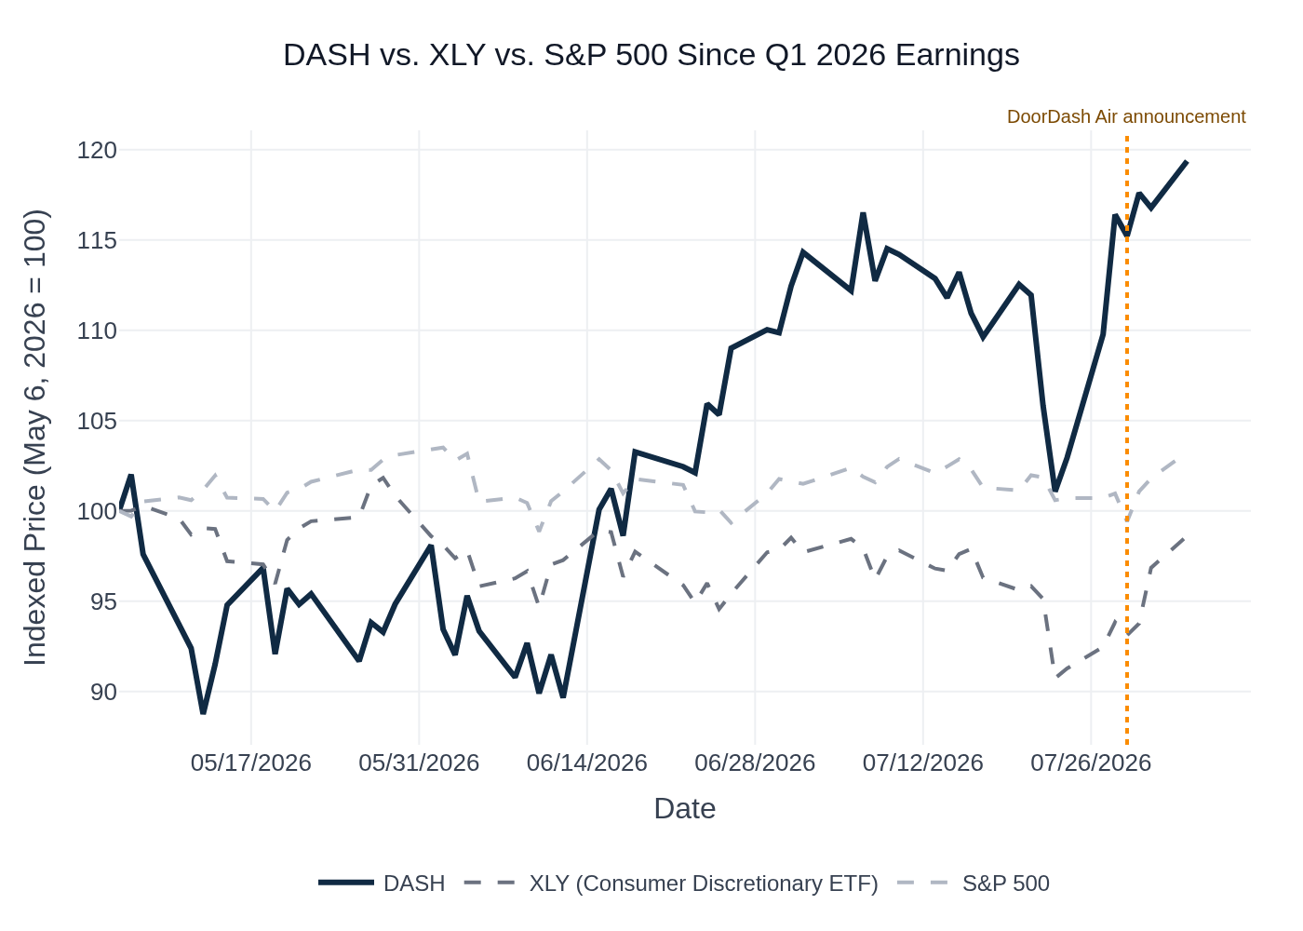
DASH vs. XLY vs. S&P 500 — Indexed Performance Since Q1 2026 Earnings (May 6, 2026). Base = 100. Key events: Uber/Delivery Hero deal announced July 16; DoorDash Air drone program announced July 29. Source: Yahoo Finance / Stock Price Data.
Since the Q1 2026 earnings print on May 6, DASH initially sold off ~11% through mid-May as investors digested the revenue miss and gas relief program cost headwind. The stock then staged a sustained recovery, rallying from ~$149 in mid-May to ~$202 by August 4 (+35% from the trough), driven by multiple re-expansion as the market gained confidence in management's full-year EBITDA framework. DASH significantly outperformed XLY over this period, which was essentially flat, while the S&P 500 was also broadly flat. The Uber/Delivery Hero acquisition announcement on July 16 caused a brief pause in DASH's rally but did not reverse it, suggesting the market views the competitive implications as manageable near-term. The DoorDash Air drone announcement on July 29 provided a modest positive catalyst. Sector ETF used: XLY (Consumer Discretionary Select Sector SPDR), which captures DASH's consumer-facing delivery business.

6. Material News & Developments
Key Takeaway: The most important development since Q1 earnings is the Uber/Delivery Hero $14.8B acquisition (July 16) — a transformative competitive event that creates the largest food delivery group outside China and directly challenges DASH's international growth narrative heading into the print.
- July 16, 2026 — Uber agrees to acquire Delivery Hero for $14.8B (WSJ, Reuters, CNBC). Uber's biggest-ever deal creates the largest food delivery group outside China, adding 50 new markets across Asia, Latin America, and the Middle East. Deal expected to close H2 2027 pending regulatory approvals.
- Implication for DASH: Significantly intensifies international competitive pressure. Uber had already paused European expansion (July 5) while pursuing the deal, but post-close will have a dramatically expanded global footprint. Investors may question DASH's international growth premium and Deliveroo's competitive positioning in Europe.
- July 29–August 4, 2026 — DoorDash launches DoorDash Air drone delivery program. DASH received FAA Part 135 air carrier certification, enabling commercial drone delivery. Currently live in parts of Dallas-Fort Worth and Charlotte. Company is building its own drones alongside existing partnerships with Alphabet's Wing and Flytrex.
- Implication: Positive long-term signal on autonomous delivery ambitions; near-term financial impact is minimal. Likely to be a topic on the Q2 call.
- July 31, 2026 — U.S. lawmakers request information on DASH's use of Chinese AI models (CNBC). House Select Committees investigating DASH's use of Moonshot AI's Kimi K2.6 model. DASH responded it "proudly supports American AI leadership" and is working with committees.
- Implication: Regulatory/reputational risk; unlikely to be material to Q2 financials but could be a distraction on the call and create headline risk.
- July 5, 2026 — Uber pauses European food delivery expansion while pursuing Delivery Hero deal (FT, Reuters). Uber halted expansion into five European markets.
- Implication: Short-term competitive relief for DASH/Deliveroo in Europe during Q2, but this pause ends with the deal announcement.
- June 11, 2026 — DoorDash shareholders approve directors, auditor, and executive pay at Annual Meeting (8-K). Routine governance event; no material financial implications.
- July 23, 2026 — Uber cuts 10% of customer service jobs citing AI adoption (Bloomberg).
- Implication: Industry-wide signal that AI-driven cost reduction is accelerating; DASH has noted ~2/3 of its code is now AI-generated, suggesting similar efficiency tailwinds.

7. Peer Commentary Read-Through
Key Takeaway: Applying the strict 60-day filter (June 5 – August 4, 2026) and the current-quarter condition (commentary must specifically address Q2 2026 / current-quarter conditions), there are no qualifying peer earnings calls or conference transcripts in the research database. The May 6–7 peer earnings calls (Uber Q1, Lyft Q1, Instacart Q1) and the June 4 Instacart Baird Conference fall outside the 60-day window or address Q1 2026 results rather than Q2 2026 conditions. The May 28 Uber Bernstein Conference is also outside the 60-day window.
The following peer events were reviewed and excluded:
Peer | Event | Date | Reason Excluded
Uber (UBER) | Q1 2026 Earnings Call | May 6, 2026 | Outside 60-day window; addresses Q1 2026 results, not Q2 2026 conditions
Lyft (LYFT) | Q1 2026 Earnings Call | May 7, 2026 | Outside 60-day window; addresses Q1 2026 results, not Q2 2026 conditions
Instacart (CART) | Q1 2026 Earnings Call | May 6, 2026 | Outside 60-day window; addresses Q1 2026 results, not Q2 2026 conditions
Uber (UBER) | Bernstein Strategic Decisions Conference | May 28, 2026 | Outside 60-day window (before June 5, 2026)
Instacart (CART) | Baird Global Consumer, Tech & Services Conference | June 4, 2026 | Outside 60-day window (before June 5, 2026); addresses Q2 2026 outlook but falls one day before the cutoff
Note on Uber/Delivery Hero (July 16, 2026): While the Uber/Delivery Hero acquisition announcement (July 16) falls within the 60-day window and has direct read-through implications for DASH's competitive positioning, it is a corporate transaction announcement rather than a peer earnings call or conference commentary on current-quarter operating conditions. It is therefore covered in the Material News & Developments section above rather than here.
Uber Q2 2026 earnings are scheduled to report after DASH (Uber typically reports in the first week of August). No qualifying peer Q2 2026 earnings commentary was available in the research database as of the preparation date.

8. Insider Transaction Activity
Key Takeaway: Insider activity since the Q1 print is dominated by routine 10b5-1 planned sales across multiple executives and directors — no open-market discretionary buys, and no unusual concentration of discretionary selling. The one notable exception is a small open-market purchase by Director Milan Kovac (20 shares each in February and March 2026, filed June 8), which is a modest positive signal but too small to be directionally meaningful. Overall, the insider picture is neutral.

Table 5 — Insider Transactions (Since Q1 2026 Earnings, May 6, 2026)
Name | Title | Transaction Type | Shares | Transaction Date | Note
Inukonda Ravi | CFO | 10b5-1 Planned Sale | 19,095 | Jul 8, 2026 | Pre-planned; routine. Also sold 19,505 shares on May 20 under same plan.
Tang Stanley | Director | 10b5-1 Planned Sale | 23,125 | Jul 2, 2026 | Pre-planned; indirect ownership. Recurring pattern (also sold 23,125 on May 4 and 1,592 on May 20).
Fang Andy | Director | 10b5-1 Planned Sale | 5,000 | Jul 1, 2026 | Pre-planned; indirect ownership. Also sold 5,000 on Jun 24 and 1,164 on May 20.
Brown Shona L | Director | 10b5-1 Planned Sale | 582 | Jun 26, 2026 | Pre-planned; small size; routine.
Still Ashley | Director | Open Market Sale | 1,164 | Jun 10, 2026 | Discretionary (not 10b5-1); indirect ownership; small size; not flagged as unusual.
Kovac Milan | Director | Open Market Buy | 20 + 20 | Feb 23 & Mar 27, 2026 (filed Jun 8) | Discretionary open-market purchases; very small size ($3,000–$4,000 estimated); mildly positive signal but not directionally meaningful.
Yandell Keith | Chief Business Officer | 10b5-1 Planned Sale | 2,643 | May 26, 2026 | Pre-planned; also sold 4,227 on May 20 under same plan.
Sherringham Tia | General Counsel & Secretary | 10b5-1 Planned Sale | 2,743 | May 22, 2026 | Pre-planned; also sold 7,690 on May 20 under same plan.
Adarkar Prabir | President & COO | Open Market Sale | 17,126 | May 20, 2026 | Discretionary (not 10b5-1); largest single discretionary sale in the period; notable but not unusual for a COO-level executive post-lockup.
Lee Gordon S | Chief Accounting Officer | Open Market Sale | 2,910 | May 20, 2026 | Discretionary; routine size for CAO-level.
Source: SEC Form 4 Filings Database (Insider Transaction Data).
Additional note: As of August 3, 2026, Form 144 filings (intended sales) were filed by Tang Stanley (~$4.5M combined) and Fang Andy (~$2.0M), consistent with their ongoing 10b5-1 programs. The cluster of May 20 sales across multiple executives reflects a routine post-earnings window opening rather than any coordinated discretionary selling signal.

