Expeditors International of Washington (EXPD)
Ticker: EXPD Earnings Date: August 4, 2026 (Pre-Market) Reporting Period: Q2 2026 (Quarter Ended June 30, 2026) Prepared: August 3, 2026

1. Earnings Preview
Key Takeaway: Consensus has been revised up ~2% since Q1 earnings, but the bar is still beatable given EXPD's consistent track record of operational outperformance; the biggest swing factor is whether air freight tonnage growth and customs brokerage momentum held through June amid tariff-driven complexity.
Heading into Q2 2026 earnings, EXPD faces a consensus EPS bar of $1.71 (operating diluted), up from $1.68 at the time of Q1 earnings — a modest upward revision that reflects continued strength in customs brokerage and air freight, partially offset by ongoing ocean headwinds. Management's Q1 tone was constructive: CEO Daniel Wall highlighted a "strong pipeline of new business," robust customs brokerage demand driven by tariff complexity, and continued technology investment in AI. The stock has outperformed both the transport ETF (IYT, +9.0%) and the S&P 500 (+4.7%) since Q1 earnings, gaining +11.4%, suggesting some beat expectation is already priced in. The key wildcard is the trajectory of air freight rates and volumes in May–June — Q1 saw Middle East conflict disrupt capacity, and whether that tailwind persisted or normalized into Q2 will be the primary determinant of the air segment surprise. Ocean remains a structural drag (volumes -4% YoY in Q1), but customs brokerage — now the largest net revenue segment — is the real earnings engine and has been growing double-digits.

2. KPIs & Consensus Expectations
Key Takeaway: Consensus expects ~$1.71 operating EPS (+27.5% YoY) and ~$1.0B in net revenue; customs brokerage is the largest segment and the key beat/miss driver, while ocean remains a headwind.

Table 1 — Current Quarter Snapshot (Q2 2026)
KPI | Q1 2026 Actual | Q2 2025 Actual | Q2 2026 Consensus | YoY Change | Guidance | Consensus vs. Guidance
Operating EPS (Diluted) | $1.71 | $1.34 | $1.71 | +27.5% | No formal guidance | N/A
Total Net Revenue | $971.8M | $898.5M | $1,002.3M | +11.5% | No formal guidance | N/A
Net Revenue — Airfreight | $261.4M | $253.4M | $278.4M | +9.9% | No formal guidance | N/A
Net Revenue — Ocean | $182.9M | $192.3M | $186.2M | -3.2% | No formal guidance | N/A
Net Revenue — Customs Brokerage | $527.6M | $452.8M | $537.7M | +18.8% | No formal guidance | N/A
Operating Income | $294.8M | $247.7M | $297.2M | +19.9% | No formal guidance | N/A
Operating Margin | 10.6% | 9.3% | 10.1% | +80 bps | No formal guidance | N/A
Note: EXPD does not provide formal quarterly guidance. All consensus figures sourced from Visible Alpha.

Table 2 — Beat/Miss History (Last 8 Quarters)

Operating EPS (Diluted)
Quarter | Reported | Consensus | Surprise % | Result
Q2 2024 | $1.24 | $1.27 | -2.4% | Miss
Q3 2024 | $1.63 | $1.33 | +22.6% | Beat
Q4 2024 | $1.68 | $1.46 | +15.1% | Beat
Q1 2025 | $1.47 | $1.37 | +7.3% | Beat
Q2 2025 | $1.34 | $1.24 | +8.1% | Beat
Q3 2025 | $1.64 | $1.40 | +17.2% | Beat
Q4 2025 | $1.49 | $1.49 | 0.0% | In-Line
Q1 2026 | $1.71 | $1.35 | +26.7% | Beat

Total Net Revenue
Quarter | Reported ($M) | Consensus ($M) | Surprise % | Result
Q2 2024 | $799.6 | $794.2 | +0.7% | Beat
Q3 2024 | $906.2 | $821.9 | +10.3% | Beat
Q4 2024 | $934.6 | $864.6 | +8.1% | Beat
Q1 2025 | $889.7 | $840.0 | +5.9% | Beat
Q2 2025 | $898.5 | $809.9 | +10.9% | Beat
Q3 2025 | $955.1 | $884.3 | +8.0% | Beat
Q4 2025 | $923.6 | $933.3 | -1.0% | Miss
Q1 2026 | $971.8 | $889.3 | +9.3% | Beat
Pattern: EXPD has beaten operating EPS consensus in 6 of the last 8 quarters, with particularly large beats in volatile freight environments (Q3/Q4 2024, Q1 2026). The one miss (Q2 2024) coincided with a period of normalizing freight rates. Net revenue beats have been consistent and large, reflecting EXPD's ability to capture rate and volume upside.

3. Guidance & Commentary Evolution
Key Takeaway: EXPD provides no formal quarterly guidance; management's Q1 2026 tone was constructive on customs brokerage and air, cautious on ocean — no material post-earnings guidance updates have been issued.
Metric | Initial Commentary (Q1 2026 Earnings, May 5) | Revised Commentary | Current Consensus | Note
Air Freight | Tonnage +5% YoY in Q1; capacity disrupted by Middle East conflict; demand from tech customers strong | No update | Net Rev consensus $278.4M (+9.9% YoY) | Middle East disruption may have created rate tailwind in Q2
Ocean Freight | Volume -4% YoY; excess capacity and weak pricing expected to persist | No update | Net Rev consensus $186.2M (-3.2% YoY) | Structural headwind; consensus reflects continued softness
Customs Brokerage | Double-digit growth; tariff complexity driving entry volumes; strong pipeline | No update | Net Rev consensus $537.7M (+18.8% YoY) | Largest segment; key earnings driver
Operating Margin | 10.6% in Q1 (at 30% historical target); headcount flat sequentially; productivity inflection | No update | 10.1% consensus | Q1 was a productivity inflection; Q2 may see modest normalization
Shareholder Returns | $288M returned in Q1 via buybacks; $3B buyback program authorized Feb 2026 | No update | N/A | Buyback pace remains aggressive

4. Guidance vs. Estimate Revision Tracker
Key Takeaway: Estimates have been revised up ~2% for Q2 2026 EPS and ~2.2% for net revenue since Q1 earnings, tracking the constructive management tone; the gap between current consensus and the post-Q1 baseline is modest, suggesting limited additional cushion.
KPI | Period | Estimate (May 10, 2026 — Post-Q1 Baseline) | Current Consensus | Estimate Δ (%) | Initial Guidance | Current Guidance | Guidance Δ | Consensus vs. Guidance
Operating EPS | Q2 2026 | $1.68 | $1.71 | +1.8% | No formal guidance | No formal guidance | N/A | N/A
Operating EPS | FY 2026 | N/A | $6.97 | N/A | No formal guidance | No formal guidance | N/A | N/A
Total Net Revenue | Q2 2026 | $980.8M | $1,002.3M | +2.2% | No formal guidance | No formal guidance | N/A | N/A
Total Net Revenue | FY 2026 | N/A | $4,033.4M | N/A | No formal guidance | No formal guidance | N/A | N/A
Net Rev — Airfreight | Q2 2026 | $273.0M | $278.4M | +2.0% | No formal guidance | No formal guidance | N/A | N/A
Net Rev — Ocean | Q2 2026 | $182.6M | $186.2M | +2.0% | No formal guidance | No formal guidance | N/A | N/A
Net Rev — Customs Brokerage | Q2 2026 | $525.2M | $537.7M | +2.4% | No formal guidance | No formal guidance | N/A | N/A
Operating Income | Q2 2026 | $287.1M | $297.2M | +3.5% | No formal guidance | No formal guidance | N/A | N/A
Estimates have drifted modestly higher across all key metrics since Q1 earnings, with operating income showing the largest revision (+3.5%). The upward drift is consistent with the constructive Q1 tone and positive peer read-throughs from UPS and CHRW on international air freight and customs complexity. EXPD does not provide formal guidance, so the guidance columns are not applicable.

5. Stock Performance
Key Takeaway: EXPD has outperformed both the transport sector (IYT) and the S&P 500 since Q1 earnings, gaining +11.4% vs. +9.0% for IYT and +4.7% for SPY — driven by a combination of estimate revisions and multiple expansion, with a notable acceleration in July on analyst upgrades.
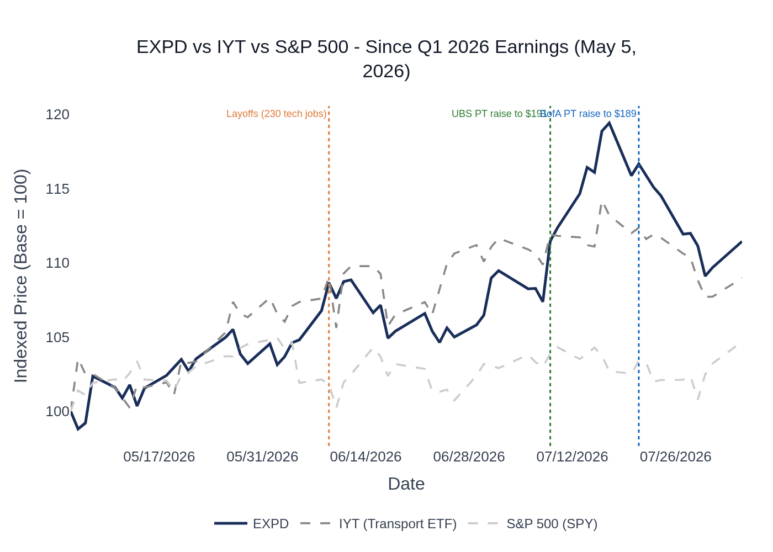
EXPD vs. IYT (iShares Transportation Average ETF) vs. S&P 500 — Indexed to 100 at Q1 2026 Earnings (May 5, 2026). Source: Stock Price Data.
- EXPD closed at $153.08 on May 5 (Q1 earnings day) and reached $170.59 by August 4, 2026 (+11.4%), outpacing IYT (+9.0%) and SPY (+4.7%).
- The stock lagged the transport sector through mid-June, then accelerated sharply in July driven by analyst price target raises: UBS to $191, BofA to $189, Truist to $175.
- The June 9 layoff announcement (230 tech jobs in Seattle) was initially a modest negative but quickly absorbed — the market read it as a productivity/efficiency signal consistent with management's AI investment narrative.
- The stock peaked at $182.80 on July 17 before pulling back ~6% into earnings, suggesting some profit-taking ahead of the print.
- Sector ETF used: iShares Transportation Average ETF (IYT) — appropriate for EXPD's freight forwarding/logistics sub-sector.

6. Material News & Developments
Key Takeaway: The most material post-Q1 development is the June 2026 tech layoff of 230 employees — EXPD's first significant workforce reduction in decades — signaling a structural shift toward AI-driven productivity; analyst PT raises in July reflect growing confidence in the earnings trajectory.
- June 9, 2026 — EXPD cuts 230 tech jobs in Seattle region, ending decades-long policy against layoffs. Implication: Management framed this as part of strategic AI investment; the market initially reacted negatively but quickly recovered, interpreting it as a productivity/margin catalyst.
- July 9, 2026 — UBS raises price target to $191 (from $175), maintaining Buy. Implication: Reflects confidence in customs brokerage growth and air freight rate environment heading into Q2 print.
- July 21, 2026 — BofA raises price target to $189 (from $181), maintaining Buy (analyst Ken Hoexter). Implication: Cited continued momentum in international freight and tariff-driven customs complexity.
- July 15, 2026 — Citizens initiates coverage with Market Perform rating. Neutral signal; adds to analyst coverage breadth.
- Post-Q1 — Truist raises price target to $175 (from $145), maintaining Hold. Reflects improved earnings trajectory.
- Post-Q1 — Barclays raises price target to $150 (from $135), maintaining Underweight. Remains cautious on valuation.
- May 2026 — EXPD expands Global Aircraft on Ground (AOG) services amid rising demand for time-critical aviation and aerospace logistics — a niche but high-margin service line.
- February 23, 2026 — Board authorized a new $3 billion share repurchase program. Implication: EXPD repurchased $288M in Q1 2026 alone, demonstrating aggressive capital return; buyback pace is a meaningful EPS tailwind.
- Ongoing (June 2026) — Multiple EXPD educational webcasts on tariff updates, customs market, ocean market, and geopolitical risks — consistent with management's positioning as a trusted advisor to customers navigating trade complexity.

7. Peer Commentaries — Q2 2026 Read-Throughs (Last 60 Days)
Key Takeaway: Peers reporting Q2 2026 results paint a constructive picture for EXPD's air freight and customs brokerage segments, while confirming continued ocean softness; the freight market inflection toward tighter capacity and higher rates is a net positive for EXPD's non-asset model.
Note: Only commentary from peers' Q2 2026 earnings calls (reporting their own Q2 2026 results, July 2026) and FedEx's fiscal Q4 2026 (covering the quarter ended May 31, 2026, reported June 23, 2026) is included. Prior-quarter results commentary has been excluded.

A. UPS — Q2 2026 Earnings (Reported July 28, 2026)
Read-through: POSITIVE for EXPD air freight and international forwarding
- UPS Supply Chain Solutions forwarding revenue increased +8.1% YoY in Q2 2026, driven by higher rates in international air freight — directly supportive of EXPD's air net revenue outlook.
- Volume growth returned on the China-U.S. trade lane starting in May, as UPS lapped the elimination of the de minimis exemption — a positive read-through for EXPD's Asia-origin air and customs volumes.
- Asia-to-Asia export volume increased +13.6% YoY at UPS, supported by investments in the region — consistent with EXPD's Q1 commentary about strong demand from technology customers.
- UPS raised its full-year 2026 consolidated revenue outlook to ~$91.2B and EPS guidance to ~$7.22 — a broadly positive macro signal for freight forwarders.
- Middle East conflict drove fuel surcharge revenue and higher air costs, but surcharge mechanisms offset the expense impact — EXPD faces similar dynamics and should benefit from rate pass-through.

B. C.H. Robinson (CHRW) — Q2 2026 Earnings (Reported July 29, 2026)
Read-through: MIXED — positive for customs/forwarding margins, cautious on overall freight demand
- CHRW's Global Forwarding segment expanded operating margin by +470 bps YoY to 33.4% in Q2 2026, achieving mid-cycle margin targets — suggests the international forwarding market is generating healthy profitability, a positive read-through for EXPD's forwarding margins.
- CHRW noted the Cass Freight Shipment Index declined -3.3% YoY in Q2 and -4.7% in H1 2026 — a cautionary signal for overall freight demand, though EXPD's international/air focus is less correlated to domestic trucking volumes.
- CHRW's Global Forwarding AGP per business day was up 9% in April, 7% in May, and 3% in June — a decelerating trend within the quarter that could signal some moderation in EXPD's air/ocean net revenue per unit in June.
- CHRW remains confident in achieving its 2026 operating income target, citing self-help initiatives — neutral for EXPD.

C. J.B. Hunt (JBHT) — Q2 2026 Earnings (Reported July 15, 2026)
Read-through: POSITIVE for freight market inflection; limited direct read-through for EXPD
- JBHT reported total revenue +19% YoY and operating income +32% YoY in Q2 2026, driven by capacity tightening across the industry — confirms the freight market inflection that benefits EXPD's non-asset model.
- Truckload capacity tightened significantly, with spot rates up ~34% YoY and tender rejection rates at levels not seen since 2021–2022 — domestic capacity tightening can spill over into air freight demand as shippers seek alternatives.
- JBHT's intermodal segment set a quarterly volume record with 578,000+ loads (+10% YoY) — the first double-digit growth quarter in over a decade, signaling broad freight demand recovery.
- Note: JBHT's business is primarily domestic trucking/intermodal with limited direct read-through to EXPD's international air/ocean/customs segments.

D. Landstar System (LSTR) — Q2 2026 Earnings (Reported July 28, 2026)
Read-through: POSITIVE for freight market tone; limited direct read-through for EXPD
- LSTR reported truck revenue per load +17% YoY in Q2 2026, the largest sequential increase in 15 years — confirms the freight market has turned decisively in favor of transportation providers after nearly four years of shipper-favorable conditions.
- ISM index was above 50 for all six months of 2026, supporting the view that industrial demand is recovering — a positive backdrop for EXPD's customs brokerage and air freight volumes.
- LSTR's July 2026 data showed truck volumes +5% YoY and revenue per load +26% YoY — momentum is carrying into Q3, which is constructive for EXPD's Q3 outlook.
- Note: LSTR is primarily a domestic trucking broker with limited direct read-through to EXPD's international segments.

E. FedEx (FDX) — Fiscal Q4 2026 Earnings (Reported June 23, 2026; Quarter Ended May 31, 2026)
Read-through: POSITIVE for international air freight and global trade
- FedEx reported international export package volumes +5% YoY for the second consecutive quarter, with double-digit international export revenue growth on Asia-Europe, within Asia, and U.S. outbound lanes — directly supportive of EXPD's air freight volume outlook.
- FDX noted strong international air freight growth and is increasing share in the $90B global market — confirms healthy demand in EXPD's core air freight market.
- FDX's APAC team achieved two consecutive quarters of international volume growth after facing significant headwinds from tariffs and de minimis changes — a positive read-through for EXPD's Asia-origin air volumes in Q2.
- FDX highlighted that the AI and data center vertical is delivering double-digit revenue growth — consistent with EXPD's Q1 commentary about strong demand from technology customers for air freight.
- FDX noted that trade patterns are evolving and the company flexed its network to keep supply chains moving — the complexity of global trade is a structural tailwind for EXPD's customs brokerage business.

8. Insider Transaction Activity
Key Takeaway: All insider activity since Q1 earnings consists of routine RSU vesting, tax withholding shares, and annual equity grants — no open-market buys or discretionary sells. Nothing signals unusual conviction or concern heading into Q2 earnings.
Name | Title | Transaction Type | Security | Date (Effective) | Note
Wall Daniel R | President & CEO | RSU Vesting / Tax Withholding | Common Stock / RSUs | May 1, 2026 | Routine annual RSU vest; tax withholding shares disposed (F code). Not discretionary.
Bell Blake R | President, Global Business Dev | RSU Vesting / Tax Withholding | Common Stock / RSUs | May 1, 2026 | Routine annual RSU vest; tax withholding shares disposed (F code). Not discretionary.
Blacker Kelly K | President, Global Geographies | RSU Vesting / Tax Withholding | Common Stock / RSUs | May 1, 2026 | Routine annual RSU vest; tax withholding shares disposed (F code). Not discretionary.
Multiple Executives | Various (CEO, Presidents, SVPs, Directors) | Annual RSU Grant (2026 RSUs) | Restricted Stock Units | May 5, 2026 | Annual equity grant. Standard compensation. Not discretionary.
Wall Daniel R | President & CEO | RSU Vesting / Tax Withholding | Common Stock / RSUs | May 7, 2026 | 2024 RSU tranche vest; 644 shares withheld for taxes (F code). Not discretionary.
Multiple Executives | Various | Dividend Equivalent Rights Accrual | RSU Dividend Equivalents | June 15, 2026 | Routine dividend equivalent accruals on outstanding RSU tranches. Not discretionary.
Note: All transactions are coded A (grant/award), M (exercise/conversion), F (tax withholding), or G (gift transfer) — none are open-market P (purchase) or S (sale) codes. There are no discretionary open-market buys or sells in the period. The absence of open-market activity is neutral — neither a bullish nor bearish signal.

