Iron Mountain Incorporated (IRM) — Q2 2026 Earnings Preview
Company: Iron Mountain Incorporated (IRM) Upcoming Earnings: Q2 2026 Prepared: August 4, 2026

1. Earnings Preview
Key Takeaway: The setup into Q2 2026 is constructive — consensus is a manageable bar given IRM’s Q1 beat-and-raise cadence, and the data center demand read-through from EQIX and DLR is unambiguously positive. The biggest swing factor is ALM revenue, where memory price stabilization and hyperscale decommissioning volumes will determine whether IRM can sustain the ~77% organic growth pace from Q1.
Iron Mountain heads into Q2 2026 earnings with consensus expecting revenue of ~$1.969B (+15% YoY) and AFFO/share of ~$1.40, both squarely in line with management’s own Q2 guidance issued on the April 30 Q1 call — leaving limited room for a guidance-driven surprise but also a low-risk bar given IRM’s track record of beating. Management’s tone exiting Q1 was the most bullish in years: they raised full-year revenue guidance by $175M at the midpoint, increased ALM revenue outlook to $950M (+$100M), and guided data center leasing to be ‘meaningfully above’ the 100MW full-year target based on advanced customer discussions. Estimate revisions have been modestly positive since Q1 earnings, with FY2026 revenue consensus rising from ~$7.909B to ~$7.916B and AFFO per share from ~$5.853 to ~$5.849 — essentially flat, suggesting the Street has already absorbed the raised guidance without building in incremental upside. The stock has been essentially flat since Q1 earnings (-0.4% vs. +7.3% for SPY and +1.7% for XLRE), meaning the stock has not priced in a beat and the multiple has actually compressed relative to the market — a setup that rewards execution. The wildcard is ALM: memory prices moderated in late March/early April before stabilizing, and the degree to which hyperscale decommissioning volumes held through Q2 will be the key debate on the call.

2. KPIs & Consensus Expectations
Key Takeaway: Consensus is a manageable bar — in line with management’s own Q2 guidance — with ALM-driven service revenue organic growth the most important swing factor. Data center revenue is the highest-visibility line given the pre-leased backlog.

Table 1 — Current Quarter Snapshot (Q2 2026)
KPI | Q1 2026 Actual | Q2 2025 Actual | Q2 2026 Consensus | YoY Change | Q2 Guidance | Cons. vs. Guidance
Total Revenue | $1,936M | $1,712M | $1,969M | +15.0% | ~$1,965M | +0.2%
Adjusted EBITDA | $708M | $628M | $716M | +13.9% | ~$715M | +0.1%
AFFO | $426M | $370M | $419M | +13.3% | ~$418M | +0.2%
AFFO per Share | $1.43 | $1.24 | $1.40 | +12.9% | ~$1.40 | flat
Adjusted EPS (Diluted) | $0.60 | $0.48 | $0.55 | +14.6% | N/A | N/A
Data Center Revenue | $255M | $189M | $257M | +35.9% | N/A | N/A
Global RIM Revenue | $1,404M | $1,324M | $1,424M | +7.6% | N/A | N/A
Capital Expenditures | $518M | $557M | $542M | -2.7% | Slightly down YoY | N/A
Storage Organic Growth | 12.4% | 9.2% | 10.6% | N/A | N/A | N/A
Service Organic Growth | 24.3% | 9.7% | 17.6% | N/A | N/A | N/A
Sources: All consensus figures from Visible Alpha. Q2 guidance from Q1 2026 earnings call (April 30, 2026). Service organic growth is the highest-variance KPI given ALM’s sensitivity to memory pricing and hyperscale decommissioning volumes.

Table 2 — Beat/Miss History (Last 4 Quarters, Top 2 KPIs)
Quarter | Rev. Reported | Rev. Consensus | Rev. Surprise | AFFO/Sh Reported | AFFO/Sh Consensus | AFFO/Sh Surprise
Q2 2025 | $1,712M | $1,683M | +1.7% | $1.24 | $1.19 | +4.2%
Q3 2025 | $1,754M | $1,756M | -0.1% | $1.32 | $1.30 | +1.5%
Q4 2025 | $1,843M | $1,807M | +2.0% | $1.44 | $1.38 | +4.3%
Q1 2026 | $1,936M | $1,863M | +3.9% | $1.43 | $1.40 | +2.1%
Pattern: IRM has beaten revenue consensus in 3 of the last 4 quarters and AFFO/share in all 4, with the beat magnitude expanding. The Q3 2025 revenue miss was marginal (-0.1%). The pattern suggests a conservative guidance philosophy that consistently sets a beatable bar.

3. Guidance & Commentary Evolution
Key Takeaway: Full-year 2026 guidance was raised meaningfully at Q1 earnings with no subsequent revisions — consensus has absorbed the raise and is now essentially in line with the guidance midpoint. Tone is the most bullish in years, with management expressing high confidence in ‘continued double-digit consolidated top and bottom line growth across cycles.’
Metric | Initial Guidance (Q1 2026 Earnings, Apr 30) | Revised Guidance | Current Consensus | Note
FY2026 Revenue | $7.825B–$7.925B | — | $7.916B | Consensus at midpoint; $175M raise vs. prior guidance
FY2026 Adj. EBITDA | $2.925B–$2.965B | — | $2.954B | Consensus at midpoint; $45M raise vs. prior guidance
FY2026 AFFO | $1.735B–$1.755B | — | $1.753B | Consensus near top of range; $25M raise vs. prior guidance
FY2026 AFFO/Share | $5.79–$5.86 | — | $5.849 | Consensus near top of range; $0.09/sh raise vs. prior guidance
FY2026 ALM Revenue | ~$950M | — | N/A (not separately tracked in VA) | $100M raise vs. prior; majority of incremental $60M in Q2
DC Leasing (FY2026) | >100MW (meaningfully above) | — | N/A | 32MW signed YTD as of April; advanced discussions on 400MW pipeline
Q2 2026 Revenue | ~$1.965B | — | $1.969B | Consensus +0.2% above guidance midpoint
Q2 2026 AFFO | ~$418M / $1.40/sh | — | $419M / $1.40 | Consensus essentially in line with guidance

4. Guidance vs. Estimate Revision Tracker
Key Takeaway: Estimates have been essentially flat since Q1 earnings, tracking guidance closely — the Street has absorbed the raise without building in incremental upside, leaving room for a beat if ALM and data center continue to outperform.
KPI | Period | Estimate (May 5, 2026) | Current Consensus | Estimate Δ | Initial Guidance | Current Guidance | Guidance Δ | Cons. vs. Guidance
Total Revenue | Q2 2026 | $1,968M | $1,969M | +0.1% | ~$1,965M | ~$1,965M | — | +0.2%
Total Revenue | FY 2026 | $7,909M | $7,916M | +0.1% | $7,875M midpoint | $7,875M midpoint | — | +0.5%
AFFO per Share | Q2 2026 | $1.404 | $1.403 | -0.1% | ~$1.40 | ~$1.40 | — | flat
AFFO per Share | FY 2026 | $5.853 | $5.849 | -0.1% | $5.825 midpoint | $5.825 midpoint | — | +0.4%
Adj. EBITDA | Q2 2026 | $718M | $716M | -0.3% | ~$715M | ~$715M | — | +0.1%
Adj. EBITDA | FY 2026 | $2,954M | $2,954M | flat | $2,945M midpoint | $2,945M midpoint | — | +0.3%
Data Center Revenue | Q2 2026 | $253M | $257M | +1.6% | N/A | N/A | — | N/A
Data Center Revenue | FY 2026 | $1,051M | $1,062M | +1.0% | N/A | N/A | — | N/A
Commentary: The near-zero estimate movement since Q1 earnings is notable — it suggests the Street has fully priced in the guidance raise but is not yet building in incremental upside from ALM acceleration or data center leasing above 100MW. Any Q2 beat driven by ALM or DC would likely trigger upward revisions to the back half. Data center revenue estimates have drifted modestly higher (+1.0–1.6%) since Q1, reflecting growing conviction in the demand environment validated by EQIX and DLR’s Q2 results.

5. Stock Performance
Key Takeaway: IRM is essentially flat since Q1 earnings (-0.4%) while the S&P 500 is up +7.3% and XLRE is up +1.7% — the stock has meaningfully underperformed the market, with multiple compression rather than earnings deterioration as the driver. The stock peaked at ~$133 in late June before selling off sharply to ~$116 in early July, recovering to ~$125 currently.
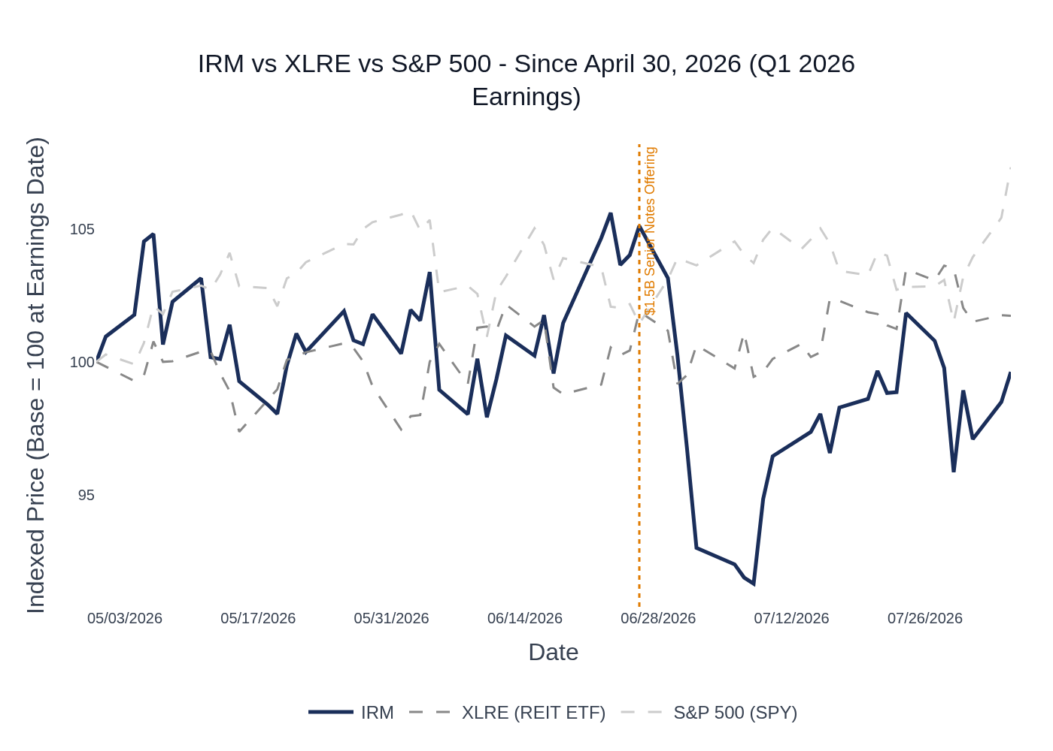
IRM vs. XLRE (REIT ETF) vs. S&P 500 (SPY) — Indexed to 100 at April 30, 2026 (Q1 2026 Earnings Date). Source: Yahoo Finance.
IRM opened Q2 2026 with a strong post-earnings pop to ~$126 on April 30, briefly rallied to a high of ~$133 in late June (coinciding with the $1.5B senior notes offering on June 26), then sold off sharply to ~$116 in early July — a ~12% drawdown from the peak — before recovering to ~$125 currently. The selloff appears to have been driven by broader REIT sector rotation and rising rate concerns rather than any company-specific negative development, as no material negative news was disclosed. The stock’s underperformance vs. SPY (+7.3%) reflects multiple compression: IRM’s growth story has not changed, but the market has re-rated the REIT sector lower. This sets up a potentially favorable risk/reward into Q2 earnings if the company can demonstrate continued execution.

6. Peer Commentary — Data Center & Digital Infrastructure Read-Throughs (Last 60 Days)
Key Takeaway: Both EQIX (Q2 2026, July 29) and DLR (Q2 2026, July 23) reported record or near-record leasing activity with accelerating AI-driven demand, strong pricing, and raised full-year guidance — all of which are unambiguously positive read-throughs for IRM’s data center segment heading into Q2 results.
Note: Commentary below is sourced exclusively from Q2 2026 earnings calls (EQIX reported July 29, 2026; DLR reported July 23, 2026) — both reporting their own Q2 2026 results, which is the same calendar quarter IRM is about to report. This is current-quarter read-through, not lagged commentary.

Equinix (EQIX) — Q2 2026 Earnings (Reported July 29, 2026)
- AI demand accelerating and broad-based: ‘The AI-driven infrastructure cycle continues to accelerate and it’s playing directly to our strengths.’ Annualized gross bookings grew 23% YoY to $424M — the second-highest volume on record — with total sales activity (including pre-sales) up over 30%. ‘The vast majority of our largest deals were driven by AI workloads’ in Q2. Monthly recurring revenue growth accelerated to 11% YoY, the third straight quarter of double-digit growth.
- Record backlog and pre-selling momentum: Record backlog entering H2 2026; EQIX has already closed over 45% of its Q3 bookings target. ~30% of remaining 2026 retail capacity expansion is pre-sold. Net interconnections added hit a record 9,700 in Q2. Backlog sold but not yet installed is at a record level.
- Pricing remains very firm: ‘Our pricing has remained very firm.’ Net pricing actions ‘continue to trend very, very favorably.’ Meaningful mark-to-market opportunity in highly constrained markets (Frankfurt, Amsterdam, Ashburn). Cabinet orders up 30%+ YoY. Churn at 1.8%, expected near the lower end of the 2–2.5% typical range in H2.
- Capacity acceleration: EQIX plans to ‘double the number of cabinets we deliver in the second half of the year,’ accelerating 7,000+ cabinets from 2027 into Q4 2026. 52 major projects underway across 33 markets. Three gigawatts of land under control with power either contracted or high-confidence contracted.
- Guidance raised for second consecutive quarter: FY2026 revenue growth guidance raised to 11–12% (up $100M); Adj. EBITDA margin guided to ~51% (+200bps YoY); AFFO/share growth guided to 10–12%. Long-term (2027–2029) revenue growth guided at 10–13% annually with EBITDA margin target of 53%+ by 2029.
- IRM Read-Through: EQIX’s record bookings and accelerating AI demand directly validate IRM’s data center leasing pipeline commentary from Q1. EQIX’s observation that clients are ramping power faster than expected mirrors IRM’s own Q1 commentary. Strong pricing environment supports IRM’s renewal spread expansion thesis. EQIX’s four AI use-case framework (Stack, Sovereign, Batch, Agency Sensitive) highlights the breadth of demand that IRM’s data center and ALM businesses are positioned to serve.

Digital Realty (DLR) — Q2 2026 Earnings (Reported July 23, 2026)
- Record colocation bookings: DLR delivered $108M of 0-to-1MW plus interconnection bookings — a third consecutive quarterly record, up 11% over the prior record. Interconnection bookings hit a new record of $20.5M, up 18% YoY. Leasing activity was strong across all three regions, with EMEA achieving a new quarterly record.
- Record backlog of $1.9B: Total backlog reached a new record of $1.9B at end of Q2 (at 100% share), up 75% since the beginning of the year. Backlog represents ~30% of in-place data center rent, ‘highlighting the potential growth that will unfold in the coming years.’ $635M of annualized rent scheduled to commence in H2 2026, with $480M in 2027.
- Exceptional renewal spreads: Cash re-leasing spreads surged to a record 25%+ in Q2, with $261M of renewals signed. Greater-than-1MW renewals delivered a remarkable 66.7% mark-to-market renewal (strongest in APAC/Singapore). Full-year cash renewal spread guidance raised to 9–11% (+250bps from last quarter). ‘The broader backdrop is that it’s becoming more and more challenging to deliver the critical digital infrastructure that we provide to our customers, which makes our installed base and capabilities even more precious and valuable.’
- AI inference driving demand: ‘In 2026, there are more inference tokens being produced than actual training.’ AI-related wins represented ~20% of the $108M in 0-to-1MW bookings. Agentic AI is the next wave, requiring bidirectional capabilities that play to DLR’s interconnected platform. A multinational financial firm deployed private AI inference capabilities; a GPU-as-a-service provider deployed in Barcelona for advanced AI workloads.
- Hyperscale momentum: Two additional hyperscale leases signed post-quarter in the US representing $410M of annualized rent. Development pipeline expanded to 1.4GW under construction (100% increase in H1 2026), 63% pre-leased at 11.5% average expected stabilized yield. DLR acquired Blackstone’s interest in three fully leased hyperscale data centers in Northern Virginia (288MW). Kansas City emerging as a major new hub with 600MW of utility power ramping in early 2028.
- Guidance raised: FY2026 core FFO/share guidance raised by $0.15 at low end and $0.10 at high end to $8.15–$8.20 (double-digit growth for second consecutive year). Same-capital cash NOI growth guided at 4.25–5.25% on constant currency basis. ‘Increased confidence in our ability to extend our double-digit core FFO per share growth runway into 2027 and beyond.’
- IRM Read-Through: DLR’s record colocation bookings and 75% backlog growth since year-start validate the demand environment IRM is operating in. The record renewal spreads (25%+) are a positive signal for IRM’s own renewal pricing. DLR’s commentary on AI inference driving demand is directly relevant to IRM’s ALM business — more AI infrastructure deployment means more eventual decommissioning opportunity. DLR’s hyperscale pipeline strength supports IRM’s expectation of being meaningfully above 100MW in data center leasing for FY2026.

7. Material News & Developments
Key Takeaway: The most material post-Q1 development is the $1.5B senior notes offering on June 26, which signals continued capital deployment confidence but adds modestly to leverage. No negative company-specific news has emerged since Q1 earnings.
- June 26, 2026 — $1.5B Senior Notes Offering (6.25% due 2035): IRM completed a $1.5B private offering of 6.25% Senior Notes due 2035. Signals continued confidence in capital deployment for data center development and ALM expansion. Adds to leverage but consistent with management’s stated capital strategy of funding growth through debt markets. Implication: Expect management to address use of proceeds and leverage trajectory on the Q2 call; watch for any update to the CapEx guidance.
- May 12, 2026 — Annual Meeting: Shareholders affirmed the board and key proposals at the annual meeting. No material governance changes. (8-K filed May 12, 2026.) Implication: Neutral; no governance overhang heading into Q2.
- July 15, 2026 — Q2 Earnings Scheduled: IRM announced Q2 2026 earnings release and conference call date. Confirms the upcoming print is imminent.
- Ongoing — Data Center Demand Environment (EQIX & DLR Q2 2026 Earnings): EQIX (July 29) and DLR (July 23) both reported record or near-record leasing activity with accelerating AI demand — a strong positive read-through for IRM’s data center segment. See Peer Commentary section for detail. Implication: Validates IRM’s data center leasing pipeline and supports the ‘meaningfully above 100MW’ full-year target.
- Ongoing — Memory Price Stabilization (ALM): Management noted on the Q1 call that memory prices moderated in late March/early April but have since stabilized at levels ‘in line with original guidance and meaningfully above last year.’ Implication: Key variable for ALM revenue in Q2; any commentary on memory price trajectory in Q2 vs. Q1 will be closely watched.

8. Insider Transaction Activity
Key Takeaway: All open-market sales since Q1 earnings are 10b5-1 plan-driven (pre-scheduled), with no discretionary selling detected. No open-market buys. The absence of discretionary selling is neutral-to-positive — insiders are not signaling concern.
Name | Title | Transaction Type | Shares | Date (Effective) | Date (Disclosed) | Note
Kidd Mark | EVP, GM Data Centers & ALM | 10b5-1 Planned Sale | 6,000 | July 1, 2026 | July 2, 2026 | Third consecutive monthly sale of 6,000 shares under 10b5-1 plan
Meaney William L | President & CEO, Director | 10b5-1 Option Exercise + Sale | 38,474 | July 1, 2026 | July 2, 2026 | 10b5-1 plan; option exercise (M) followed by same-day sale (S); recurring monthly pattern
Kidd Mark | EVP, GM Data Centers & ALM | 10b5-1 Planned Sale | 6,000 | June 1, 2026 | June 2, 2026 | 10b5-1 plan; recurring monthly sale
Meaney William L | President & CEO, Director | 10b5-1 Option Exercise | 38,474 | June 1, 2026 | June 2, 2026 | 10b5-1 plan; option exercise
Borges Daniel | SVP & Chief Accounting Officer | 10b5-1 Planned Sale | 7,189 | May 21, 2026 | May 26, 2026 | 10b5-1 plan
Arway Pamela M | Director | 10b5-1 Planned Sale | 1,892 | May 12, 2026 | May 13, 2026 | 10b5-1 plan; annual director equity grant offset
Meaney William L | President & CEO, Director | 10b5-1 Option Exercise + Sale | 38,474 | May 8, 2026 | May 12, 2026 | 10b5-1 plan; recurring monthly exercise and sale
Kidd Mark | EVP, GM Data Centers & ALM | 10b5-1 Planned Sale | 6,000 | May 8, 2026 | May 11, 2026 | 10b5-1 plan; recurring monthly sale
Note: All sales are flagged as 10b5-1 plan transactions. Director grants (transaction code A) in May reflect routine annual equity compensation — not open-market purchases. No discretionary open-market buys or sells detected in the period. The CEO’s recurring monthly option exercise-and-sell pattern is consistent with a pre-scheduled liquidity program and carries no informational signal.

