Prudential Financial (PRU) — Q2 2026 Earnings Preview
Company: Prudential Financial, Inc. (NYSE: PRU) Earnings Date: August 4, 2026 (Q2 2026 Earnings & Strategy Call) Prepared: August 3, 2026

1. Earnings Preview
Key Takeaway: The setup is mixed — PRU has pre-announced a $20–40M alternative investment income shortfall and a net ~$65M actuarial charge headwind for Q2, but the stock has already rallied ~22.6% since Q1 earnings, pricing in significant optimism ahead of the August 4 Strategy Call where management will unveil its long-term vision. The biggest swing factor is the strategic update, not the quarter itself.
Heading into Q2 2026 earnings, the bar has been partially reset by PRU's July 15 pre-announcement, which flagged alternative investment income of $20–40M below near-term expectations and disclosed net actuarial adjustments of approximately +$65M (Retirement −$90M, International +$80M, Group Insurance +$30M, Individual Life +$30M, US Legacy +$15M). Consensus EPS for Q2 2026 stands at $3.53, up from the post-Q1 baseline of $3.49, suggesting the Street has partially absorbed the pre-announcement. The stock has surged ~22.6% since Q1 earnings (vs. KIE +14.4%, SPY +4.7%), driven by multiple expansion and growing anticipation of the August 4 Strategy Call, where CEO Andy Sullivan has promised a comprehensive long-term vision update including portfolio simplification and capital reallocation. Japan remains the key overhang — the sales suspension runs through November 5, 2026, with the full-year AOI impact guided at $525–575M; Q2 will be the heaviest quarter of impact as LP compensation and surrender headwinds build. The wildcard is the strategic update itself: any announcement of meaningful portfolio exits, accelerated Prismic third-party reinsurance deals, or a more aggressive capital return framework could drive further re-rating, while a disappointing or vague strategy presentation could reverse the recent run.

2. KPIs & Consensus Expectations
Key Takeaway: Consensus EPS of $3.53 for Q2 2026 is a modest bar given the pre-announced headwinds; PGIM AUM and margin are the cleaner read-through on underlying business momentum.

Table 1 — Current Quarter Snapshot (Q2 2026)
KPI | Q1 2026 Actual | Q2 2025 Actual | Q2 2026 Consensus | YoY Change | Guidance | Consensus vs. Guidance
Adj. Operating EPS ($) | $3.66 | $3.62 | $3.53 | -2.5% | No specific Q2 guide | N/A
Total Revenues - Operating ($B) | $15.2B | $13.5B | $14.3B | +5.9% | No specific Q2 guide | N/A
PGIM AUM ($T) | $1.43T | $1.44T | $1.48T | +2.8% | No specific Q2 guide | N/A
PGIM Adj. Operating Margin (%) | 19.1% | 23.5% | 25.4% | +190bps | 25–30% target (FY) | Within target
Adj. Operating ROE (%) | 15.7% | 15.1% | 14.6% | -50bps | No specific Q2 guide | N/A
Source: Q2 2026 Consensus, Q1 2026 Actual, and Q2 2025 Actual from Visible Alpha.

Table 2 — Beat/Miss History (Last 8 Quarters, Adj. Operating EPS)
Quarter | Reported | Consensus | Surprise % | Result
Q2 2024 | $3.32 | $3.49 | -4.9% | Miss
Q3 2024 | $3.37 | $3.53 | -4.5% | Miss
Q4 2024 | $2.99 | $3.26 | -8.3% | Miss
Q1 2025 | $3.34 | $3.18 | +4.9% | Beat
Q2 2025 | $3.62 | $3.23 | +12.1% | Beat
Q3 2025 | $4.31 | $3.77 | +14.3% | Beat
Q4 2025 | $3.33 | $3.42 | -2.6% | Miss
Q1 2026 | $3.66 | $3.20 | +14.4% | Beat
PRU has beaten EPS consensus in 5 of the last 8 quarters, with the last 3 quarters showing a strong beat-miss-beat pattern; the two most recent beats were outsized (+14.3% and +14.4%), setting a high bar for Q2 2026 given the pre-announced headwinds.

3. Guidance & Commentary Evolution
Key Takeaway: Full-year Japan impact guidance is unchanged at $525–575M AOI headwind; the only post-Q1 update was the July 15 pre-announcement flagging below-target alternative investment income and actuarial adjustments.
Metric | Initial Guidance (Q1 2026 Call, May 5) | Revised Guidance | Current Consensus | Note
FY 2026 Japan AOI Impact | -$525M to -$575M | Unchanged | N/A | Reiterated; no change
FY 2026 Tax Rate | 21%–22% (lowered from 23%–24%) | Unchanged | N/A | Lowered at Q1 call; reflects lower Japan earnings and portfolio asset allocation changes
Q2 2026 Alt. Investment Income | Near-term expectations | $20–40M below expectations | N/A | ↓ Pre-announced July 15, 2026 via 8-K
Q2 2026 Actuarial Adjustments | N/A (annual review) | Net +$65M one-time AOI impact | N/A | Disclosed July 15, 2026; Retirement -$90M, Intl +$80M, GI +$30M, Ind. Life +$30M, US Legacy +$15M; no ongoing impact expected
PGIM Margin Target | 25%–30% (long-term); 200bps+ expansion in 2026 | Unchanged | 25.4% (Q2 2026E) | On track; within target range
FY 2026 Corporate Expenses | $1.65B (H1 lighter, H2 heavier) | Unchanged | N/A | No update since Q1 call

4. Guidance vs. Estimate Revision Tracker
Key Takeaway: Q2 2026 EPS estimates have been essentially flat since Q1 earnings (+1.1%), suggesting the Street has absorbed the pre-announcement without major revision; FY 2026 estimates are also stable, implying the actuarial and alt income headwinds were largely anticipated.
KPI | Estimate (May 12, 2026) | Current Consensus | Estimate Δ (%) | Initial Guidance | Current Guidance | Guidance Δ | Consensus vs. Guidance
Q2 2026 Adj. Operating EPS | $3.49 | $3.53 | +1.1% | No Q2 guide | No Q2 guide | N/A | N/A
FY 2026 Adj. Operating EPS | $13.94 | $13.97 | +0.2% | No FY EPS guide | No FY EPS guide | N/A | N/A
Q2 2026 Total Revenues ($B) | $14.37B | $14.28B | -0.6% | No Q2 guide | No Q2 guide | N/A | N/A
FY 2026 Total Revenues ($B) | $59.25B | $59.23B | -0.0% | No FY guide | No FY guide | N/A | N/A
Q2 2026 PGIM AUM ($T) | $1.46T | $1.48T | +1.5% | No Q2 guide | No Q2 guide | N/A | N/A
Source: Estimate as of May 12, 2026 (5 trading days post Q1 earnings) and current consensus as of August 3, 2026 from Visible Alpha.

5. Stock Performance
Key Takeaway: PRU has surged +22.6% since Q1 earnings (vs. KIE +14.4%, SPY +4.7%), driven by multiple expansion and strategic re-rating anticipation — the stock is now trading well above the consensus price target of ~$105, suggesting the market is pricing in a positive strategy update.
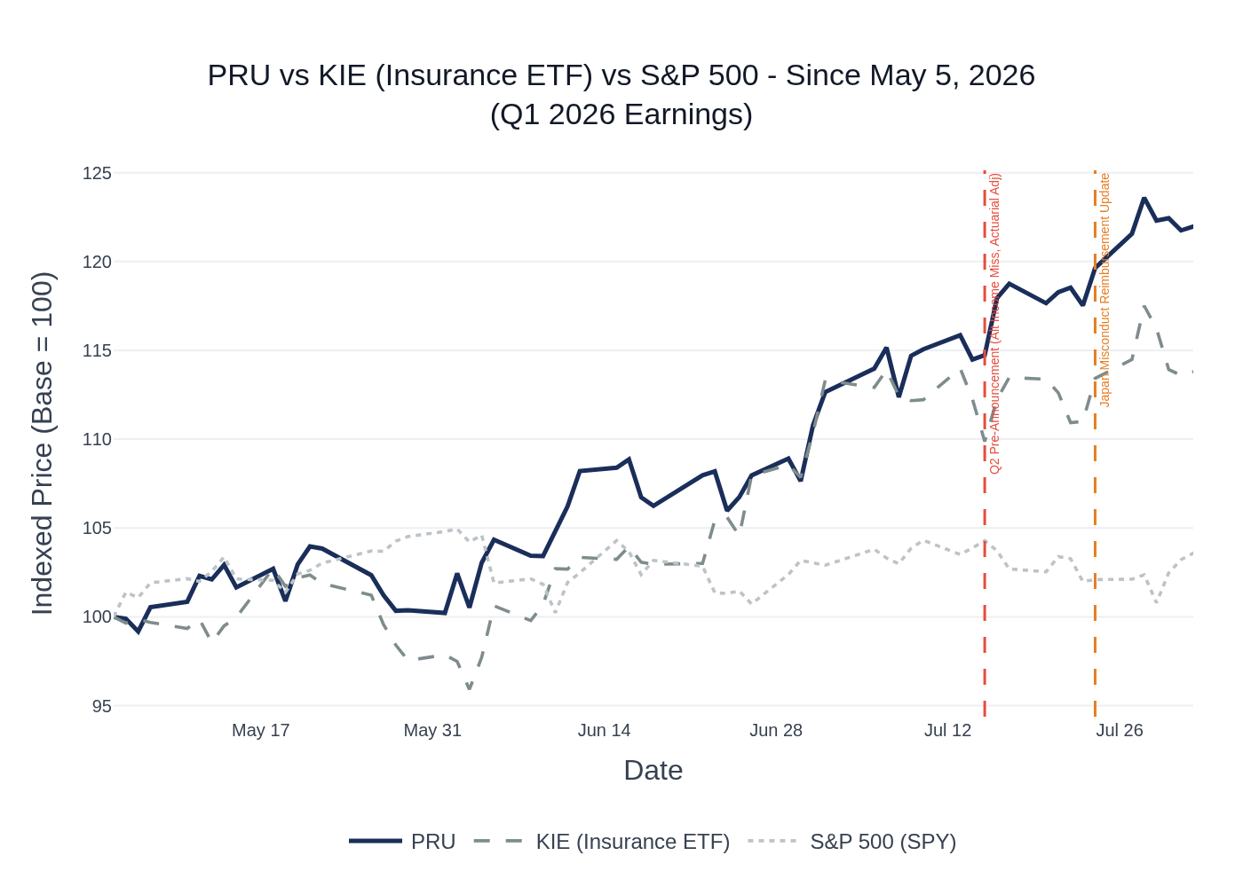
PRU vs KIE (Insurance ETF) vs S&P 500 — Indexed to 100 at May 5, 2026 (Q1 2026 Earnings Date). Vertical lines mark the July 15 Q2 pre-announcement and July 24 Japan reimbursement update.
PRU's outperformance vs. the insurance sector ETF (KIE) and the broader market (SPY) has been driven primarily by multiple expansion rather than estimate revisions (FY 2026 EPS consensus is essentially flat since Q1 earnings). The stock re-rated sharply in early July as the market began pricing in the August 4 Strategy Call. The July 15 pre-announcement (alt income miss + actuarial adjustments) caused only a brief pause before the stock resumed its rally, suggesting the market viewed the disclosures as manageable and already partially priced in. At ~$122, PRU trades at approximately 8.7x NTM EPS ($14.0), a meaningful premium to its recent historical range and well above the Street's average price target of ~$105 (consensus rating: Reduce/Hold). The stock's outperformance relative to analyst targets implies the market is assigning significant option value to the strategic update.

6. Material News & Developments
Key Takeaway: The most important development is the July 15 pre-announcement of Q2 headwinds (alt income miss + actuarial adjustments) and the upcoming August 4 Strategy Call, which is the primary catalyst for the stock's recent re-rating.
- August 4, 2026 — Q2 Earnings & Strategy Call (Upcoming): Management has committed to unveiling PRU's long-term vision and strategic portfolio simplification plan. CEO Andy Sullivan signaled at Q1 that 'the status quo is not an option' and that PRU is 'early in its business mix shift.' Potential announcements include additional international market exits, accelerated Prismic third-party reinsurance pipeline, and capital reallocation framework. This is the primary market catalyst.
- July 15, 2026 — Q2 Pre-Announcement (8-K): PRU disclosed that Q2 alternative investment income would be $20–40M below near-term expectations, and provided actuarial adjustment estimates: Retirement −$90M, International +$80M, Group Insurance +$30M, Individual Life +$30M, US Legacy +$15M (net +$65M). No material ongoing AOI impact expected. Stock initially dipped but recovered quickly.
- July 24, 2026 — Japan Misconduct Reimbursement Update (8-K): Prudential Holdings of Japan provided a quarterly update on customer reimbursement progress. As of July 8, 2026, review/reimbursement completed for 437 of 498 originally disclosed individuals (2.85B yen in claims). An additional 365 post-January 16 inquiries reviewed, with 125 eligible for reimbursement (792M yen). The reimbursement process is progressing on schedule. Sales suspension remains in effect through November 5, 2026.
- May 5, 2026 — Q1 2026 Earnings Beat: PRU reported Q1 2026 adj. operating EPS of $3.66, beating consensus of $3.20 by +14.4%. Key drivers: strong spread income in US and International Insurance, Individual Life more than doubled YoY (record Q1 sales), Retirement +9% YoY. Group Insurance declined sharply YoY on disability normalization. Japan impact of $130M was in line with guidance.
- Analyst Rating Actions (Post-Q1): Multiple firms raised price targets post-Q1 beat: KBW raised to $113 (July 13), TD Cowen raised to $114 (July 22), Jefferies raised to $110 (July 10), Mizuho raised to $109 (July 9), Piper Sandler raised to $110 (June 24). However, consensus remains Reduce/Hold with average PT ~$105, well below current price. Argus downgraded from Buy to Hold (June 9). Barclays maintained Underweight with $92 PT.
- Prismic Third-Party Reinsurance (Q1 2026): Prismic completed its first third-party transaction — reinsuring yen-denominated in-force whole life and annuity policies from Daiichi Life. This validates Prismic as a capital optimization tool beyond affiliated balance sheet use and opens the Japan reinsurance market opportunity.

7. Peer Commentaries — Q2 2026 Read-Throughs
Key Takeaway: Peers reporting Q2 2026 results (LNC, UNM) signal continued disability normalization and below-target alternative investment returns — both headwinds PRU has already pre-announced. Group life mortality remains favorable across the sector, which is a modest positive for PRU's Group Insurance segment.
Note: This section includes only commentary from peers about Q2 2026 (the current reporting quarter) or forward-looking commentary made after Q1 2026 earnings. Q1 2026 peer results commentary about Q1 itself is excluded; only forward-looking statements about Q2/H2 2026 from Q1 calls are included.

A. Lincoln National (LNC) — Q2 2026 Results (Reported July 30, 2026)
Read-through relevance: LNC is a direct peer in group insurance, disability, annuities, and retirement. Its Q2 2026 results are the most timely read-through for PRU.
- Group Insurance / Disability Normalization: LNC's Q2 2026 group protection margin was 10.4%, down 210bps YoY, with disability loss ratio of 71.9% vs. 64.2% a year ago. Management noted 'modest normalization from historically strong results' in disability and expects 'a broadly similar year-over-year headwind' in H2 2026. This is consistent with PRU's Q1 2026 Group Insurance decline and confirms disability normalization is a sector-wide theme, not PRU-specific. PRU's Group Insurance benefits ratio was 83.7% in Q1 (within 83–87% target range).
- Alternative Investment Returns Below Target: LNC's alternatives portfolio delivered an annualized return of ~5% in Q2 2026, below its 10% target, representing a $43M after-tax headwind. This directly corroborates PRU's July 15 pre-announcement of $20–40M below-target alternative investment income for Q2. LNC expects alternatives to recover to at or above target in Q3.
- Spread Income Growth Continues: LNC reported continued spread income growth in annuities and retirement plan services (base spreads +20bps YoY to 119bps in RPS). This is a positive read-through for PRU's Retirement and Individual Life segments, which have been benefiting from higher spread income.
- Annuity Sales Momentum: LNC total annuity sales of $3.5B in Q2, with spread-based products at 63% of sales. Fixed annuity sales were lower but management expects to 'meaningfully increase fixed annuity sales over the remainder of the year.' PRU's Retirement segment had $7.4B in total sales in Q1 including $3.3B retail annuity and $1.4B PRT.
- Group Life Mortality Favorable: LNC group life mortality remained favorable, consistent with broader US mortality trends. Positive read-through for PRU's Group Insurance life underwriting.

B. Unum Group (UNM) — Q2 2026 Results (Reported July 29, 2026)
Read-through relevance: UNM is a direct peer in group insurance and disability. Its Q2 2026 results provide additional color on disability trends.
- PFML Pressure Continues: UNM's US Group Disability benefit ratio was 65.8% in Q2, above its 62–64% target, driven by elevated short-term disability from newer paid family medical leave (PFML) states. Management expects 'continued elevation of the benefit ratio in line with the experience of the past two quarters' for the remainder of 2026. PRU's Group Insurance disability was also pressured in Q1 by 'higher incidence and severity amid increased macroeconomic uncertainty.' The PFML dynamic is sector-wide.
- Group Life Mortality Remains Favorable: UNM's US Group Life benefit ratio was 66% in Q2, well below its 68–72% target range, driven by 'continued lower incidents' and favorable mortality trends. Management expects this to be 'sustainable for the back half of the year.' Positive read-through for PRU's Group Insurance life underwriting.
- Full-Year Guidance Reaffirmed: UNM reaffirmed its full-year after-tax adjusted operating EPS guidance of $8.60–$8.90 despite PFML and UK disability pressure. This suggests the disability headwinds are manageable and within guidance ranges — a reassuring signal for PRU's Group Insurance segment.
- LTD Trends Stable: UNM noted that 'underlying trends in long-term disability remain stable,' with LTD experience within expectations. Relevant for PRU's Group Insurance LTD book.

C. Forward-Looking Commentary from Q1 2026 Peer Calls (About Q2/H2 2026)
Note: The following commentary was made by peers on their Q1 2026 earnings calls (May 2026) about Q2 2026 or the rest of 2026 — it is forward-looking and relevant to PRU's current quarter.

MetLife (MET) — Q1 2026 Call (May 7, 2026)
- Spread Income Stabilizing: MET's total investment spread was 119bps in Q1, at the top of its 100–120bps guidance range. Management expects 'core spreads will remain close to where we are in Q1, maybe slightly above' in Q2. Positive read-through for PRU's spread-dependent businesses (Retirement, Individual Life, International).
- PRT Market Demand Strengthening in H2: MET expects PRT demand to 'get stronger in the second half' of 2026, consistent with PRU management's own Q1 commentary that '2026 will mirror 2025' with demand strengthening in H2. PRU had $1.4B in PRT sales in Q1 across 4 middle market transactions.
- Group Benefits Momentum: MET's Group Benefits generated $439M in adjusted earnings in Q1, up 19% YoY, with sales up 15%. Management noted employers 'continue to see the value of benefits beyond medical coverage.' Positive read-through for PRU's Group Insurance sales momentum (PRU had $526M in Group Insurance sales in Q1, up 32% YoY).
- Variable Investment Income Above Target in Q1: MET's VII was $518M pretax in Q1, the third consecutive quarter of above-expectation VII. However, PRU's alt income was below target in Q2 (per pre-announcement), diverging from MET's Q1 experience — the sector-wide weakness materialized in Q2 as EQH had also flagged.

Equitable Holdings (EQH) — Q1 2026 Call (May 5, 2026)
- Alternative Investment Returns Projected Weak in Q2: EQH projected its alt portfolio return of 2–3% in Q2 2026 (vs. 3.5% in Q1), and noted full-year return would be 'below prior 8–9% guidance.' This directly foreshadowed PRU's July 15 pre-announcement of below-target alt income in Q2 — the weakness was sector-wide.
- Annuity Demand Remains Strong: EQH noted 'strong demand for RILAs driven by favorable demographics and macro uncertainty,' with RILA sales up 14% YoY in Q1. Positive read-through for PRU's retail annuity momentum (FlexGuard 2.0 launched December 2025, driving $3.3B in retail annuity sales in Q1).
- Spread Stabilization: EQH's NIM spread improved 5bps sequentially in Q1, 'reversing the downward trend in spreads we experienced over the past year.' Management expects spread income to grow as the general account grows. Positive read-through for PRU's spread-based earnings.

Lincoln National (LNC) — Q1 2026 Call (May 7, 2026) — Forward-Looking Only
- Disability Expected to Improve Seasonally in Q2: LNC noted that 'risk results have historically improved from the first to the second quarter' and expected this seasonal pattern to repeat in 2026. The PFML impact was expected to 'moderate as we move through the year.' Modest positive read-through for PRU's Group Insurance disability in Q2.
- Alternative Investment Returns Variable in Q2: LNC warned that 'elevated volatility we have seen across markets could lead to some variability in our alternatives portfolio in the near term.' This foreshadowed the sector-wide alt income weakness that PRU pre-announced for Q2.

8. Insider Transaction Activity
Key Takeaway: No open-market buys or discretionary sells by executives since Q1 earnings — all transactions are routine director RSU grants and subsidiary-level preferred stock purchases. No meaningful insider signal heading into earnings.
Name | Title | Transaction Type | Value / Amount | Filing Date | Note
Prudential Insurance Co. of America | 10% Owner (Subsidiary) | Open Market Sale | ~$214,746 (PGIM fund shares) | July 30, 2026 | Subsidiary-level fund share sale; not a PRU common stock transaction
Prudential Insurance Co. of America | 10% Owner (Subsidiary) | Purchase | $3,000,000 (Series L Preferred) | July 17, 2026 | Subsidiary purchase of PRU Series L Mandatory Redeemable Preferred Stock; capital structure transaction
Prudential Insurance Co. of America | 10% Owner (Subsidiary) | Purchase | $3,000,000 (Series K Preferred) | July 17, 2026 | Subsidiary purchase of PRU Series K Mandatory Redeemable Preferred Stock; capital structure transaction
Multiple Directors (8 directors) | Board of Directors | RSU Grant (Award) | Various | June 11–15, 2026 | Routine annual director RSU grants; non-economic signal
Multiple Directors (8 directors) | Board of Directors | RSU Grant (Award) | Various | May 12–14, 2026 | Routine annual director RSU grants; non-economic signal
No open-market buys or discretionary sells by named executive officers or directors since Q1 earnings. The subsidiary-level preferred stock purchases are internal capital structure transactions, not market signals. The absence of insider buying ahead of the August 4 Strategy Call — which management has heavily telegraphed as a positive catalyst — is notable but not alarming given the stock's significant run-up.

