STERIS plc (STE) — Earnings Preview
Company | STERIS plc
Ticker | STE
Upcoming Earnings Date | August 6, 2026 (Q1 FY2027, quarter ending June 30, 2026)
Last Earnings Date | May 11, 2026 (Q4 FY2026)
Prepared Date | August 4, 2026

1. Earnings Preview
Key Takeaway: The setup into Q1 FY27 is modestly constructive — consensus sits near the low end of management's guided range, AST is the key swing factor given management's own cautious H1 framing, and the stock's +15% post-earnings run means the bar is not low.
STERIS heads into its Q1 FY27 print on August 6 with consensus tracking near the bottom of management's guided range, suggesting limited downside risk to numbers but also limited room for a meaningful beat. The most important variable is AST services growth, where management explicitly guided for a slow H1 due to med-tech customer inventory destocking and difficult year-over-year comparisons — the question is whether the actual Q1 result comes in at, above, or below that already-cautious framing. Healthcare and Life Sciences are expected to be steady contributors, with the two tuck-in acquisitions (MEDglas walls and GI products) adding approximately $45M in inorganic revenue for the full year. The stock has rallied approximately +15% since the May 11 earnings print, outperforming both the MedTech ETF (IHI, +14%) and the S&P 500 (+3%), driven primarily by the FY27 EPS guidance beat and the new $1B buyback authorization — meaning the stock is entering the print with some multiple expansion already baked in. The wildcard is whether tariff policy has remained stable (management assumed flat tariff spend YoY in FY27 guidance) and whether AST volumes show any early signs of the H2 recovery management is counting on.

2. KPIs & Consensus Expectations
Key Takeaway: Consensus is tracking near the low end of management's guided range on both revenue and EPS, making the bar achievable but not easy. AST services growth is the biggest swing factor — management guided conservatively for H1, and any upside there would be the most positive surprise.

Table 1 — Current Quarter Snapshot (1QFY27, ending June 30, 2026)
KPI | Last Quarter Actual (4QFY26) | Prior Year Period (1QFY26) | Consensus Estimate (1QFY27) | YoY Change | Guidance (FY27 Full Year) | Consensus vs. Guidance
Total Revenue | $1,588.4M | $1,391.1M | $1,495.9M | +7.5% | +7% to +8% as-reported | Near low end of range
Adj. Operating EPS | $2.83 | $2.34 | $2.51 | +7.3% | $11.10–$11.30 FY | Tracking to low end
AST Revenue | $289.2M | $281.2M | $298.8M | +6.2% | +7% to +8% CC organic | Below midpoint
Healthcare Revenue | $1,136.3M | $974.7M | $1,051.7M | +7.9% | +6% to +7% CC organic | Near midpoint
Life Sciences Revenue | $163.0M | $135.2M | $145.5M | +7.6% | +6% to +7% CC organic | Below midpoint
Total Organic Growth | 7.1% | 7.8% | 6.3% | -150bps YoY | 6%–7% CC organic | Near low end
Adj. Operating Income | $384.9M | $316.9M | $341.2M | +7.7% | ~50bps EBIT margin expansion | Tracking guidance
Adj. Gross Profit | $699.6M | $629.6M | $670.9M | +6.6% | N/A | N/A
Source: All consensus figures from Visible Alpha as of August 4, 2026. FY27 guidance provided on May 11, 2026 Q4 FY26 earnings call.

Table 2 — Beat/Miss History (Last 8 Quarters, Top 2 KPIs)
Quarter | KPI | Reported | Consensus | Surprise % | Result
4QFY26 | Revenue | $1,588.4M | $1,593.8M | -0.3% | Miss
4QFY26 | Adj. EPS | $2.83 | $2.85 | -0.7% | Miss
3QFY26 | Revenue | $1,496.2M | $1,480.5M | +1.1% | Beat
3QFY26 | Adj. EPS | $2.53 | $2.53 | 0.0% | In-line
2QFY26 | Revenue | $1,460.3M | $1,431.0M | +2.0% | Beat
2QFY26 | Adj. EPS | $2.47 | $2.36 | +4.7% | Beat
1QFY26 | Revenue | $1,391.1M | $1,359.6M | +2.3% | Beat
1QFY26 | Adj. EPS | $2.34 | $2.26 | +3.5% | Beat
4QFY25 | Revenue | $1,480.5M | $1,473.8M | +0.5% | Beat
4QFY25 | Adj. EPS | $2.74 | $2.60 | +5.4% | Beat
3QFY25 | Revenue | $1,370.6M | $1,379.4M | -0.6% | Miss
3QFY25 | Adj. EPS | $2.32 | $2.35 | -1.3% | Miss
2QFY25 | Revenue | $1,328.9M | $1,330.2M | -0.1% | In-line
2QFY25 | Adj. EPS | $2.14 | $2.14 | 0.0% | In-line
1QFY25 | Revenue | $1,279.5M | $1,264.1M | +1.2% | Beat
1QFY25 | Adj. EPS | $2.14 | $2.01 | +6.5% | Beat
Pattern: STE has beaten or met revenue consensus in 6 of the last 8 quarters, with the only meaningful misses in 3QFY25 and 4QFY26. EPS beats have been more consistent, with the exception of 3QFY25 and 4QFY26. The Q4 FY26 miss was modest and did not prevent a strong stock reaction driven by FY27 guidance.

3. Guidance & Commentary Evolution
Key Takeaway: FY27 guidance was set on May 11 and has not been formally revised since. Management's tone on AST is explicitly cautious for H1, while Healthcare and Life Sciences commentary remains constructive. No post-earnings guidance updates have been issued.
Metric | Initial Guidance (May 11, 2026 — Q4 FY26 Call) | Revised Guidance | Current Consensus | Note
Total Revenue (as-reported growth) | +7% to +8% | — | ~+6.8% implied | Unchanged; FX expected slightly favorable
CC Organic Revenue Growth | +6% to +7% | — | ~6.3% | Unchanged
Adj. EPS | $11.10–$11.30 | — | $11.17 | Unchanged; 9%–11% growth over FY26
EBIT Margin Expansion | ~50bps | — | Tracking | Assumes flat tariff spend YoY and incentive comp tailwind (~$20M)
AST CC Organic Growth | +7% to +8% | — | Tracking low end | Cautious H1 due to med-tech inventory destocking; improvement expected H2
Healthcare CC Organic Growth | +6% to +7% | — | Tracking | Includes ~$45M inorganic from two tuck-in acquisitions
Life Sciences CC Organic Growth | +6% to +7% | — | Tracking | Pharma reshoring tailwind; capital equipment orders recovering
Free Cash Flow | $850M | — | N/A | CapEx of $375M; includes ~$50M incentive comp payments in June
Share Buybacks | $200M–$300M/year | — | N/A | New $1B authorization; measured approach due to withholding tax
Adj. Tax Rate | ~25% | — | N/A | Up from 24.4% in FY26; geographic mix and withholding taxes

4. Guidance vs. Estimate Revision Tracker
Key Takeaway: Estimates have been essentially stable since the May 11 print, with consensus tracking near the low end of management's guided range on both revenue and EPS. The lack of upward revision despite a strong stock move suggests the market is pricing in execution rather than estimate upgrades.
KPI | Period | Estimate (May 16, 2026 — Post-Earnings Baseline) | Current Consensus (Aug 4, 2026) | Estimate Δ (%) | Initial Guidance (May 11) | Current Guidance | Guidance Δ | Consensus vs. Guidance
Total Revenue | 1QFY27 | $1,497.1M | $1,495.9M | -0.1% | N/A (quarterly not guided) | N/A | — | N/A
Total Revenue | FY27 | $6,374.4M | $6,371.5M | -0.0% | +7%–+8% as-reported | Unchanged | — | Near low end
Adj. Operating EPS | 1QFY27 | $2.52 | $2.51 | -0.4% | N/A (quarterly not guided) | N/A | — | N/A
Adj. Operating EPS | FY27 | $11.18 | $11.17 | -0.1% | $11.10–$11.30 | Unchanged | — | Near midpoint
AST Revenue | 1QFY27 | $297.9M | $298.8M | +0.3% | +7%–+8% CC organic | Unchanged | — | Below midpoint
Total Organic Growth | 1QFY27 | 6.5% | 6.3% | -20bps | 6%–7% | Unchanged | — | Near low end
Commentary: Estimates have barely moved since the post-earnings baseline, consistent with management providing clear FY27 guidance on May 11. The slight downward drift in organic growth consensus (6.5% to 6.3%) may reflect incremental caution on AST H1 timing. The stock's +15% move since earnings has been driven by multiple re-rating on the buyback announcement and FY27 EPS guidance, not by estimate upgrades.

5. Stock Performance
Key Takeaway: STE has outperformed both the MedTech ETF and the S&P 500 since the May 11 earnings print, with the move driven primarily by multiple re-rating on the $1B buyback authorization and FY27 EPS guidance beat — not by estimate upgrades. The stock is entering Q1 FY27 earnings with some premium already priced in.
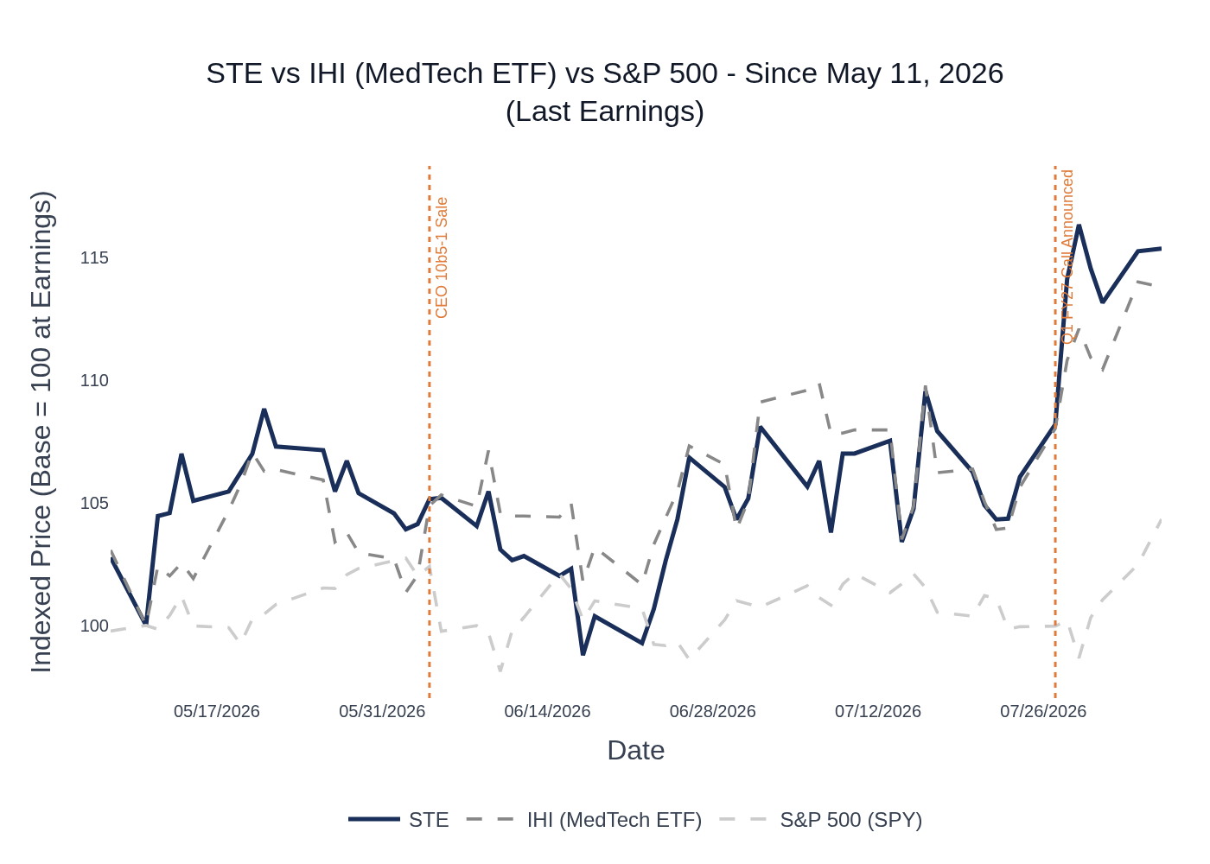
STE vs. IHI (MedTech ETF) vs. S&P 500 (SPY) — Indexed to 100 at May 11, 2026 close
- STE: +$30.79 / +15.3% (from $201.85 on May 11 to $232.64 as of Aug 3, 2026)
- IHI (MedTech ETF): +14.0% over the same period
- S&P 500 (SPY): +2.5% over the same period
Key observations:
- STE initially dipped on May 11 earnings day (modest Q4 miss) before rallying sharply on May 12 as investors digested the FY27 guidance and buyback announcement.
- The stock pulled back in mid-June to the $199–$207 range, giving back some post-earnings gains, before recovering in late June/July.
- A notable jump occurred around July 28 (stock moved from ~$218 to ~$230), coinciding with broader MedTech sector strength following ABT's strong Q2 print on July 16.
- The stock is now trading at approximately 22x NTM EPS (based on ~$232 price and ~$10.70 NTM EPS), near the high end of its historical range.

6. Material News & Developments
Key Takeaway: No major company-specific announcements since the May 11 earnings call. The most material development is the Q1 FY27 earnings call announcement on July 27, confirming August 6 as the reporting date. Peer commentary from ABT (July 16) provides a constructive read-through on hospital procedure volumes and medtech demand.
- July 27, 2026 — STERIS announced it will host a conference call for Q1 FY27 results on August 6, 2026. No pre-announcement or guidance update was issued alongside the announcement, which is consistent with prior quarters.
- July 16, 2026 — Abbott Laboratories (ABT) Q2 2026 earnings: ABT reported strong medtech demand with hospital lab volumes up 13% and US cardio business performing "better than ever." ABT explicitly pushed back on concerns about declining procedure volumes, noting that Medicare (not Medicaid) is the primary payer for devices and that demand for high-acuity products is inelastic. Constructive read-through for STE's Healthcare segment, which relies on procedure volumes for consumables and services revenue.
- May 11, 2026 — Q4 FY26 earnings: STE reported a modest miss on both revenue (-0.3%) and EPS (-0.7%) vs. consensus, but the stock rallied sharply on FY27 EPS guidance of $11.10–$11.30 (at or above prior consensus) and a new $1B share buyback authorization. Management committed to $200M–$300M in annual buybacks going forward.
- May 11, 2026 — Two tuck-in acquisitions disclosed: (1) vertical integration of MEDglas walls supplier (global reach expansion); (2) acquisition of a family of GI products adding ~20–25 US sales reps. Combined FY27 revenue contribution of ~$45M.
- May 11, 2026 — New sterility assurance manufacturing plant announced: STERIS will invest ~$60M over two years to build a new facility in Mentor, Ohio, expected operational by end of calendar 2027. Driven by capacity needs for a high-growth, high-margin product line.
- May 11, 2026 — Tariff update: Management noted recent tariff policy changes are favorable, with FY27 total tariff spend expected to be flat YoY at $60M–$65M (including $46M incremental). No refunds included in guidance. USMCA outcome not assumed.

7. Peer Commentaries — Read-Through for STE Q1 FY27
Key Takeaway: Peer commentary from the last 60 days is broadly constructive for STE's Healthcare and Life Sciences segments, with ABT confirming durable hospital procedure demand and BRKR signaling biopharma spending recovery. The most relevant cautionary signal is from BIO, which notes ongoing academic/government funding softness — less directly relevant to STE but worth monitoring for Life Sciences capital equipment.
Note: All peer commentary below is forward-looking or current-quarter commentary from earnings calls reported after STE's last earnings (May 11, 2026). Prior-quarter results commentary has been excluded.

Abbott Laboratories (ABT) — Q2 2026 Earnings (July 16, 2026)
Relevance: HIGH for Healthcare segment
- Hospital procedure volumes remain strong and durable. ABT's diagnostic instruments globally continue to reflect "strong and stable demand for testing," with hospital labs specifically up 13% in Q2. ABT explicitly pushed back on investor concerns about declining procedure volumes, noting that demand for high-acuity, life-saving products is "very inelastic." This is directly supportive of STE's Healthcare services and consumables revenue, which is tied to surgical procedure volumes.
- Medicare is the dominant payer for medical devices (over two-thirds of ABT's US cardio business), not Medicaid — meaning ACA/Medicaid enrollment changes have limited impact on medtech demand. This reduces the macro risk to STE's Healthcare segment from potential healthcare policy changes.
- ABT raised its full-year EPS guidance to $5.45–$5.60 and reaffirmed 6.5%–7.5% comparable sales growth, signaling confidence in the broader medtech demand environment through the rest of calendar 2026.
- Aging population dynamics continue to drive durable healthcare demand globally — "every day in the United States, 10,000 people turn 65." This structural tailwind supports STE's long-term Healthcare services growth thesis.

Bruker Corporation (BRKR) — Q2 2026 Earnings (August 4, 2026)
Relevance: MODERATE for Life Sciences segment
- Biopharma spending is recovering. BRKR reported biopharma organic bookings growth of more than 20% in Q2, driven by demand for NMR, X-ray, and mass spectrometry solutions. Management noted "biopharma has been great in the last 2 or 3 quarters and again in Q2." This is a constructive signal for STE's Life Sciences segment, where management noted capital equipment orders are recovering and pharma reshoring is creating new demand.
- Hospital and clinical demand is strong. BRKR's Biospin group saw "strong revenue growth in hospital, clinical and biopharma" in H1 2026, partially offset by weakness in China food testing. This supports STE's Healthcare segment read-through.
- Microbiology and infection diagnostics is a growth area. BRKR elevated its Microbiology and Infection Diagnostics business (BEAMIT) to a standalone group, citing a "fast-growing portfolio from microbial identification, molecular diagnostics, hospital hygiene to emerging antimicrobial resistance testing." While BRKR competes in diagnostics rather than sterilization, the elevated focus on infection control is thematically supportive of STE's infection prevention franchise.
- Americas and European revenues both grew approximately 10% organically in Q2, with Asia Pacific declining. The geographic split is relevant context for STE's international revenue mix.
- Tariff refunds came in faster than expected in Q2, adding ~200bps to operating margins. BRKR's experience suggests the tariff environment may be more favorable than feared for medtech/life sciences companies — a modest positive read-through for STE's flat tariff spend assumption.

Medtronic (MDT) — Q4 FY2026 Earnings (May 20, 2026)
Relevance: MODERATE for Healthcare segment
- Medtech is "structurally resilient" despite a "challenging and dynamic" macro environment. MDT cited aging population, rising chronic diseases, and growing demand for medical procedures as durable demand drivers. AI, digital, robotics, and advanced electronics are "meaningful accelerants." This macro framing is supportive of STE's Healthcare segment growth thesis.
- MDT delivered 9.9% reported revenue growth and 6.6% organic growth in Q4 FY26, its strongest top-line performance in 10 years. Strong procedure volumes across cardiovascular, surgical, and endoscopy are directly supportive of STE's sterilization and infection prevention demand.
- Medical-Surgical segment grew 5% globally, including 8% in the US, with Endoscopy delivering high single-digit growth. Endoscopy procedure volumes are a key driver of STE's Healthcare consumables and services revenue.
- Tariff impact was $74M or 80bps in Q4 FY26, in line with expectations. FY27 total tariff impact expected at ~$250M. MDT's ability to manage tariffs through pricing and efficiency is consistent with STE's own tariff mitigation approach.
- FY27 organic revenue guidance of 6.75%–7.25% signals continued confidence in the medtech demand environment, which is supportive of STE's Healthcare segment guidance.

Bio-Rad Laboratories (BIO) — Q2 2026 Earnings (August 4, 2026)
Relevance: LOW-MODERATE for Life Sciences segment
- Life sciences academic/government market remains soft. BIO noted that "demand in the academic and government market remains below historical levels, particularly in the Americas," with NIH funding outlays beginning to increase but purchasing activity lagging. This is a cautionary signal for STE's Life Sciences capital equipment business, though STE's exposure is more to pharma/biopharma than academic research.
- Biopharma showing early stabilization. BIO noted "early signs of stabilization" in biopharma, with improvement "most apparent among later-stage and commercial-scale biotech customers." This is consistent with STE management's constructive commentary on Life Sciences capital equipment orders recovering.
- Process chromatography (bioprocessing) remains lumpy. BIO's process chromatography business was sequentially up but declined YoY. The lumpiness in bioprocessing demand is a reminder that STE's Life Sciences segment can also be volatile quarter-to-quarter.
- Clinical diagnostics returned to modest growth (+0.3% currency neutral), led by quality controls and blood typing. This is a mild positive for STE's infection prevention and sterilization demand in clinical settings.

8. Insider Transaction Activity
Key Takeaway: Two 10b5-1 planned sales by the CEO and General Counsel in early June are the only insider activity since the May 11 earnings print. Both transactions were pre-planned and are not discretionary signals. No open-market buys have been reported.
Name | Title | Transaction Type | Shares | Est. Value | Transaction Date | Disclosure Date | Note
Daniel A. Carestio | President and CEO | 10b5-1 Planned Sale | 3,054 shares | ~$648K | June 4, 2026 | June 8, 2026 | Pre-planned; not a discretionary signal
Daniel A. Carestio | President and CEO | 10b5-1 Planned Sale | 1,374 shares | ~$292K | June 5, 2026 | June 8, 2026 | Pre-planned; not a discretionary signal
John Adam Zangerle | Sr. VP, Gen. Counsel & Secretary | 10b5-1 Planned Sale | 1,419 shares | ~$292K | June 15, 2026 | June 16, 2026 | Pre-planned; not a discretionary signal
Note: All transactions were executed under pre-established 10b5-1 trading plans. No open-market purchases have been reported since the May 11 earnings print. The absence of discretionary buying is neutral — not a negative signal given the stock's strong post-earnings performance.

