Waters Corporation (WAT) — Q2 2026 Earnings Preview
Prepared: August 3, 2026 | Earnings: August 4, 2026 (Before Market Open)

1. Earnings Preview
Key Takeaway: The setup into Q2 is constructive — consensus sits at the midpoint of guidance, the BD integration is inflecting faster than feared, and peer commentary from TMO, DHR, MTD, and RGEN all confirm a healthy pharma/biopharma spending environment; the key swing factor is whether BD's Biosciences division can sustain its Q1 inflection and whether cost synergies begin flowing through the P&L as guided for Q3.
WAT heads into Q2 2026 earnings with a bar that is neither stretched nor easy — consensus EPS of $3.01 sits at the midpoint of management's $2.95–$3.05 guidance range, and revenue consensus of ~$1.62B aligns tightly with the guided $1.616–$1.631B range. The Q1 print was a significant beat (EPS $2.70 vs. $2.32 consensus, revenue $1.27B vs. $1.20B expected), which reset expectations higher and drove the stock up ~12% on earnings day. Since then, WAT has gained ~9.3% vs. XBI +10.1% and SPY +4.7%, suggesting the market has largely priced in continued BD execution but has not yet awarded a full re-rating. The key wildcard is the pace of BD Biosciences recovery — Q1 showed a sharp inflection from -10% to -1% pro forma growth, and any further acceleration toward positive territory would be a meaningful positive surprise; conversely, any re-deceleration or commentary about China DRG headwinds persisting would be the primary downside risk. Cost synergies are also a Q3 story, not Q2, so margin upside this quarter is limited.

2. KPIs & Consensus Expectations
Key Takeaway: Consensus is a fair bar — aligned with guidance midpoints across all key metrics. The bigger swing factor is BD segment revenue vs. the ~$802M guided figure, as any outperformance there would drive the largest EPS upside.

Table 1 — Current Quarter Snapshot (Q2 2026)
KPI | Q1 2026 Actual | Q2 2025 Actual | Q2 2026 Consensus | YoY Change | Guidance | Consensus vs. Guidance
Total Revenue | $1,267M | $771M | $1,624M | +111% (BD acq.) | $1,616M–$1,631M | At midpoint
Adj. EPS (Diluted) | $2.70 | $2.95 | $3.01 | +2.0% | $2.95–$3.05 | At midpoint
Adj. Operating Income | $300M | $225M | $404M | +80% (BD acq.) | N/A | N/A
Instruments Sales | $295M | $308M | $321M | +4.2% | N/A | N/A
Chemistry | $154M | $165M | $172M | +4.2% | ~6.5% FY organic | In line
Service Net Sales | $348M | $298M | $316M | +6.0% | N/A | N/A
Pharma Segment | $531M | $462M | $718M | +55% (BD acq.) | N/A | N/A
Waters Organic Growth | N/A (BD close) | +9.6% | +7.1% | N/A | 6%–8% organic | At midpoint
Total Organic Growth | +11.9% | +8.3% | +7.0% | N/A | 6%–8% organic | At midpoint
Note: YoY comparisons for revenue and pharma are inflated by the BD Biosciences & Diagnostic Solutions acquisition closed February 9, 2026. Organic growth is the more meaningful comparison. Source: Visible Alpha Consensus and Actuals Data.

Table 2 — Beat/Miss History (Last 8 Quarters, Top 2 KPIs: Total Revenue & Adj. EPS)
Quarter | Revenue Reported | Revenue Consensus | Rev. Surprise | EPS Reported | EPS Consensus | EPS Surprise | Result
Q1 2026 | $1,267M | $1,231M | +2.9% | $2.70 | $2.32 | +16.4% | Beat
Q4 2025 | $932M | $929M | +0.3% | $4.53 | $4.51 | +0.4% | Slight Beat
Q3 2025 | $800M | $781M | +2.4% | $3.40 | $3.21 | +5.9% | Beat
Q2 2025 | $771M | $747M | +3.2% | $2.95 | $2.94 | +0.5% | Slight Beat
Q1 2025 | $662M | $654M | +1.2% | $2.25 | $2.22 | +1.4% | Beat
Q4 2024 | $873M | $856M | +2.0% | $4.10 | $4.02 | +2.0% | Beat
Q3 2024 | $740M | $713M | +3.8% | $2.93 | $2.68 | +9.3% | Beat
Q2 2024 | $709M | $700M | +1.3% | $2.63 | $2.56 | +2.7% | Beat
Pattern: WAT has beaten revenue consensus in each of the last 8 quarters, with EPS beats ranging from modest (Q4 2025: +0.4%) to substantial (Q1 2026: +16.4%); the Q1 2026 EPS beat was outsized because consensus had been anchored near the low end of guidance following the Q4 2025 earnings reaction. Source: Visible Alpha Consensus and Actuals Data.

3. Guidance & Commentary Evolution
Key Takeaway: Guidance was raised at Q1 earnings and has not been revised since; tone is constructive with management explicitly flagging Q3 as the inflection point for cost synergy flow-through and BD acceleration.
Metric | Initial Guidance (Q1 2026 Earnings, May 5) | Revised Guidance | Current Consensus | Note
Q2 2026 Revenue | $1,616M–$1,631M | — | $1,624M | At midpoint; no post-earnings revision
Q2 2026 Adj. EPS | $2.95–$3.05 | — | $3.01 | At midpoint; no post-earnings revision
FY 2026 Revenue | $6,405M–$6,455M | — | $6,445M | Raised from prior $6.3B–$6.4B range at Q1 earnings
FY 2026 Adj. EPS | $14.40–$14.60 | — | $14.52 | Raised $0.10 at Q1; reflects 10%–11% growth
FY 2026 Adj. EBIT Margin | 28.2% | — | N/A | Raised at Q1 earnings
Waters Organic Growth (FY) | 6.5%–8.0% | — | ~7.2% | Raised from prior 6%–7.5% range
BD Revenue (FY) | ~$3,035M | — | N/A | Includes $35M revenue synergy contribution
Cost Synergies (FY) | $55M | — | N/A | On track; savings begin flowing Q3 2026
Key commentary: Management was explicit that Q2 EPS guidance reflects the “full burden of higher interest costs and newly issued shares” ahead of cost synergy benefits that begin in Q3. This creates a natural setup where Q3 and Q4 should show meaningful margin expansion as synergies flow through.

4. Guidance vs. Estimate Revision Tracker
Key Takeaway: Estimates have moved modestly higher since Q1 earnings, tracking guidance closely; the lack of meaningful upward revision despite a large Q1 beat suggests the Street is appropriately cautious on BD execution risk, leaving room for positive surprise if BD continues to inflect.
KPI | Period | Estimate (~May 12, 2026) | Current Consensus | Estimate Δ (%) | Initial Guidance (Q1 Call) | Current Guidance | Guidance Δ | Consensus vs. Guidance
Total Revenue | Q2 2026 | $1,622M | $1,624M | +0.1% | $1,616M–$1,631M | Unchanged | — | At midpoint
Total Revenue | FY 2026 | $6,441M | $6,445M | +0.1% | $6,405M–$6,455M | Unchanged | — | At midpoint
Adj. EPS | Q2 2026 | $3.01 | $3.01 | Flat | $2.95–$3.05 | Unchanged | — | At midpoint
Adj. EPS | FY 2026 | $14.50 | $14.52 | +0.1% | $14.40–$14.60 | Unchanged | — | At midpoint
Commentary: Estimates have been remarkably stable since Q1 earnings, with virtually no revision in either direction. This reflects the Street’s view that Q1 was a clean beat but that BD execution risk remains the key variable — analysts are not willing to extrapolate Q1 BD outperformance into the full year until they see another quarter of evidence. Source: Visible Alpha Consensus and Actuals Data.

5. Stock Performance
Key Takeaway: WAT has gained ~9.3% since Q1 earnings, roughly in line with XBI (+10.1%) but well ahead of SPY (+4.7%); performance has been driven by a combination of the Q1 beat re-rating and sector-wide biotech/life science recovery, with WAT’s relative underperformance vs. XBI suggesting the BD integration premium has not yet been fully awarded.
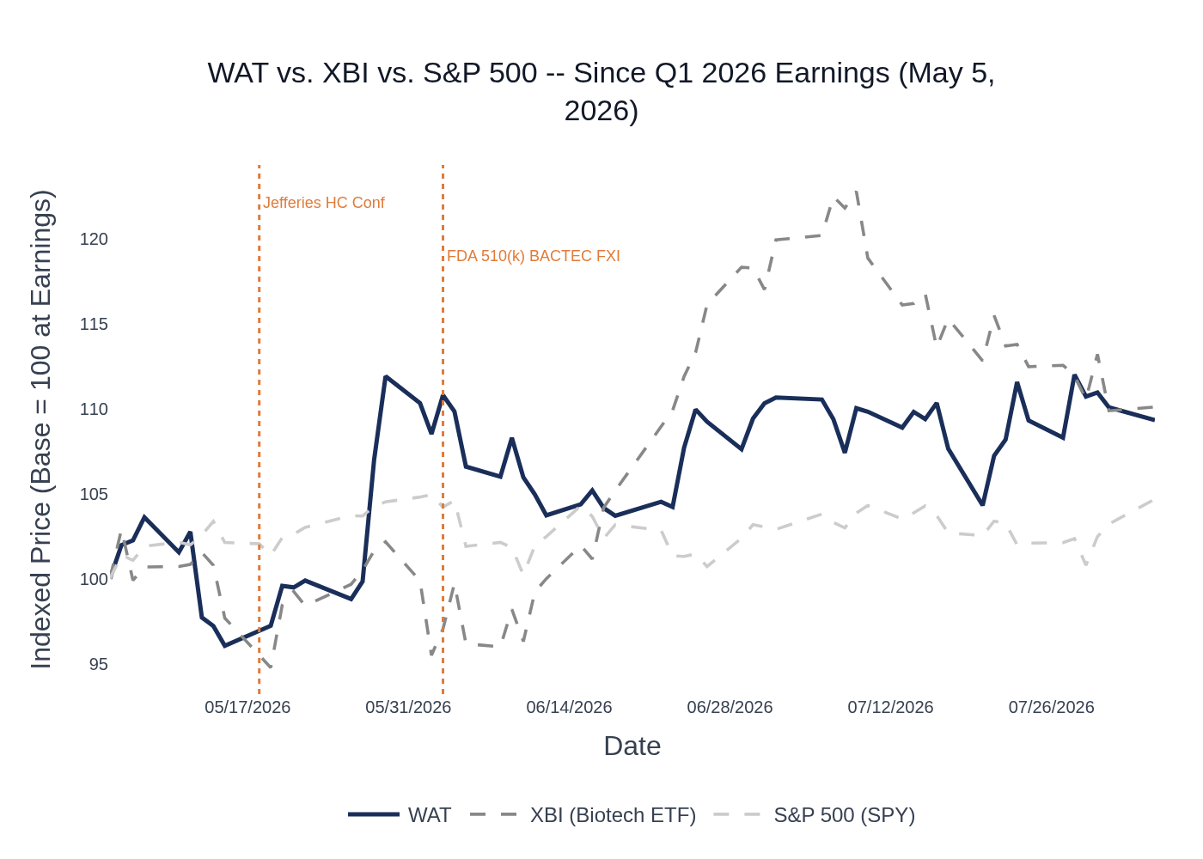
WAT vs. XBI (Biotech ETF) vs. S&P 500 (SPY) — Indexed to 100 at Q1 2026 Earnings (May 5, 2026). Source: Yahoo Finance.
WAT opened Q2 earnings season at $307 (May 1), surged to $343 on earnings day (May 5) on the large Q1 beat, and has since traded in a range of $329–$384, closing at ~$375 as of August 1. The stock pulled back ~7% from its post-earnings high in mid-May as the broader biotech sector softened, then recovered through June–July as peer earnings (TMO, DHR, MTD) confirmed healthy pharma end markets. The stock has not re-tested its post-earnings high, suggesting the market is waiting for Q2 results to confirm BD execution before awarding further multiple expansion. XBI (used as the sector proxy given WAT’s new diagnostics/biosciences exposure) outperformed WAT slightly, reflecting broader biotech recovery that WAT has partially but not fully captured. Analyst consensus remains “Moderate Buy” with an average price target of $401.60, implying ~7% upside from current levels. Source: Stock Price Data (Yahoo Finance).

6. Peer Commentaries — Q2 2026 Read-Throughs
Key Takeaway: Peer Q2 2026 earnings from TMO, DHR, MTD, and RGEN collectively paint a constructive picture for WAT — pharma/biopharma demand is healthy and accelerating, China pharma is growing, and instrument demand is recovering; the one nuance is DHR’s bioprocessing consumable timing push-out, which is idiosyncratic and not a WAT read-through.
Note: All commentary below is from Q2 2026 earnings calls (reported July 21–31, 2026), reflecting the current reporting quarter that WAT is about to report. This is forward-looking read-through, not backward-looking.

Thermo Fisher Scientific (TMO) — Q2 2026 Earnings (July 23, 2026)
Relevance to WAT: TMO is the closest large-cap peer in analytical instruments and pharma/biopharma end markets. TMO’s pharma/biotech segment (~60% of revenue) delivered mid-single digit growth in Q2, with management noting that “customer activity picked up across our end markets” and “good momentum continues in pharma, but also biotech.” Biotech specifically is recovering, with funding translating into revenue — a
positive read-through for WAT’s pharma segment. TMO’s Analytical Instruments segment grew 7% organically, led by chromatography and mass spectrometry, with “strong adoption of high-end instrumentation globally” — directly supporting WAT’s instrument replacement cycle thesis. China returned to low-single-digit growth at TMO, driven by pharma/biotech and industrial, consistent with WAT’s own China pharma strength. TMO raised full-year organic revenue growth guidance to ~4% and raised EPS guidance, signaling confidence in H2.
Key quote: “Irrespective of funding environments, if you have really relevant innovation, customers get money and we saw that show up very nicely.”

Danaher Corporation (DHR) — Q2 2026 Earnings (July 21, 2026)
Relevance to WAT: DHR’s life sciences and diagnostics businesses overlap with WAT’s BD-acquired Biosciences and Diagnostic Solutions divisions. DHR reported core revenue up 3% (4.5% ex-respiratory), with life sciences instruments growing mid-single digits. Large pharma/biopharma demand “remained healthy and continued to strengthen,” and biotech funding is “starting to play through” into orders and revenue. China grew mid-single digits at DHR, with biotech delivering “solid growth” and diagnostics improving sequentially as DRG/VBP headwinds begin to lessen — a
direct positive read-through for WAT’s BD Advanced Diagnostics division, which faces similar China DRG headwinds. The one nuance: DHR’s bioprocessing consumables came in below expectations due to a few large chromatography resin shipments ($10–$30M each) being pushed out by commercial customers due to production schedule changes — management was clear this is idiosyncratic (a few very large customers) and not a broad demand signal, with mid-teens order growth in both consumables and equipment. DHR raised full-year EPS guidance.
Key quote: “We do see biotech funding stronger. We’re seeing that funding starting to play through. Previously it was just in the funnel. Now we’re starting to see some orders there.”

Mettler-Toledo (MTD) — Q2 2026 Earnings (July 31, 2026)
Relevance to WAT: MTD’s laboratory business (~50% of revenue) serves similar pharma/biopharma QA/QC customers as WAT’s core analytical instruments business. MTD reported 4% organic lab growth in Q2, with analytical instruments performing “very good” and the pipette business returning to growth — a positive signal for lab instrument demand broadly. China grew 9% at MTD (stronger than expected), led by industrial/biopharma, with continued improvement expected in H2. MTD noted that “increased certainty in the market” is helping biopharma spend more, and that pharma companies are automating experimental setups using MTD equipment — consistent with WAT’s thesis around instrument replacement and new product adoption. MTD raised full-year guidance and guided Q3 lab growth at mid-single digits. Pricing realization of ~3% in Q2 is also a
positive read-through for WAT’s pricing power.
Key quote: “The increased certainty certainly helps — we hear that a lot in terms of biopharma generally spending more than where there was a lot of hesitancy at the beginning of the year.”

Repligen (RGEN) — Q2 2026 Earnings (July 28, 2026)
Relevance to WAT: RGEN is a bioprocessing/biopharma tools company with strong China exposure and bioseparations/chromatography products that overlap with WAT’s chemistry segment. RGEN delivered 13% organic growth in Q2, with emerging biotech growing high-teens and CDMO growth remaining strong. China grew more than 60% in H1 2026 at RGEN, driven by pharma/CDMOs — a
very strong positive read-through for WAT’s China pharma thesis. RGEN’s chromatography revenue grew low-double digits, with large-scale column units up 18% in H1 — directly supportive of WAT’s bioseparations/chemistry growth narrative. Analytics demand grew 30%+ at RGEN. Capital equipment book-to-bill was “significantly above 1” in Q2, suggesting instrument demand is recovering. RGEN raised full-year organic growth guidance by 1 percentage point.
Key quote: “Emerging biotech grew high teens even against a high comparison — a clear sign this customer base is recovering in a sustainable manner.”

Peer Read-Through Summary
Peer | Report Date | Key Metrics | WAT Read-Through | Signal
TMO | July 23, 2026 | Pharma/biotech mid-SD growth; Analytical Instruments +7% organic; China low-SD; guidance raised | Pharma demand healthy; instrument cycle intact; China recovering | Positive
DHR | July 21, 2026 | Life sci instruments mid-SD; biopharma healthy; China mid-SD; bioprocessing consumable push-out (idiosyncratic) | BD diagnostics DRG headwinds easing; biopharma spending up; consumable push-out is NOT a WAT read-through | Positive (with nuance)
MTD | July 31, 2026 | Lab +4% organic; analytical instruments strong; China +9%; biopharma spending up; pricing ~3% | Lab instrument demand recovering; China pharma strong; pricing power intact | Positive
RGEN | July 28, 2026 | +13% organic; China +60% H1; chromatography +low-DD; biotech high-teens; guidance raised +1pp | WAT chemistry/bioseparations demand strong; China pharma robust; biotech recovery real | Strongly Positive
Source: TMO Q2 2026 Earnings Call (July 23, 2026); DHR Q2 2026 Earnings Call (July 21, 2026); MTD Q2 2026 Earnings Call (July 31, 2026); RGEN Q2 2026 Earnings Call (July 28, 2026).

7. Material News & Developments
Key Takeaway: The most important post-Q1 development is the FDA 510(k) clearance of BACTEC FXI (June 3, 2026), completing regulatory approvals across U.S., Europe, and Japan and unlocking the instrument replacement cycle for ~12,000 aging BACTEC instruments — a multi-year revenue synergy driver not yet in guidance.
- June 3, 2026 — FDA 510(k) clearance received for BACTEC FXI blood culture system, completing regulatory approvals in U.S., Europe, and Japan. Unlocks replacement of ~12,000 instruments (>50% over 5 years old, >25% over 10 years old). Management had guided $50M of revenue synergies for FY2026; BACTEC FXI is a key lever. Implication: Positive for H2 2026 and multi-year revenue synergy trajectory.
- June 2026 — BD FACSDiscover A7 spectral flow cytometer unveiled at CYTO 2026, targeting high-volume routine applications. Implication: New product catalyst for Biosciences division; supports recovery from Q4 2025 decline.
- June 2026 (ASMS) — Xevo MRT P10 and Cyclic IMS P20 mass spectrometers launched at ASMS 2026. MRT P10 positioned for proteomics, lipidomics, and metabolomics — management flagged proteomics as an emerging strategic ambition. Implication: New product cycle supports instrument growth in H2 2026 and 2027.
- May 18, 2026 — WAT presented at Jefferies Global Healthcare Conference. No material guidance revision disclosed. Implication: Management tone consistent with Q1 guidance; no pre-announcement.
- July 20, 2026 — Wall Street Zen downgraded WAT from Buy to Hold. Broader analyst consensus remains “Moderate Buy” with average price target of $401.60 (vs. ~$375 current price). Implication: Modest negative sentiment signal, but consensus remains constructive.
- Q3 2026 (expected) — Cost synergy savings from restructuring actions expected to begin flowing through P&L in Q3. Management guided $55M of cost synergies for FY2026. Implication: Q2 margins will not yet reflect synergy benefits; Q3 is the inflection point to watch.
- Q3 2026 (expected) — China localization of flow instruments at Suzhou site targeting Q3 manufacturing start. Implication: Key catalyst for Biosciences China recovery; watch for update on timing.

8. Insider Transaction Activity
Key Takeaway: No open-market buys or discretionary sells since Q1 earnings; all transactions are tax-withholding (code F) or compensation-related grants (code A), which carry no informational signal about management’s view of the stock.
Name | Title | Transaction Type | Value | Filing Date | Transaction Date | Note
Jiang Wei | Director | Compensation Grant (A) | $67 | July 2, 2026 | June 30, 2026 | Routine compensation grant; no informational signal
Knight Heather | Director | Compensation Grant (A) | $63 | July 2, 2026 | June 30, 2026 | Routine compensation grant; no informational signal
Carpio Robert L III | SVP Waters Analytical Sciences | Tax Withholding (F) | $189 | June 25, 2026 | June 24, 2026 | Shares withheld for tax on vesting; not a discretionary sale
Chaubal Amol | SVP & CFO | Tax Withholding (F) | $239 | May 14, 2026 | May 12, 2026 | Shares withheld for tax on vesting; not a discretionary sale
No open-market buys (code P) or discretionary sells (code S) have been filed since Q1 earnings. The absence of insider buying is not a negative signal given the stock’s strong post-earnings performance; the absence of discretionary selling is mildly positive. Source: SEC Form 4 filings (Insider Transaction Data).

