Zebra Technologies (ZBRA) — Q2 2026 Earnings Preview
Company | Zebra Technologies Corporation
Ticker | NASDAQ: ZBRA
Reporting Period | Q2 2026 (quarter ending June 30, 2026)
Earnings Date | August 4, 2026 (pre-market)
Last Earnings | May 12, 2026 (Q1 2026)
Prepared Date | August 3, 2026

1. Earnings Preview
Key Takeaway: Setup leans toward a beat — consensus is a manageable bar, guidance was raised at Q1, and the primary wildcard is whether memory supply constraints tighten further in Q2 and pressure margins more than the ~1.5-point sequential EBITDA headwind management already guided.
Heading into Q2 2026, ZBRA enters with a strong backlog and pipeline that management cited explicitly when issuing 14–17% sales growth guidance (including ~10.5 pts from acquisitions and FX), with the Non-GAAP EPS range of $4.20–$4.50 sitting above where consensus stood before the Q1 print. The bar is not demanding: current consensus of ~$4.37 EPS and ~$1.50B revenue sits near the midpoint of guidance, leaving room for the same deal-mix and productivity tailwinds that drove the Q1 beat to recur. Management's tone on the Q1 call was explicitly confident — "the year is off to a great start" — and the full-year EPS guide was raised to $18.30–$18.70, signaling no deterioration in the underlying demand picture. Estimate revisions since the Q1 print have been essentially flat (EPS consensus moved from ~$4.37 to ~$4.37, revenue from ~$1.497B to ~$1.499B), suggesting the Street has largely digested the guidance raise without adding incremental optimism — a neutral-to-slightly-favorable setup. The stock has rallied ~21% since the Q1 earnings date (indexed to 100 at May 12), meaningfully outperforming the S&P 500 (+2.6%) and Russell 1000 (+3.0%), so some beat is priced in, but the multiple is not stretched relative to history given the raised guidance. The single biggest wildcard is memory supply: management guided for ~1.5 pts of sequential EBITDA margin compression in Q2 from memory cost step-up, and any incremental tightening beyond that — or conversely, better-than-expected mitigation — is the key swing factor for the print.

2. KPIs & Consensus Expectations
Key Takeaway: Consensus is a low-to-moderate bar — EPS and revenue estimates sit near the midpoint of company guidance, leaving room for upside from deal mix and productivity. Adjusted EPS is the bigger swing factor: the Q1 beat was driven by gross margin outperformance, and any recurrence (or reversal) of that dynamic will move the stock more than a revenue in-line.

Table 1 — Q2 2026 Current Quarter Snapshot
KPI | Q1 2026 Actual | Q2 2025 Actual (Prior Year) | Q2 2026 Consensus Estimate | YoY Change | Q2 2026 Guidance | Consensus vs. Guidance Midpoint
Revenue ($M) | $1,495M | $1,293M | $1,499M | +15.9% YoY | +14% to +17% growth (implied ~$1,474M–$1,513M) | +0.1% vs. midpoint (~$1,494M)
Non-GAAP Diluted EPS | $4.75 | $3.61 | $4.37 | +21.1% YoY | $4.20–$4.50 | +0.8% vs. midpoint ($4.35)
Adj. EBITDA ($M) | $347M | $267M | $320M | +19.9% YoY | Slightly above 21% margin | ~21.4% margin implied; consensus at ~21.4%
Adj. Gross Margin (%) | 50.4% | 47.9% | 48.2% | +30 bps YoY | Not explicitly guided; memory step-up implies sequential compression | N/A — no explicit guidance midpoint
Revenue — Connected Frontline ($M) | $825M | $717M | $870M | +21.3% YoY | Not separately guided | N/A
Revenue — Asset Visibility & Automation ($M) | $670M | $576M | $630M | +9.4% YoY | Not separately guided | N/A
Free Cash Flow ($M) | $163M | $130M | $252M | +93.8% YoY | FY2026 ≥$900M (100% conversion) | N/A — quarterly not guided
Sources: Visible Alpha consensus and actuals data; Q1 2026 earnings call transcript (May 12, 2026). Revenue prior year Q2 2025 actual: $1,293M. EPS prior year Q2 2025 actual: $3.61. Adj. EBITDA prior year Q2 2025 actual: $267M. Gross margin prior year Q2 2025 actual: 47.9%. CF segment prior year: $717M. AVA segment prior year: $576M. FCF prior year: $130M.

Table 2 — Beat/Miss History (Last 8 Quarters, Top 2 KPIs)
Top 2 KPIs: Revenue and Non-GAAP Diluted EPS
Quarter | KPI | Reported | Consensus | Surprise % | Result
Q1 2026 | Revenue | $1,495M | $1,479M | +1.1% | Beat
Q1 2026 | Non-GAAP EPS | $4.75 | $4.24 | +12.0% | Beat
Q4 2025 | Revenue | $1,475M | $1,466M | +0.6% | Beat
Q4 2025 | Non-GAAP EPS | $4.33 | $4.33 | 0.0% | In-Line
Q3 2025 | Revenue | $1,320M | $1,316M | +0.3% | Beat
Q3 2025 | Non-GAAP EPS | $3.88 | $3.75 | +3.5% | Beat
Q2 2025 | Revenue | $1,293M | $1,291M | +0.2% | Beat
Q2 2025 | Non-GAAP EPS | $3.61 | $3.31 | +9.1% | Beat
Pattern: ZBRA has beaten EPS consensus in every quarter shown, with the magnitude of EPS beats consistently exceeding revenue beats — the Q1 2026 EPS beat of +12% was the largest in the trailing 8 quarters, driven by record gross margin and favorable deal mix. Revenue beats have been narrow (+0.2% to +1.1%), suggesting the Street calibrates revenue well but consistently underestimates margin leverage and operating efficiency.
Source: Visible Alpha consensus and actuals data.

3. Guidance & Commentary Evolution
Key Takeaway: Guidance was raised at Q1 2026 earnings (May 12) and has not been formally revised since — no 8-K, pre-announcement, or conference update has changed the numbers. Management tone remains confident: the Q1 call opened with "the year is off to a great start" and the full-year EPS raise to $18.30–$18.70 was above prior consensus, signaling management conviction in the demand and margin outlook.
Metric | Initial Guidance (Q1 2026 Earnings Call, May 12, 2026) | Revised Guidance | Current Consensus | Note
Q2 2026 Revenue Growth | +14% to +17% YoY (incl. ~10.5 pts from acquisitions & FX) | — | ~+15.9% YoY ($1,499M) | No post-earnings revision; consensus sits near midpoint
Q2 2026 Adj. EBITDA Margin | Slightly above 21% | — | ~21.4% | No revision; memory step-up of ~1.5 pts vs. Q1 already embedded in guide
Q2 2026 Non-GAAP EPS | $4.20–$4.50 | — | $4.37 | No revision; consensus at midpoint ($4.35); slight premium to midpoint
FY2026 Revenue Growth | +10% to +14% YoY (incl. ~7 pts from acquisitions & FX); raised 1 pt at midpoint vs. prior guide | — | $6,067M (~+12% YoY) | No post-earnings revision; consensus near midpoint
FY2026 Adj. EBITDA Margin | ~22% | — | ~22.2% | No revision; full mitigation of 2-pt memory headwind embedded; management increasingly confident
FY2026 Non-GAAP EPS | $18.30–$18.70 (raised from prior range; assumes $100M additional buybacks) | — | $18.58 | No revision; consensus near midpoint ($18.50); raised above prior consensus at Q1 print
FY2026 Free Cash Flow | ≥$900M (~100% conversion) | — | $945M | No revision; consensus above floor guidance
Source: Q1 2026 Earnings Call Transcript (May 12, 2026); Visible Alpha consensus data.

4. Guidance vs. Estimate Revision Tracker
Key Takeaway: Estimates have been essentially flat since the Q1 print — the Street absorbed the guidance raise without adding incremental optimism, leaving consensus near the midpoint of guidance for both Q2 and FY2026. This is a neutral-to-favorable setup: no estimate creep above guidance means the bar hasn’t risen, and any positive surprise on memory mitigation or deal mix could drive upside.
KPI (Period) | Estimate ~5 Days Post Q1 Earnings (as of May 19, 2026) | Current Consensus | Estimate Δ (%) | Initial Guidance (Q1 Call) | Current Guidance | Guidance Δ | Consensus vs. Guidance Midpoint
Revenue — Q2 2026 | $1,497M | $1,499M | +0.1% | +14% to +17% YoY (~$1,474M–$1,513M) | Unchanged | — | +0.3% above midpoint
Non-GAAP EPS — Q2 2026 | $4.37 | $4.37 | 0.0% | $4.20–$4.50 | Unchanged | — | +0.5% above midpoint ($4.35)
Adj. EBITDA — Q2 2026 | $320M | $320M | 0.0% | Slightly above 21% margin | Unchanged | — | ~21.4% margin; in-line with guidance floor
Revenue — FY2026 | $6,065M | $6,067M | +0.0% | +10% to +14% YoY | Unchanged | — | Near midpoint
Non-GAAP EPS — FY2026 | $18.58 | $18.58 | 0.0% | $18.30–$18.70 | Unchanged | — | +0.4% above midpoint ($18.50)
Adj. EBITDA — FY2026 | $1,348M | $1,348M | 0.0% | ~22% margin | Unchanged | — | ~22.2% margin; slight premium to guidance
Estimates have been remarkably stable since the Q1 print — essentially zero revision across all KPIs for both Q2 and FY2026. This reflects the Street’s view that guidance is credible and the midpoint is the right anchor, with no incremental positive or negative data points since May 12 to shift the consensus. The lack of estimate creep above guidance is a favorable setup: it means the hurdle rate has not risen, and any positive surprise on memory mitigation, deal mix, or buyback pace could drive upside to both EPS and the stock.
Source: Visible Alpha consensus and actuals data (as-of date: May 19, 2026 for baseline; current as of August 3, 2026).

5. Stock Performance
Key Takeaway: ZBRA has dramatically outperformed since the Q1 print (+20.6% indexed vs. S&P 500 +2.6%), driven primarily by the magnitude of the EPS beat and the guidance raise — this is a revision-driven rally, not multiple expansion, as the stock re-rated to reflect the raised FY2026 EPS guide. The stock pulled back ~10% from its mid-June peak before recovering into earnings, suggesting some profit-taking but no fundamental deterioration in the thesis.
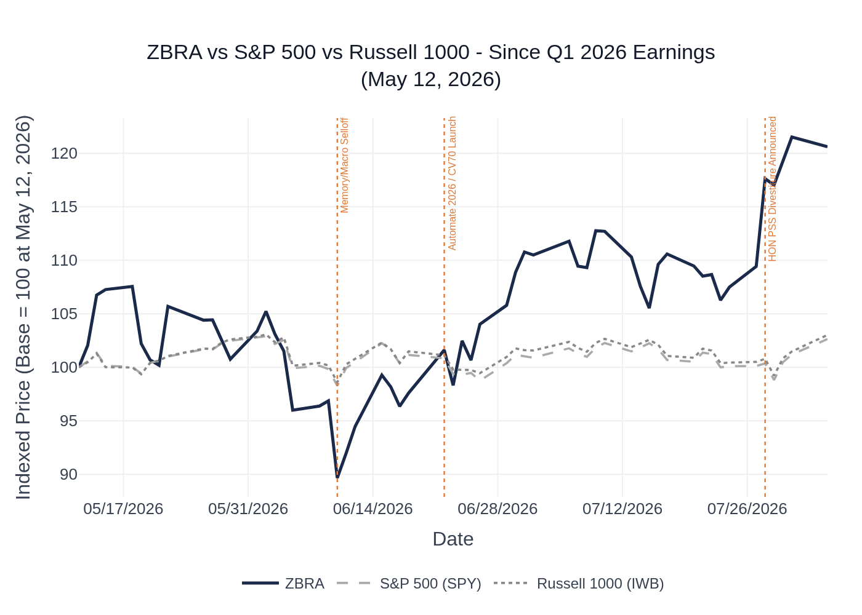
ZBRA vs. SPY vs. IWB (Russell 1000) — Indexed to 100 at Q1 2026 Earnings Date (May 12, 2026). Source: Yahoo Finance / Stock Price Data.
Sector ETF note: IWB (iShares Russell 1000 ETF) used as the broad market benchmark alongside SPY (S&P 500 ETF). ZBRA is a large-cap industrial technology company; IWB captures the broad large-cap universe. A more sector-specific ETF (e.g., IYJ — iShares U.S. Industrials ETF) would also be appropriate.
Key events since Q1 earnings (May 12, 2026):
- May 12–15: ZBRA surged ~7% in the 3 days following the Q1 print on the EPS beat and guidance raise. Multiple analyst upgrades and price target increases followed (BNP Paribas Exane to $370 Outperform; KeyCorp upgraded to Overweight with $305 PT; Citi raised PT to $306 Neutral).
- June 5–10: Stock pulled back ~11% from its post-earnings high, broadly in line with a market-wide risk-off move; no ZBRA-specific negative catalyst identified.
- June 22: ZBRA presented at Automate 2026 in Chicago, launching the CV70 CXP machine vision camera and showcasing its end-to-end vision ecosystem — reinforced the machine vision growth narrative.
- July 13: Citi raised PT from $284 to $306 (Neutral). Barclays raised PT from $345 to $346 (Overweight) on June 22.
- July 28: Stock jumped ~7.3% in a single session, likely on sympathy with strong industrial/tech earnings from peers (UPS Q2 beat, IEX raised guidance).
- August 3 (today): HON completed the sale of its Productivity Solutions & Services business to Brady Corp. — removes ZBRA’s largest direct competitor in mobile computing and barcode scanning from the market as an independent entity.
Source: Yahoo Finance stock price data; internet search results for analyst actions and company events.

7. Material News & Developments
Key Takeaway: The most important development since Q1 earnings is the completion of Honeywell’s PSS divestiture to Brady Corp. (August 3, 2026) — this structurally reduces competitive intensity in ZBRA’s core mobile computing and barcode scanning markets. Secondary positive: the CV70 machine vision camera launch at Automate 2026 reinforces the double-digit machine vision growth narrative heading into Q2.
- August 3, 2026 — HON completes PSS sale to Brady Corp.: Honeywell completed the $1.4B all-cash sale of its Productivity Solutions and Services business (mobile computers, barcode scanners, printing) to Brady Corporation. This is the most significant competitive landscape change for ZBRA in years. Brady is a much smaller, niche identification/protection solutions company — the PSS business will likely receive less investment and strategic focus under Brady than it did under Honeywell.
- July 7, 2026 — ZBRA confirms Q2 2026 earnings date (August 4, pre-market): Zebra Technologies confirmed it will report Q2 2026 results on August 4, 2026, with a conference call at 7:30 a.m. CT / 8:30 a.m. ET. No pre-announcement or guidance update was issued alongside this press release — consistent with management’s confidence in the Q2 outlook.
- June 22, 2026 — CV70 CXP machine vision camera launched at Automate 2026: Zebra debuted the CV70 CXP, a high-performance, ultra-compact machine vision camera designed for high-speed, high-resolution applications including small parts inspection, EV battery assembly, and semiconductor inspection. The CV70 pairs with Zebra’s Aurora software and 4Sight XV7 controllers to offer a complete single-vendor vision solution.
- June 22, 2026 — Barclays raises PT to $346 (Overweight): Barclays increased its price objective from $345 to $346 and maintained an Overweight rating. Modest PT increase suggests incremental confidence in the thesis without a major re-rating.
- June 28, 2026 — Wall Street Zen upgrades ZBRA to Buy: Wall Street Zen upgraded from Hold to Buy. Adds to the constructive analyst sentiment backdrop.
- July 13, 2026 — Citi raises PT to $306 (Neutral): Citigroup raised its price target from $284 to $306 while maintaining a Neutral rating. The PT raise reflects the guidance raise at Q1 but the Neutral rating signals Citi sees limited upside from current levels.
- May 13, 2026 — Multiple analyst actions post-Q1 beat: BNP Paribas Exane raised PT from $365 to $370 (Outperform); KeyCorp upgraded from Sector Weight to Overweight with a $305 PT; Citi raised PT from $274 to $284 (Neutral). Broad positive analyst reaction to the Q1 beat and guidance raise.
- May 12, 2026 — Q1 2026 results: beat on revenue and EPS, guidance raised: Revenue of $1,495M (+14% YoY, +4% organic); Non-GAAP EPS of $4.75 (+18% YoY, +12% vs. consensus); Adj. EBITDA margin of 23.2% (multiyear high gross margin of 50.4%); FY2026 EPS guidance raised to $18.30–$18.70; $500M in share repurchases executed YTD through early May. This was the primary catalyst for the post-earnings rally.
- April 20, 2026 — HON announces PSS sale to Brady Corp. for $1.4B: Honeywell announced the agreement to sell its PSS business (mobile computers, barcode scanners, printing) to Brady Corporation in an all-cash transaction. This was the initial announcement of the competitive landscape change that completed on August 3.
- Ongoing — Memory supply constraints remain the primary risk: Management guided for ~1.5 pts of sequential EBITDA margin compression in Q2 from memory cost step-up. Amazon’s Q2 call (July 30) corroborated that memory costs are elevated industry-wide, with Amazon revising CapEx upward “mainly due to higher cost of memory.” Itron (July 28) also flagged memory pricing as a “pocket of tightness.” This is the key watch item for the Q2 print.
Sources: Business Wire press releases; internet search results; Q1 2026 earnings call transcript; HON Q2 2026 earnings call transcript; AMZN Q2 2026 earnings call transcript; ITRI Q2 2026 earnings call transcript.

8. Insider Transaction Activity
Key Takeaway: Two open-market sales since Q1 earnings — both are small in size relative to the sellers’ remaining holdings and appear to be routine discretionary sales rather than a signal of concern.
Name | Title | Transaction Type | Shares | Date | Shares Remaining | Note
Janice M. Roberts | Director | Open Market Sale | 3,000 shares | May 14, 2026 | 6,183 shares | Discretionary sale; no 10b5-1 plan indicated; sold ~33% of position; occurred 2 days after Q1 earnings
Melissa Luff Loizides | Chief People Officer | Open Market Sale | 500 shares | May 26, 2026 | 3,702 shares | Discretionary sale; no 10b5-1 plan indicated; small size relative to remaining position
Both transactions are open-market sales (Form 4, transaction code S) with no 10b5-1 plan indicated. The Roberts sale of 3,000 shares occurred just 2 days after the Q1 earnings release — likely a post-lockout discretionary sale following the stock’s sharp post-earnings rally. The Loizides sale of 500 shares is immaterial in size. Neither transaction is clustered with other insider sales, and there are no open-market purchases on record since Q1 earnings. The absence of insider buying despite the company’s own aggressive buyback program ($500M YTD through early May) is not unusual — management has been signaling attractive valuation through the corporate buyback rather than personal purchases.
Source: SEC Form 4 filings database.

