Table S1 Case diagnoses with representative features present at each auscultation location

Diagnosis* | Abnormal Sound |  |  | Systolic Murmur Location† |  |  |  | Diastolic Murmur Location†
 | Split S2 | S3 | S4 | RUSB | LUSB | LLSB | Apex | RUSB | LUSB | LLSB | Apex
Normal‡ | - | - | - | - | - | - | - | - | - | - | -
Fixed Split S2 | + | - | - | - | - | - | - | - | - | - | -
S3 | - | + | - | - | - | - | - | - | - | - | -
S4 | - | - | + | - | - | - | - | - | - | - | -
Aortic Stenosis | - | - | - | + | + | + | + | - | - | - | -
Mitral Regurgitation | - | - | - | - | - | - | + | - | - | - | -
Aortic Regurgitation | - | - | - | - | - | - | - | - | + | + | -
* Each of the seven diagnoses was represented by a single case in the training phase; a second unique case was added to the assessment, for a total of 14 cases. For each box, (+) indicates the presence and (-) the absence of the abnormal sound or murmur in the case and at the specified location.
† RUSB: Right upper sternal border, LUSB: Left upper sternal border, LLSB: Left lower sternal border.
‡ Gray boxes indicate relevant features for key feature scoring for each diagnosis group.

Fig. S1 Ten-second phonocardiogram for S3 training case*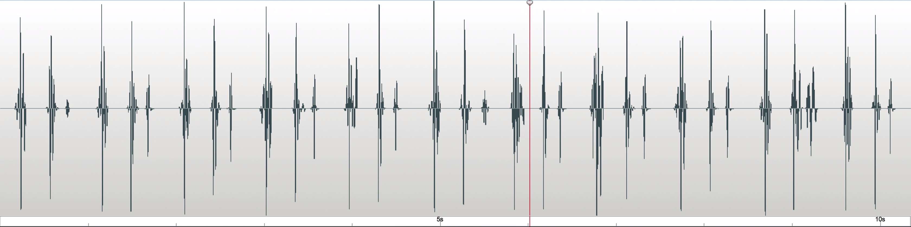
S2
S1
S3
* S1, S2, S3 labeled for beat 6. Red vertical line indicates time point at 6-second mark, during systole of beat 7.

