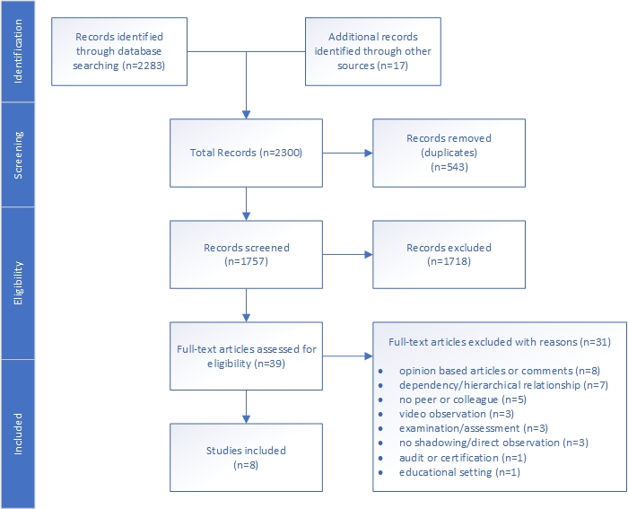
Figure 1: Flow Chart of the selection process

