
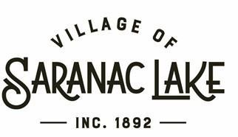

HOUSING ADVISORY BOARD AGENDA

JULY 16, 2026
5:00 PM – HARRIETSTOWN HALL, 2nd FLOOR

Minutes

5:05 p.m. - Meeting called to order

Present Members: Ben Douglass, Brian Draper, Mark Legeza, Rich Loeber, Jodi Gunther, Steve Erman, Peter Waldt, Doug Haney, Katrina Glynn.

Nominations for Advisory Board officers
- Ben Douglass nominated and unanimously voted to continue as chair
- Steve Erman nominated and unanimously voted as vice chair
- Doug Haney nominated and unanimously voted as secretary

Community Fund Enhancement Program
- 10K in the village budget. Current funds go to DAB, PTAB, Arts & Culture
- HAB and Climate Action not currently receiving these funds
- Discussion about whether HAB would like to ask Village for a portion of the funds
- HAB decides to individually research how CFEP funds could be utilized by HAB and to come to next meeting with the goal of narrowing those ideas into something to submit to the Village in the form of a resolution requesting access to the funds including examples of how they would be used.

Future Goals
- HAB requests how it can best support Village regards to Village approach to housing initiatives (Sand Pit, etc.)
- Closer liaison relationship with Village Board rep to ensure advisory board efforts are best spent towards initiatives Village Board agrees are worth pursuing
- Continue to build database of available properties for housing development
- Gain more knowledge on new housing properties coming online (Lofts), specifically how the properties will be managed moving forward
- Potentially look at finding funding for a housing assessment survey to have data to put toward community housing needs and what it can afford
- Leaders and members of all of the Village’s advisory boards should be encouraged to meet periodically to share information about their priorities, and to determine how we can each support complementary objectives.

6:07 p.m. meeting closed

