
Village of Biron Berries & Boo’s
Scarecrow Contest & Craft Event
October 17, 2026

- $5 Entry Fee
- Open to everyone
- The contest takes place with the setup at the Biron Municipal Center, 451 Kahoun Rd.
- Each entry will receive a *10x10 space to call their own
crow home! *Spaces will be outside, so plan accordingly!
- Scarecrows can be placed starting October 1, 2026, once
you register.
- You MUST register by Wednesday, Oct. 14th to be judged.
- One entry per person or group.
- All entries must be removed by Monday, November 2, 2026. If not removed, the village will remove and dispose of them.
This is a family-friendly event. No advertising, political or religious statements, or offensive or distasteful entries will be permitted. Please remember that the scarecrow's design will be viewed by children and adults and must be in good taste. Use your imagination. Scary, funny, artsy, colorful. Use straw or not!
Trophies will be awarded to 1st, 2nd, and 3rd place and will be determined by votes received at the Village of Biron’s Berries & Boo’s Craft & Vendor Event, October 17th at 2 p.m. Voting is 25 cents per vote, with the highest dollar amount being the winner. Money raised will go to the Village Park & Christmas decoration fund.
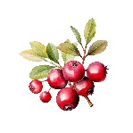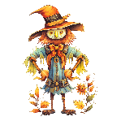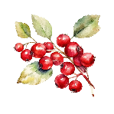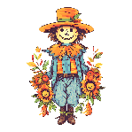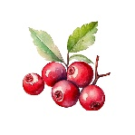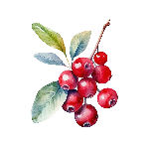

Name: ____________________________________________________________________________________________
Address: ___________________________________________________________________________________________
Email Address: ______________________________________________________________________________________
Telephone Number: _________________________________________________________________________________
Name of Scarecrow: _________________________________________________________________________________
I/we hereby agree to follow the rules of the Village of Biron Berries & Boo’s contest as outlined. I/we also hereby release and hold harmless the Village of Biron and its employees from all claims for loss, damage, or injury incurred to my property by the scarecrow viewers. Photographs of all entries become the property of the Village of Biron. Photographs may be used in various publications, community calendars, public presentations, advertising, publicity, and promotion.
Signature: ___________________________________________________ Date: ________________________________
Office Use:
Entry # ________
Submit entries to the Village of Biron Crow Parade
451 Kahoun Rd
Wisconsin Rapids, WI 54494
Or drop it off during business hours

