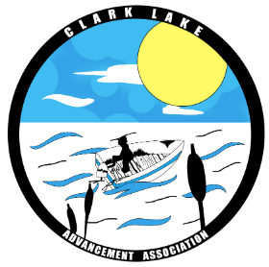
Help Spread the Word: Boat Safely
Fourth of July Weekend

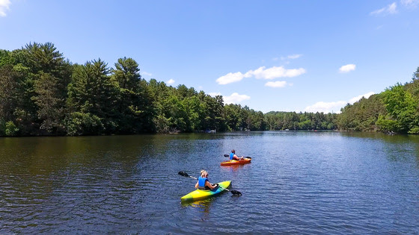
The Clark Lake Advancement Association (CLAA) needs your help spreading critical boating safety messaging around Clark Lake. We're asking you, our members, to assist in communicating this important safety reminder that life jackets save lives and it's essential to operate watercraft sober.
If you'd prefer to amplify CLAA's messaging or share from our Facebook and Instagram profiles rather than posting to your own social, that would also be helpful.
Thanks for spreading the word however you're able and helping keep your constituents and our members safe over the coming days.

