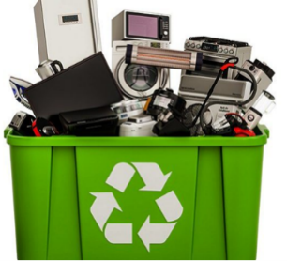
Unwanted/unused electronics or appliances to dispose of? Recycle them on Saturday, May 10 at the Jefferson County Fair Park (502 N Jackson Ave, Jefferson) from 8-11 a.m. First come, first served. $10 per vehicle (cash only). Households only! No registration required! Go to https://www.jeffersoncountywi.gov/departments/
planning_and_zoning/solid_waste_clean_sweep_recycling/clean_sweep.php for more information!

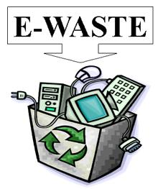
RECYLCE your appliances & electronics on Saturday, May 10 (8-11 a.m.) at the Jefferson County Fair Park (502 N Jackson Ave, Jefferson).

Households only! No registration required. First come, first served. $10 per vehicle (cash only). Go to https://www.jeffersoncountywi.gov/departments/
planning_and_zoning/solid_waste_clean_sweep_recycling/clean_sweep.php for more information!

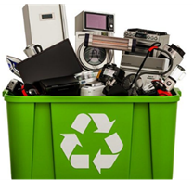
E-WASTE OR OLD APPLIANCES got you down! Recycle them!
Saturday, May 10 (8-11 a.m.) at the Jefferson County Fair Park (502 N Jackson Ave, Jefferson).

Households only! No registration required. First come, first served. $10 per vehicle (cash only). Go to https://www.jeffersoncountywi.gov/departments/
planning_and_zoning/solid_waste_clean_sweep_recycling/clean_sweep.php for more information!

